POLICY STATEMENT | To insure the accuracy of patient results reported by Microbiology, all results are reviewed daily for accuracy. Any clerical, analytical or procedure errors detected are corrected.
PURPOSE | To Insure that all patient results are correct, accurate and adhere to departmental policies.
SCOPE | This policy applies to all associates that work in the Microbiology Laboratory.
RESPONSIBILITY | Microbiology associates are responsible for insuring the accuracy of all patient results reported by the department.
RELATED DOCUMENTS | MICR 6015 R Corrected Reports

Microbiology and Immunology tests utilizing worksheets:
- Record patient results on the worksheet
- Enter patient results in Meditech
- Reprint the worksheet with the results
- Review the results against the original worksheet
- Correct any errors detected and document
- The worksheets are signed, dated, stapled together and filed in the appropriate notebook

Microbiology Daily Report Review:
Microbiology reports are reviewed daily. Any clerical, analytical or procedure errors detected are corrected.
MIC Management Reports:
- Result Activity Report
- Outstanding Report
- Specimen Log
LAB Management Reports:
- Outstanding Test Report
Select Laboratory > St. Agnes Hospital > ML
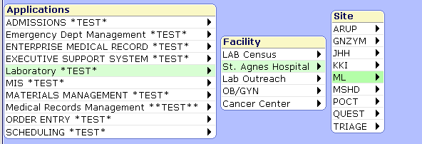

Select Management Reports
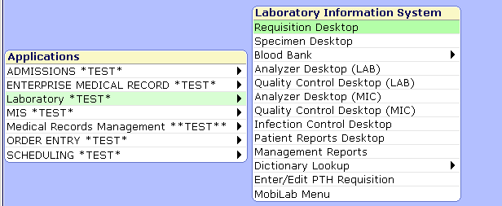

Select MIC Management
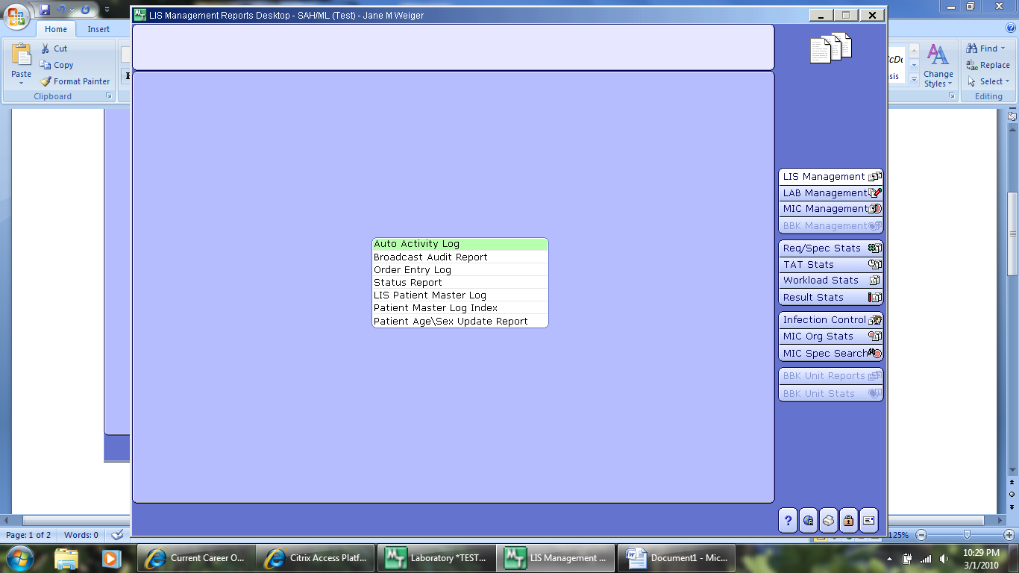

Select Result Activity Report
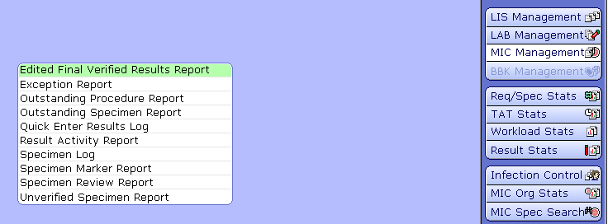

Enter Date Range – from the time yesterdays report was printed until now
Prefix – M for microbiology cultures; AM for anaerobe cultures and BL for Blood culture
Specimen Criteria – Specimens W/ Organisms Only = N (M and AM); Y (BL)
Include unverified results = Y
Complete Specimens only = N
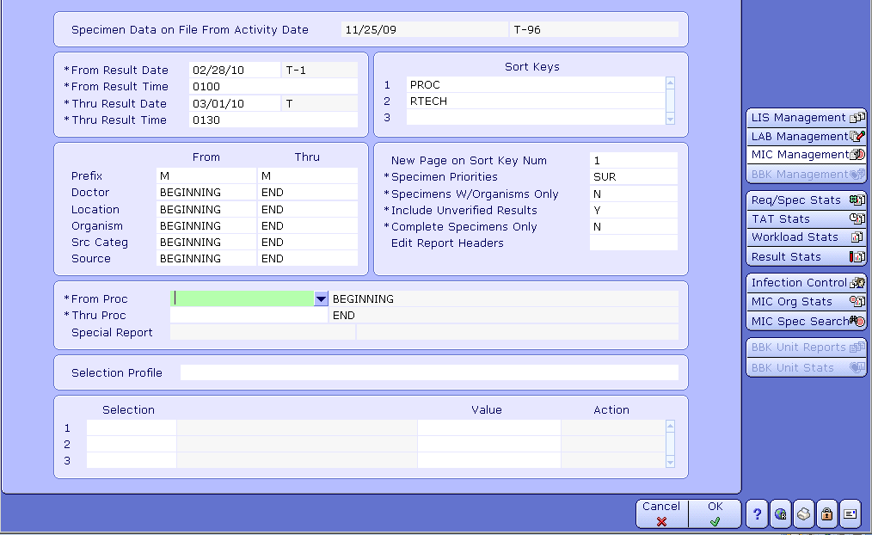
Select Outstanding Procedure Report

Enter Department > Overdue Y > Received
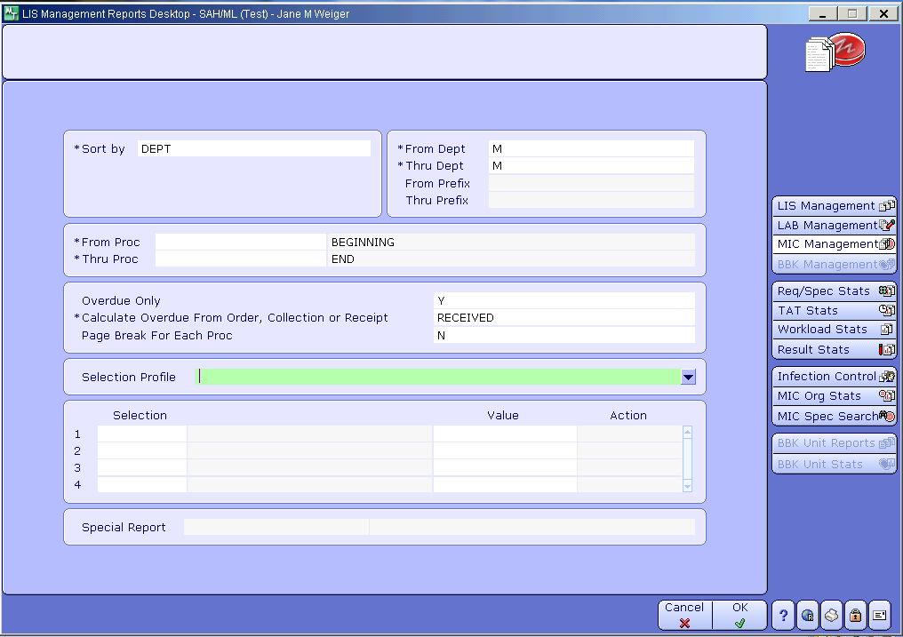

Select Specimen Log Report

Enter Date Range > Procedure
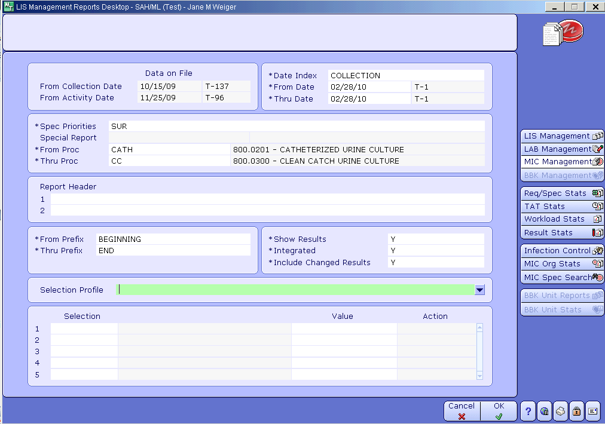

Select LAB Management

Select Outstanding Test Report
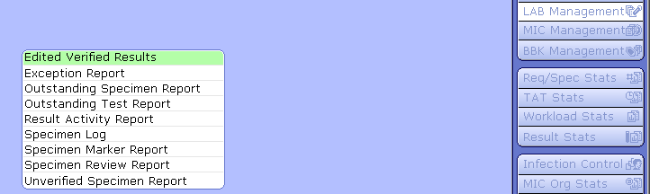

For Micro - Enter Department M > Overdue Y > Received
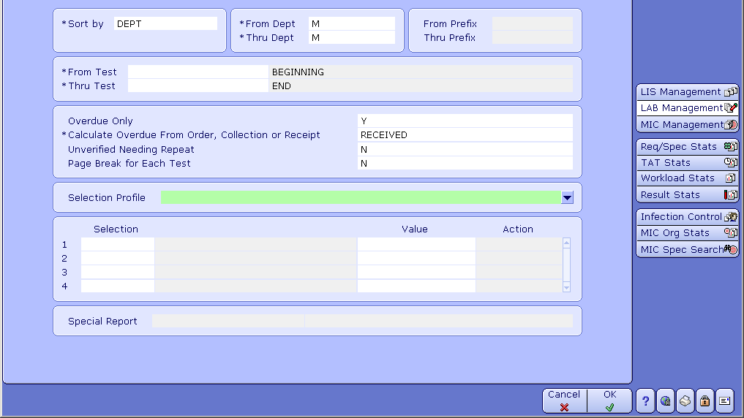

For Immunology - Enter Prefix I > Overdue Y > Received
