**NOTES:**

This process will not be used for blood requested to be issued to OR, PACU, ONC, “Specials” (i.e. GI Services, Cardiac Cath, etc.), or in the event of any sort of acute bleeding scenario or massive hemorrhage. Use your best judgment. If there are any problems, complaints or discrepancies while using this process, document with an occurrence report form (ORF).

If using this process reveals that there is no order for transfusion of a patient or if the order is cancelled (the order would be in red text on the status board and the status would be CNC), call the patient’s nurse and verify the order.

* Hold off on releasing the blood products until it is resolved (except in the case of emergencies).
* Document the date, time, and name of RN you spoke with.
* Ask the nurse to verify the order for transfusion.
* During downtime or if the nurse has the order for transfusion but it is not filed electronically, seeing a copy of the written order is acceptable (faxed or tubed to the blood bank).

This same process can also be used to verify the specific information on the request to blood to determine if special transfusion requirements were ordered.

**PROCEDURE**

1. To load the status board, navigate to: **ORDER ENTRY – Saint Agnes Hospital – Process Orders.**

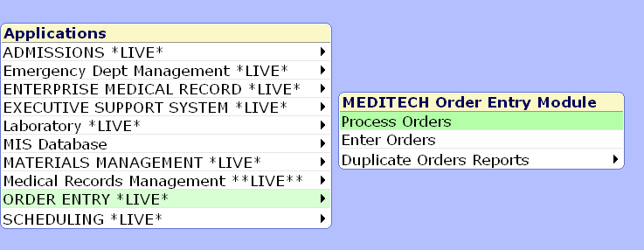

1. The orders desktop will load, navigate to **Process by Location** via the button at the bottom of the screen.



1. The Process by Location interface will load.

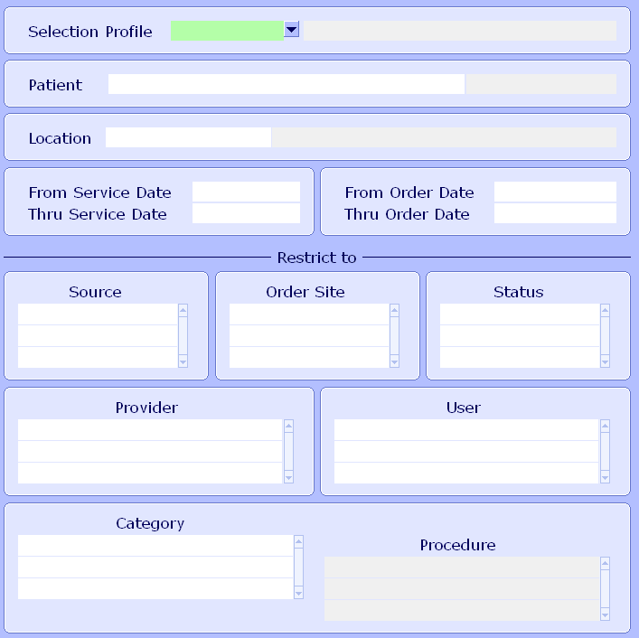

1. Enter the selection Profile, “zTEST”.

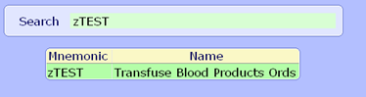

1. Enter (Scan) the patient’s account number into the Patient field.



1. A confirmation window will appear, if the patient information is correct, click Yes.
2. There is an option to determine what time period the interface will load. The default is today’s date. Entering “T-3” will into “From Service Date” will pull all orders from the last 3 days.

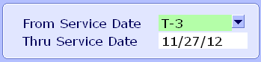

1. The interface defaults with BBK orders, EDNUR, and NUR orders showing.

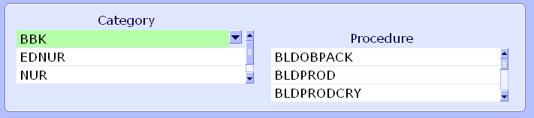

1. Click OK or hit F12.



1. The desktop will take several seconds to load.



1. The desktop appears as below.

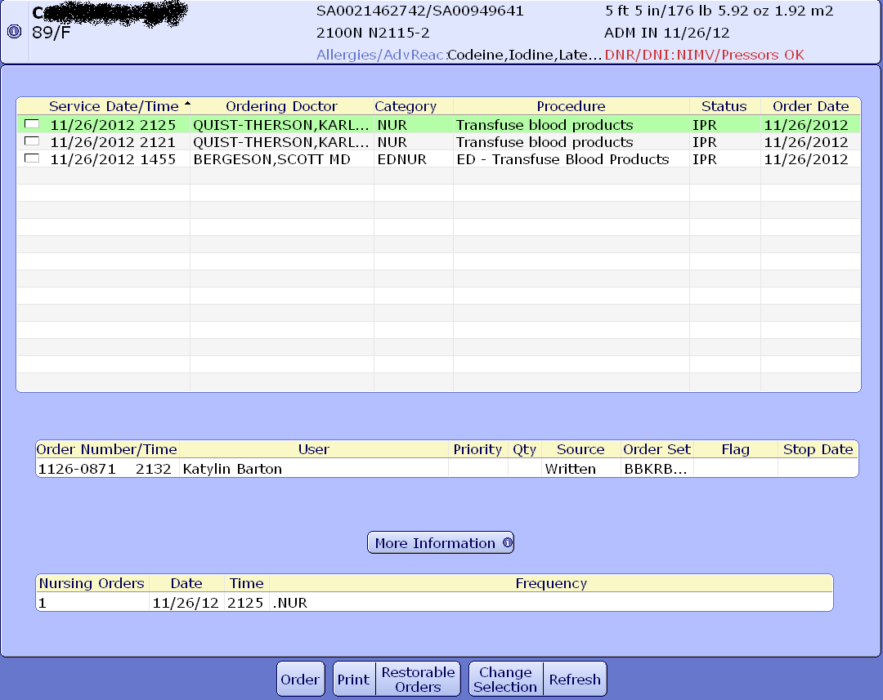

**Verifying Transfusion Orders (NUR, EDNUR orders)**

* The process board loads with the most recent order at the top.
* Each column in the desktop is sortable.
* Status column indicates that an order is either.
  + CMP “Complete”.
  + IPR “In progress”.
  + CNC “Cancelled”.
* To view the information for an order, highlight the order and click the More Information button.
  + This will indicate the number and type of products requested in that order; you may have to click the arrows to go to the next page.
  + In the example order shown below, 3 units of RBCs were ordered for transfusion 11/26/12 at 2125.

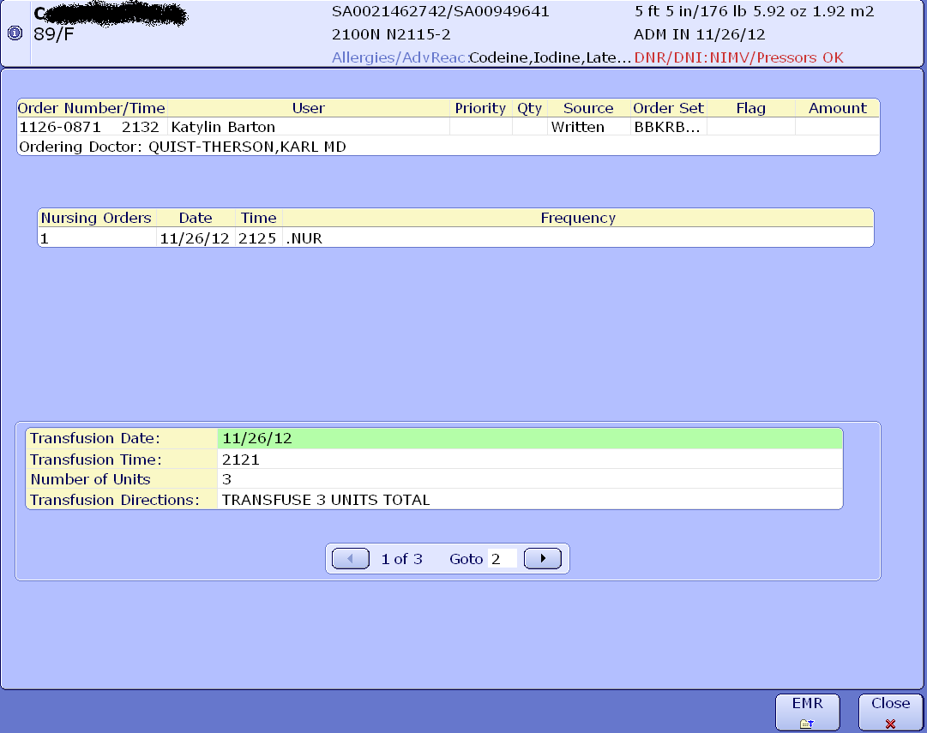

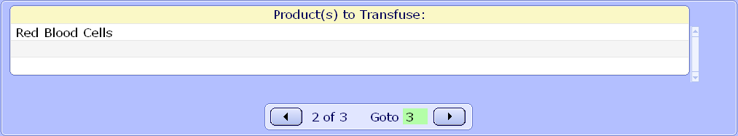

* To verify whether this transfusion order has been filled or not, click on the EMR button in the bottom right.

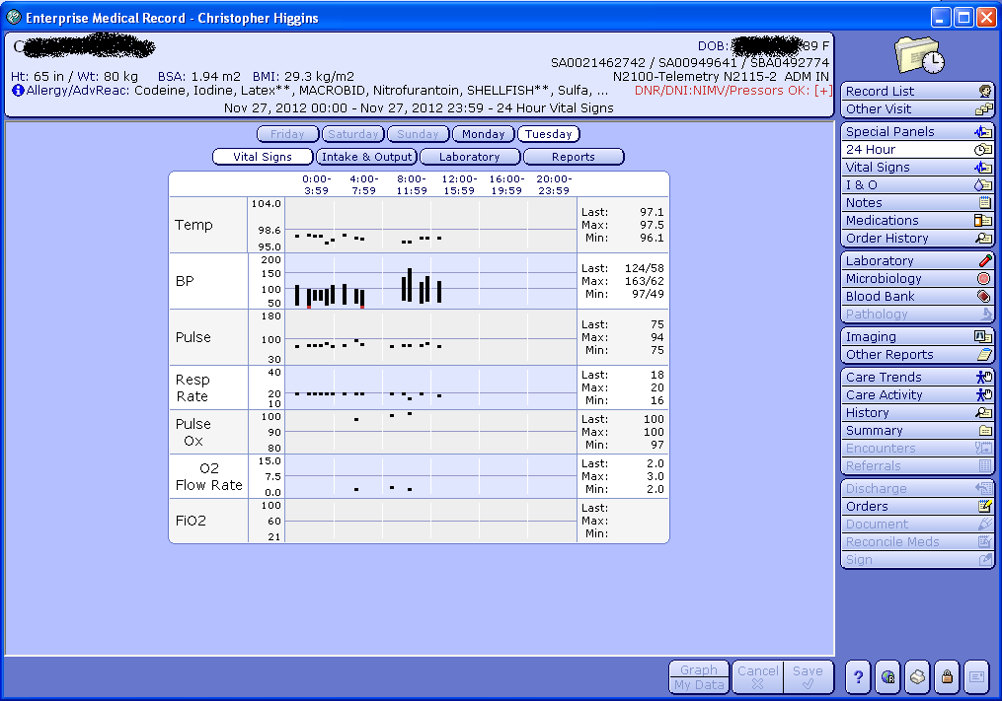

* Click on the blood bank tab in the middle right.

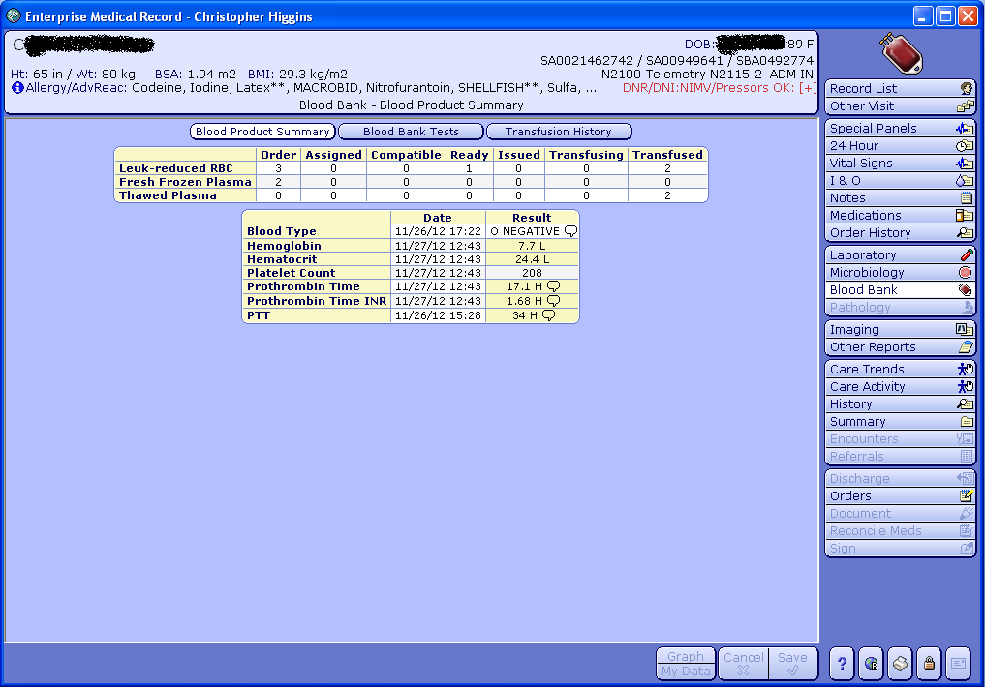

* In this example, we can see there were 3 RBCs ordered for the patient in the blood bank, 1 is ready and 2 have been transfused.
* Also you can see the patient had 2 FFP ordered in the blood bank and 2 thawed plasma transfused.
* Click on the “Leuko-reduced RBC” field and it loads the time/date that the products were issued for transfusion.

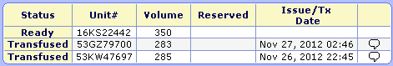

* In this example scenario, if an additional RBC was requested by nursing staff it would be acceptable for issue.

**Verifying Requests for Blood (BBK orders)**

With the interface loaded, select the appropriate Request for Blood from the list to match the blood product and click More Information.

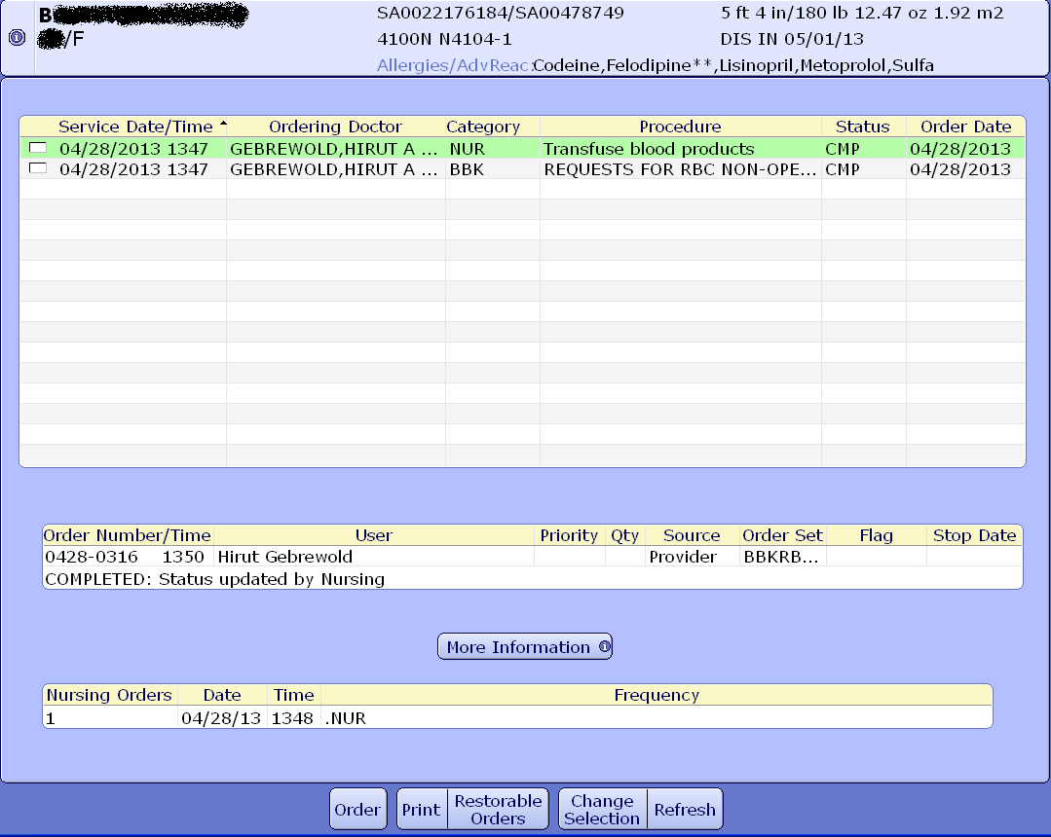

This will load a display of the query responses from the blood request.

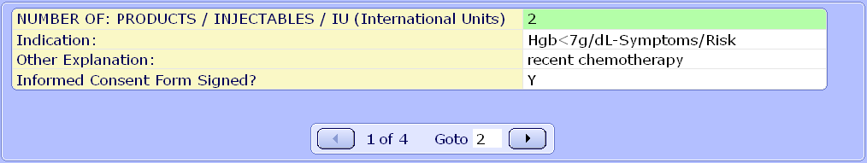

Click the right and left arrow to navigate through the entire order.

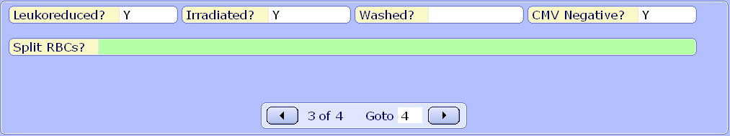

This page will clearly indicate scenarios where the patient’s transfusion was ordered with a special transfusion requirement.