|  |  |
| --- | --- |
| Policy Statement | Frozen plasma products (such as FFP, FP24 or cryo-poor plasma), when thawed, can be used in the treatment of a variety of medical conditions. Saint Agnes Hospital Transfusion Services provides this blood product to meet those patient needs.  The product is stored on site at ≤ -18oC. It is processed and converted to thawed plasma per physician’s request. Generally, thawed plasma is provided to the patient within 4 hours for routine cases, 60 minutes for stats to accommodate processing times. |
| Purpose | To provide guidelines and information to those blood bank technologists who process frozen plasma. |
| Scope | This procedure covers the selection, preparation, assignment and issue of thawed frozen plasma. |
| **Responsibility** | * It is the responsibility of the Transfusion Services Medical Director to participate in the selection of the supplier of blood products. * It is the responsibility of the supplier, to provide those products as requested according to the contract (depending upon product availability.) * It is the responsibility of the Transfusion Services Lead Technologist or designee to maintain adequate levels of frozen plasma that will cover most physicians’ requests. |
| **Related Documents** | * Supplier shipment documentation * Saint Agnes down time forms when the information system is not operational. * Cross-match tag * Consultation form, if necessary * TRAN 6021 Ja Job Aid for Processing of Fresh Frozen Plasma * AABB Standards for Blood Banks and Transfusion Services (Latest Edition) Bethesda, MD * AABB Technical Manual (Current Edition) Bethesda, MD * Food and Drug Administration, Department of Health and Human Services. 21 CFR parts 200 to 299. Washington, DC: US Government Printing Office, (revised annually) * Laboratory Information System (Current Version) * Circular of Information for the use of Human Blood and Blood Components (Current Version) * TRAN 6055 R Administration of Blood Products (Latest Version) |

**Procedure**

Pre-Thawing

1. Individual Units
   1. Once the physician has entered the order for plasma, request the product by using the specimen number generated by the order.
   2. The product to be requested should be entered as either BBFFP (frozen plasma) or CRFFP (cryo-poor plasma.)
   3. Indicate the number of units requested in the **“*Ct”** column (see screen grab below.) Proceed to Thawing Plasma instructions.

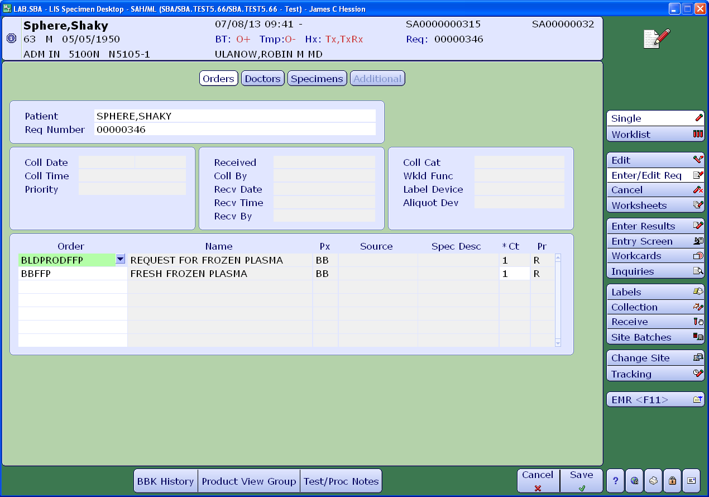

1. Plasma Pheresis Patients
   1. The order for plasma pheresis is entered the same as for individual units except the total volume requested will be seen in the comments section.
   2. Since the order is requested by volume, pheresis patients may require multiple units of plasma. Do not enter the number of units until after thawing is completed. Proceed to the Thawing Plasma section.

Thawing Plasma

1. Once you have selected the appropriate unit(s) of frozen plasma for the patient, proceed to convert the product to THAWED PLASMA in the computer.
2. Barcode one unit at a time.
3. The information system is going to ask to re-enter the volume of each unit.
4. Once the processing of each unit is completed, the new product will be called THAWED PLASMA.
5. The rest of the information, such as expiration date and time will be automatically generated by the information system.
6. Place the unit(s) in a plastic bag.
7. The units are thawed in the water bath which is maintained at a temperature of 35º C ± 2º.
8. Remove the lid of the water bath.
9. Push the lift button of the water bath.
10. Securely put the units inside of the water bath by using the clip included in the device.
11. Press the cycle button located in front of the water bath. The process will take approximately 15 to 20 minutes, depending upon the number of units (more than 2 may take several minutes more.)
12. At the end of the cycle, the device will lift the part that holds the plasma.
13. Make sure that the product is dry, and proceed to assign the plasma to the patient as depicted on Job Aid TRAN 6021 Ja and print the assignment tags.
14. For pheresis patients:
    1. The number of units to be entered on the order will be based on the volume. For example, if 3 liters (3,000 mL) is requested, you will need to process 12 to15 individual units of frozen plasma.
    2. Add up the volume of each unit thawed to determine the exact number of units. Then, enter the total number of units.
    3. Always provide at least the amount requested, even if slightly over the volume requested (ex. total units thawed may be >3,000 mL if 3,000 mL was requested.)
15. Print the labels that will show the new name, volume and expiration of the product.
16. Thawed plasma expires within five days after thawing. We do not extend thawed plasma beyond that time. Any thawed plasma units that are not used before they expire are not transfused under any circumstances and must be discarded.
17. Place the labels on the unit.
18. Store thawed plasma in approved refrigerator between 1-6°C until ready for issue.