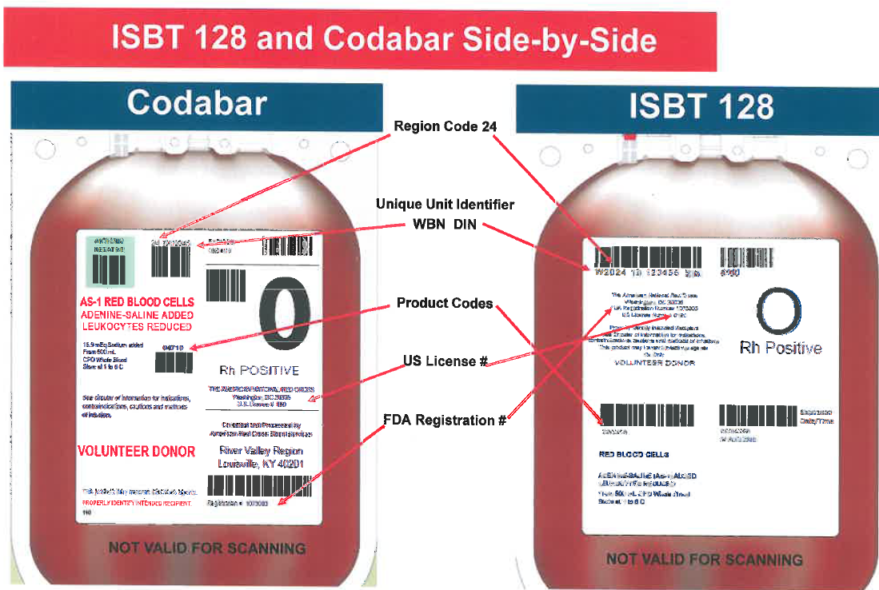
Note the difference between the coda bar and ISBT 128.
There are 5 places to scan with the coda bar and only 4 with the ISBT 128. The donor identification number now contains the source code.

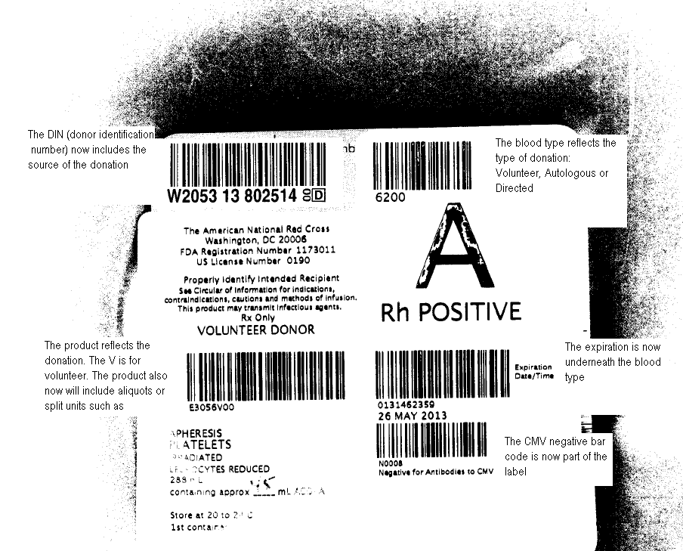
The product reflects the type of donation. In this example the V stands for Volunteer. The 00 represent the division code
The DIN (donor identification number) now includes the region source of the donation
The blood type reflects the type of donation: volunteer, autologous, directed etc…
The expiration is now underneath the blood type.
The unit’s attributes are now part of the label. This example is CMV negative.
An example of a platelet: Note the region source code is now part of the donor identification number. Also note the attributes such as antigen typing, HgBS testing and CMV testing are now part of the label instead of separate labels. All American Red Cross sources

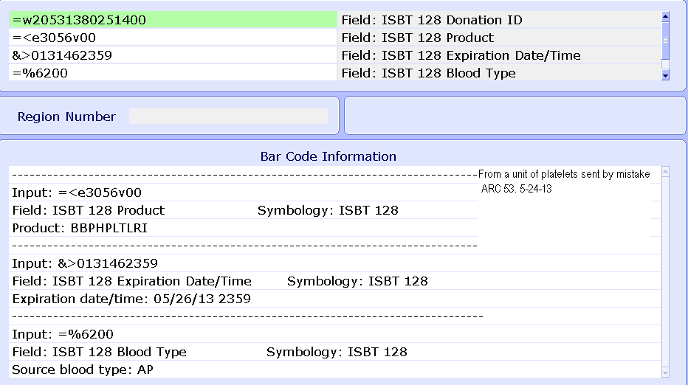
With ISBT 128, any of the 4 bar codes can be entered in any order.
Note: All the ARC units will have the same source name.
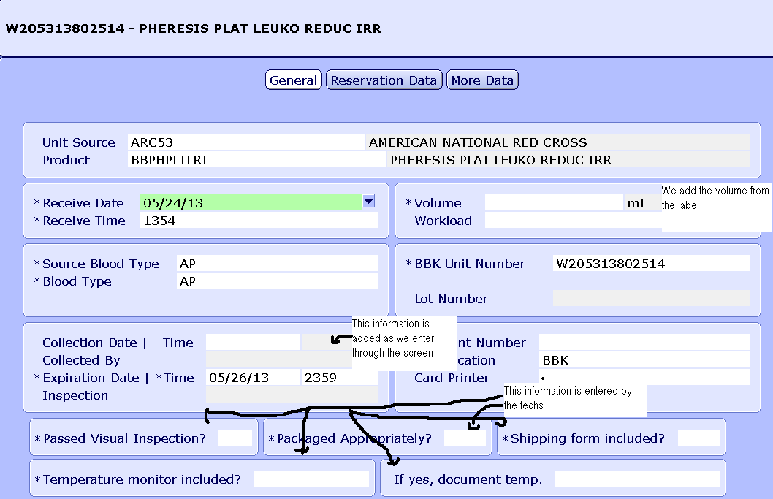
The unit was able to display all the information just like the coda bar labeled units.
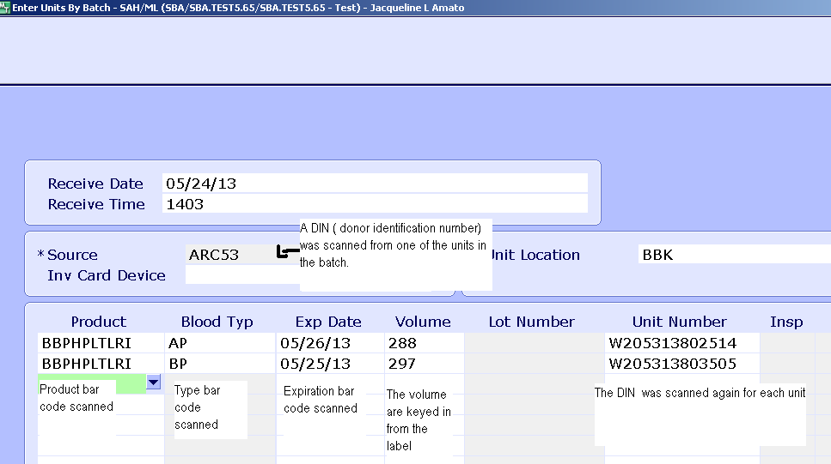
Scan one of the DIN numbers from one of the batch units at the Source (source and donor identification number are the same bar code).

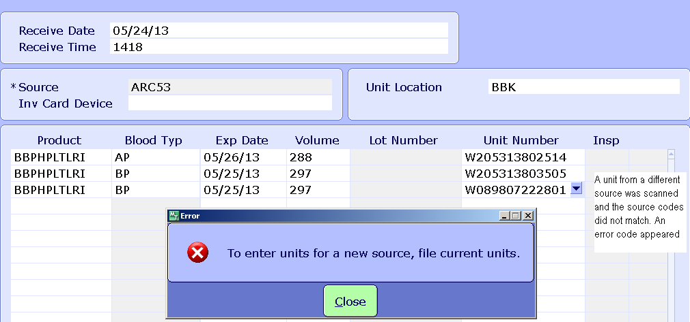
A unit with a different source was scanned into this batch. A warning does appear.
Meditech now gives a warning if the original source code does not match a unit from a different source code scanned in the same batch.
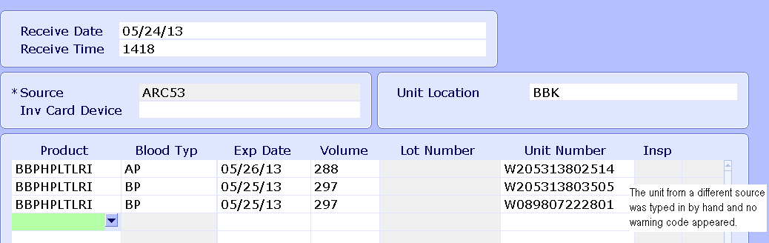

The batch will allow you to incorrectly enter by typing a unit number from a different source.

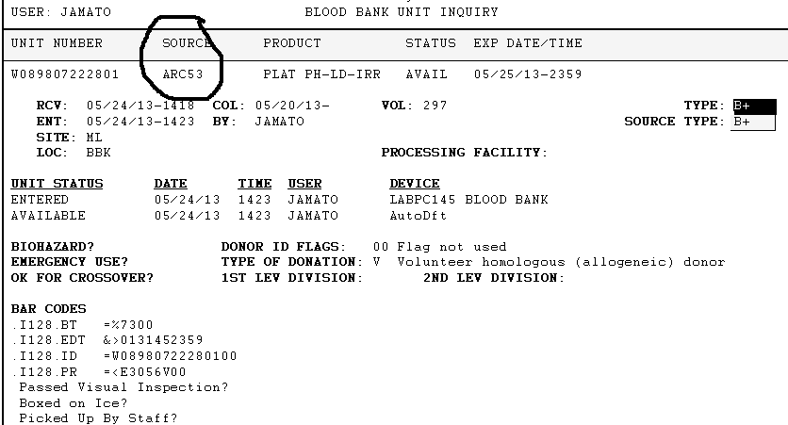
The source now defaults to the original source code from the batch instead of the source code from the unit of blood.
No hand entering should be done in batch.

