Enter the crossmatch into Meditech as usual for the ISBT 128 unit.

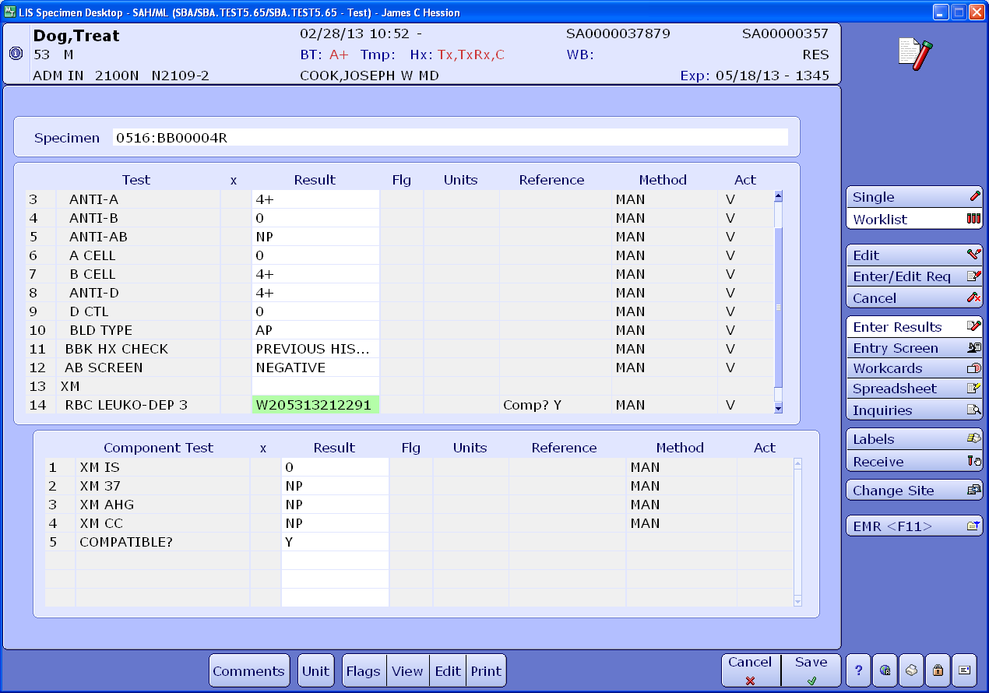

History indicates that split units are needed.

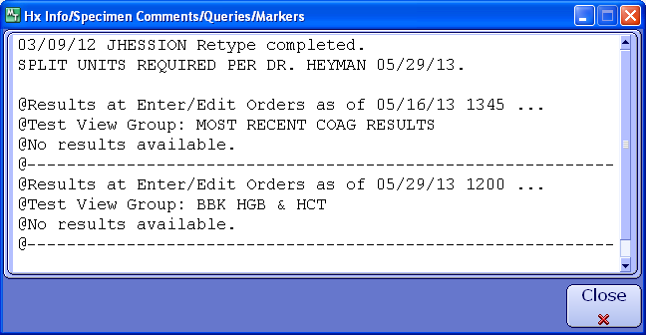

To create the aliquot navigate to the Units module -> Unit Entry -> Make Aliquots

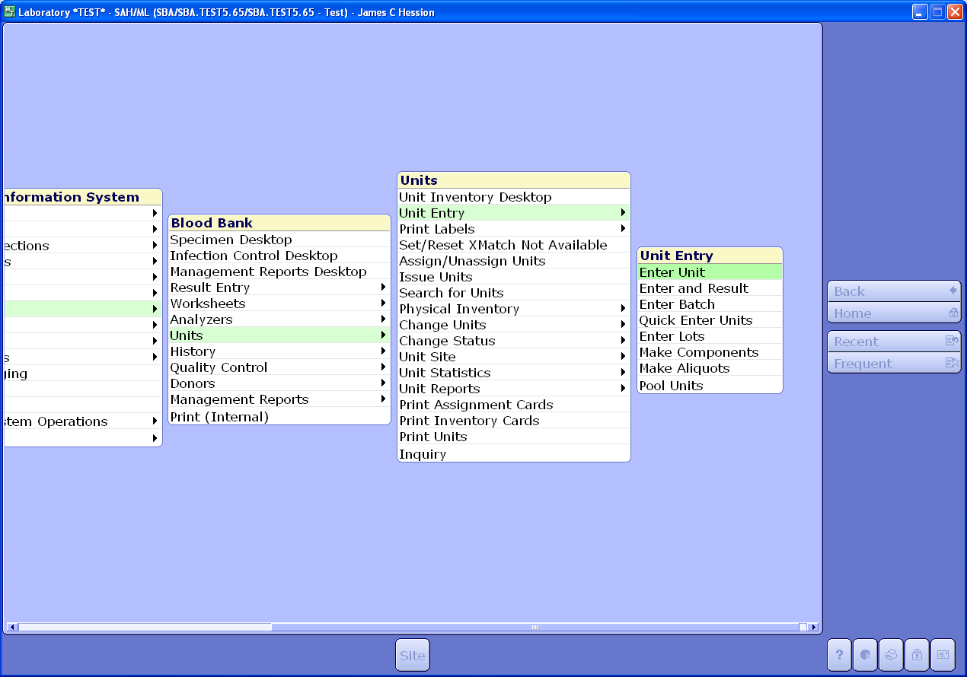

The Make Aliquots interface will load

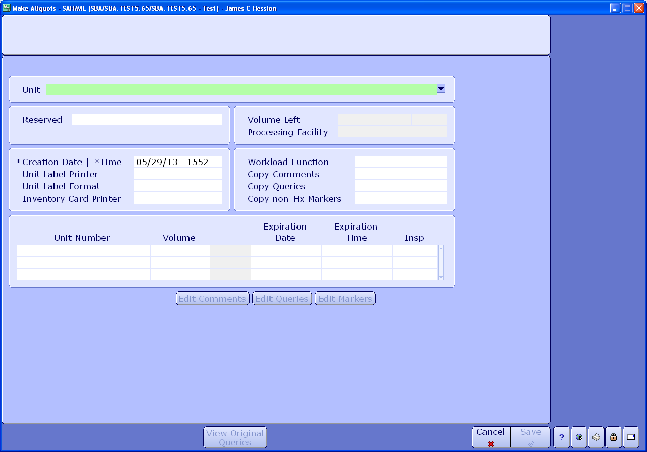

With the cursor in the Unit field, scan the unit number barcode.

Click on the Copy Comments field and type Y. Press enter.

In the Copy Queries field type Y. Press enter.

In the Copy non-Hx Markers field type Y. Press enter.

The unit number with aliquot designation character (A for first aliquot, B for second and so on) should populate.

Enter the volume of the aliquot that was created.

Enter the appropriate expiration date and time

Click Save or press F12 to create the aliquot in Meditech.

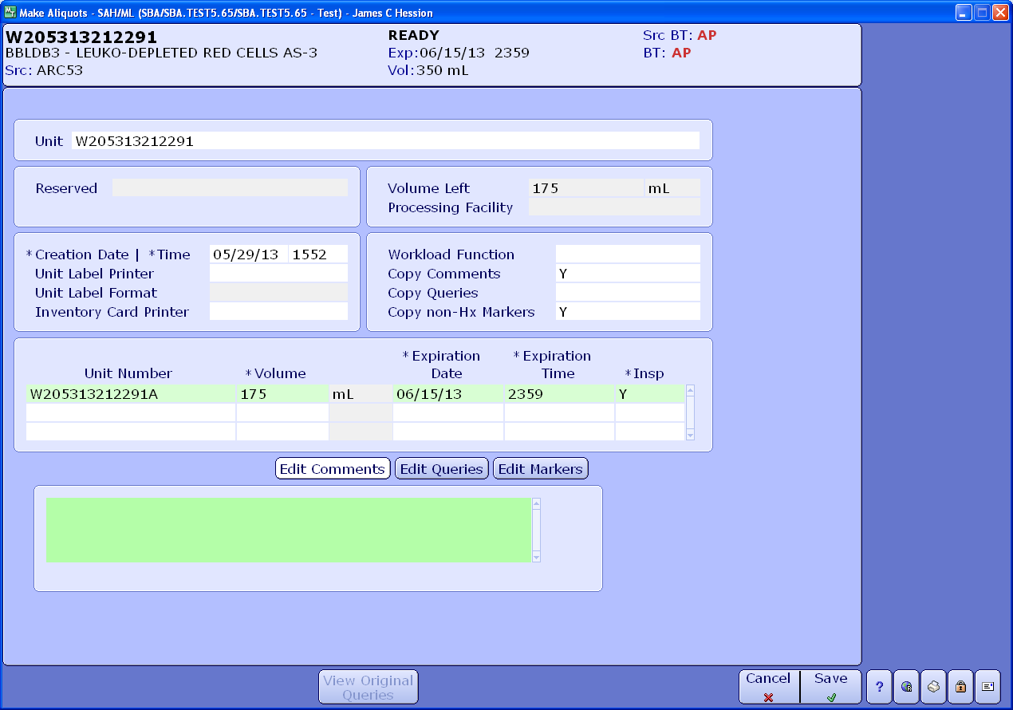

The following confirmation window should appear. Click yes.

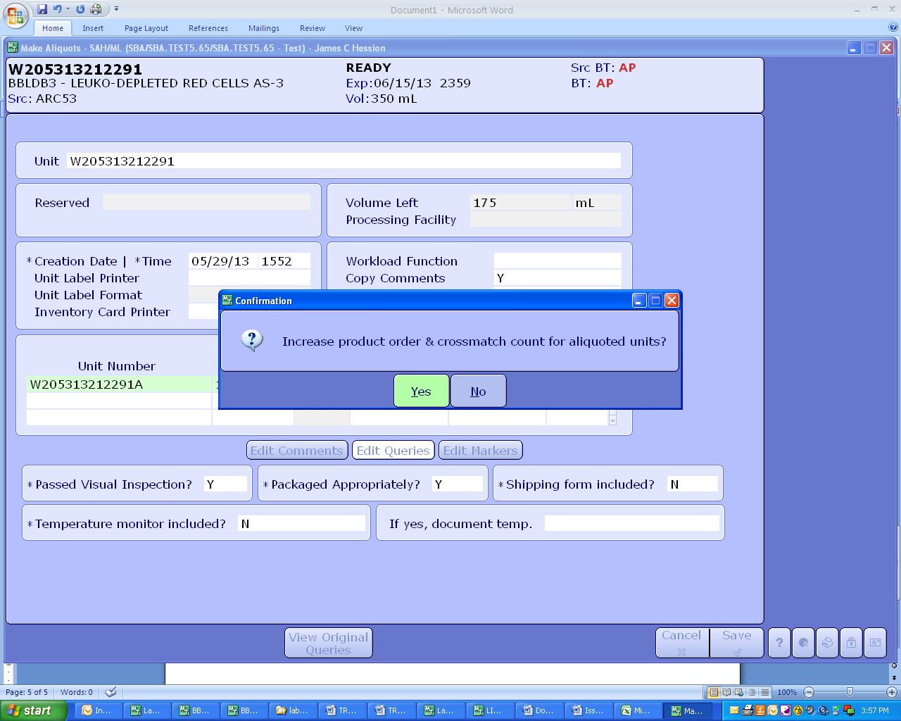

Another confirmation window will appear to confirm how much you want to increase the product order. If you’re just doing one aliquot, leave it at 1 and click OK or press F12.

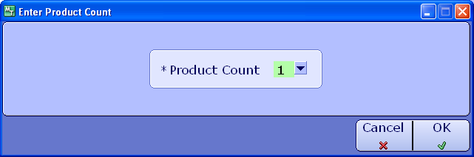

The aliquot will automatically be added to the TYSC with all crossmatch information.

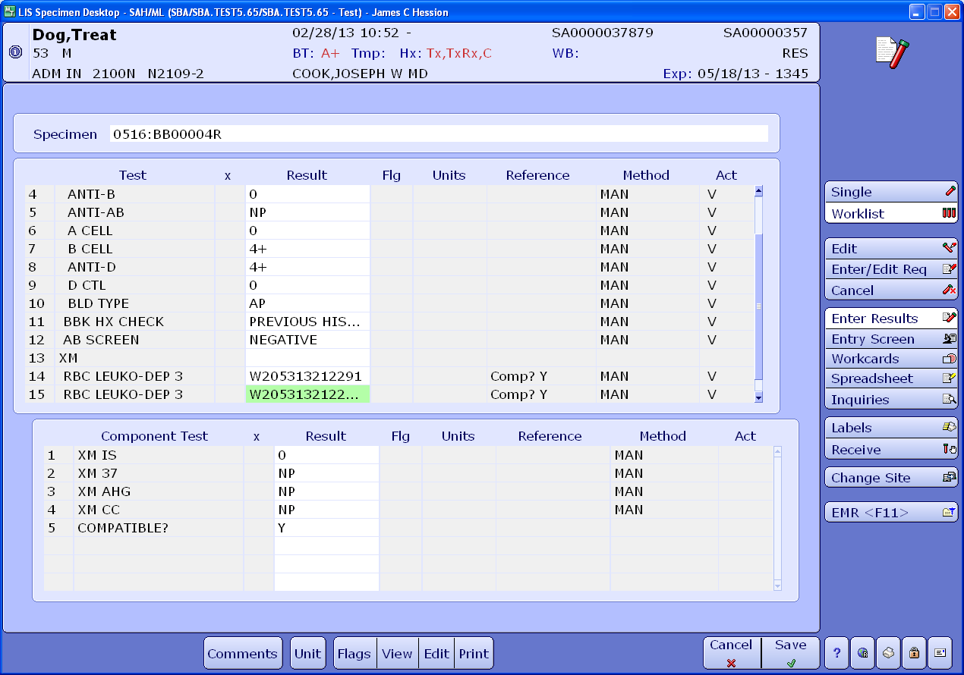

To print a label for the aliquot, navigate to Units -> Print Labels -> Print

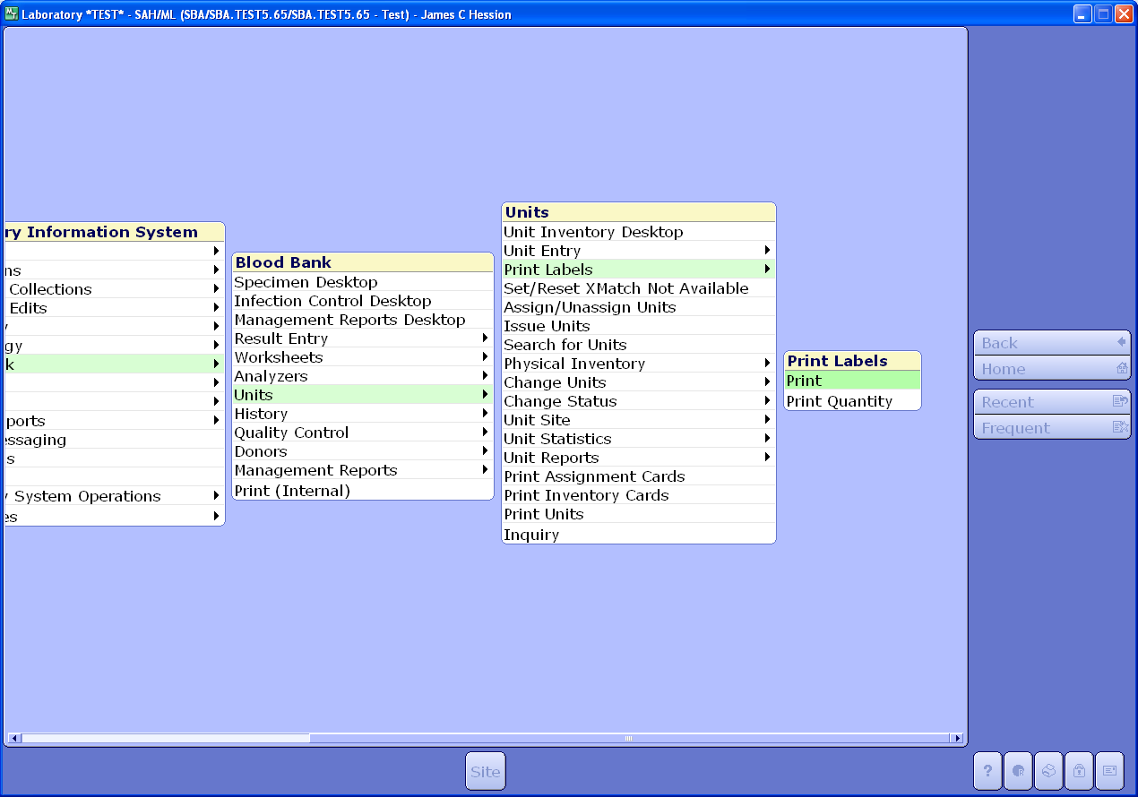

Select the appropriate aliquot.

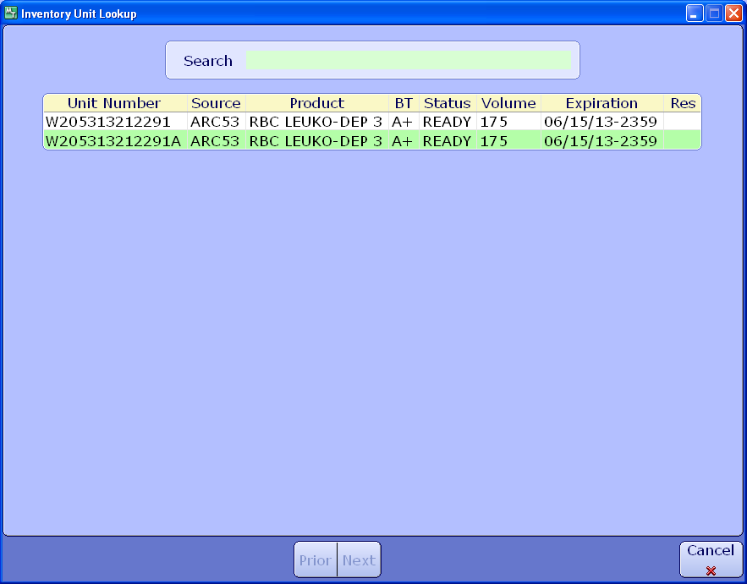

Select “OK” to print

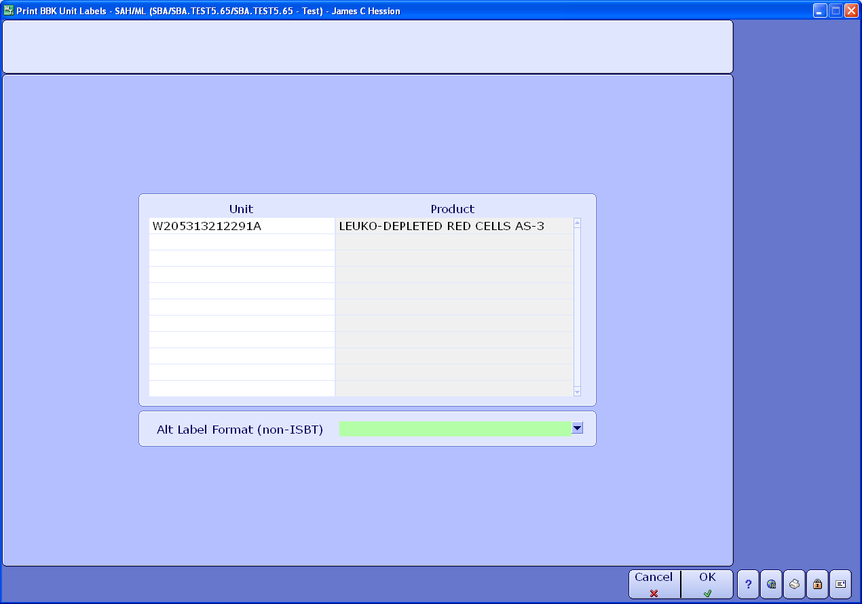

You must select Printer LBBP31. That is the designation for the Hematrax ISBT128 which must be used to print all ISBT 128 labels.

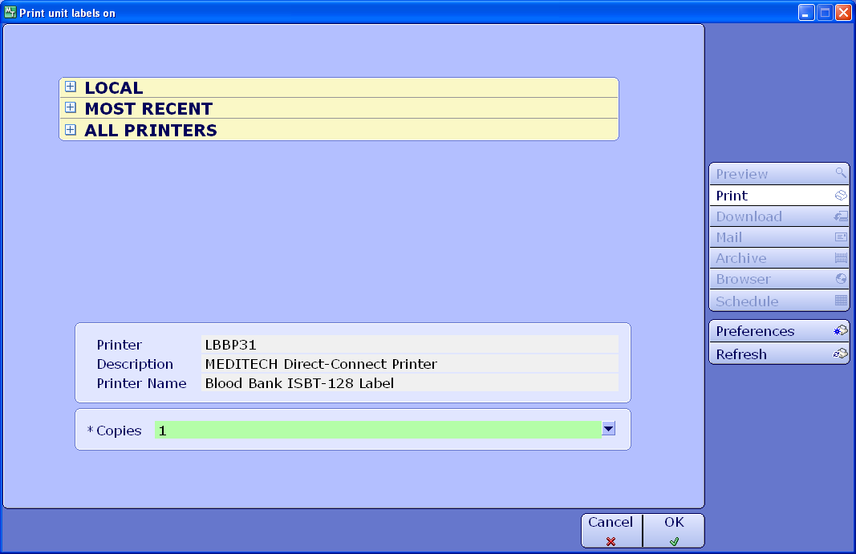

The following screen will appear. Notice the Unit Number field. The suffix (division code) does not appear. However, in the “Division Codes” field, it appears as A0. This indicates that it is the aliquot designated as “A.” These appear automatically. Now, select the “Code” field in the attributes section. Note: do not edit any of the other information in the other sections.

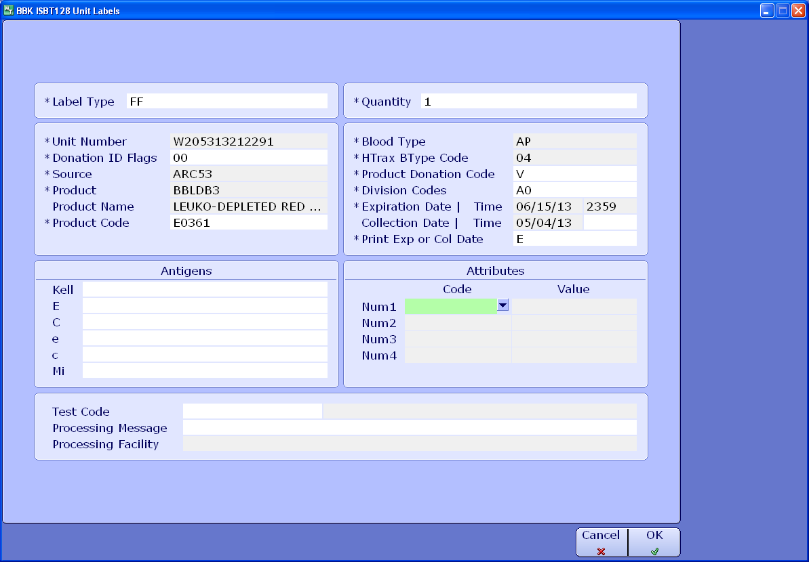

Press F9 and the following codes with descriptions appear. Select Code 2 “Unit volume in mLs.”

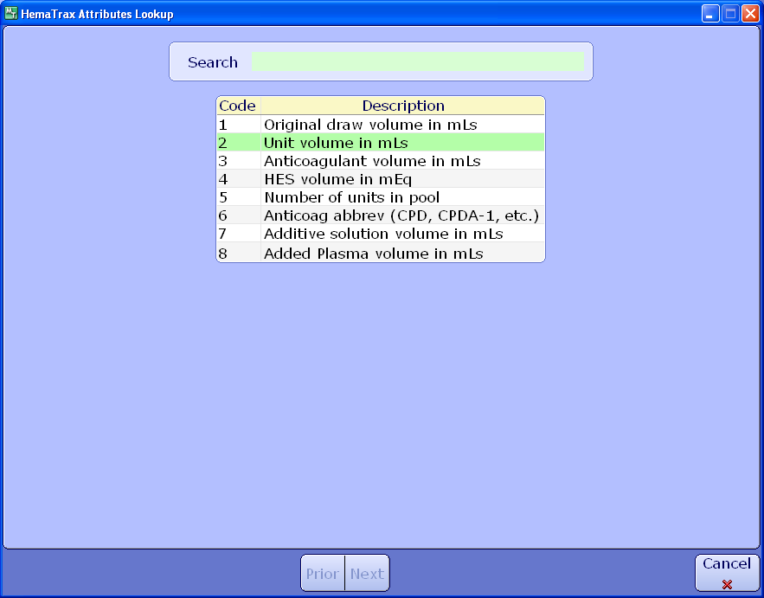

After making your selection, enter the volume of the unit you are about to label. Then select “OK” or F12.

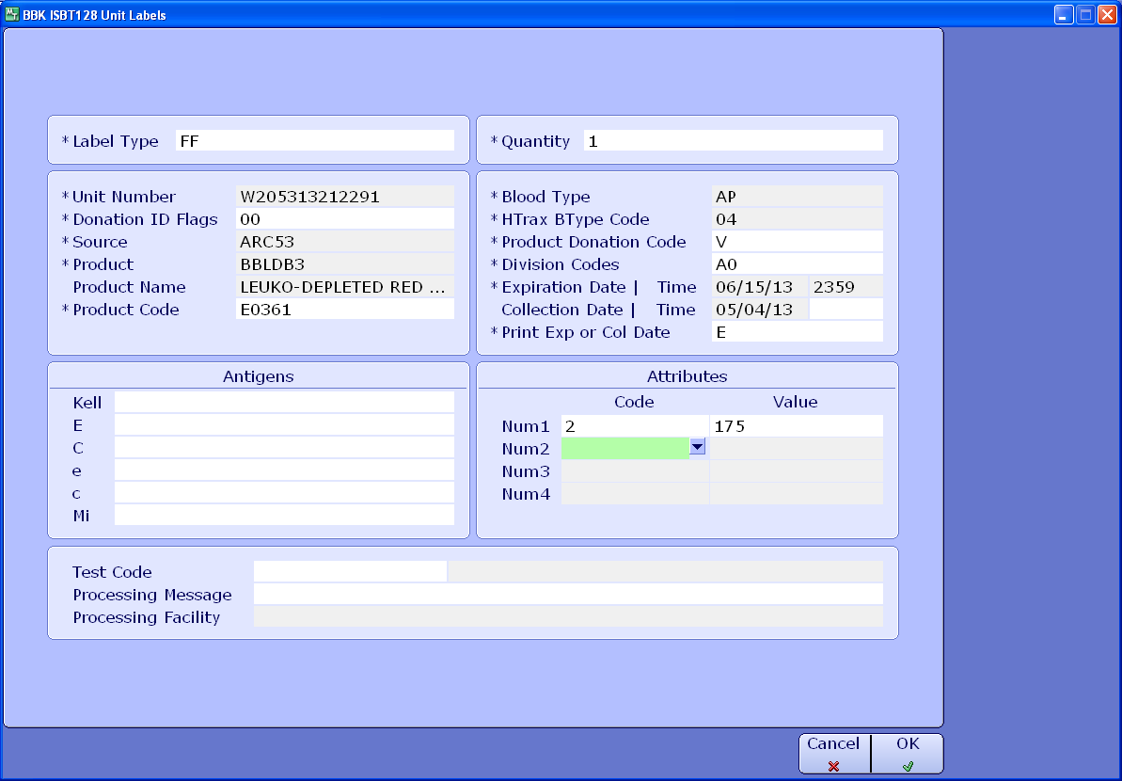

The label will appear as below. Note the placement of the division codes.

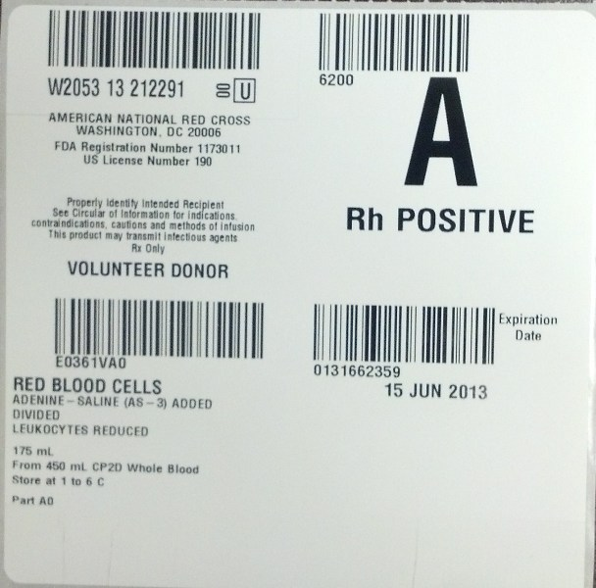

The division code also prints here

The division code is now a part of the product code

The volume is now below the product description

The division code “A”, “B”, etc does not print at the donor identification number

Then print the crossmatch cards as is normally done.

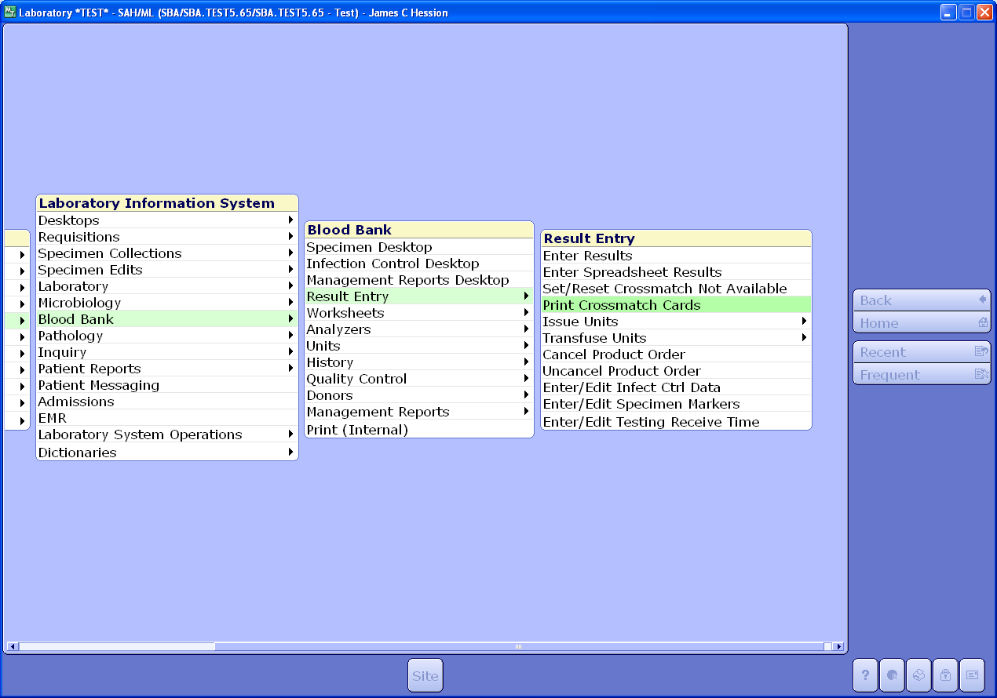

Again, make certain that you choose the correct unit.

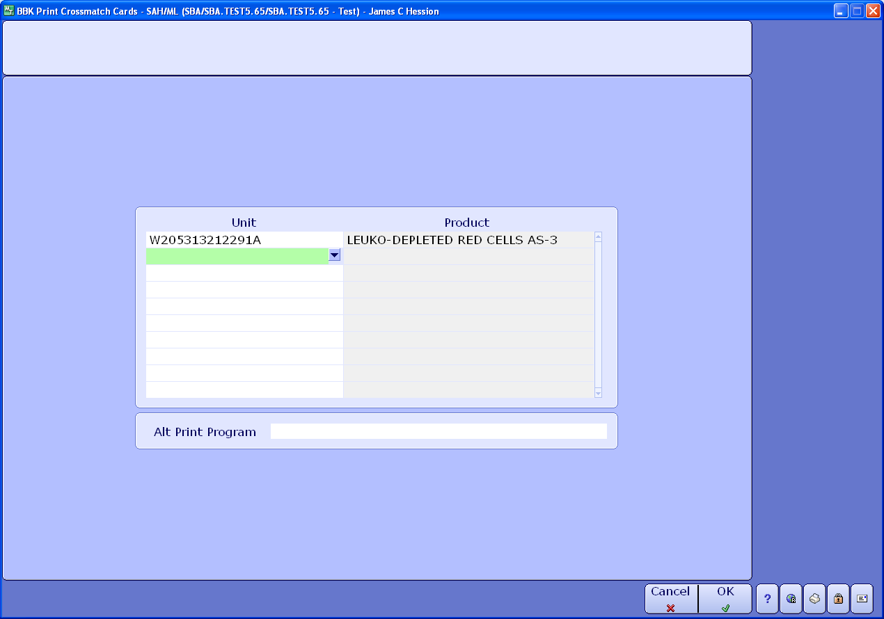

Note that the division code on the crossmatch cards appears as the last character on the unit number just as in Meditech.

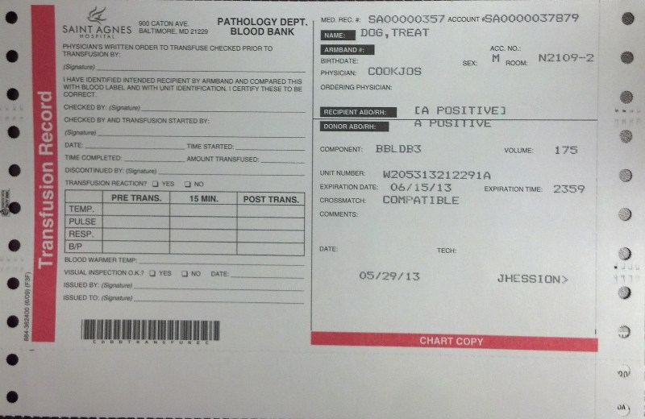

The division code prints here

**Autologous Units**

Please note that a divided autologous unit label may not print correctly. The label may print as “Volunteer Donor” rather than as “Autologous.” If that’s the case, it may be necessary to follow either one of the following practices:

* Affix a commercially purchased label indicating that the unit is for “Autologous Use Only” to the unit that has a face label printed with the Hematrax printer from Meditech. Cross out “Volunteer Donor” with a pen to indicate the change.

If no commercially purchased label is available, any autologous labels printed through Meditech using the Hematrax printer modify it by crossing out the word “Volunteer Donor” and writing “Autologous” in its place.