Go to “Issue Units by Patient” per standard procedure.

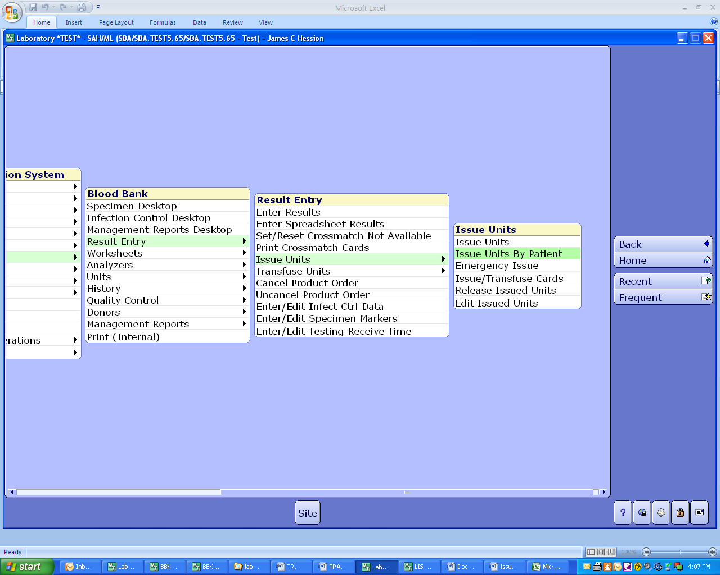

Scan unit. When you scan the divided unit, both the “parent” unit and the divided unit will display.

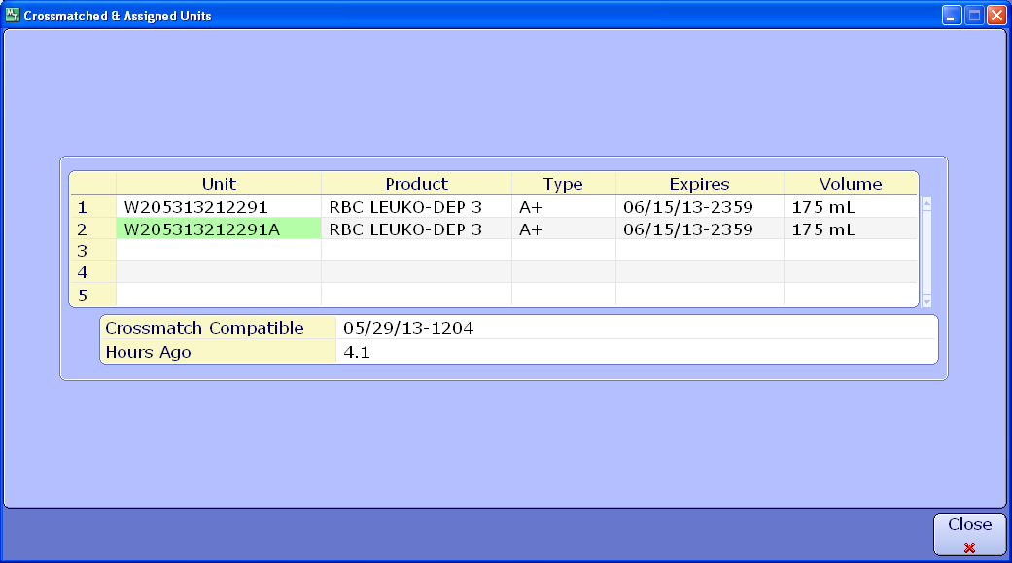

Select the divided unit with the correct division code.

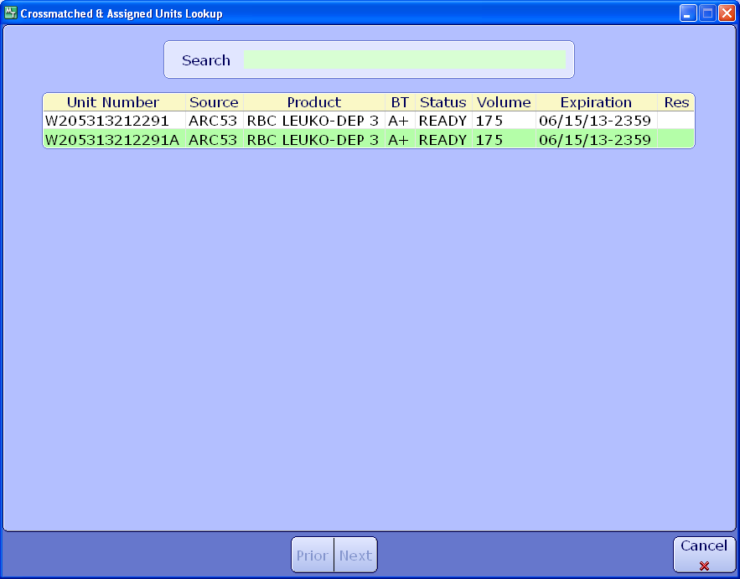

Complete issue of product in Meditech as appropriate.

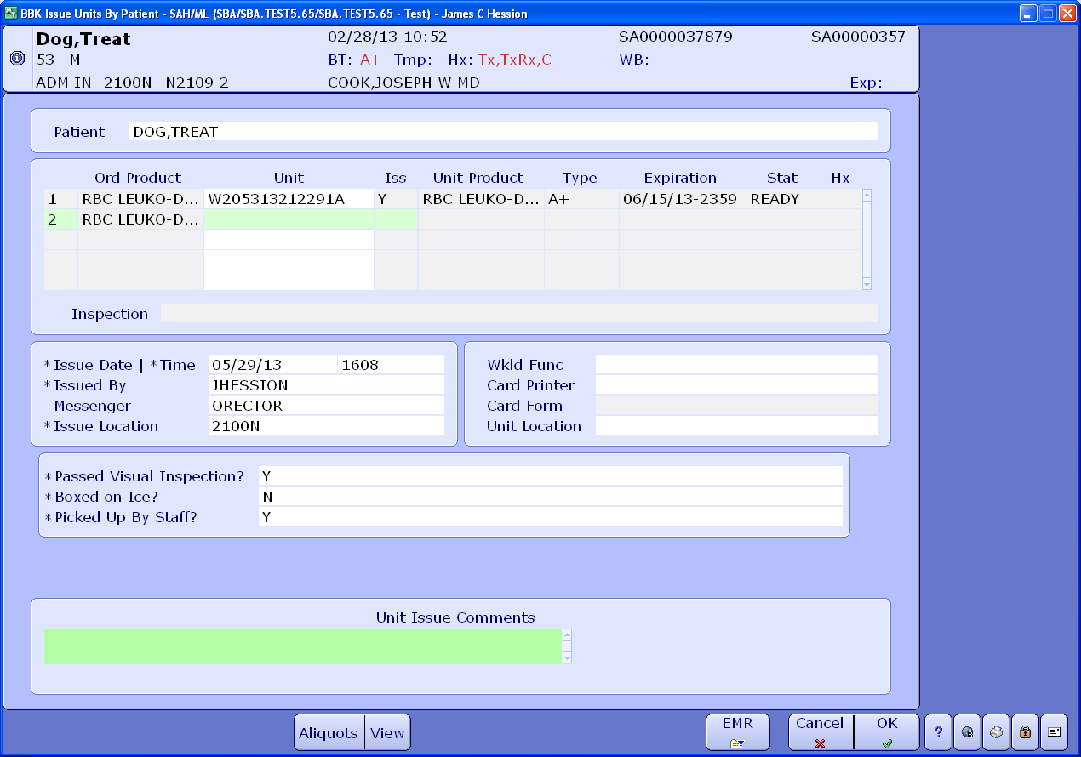

**Autologous Units**

Please note that a divided autologous unit label may not print correctly. The label may print as “Volunteer Donor” rather than as “Autologous.” If that’s the case, it may be necessary to follow either one of the following practices:

* Affix a commercially purchased label indicating that the unit is for “Autologous Use Only” to the unit that has a face label printed with the Hematrax printer from Meditech. Cross out “Volunteer Donor” with a pen to indicate the change.
* If no commercially purchased label is available, any autologous labels printed through Meditech using the Hematrax printer modify it by crossing out the word “Volunteer Donor” and writing “Autologous” in its place.