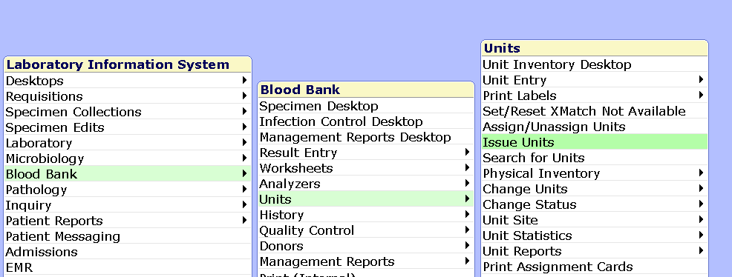
Go to Blood Bank<Units<Issue

Or

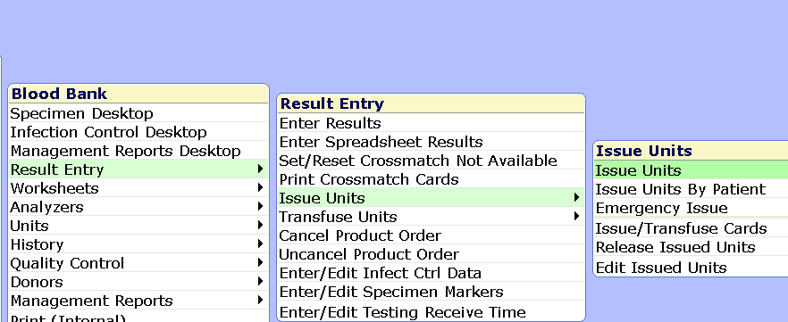
Blood Bank<Result Entry<Issue Units< Issue Units (Not Issue Units by Patient)
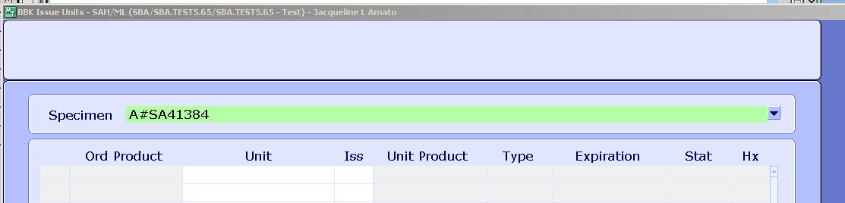
A# and scan the Requisition form or key in the account number.
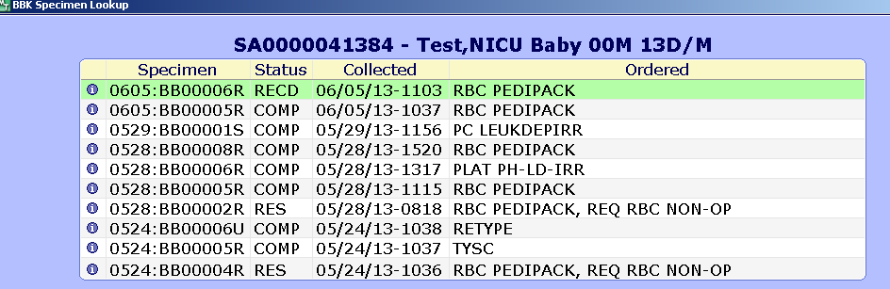
Select the correct specimen.

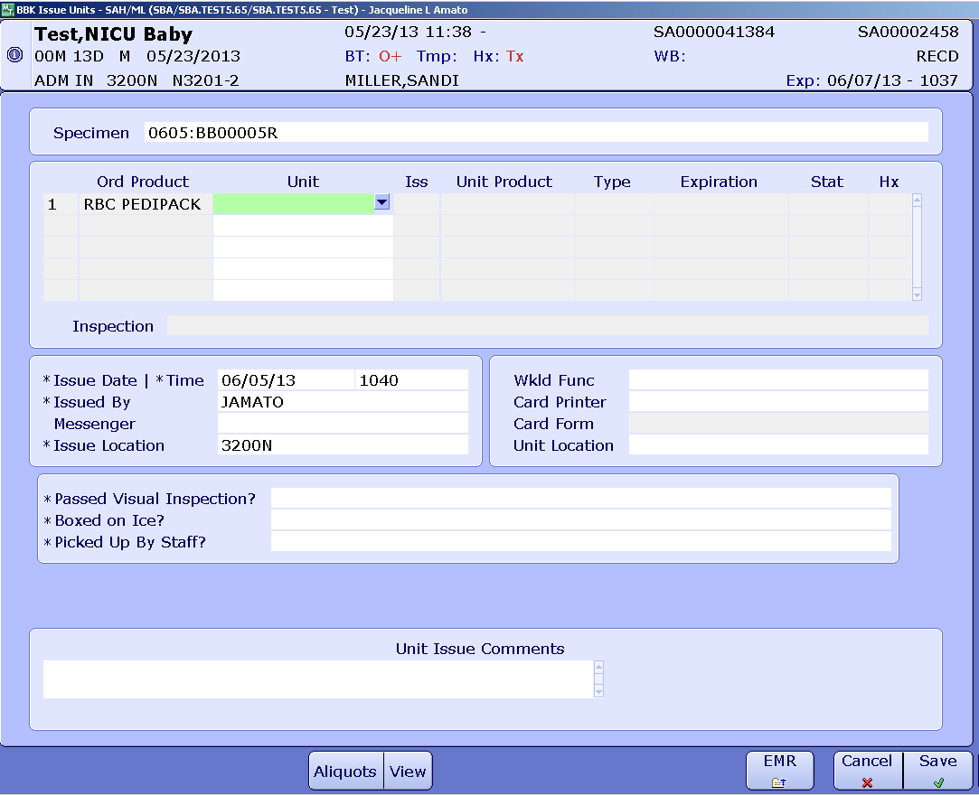
Scan the unit bar code
Scan the DIN bar code.
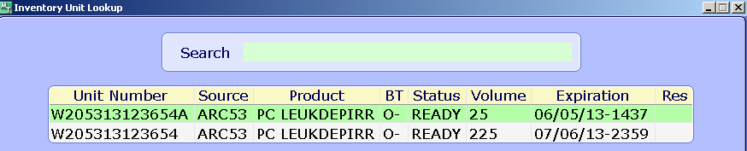
Select the correct unit.
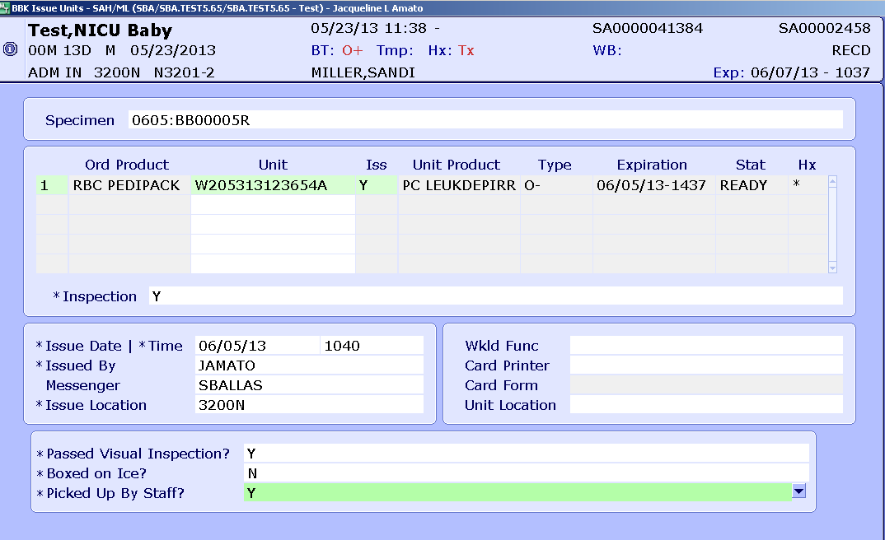
Issue the unit.
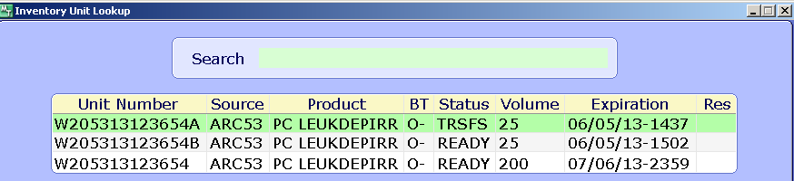
Be aware if there are multiple aliquots.
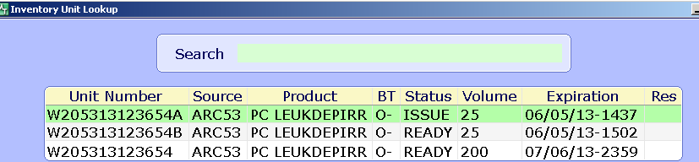
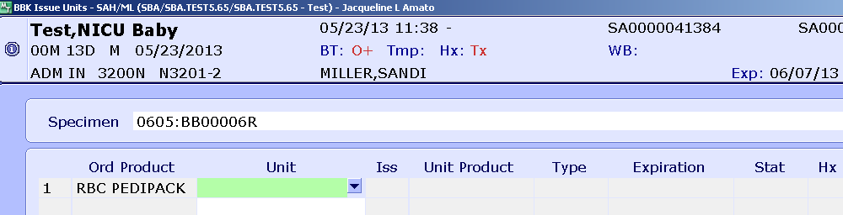
Do an F9 or arrow down at Unit.
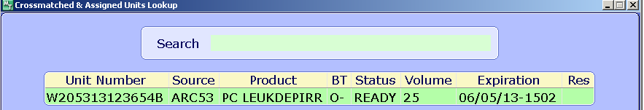
The unit that is assigned to the specimen is the only one that can be selected. Make sure the correct specimen was selected.

