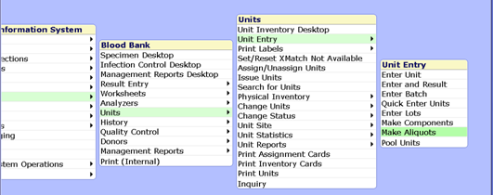
Go to Blood Bank<Units <Unit Entry < Make Aliquots

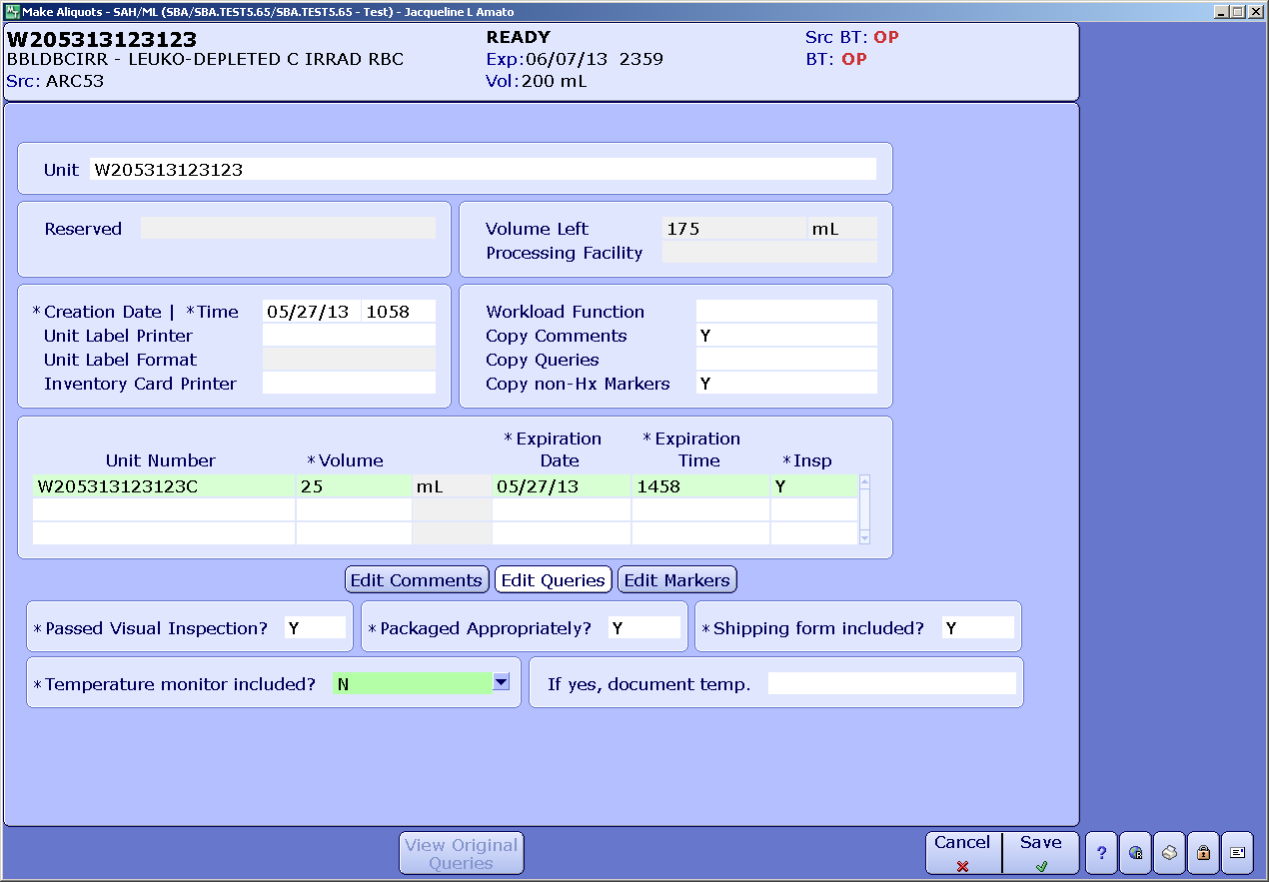
Follow procedure in TRAN 6025 Ja.
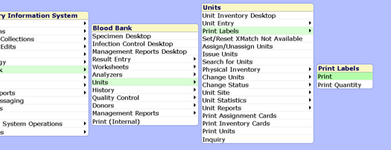
To print the label go to Units and select Print Labels.

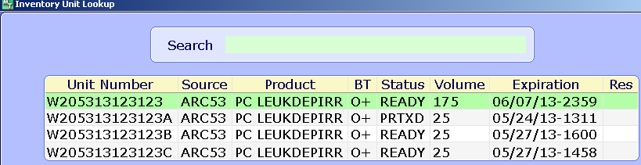
When scanning the number into the Unit all the selections will appear. The unit number did not change. Select the correct aliquot.
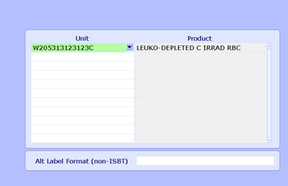
In this example C was selected. F12 or select OK to bring the “Print unit labels on” screen.

If the LBB31 printer is not found under LOCAL,select ALL PRINTERS to find the LBB31.

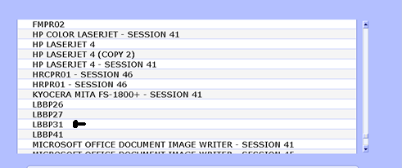

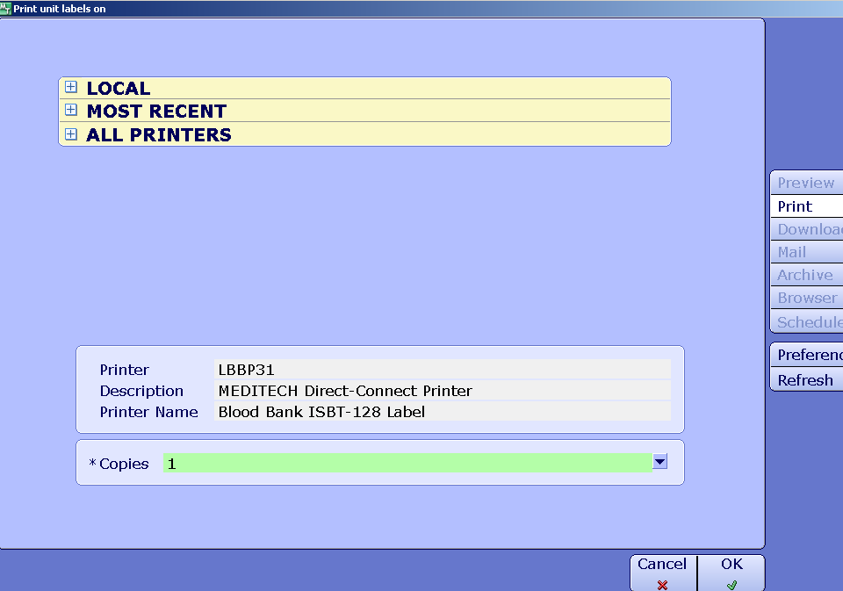
F12 or OK to print.

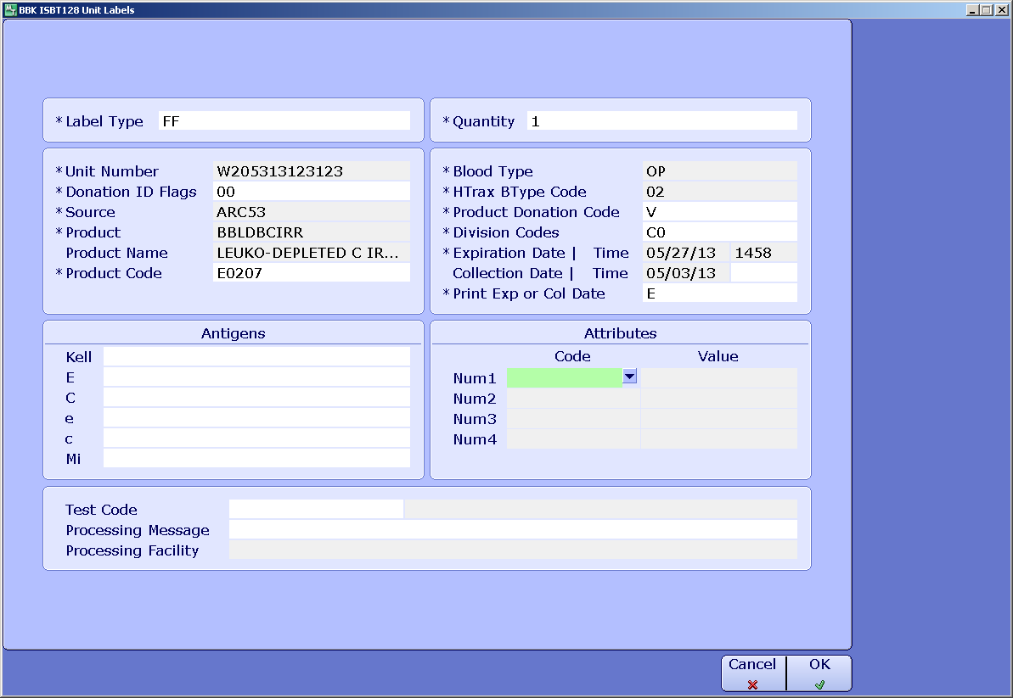
The BBK ISBT 128 Unit Labels screen will display. Go to Attributes on the bottom right hand side. Under the Code arrow down to bring up the HemaTrax Attributes Lookup.

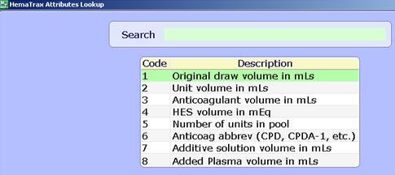
Select “2” for Unit volume in mLs.
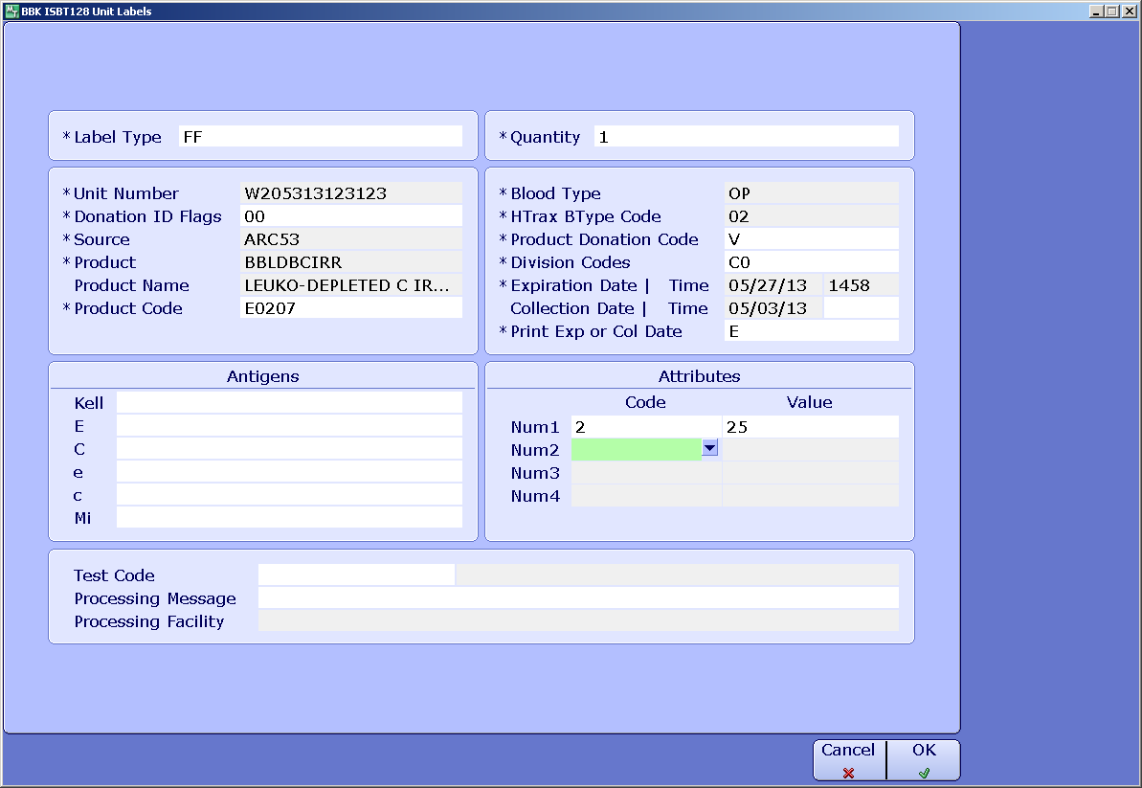
This will place the cursor under Volume. Enter the volume of the aliquot. Please pay close attention to make sure the correct volume is entered.
F12 or select OK to print the label.
The volume is now below the product description
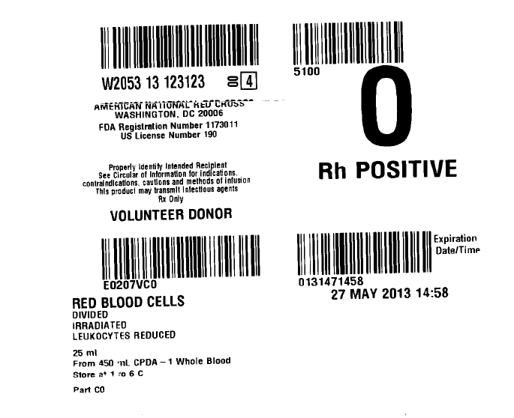
The division code “A”, “B”, etc does not print at the donor identification number

The division code is now a part of the product code

The volume is now below the product description

The division code also prints here

The label should print out like this example. Note the DIN can be easily separated from the rest of the face label. Note the “A”, “B”, etc does not print with the DIN. Instead it is now part of the product bar code. Hand write an A, B, etc on the label.

NOTE: Be careful when assigning the units to make sure the correct aliquot is assigned and issued.
Autologous Units

Also note that a divided autologous unit label may not print correctly. The label may print as “Volunteer Donor” rather than as “Autologous.” If that’s the case, it may be necessary to follow either one of the following practices:
- Affix a commercially purchased label indicating that the unit is for “Autologous Use Only” to the unit that has a face label printed with the Hematrax printer from Meditech. Cross out “Volunteer Donor” with a pen to indicate the change.
- If no commercially purchased label is available, any autologous labels printed through Meditech using the Hematrax printer modify it by crossing out the word “Volunteer Donor” and writing “Autologous” in its place.

