Order is entered in Meditech for product.

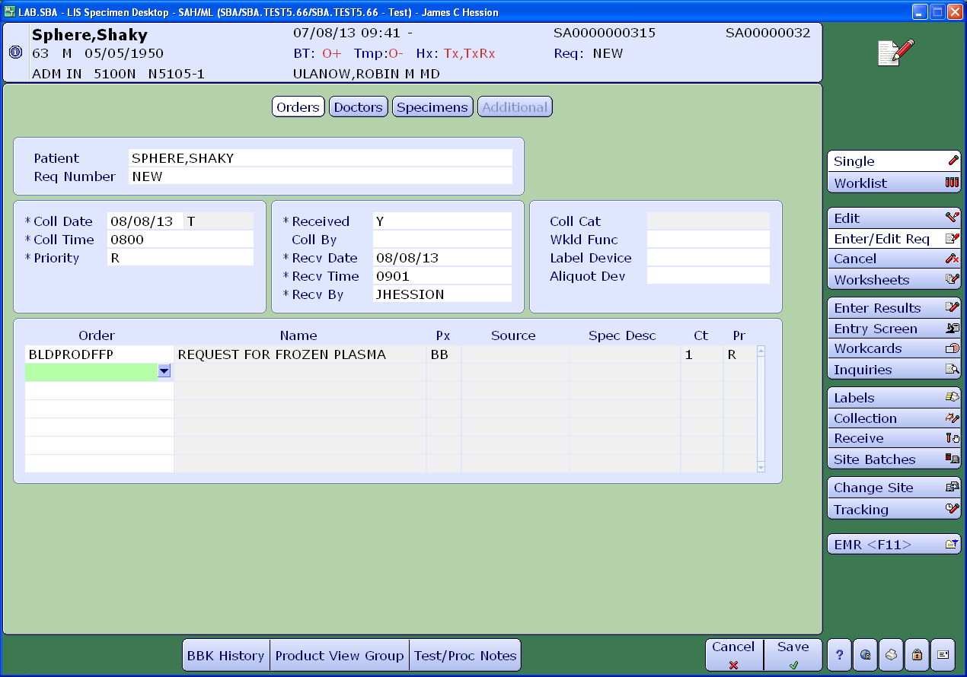

Select **Enter/Edit Req** button, enter order for FFP. Enter **F12** or select **Save** at the bottom of the screen.

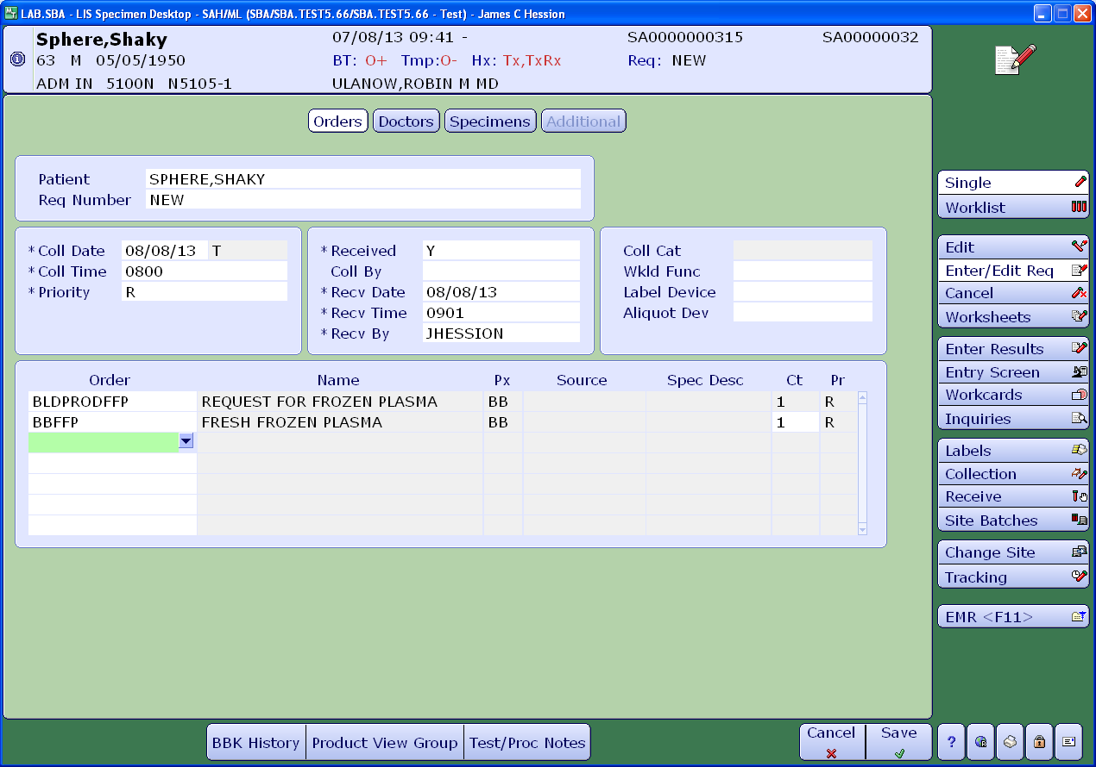

Choose a unit from the available inventory. Always pick the unit with the shortest expiration when removing it from the freezer.

Optional: If desired, you may use the **Search for Units** function to find available frozen plasma. Enter the required fields. Then enter **F12** or select **Save** at the bottom of the screen. You will then get a report of units in inventory. Locate the product and remove from freezer.

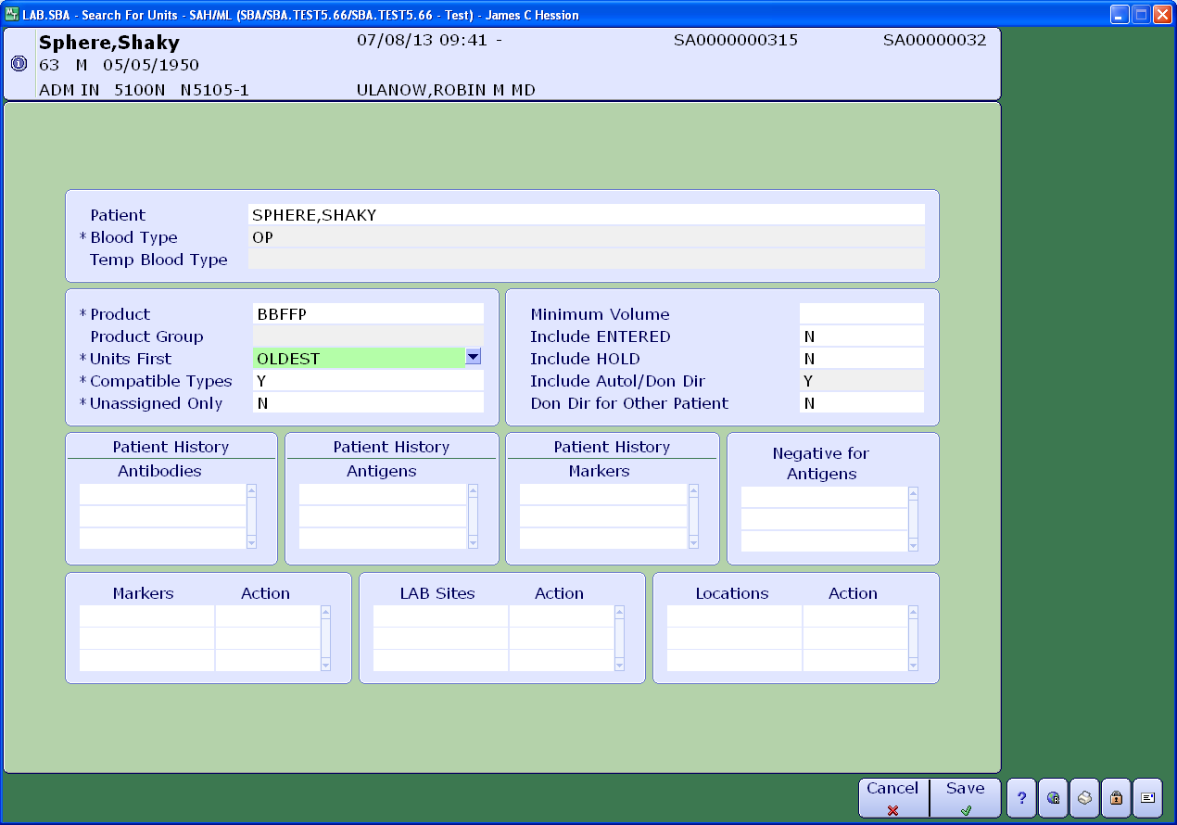

Place the FFP in thawer. Go to **Make Components** in Meditech and scan unit barcode number. Enter.

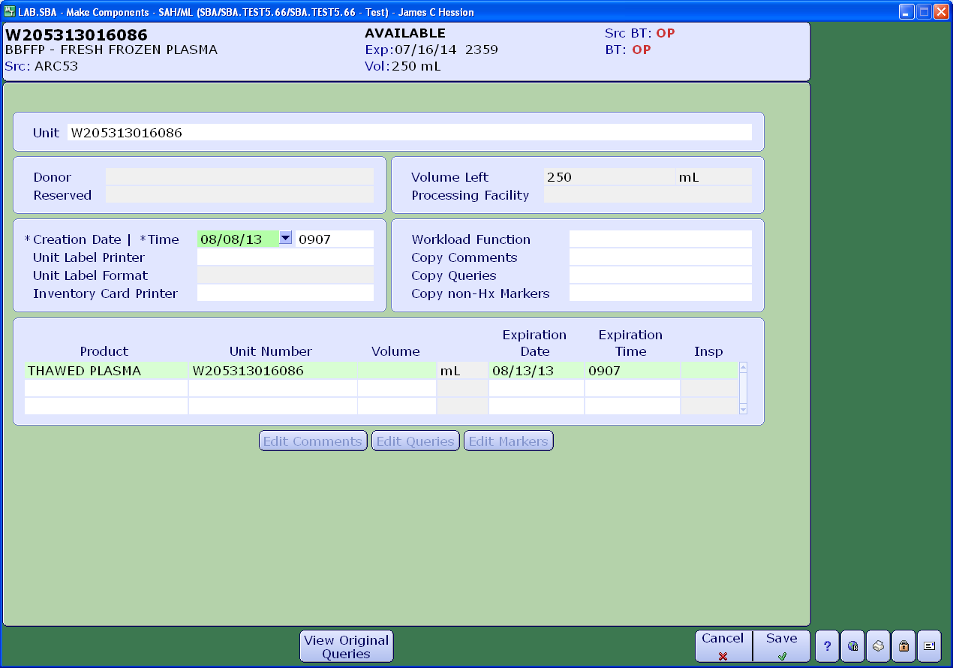

Meditech will then automatically create the new product as **THAWED PLASMA**. Enter the total volume of the original unit. Enter **F12** or select **Save** at the bottom of the screen.

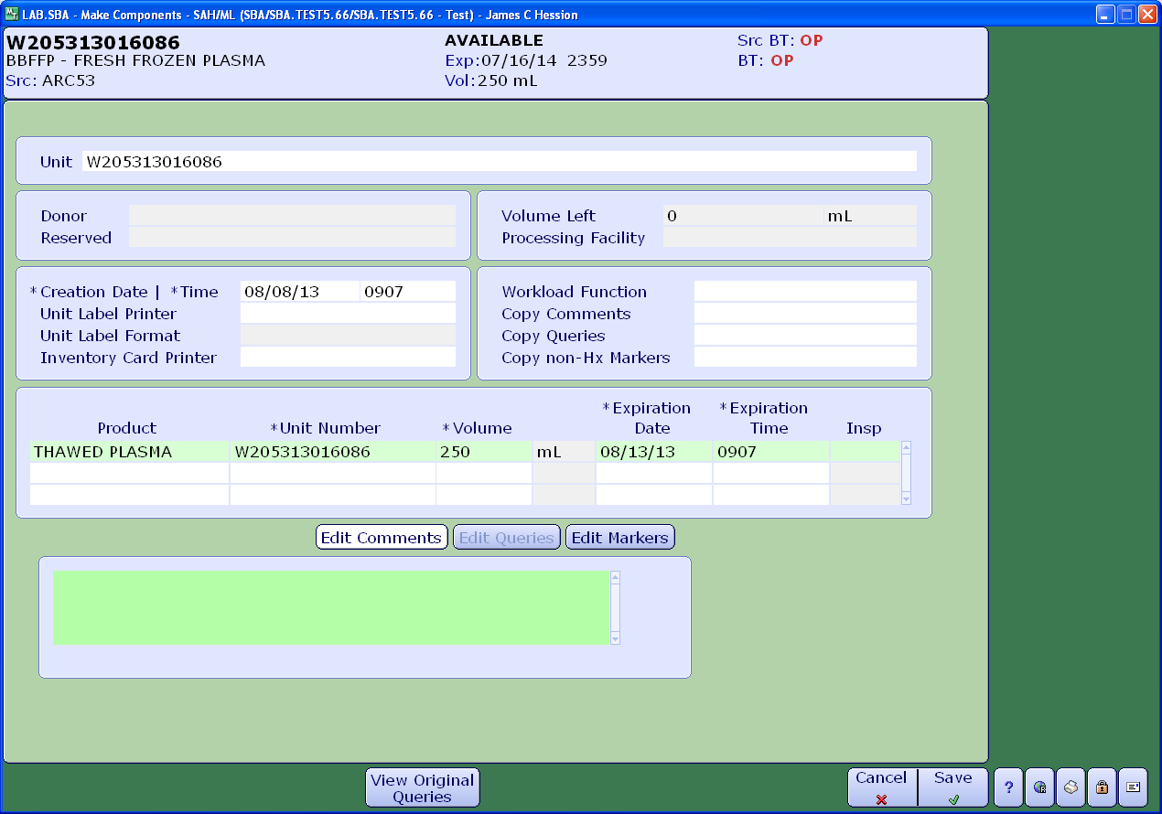

Inspect the unit after it has thawed. Make sure the unit is not damaged or broken and appears acceptable. If unit is acceptable, then assign to patient under **Assign/Unassign Units**. Enter the corresponding specimen number, product and unit number. Enter **F12** or click **OK** at the bottom of the screen.

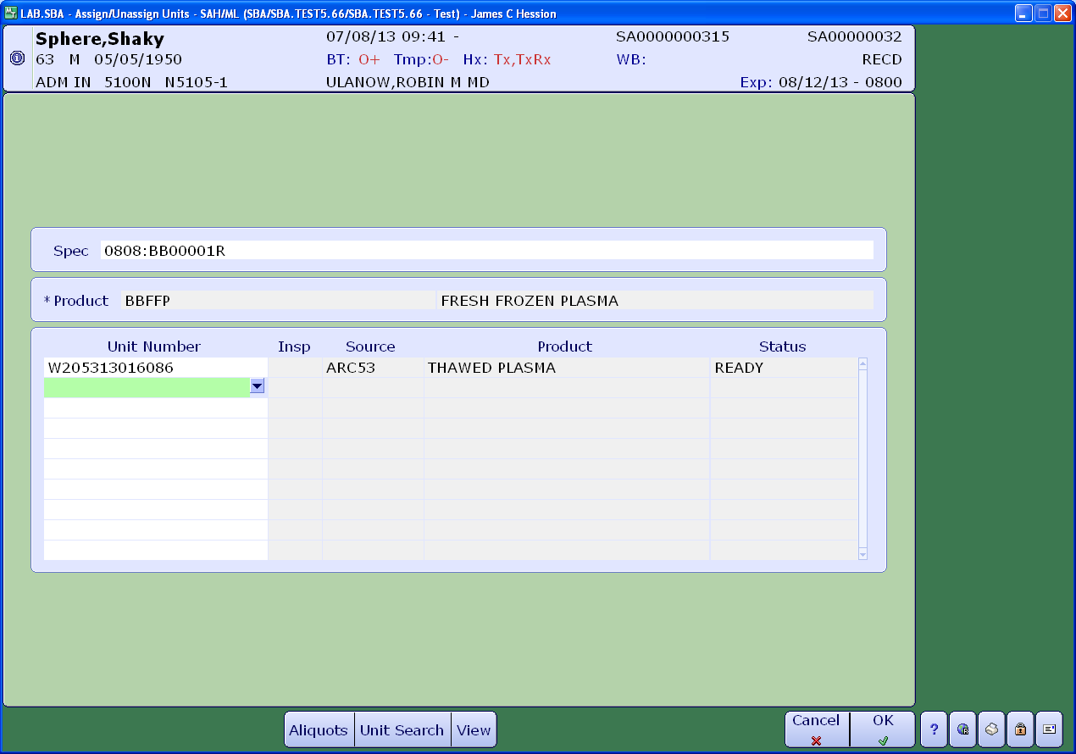

Go to **Print Labels** in Meditech and print the labels for thawed product.

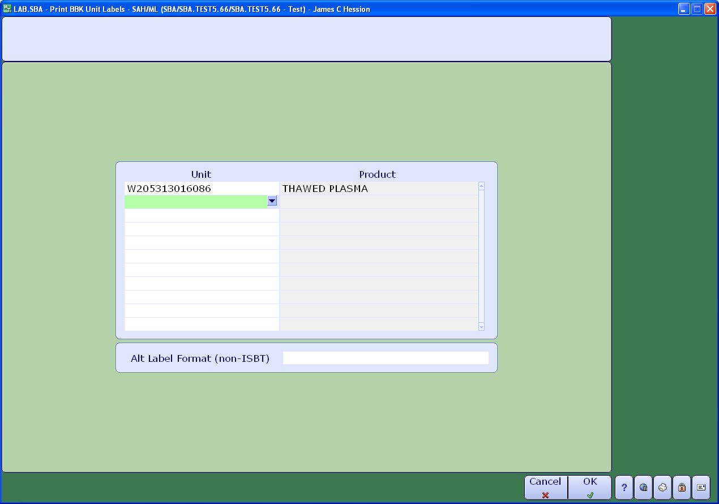

Select the correct printer for the product labels, for example ISBT 128 labels as seen below.

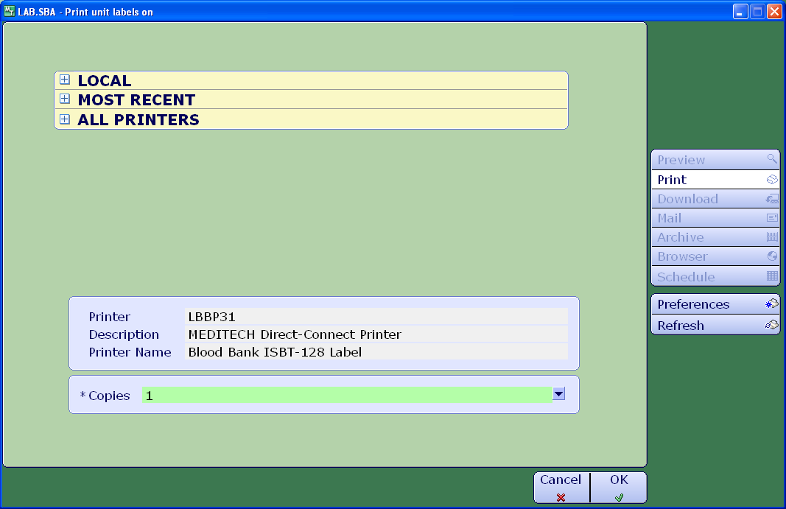

Verify the information as it appears below.

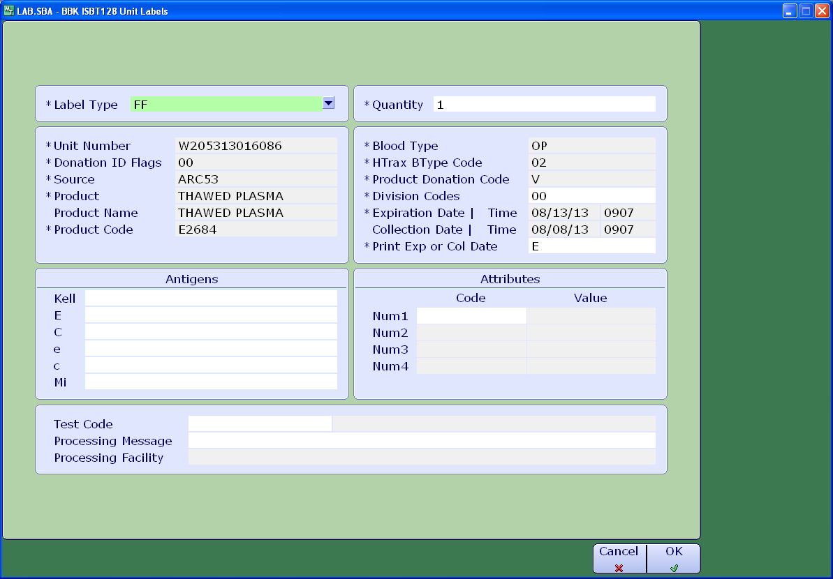

Indicate the volume of the unit under attributes.

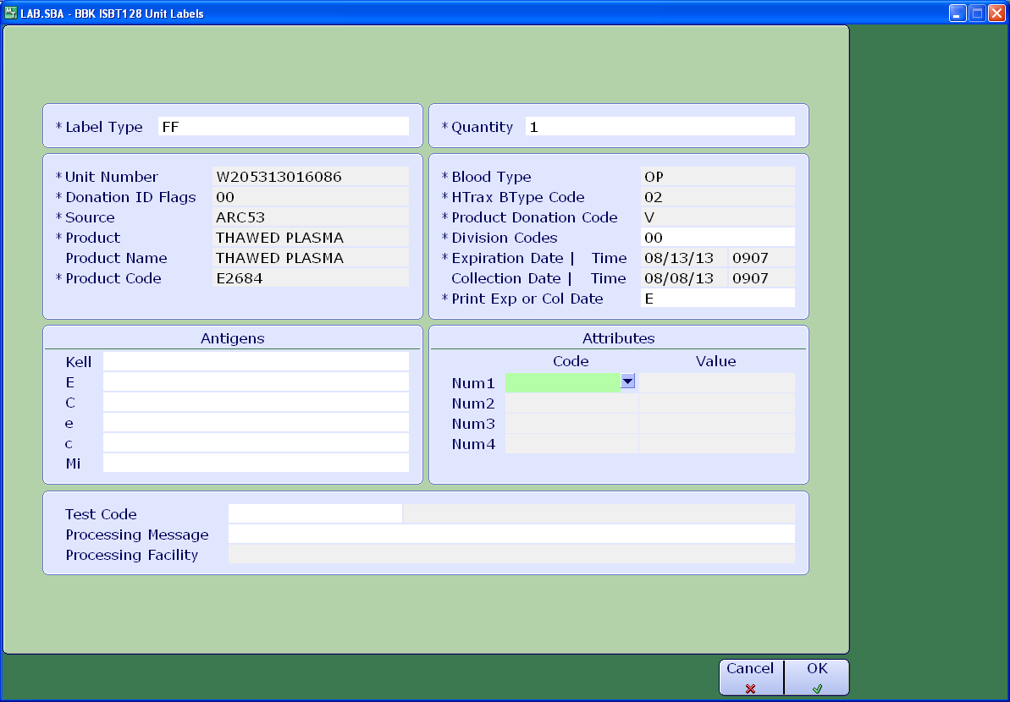

Select code #2 for volume in mLs.

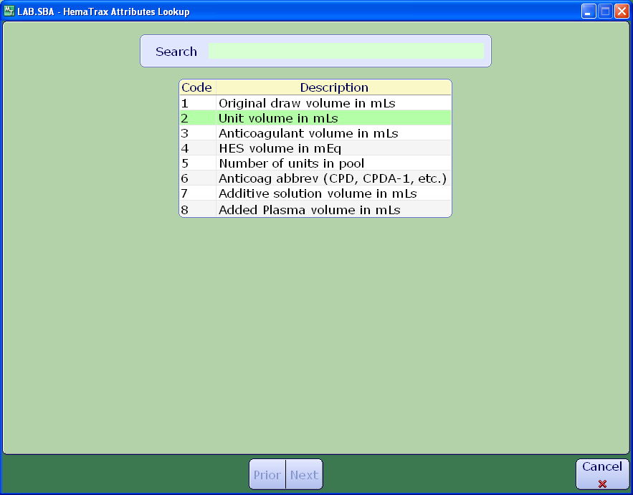

Enter the volume in the **Value** field. Enter **F12** or choose **OK** at the bottom of the screen to print.

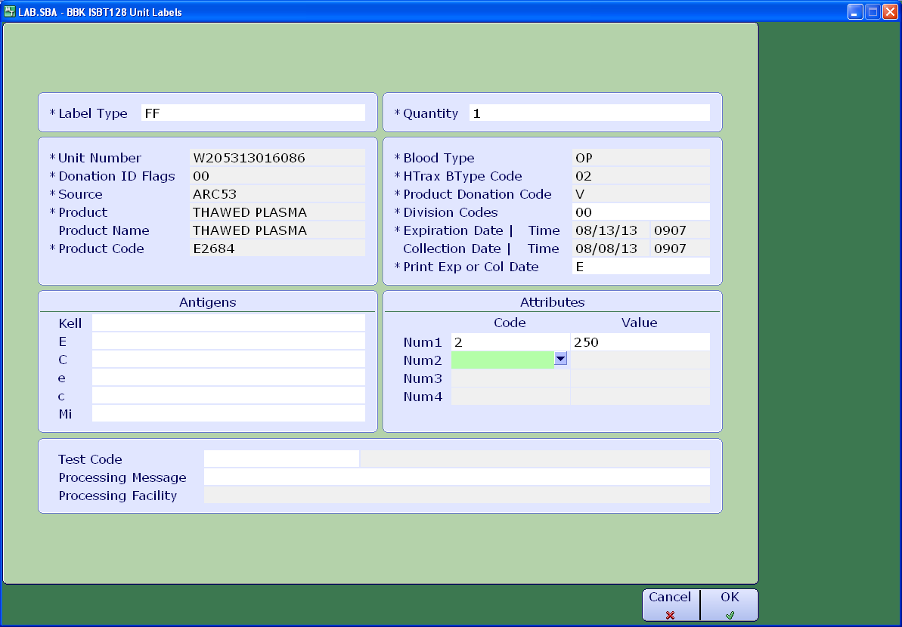

The unit on the left shows thawed plasma labeled with codabar labels. The one on the right is labeled with ISBT 128 labels. Note the label placement on the bag. Product name and expiration dates are indicated.

Next, go to **Print Assignment Cards** and print the form and attach to the unit. Enter **F12** or click **OK** at the bottom of the screen to print.

Expiration Date

Product name

Product name

Expiration Date

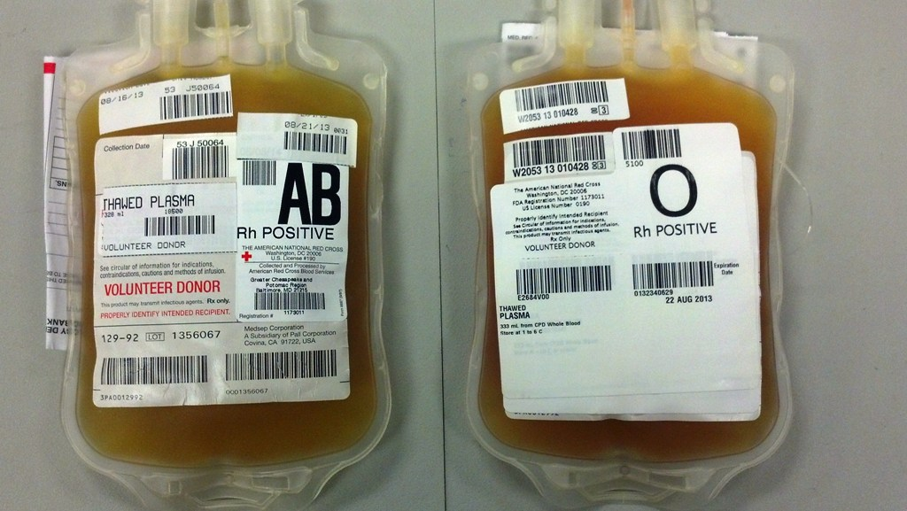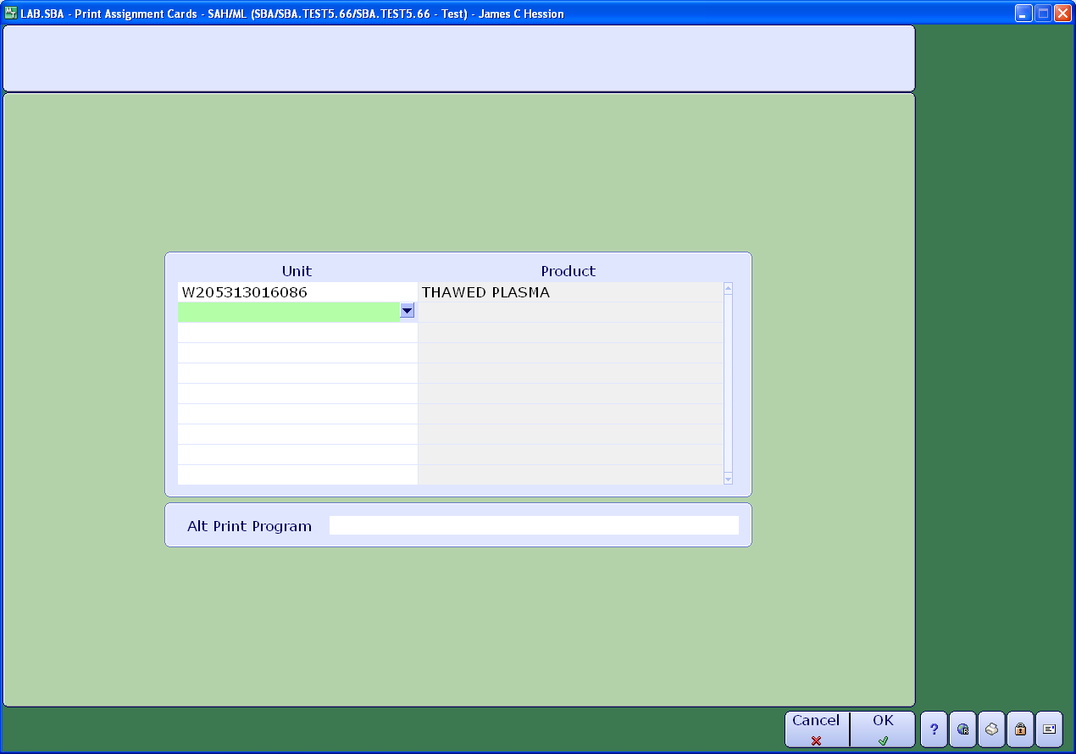

If the product will not be used, it should b unassigned. Go to **Assign/Unassign Units**. Enter specimen number and product type. Unit number will appear.

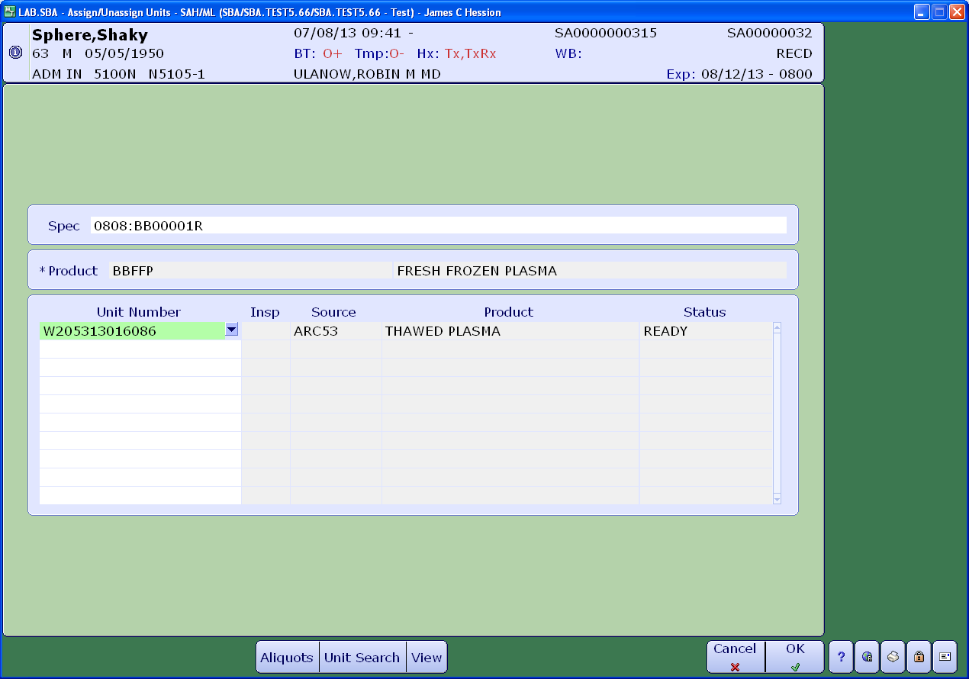

Highlight unit number and enter delete or backspace. Enter then choose **F12** or select **OK** at the bottom of the screen.

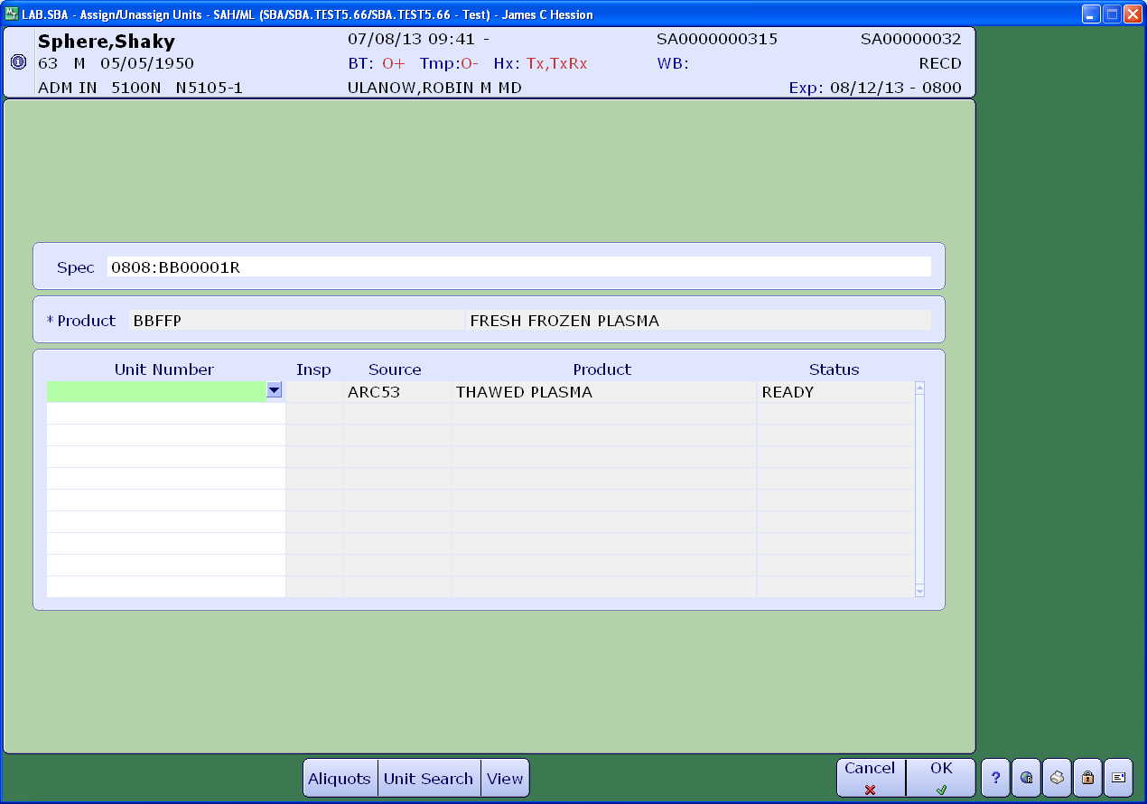

Unit is then unassigned and returns to inventory as pictured below. Remember, thawed plasma is good for five days after thawing and can be used for another patient if needed.

