POLICY STATEMENT | Presumptive identification of Candida albicans is based on its ability to produce short, tube-like structures called germ tubes when incubated at 35° to 37°C for 2 to 4 hours. The formation of germ tubes is associated with increased synthesis of protein and ribonucleic acid. The essential requirements for this synthesis are contained in tryptic soy broth and fetal bovine sera.
PURPOSE | This procedure provides technical instruction for the performance of the Germ Tube.
SCOPE | This procedure applies to testing personnel authorized to perform testing. This group includes, but is not limited to Laboratory Technologists as well as leads and supervisory personnel.
RESPONSIBILITY | All the above personnel are responsible for following the Germ Tube procedure without exception. In addition, testing personnel are also responsible for evaluating the results and taking proper remedial action.
RELATED DOCUMENTS | MICR 6730 F Germ Tube QC Chart

SPECIMEN HANDLING
Yeast colony isolated from a clinical source.

REAGENT

Germ Tube Solution (Typtic Soy Broth and Fetal Bovine Solution)
- Store lyophilized product at 2° to 8°C until expiration date.
- Rehydrated aliquots may be stored at -20°C for up to 4 months.

QUALITY CONTROL
- Positive Control = Candida albicans (ATCC 10231)
- Negative Control = Candida glabrata (ATCC 2001)

Perform QC each day of use

PROCEDURE
- Rehydrate with 25 ml of sterile demineralized water.
- Aliquot 0.5ml of the solution into clean tubes. Cap tightly. These aliquots may be stored at -20°C for up to 4 months.
- Touch the tip of a disposable loop to a yeast colony and emulsify into the solution.
- Suspend the yeast cells in an appropriately labeled tube of Germ tube solution.
Note: Do not over inoculate the solution. This may cause a significant decrease in the percentage of cells forming germ tubes.
- Incubate at 35° to 37°C for 2 to 4 hours.
- Place a drop of the suspension on a microscope slide.
- Place a coverslip over the suspension.
- Examine under high power (40X) for the presence or absence of germ tubes.

Limintations:
- Candida tropicalis may produce early pseudohyphae that can be confused with germ tubes.
- Candida dubliniensis produces germ tubes. Growth at elevated temperatures (42°C) will differentiate between Candida dubliniensis and Candida albicans.

REPORTING
- A germ tube appears as a short lateral extension from the yeast cell with no constrictions.
- A constriction where the lateral extension meets the yeast cell is produced by pseudohyphae or budding cells.
- A minimum of five germ tubes should be observed before calling the isolate positive.
- A positive germ tube is reported as Candida albicans
- A negative germ tube negative is reported Candida species, not Candida albicans.
- If the specimen is a sterile body site or has been requested for fungal culture, further identification is required using a yeast identification system.
- Enter results in the workcard.
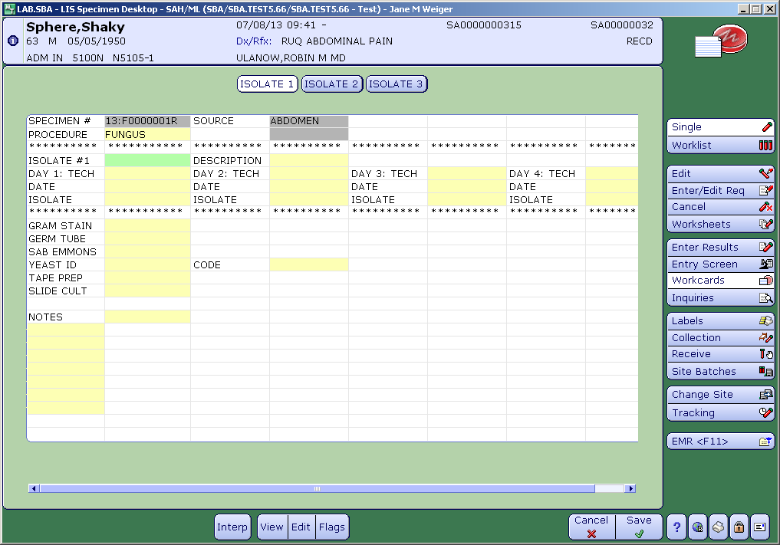

REFERENCES

Remel Germ Tube Solution package insert, October 28, 2008.

