POLICY STATEMENT | Lactophenol cotton blue is a blue stain used for direct examination of clinical specimens for fungal elements. Upon the addition of Lactophenol cotton blue, fungi stain blue allowing for easier visualization and examination. The phenol in the stain will kill any organism, while the lactic acid preserves fungal structures. Cotton blue stains the chitin in fungal cell walls. It also serves as a mounting medium.
PURPOSE | This procedure provides technical instruction for the performance of the Lactophenol Cotton Blue Stain.
SCOPE | This procedure applies to testing personnel authorized to perform testing. This group includes, but is not limited to Laboratory Technologists as well as leads and supervisory personnel.
RESPONSIBILITY | All the above personnel are responsible for following the Lactophenol Cotton Blue Stain procedure without exception. In addition, testing personnel are also responsible for evaluating the results and taking proper remedial action.

SPECIMEN HANDLING
Mold colony isolated from a clinical source.

REAGENT
Lactophenol cotton blue stain dropper, a commercially prepared reagent
- 40 % glycerol
- 20% phenol
- 20% lactic acid
- 0.05% cotton blue dye (Poirrier’s blue)
- water
Store droppers at room temperature 15° to 30°C protected from light until expiration date.

QUALITY CONTROL

Fungal elements stain blue

PROCEDURE
- Label a clean glass microscope slide with the patient's name and accession number.
- Perform all work in a level II biological safety cabinet.
- Hold dropper upright and point tip away from yourself. Grasp the middle with thumb and forefinger and squeeze gently to crush inner ampule.
- Put 2-3 drops lactophenol cotton blue on a microscope slide.
- Prepare a tape mount or tease mount:
  - Tape Mount
- Using clear scotch tape, gently press sticky side of tape onto mold.
- Place tape on top of the slide, sticky side down.
- Put 2-3 drops of lactophenol cotton blue stain on top of the scotch tape making sure that the mold is submerged in the stain.
- Place coverslip on top of the tape.
  - Tease Mount
  - Using an inoculating needle, take a fragment of the mold culture
  - Tease the mold apart on the slide.
  - Place coverslip on top
- Read using a light microscope scanning on low power (20X or 40X) before changing to high power (60X).

REPORTING
Fungal elements stain a delicate blue color, while the background appears a faint, pale blue. Use the various atlases, texts and manuals to identify the mold. Enter the results in the workcard and charge for the tape prep by entering S (setup) in the tape prep.
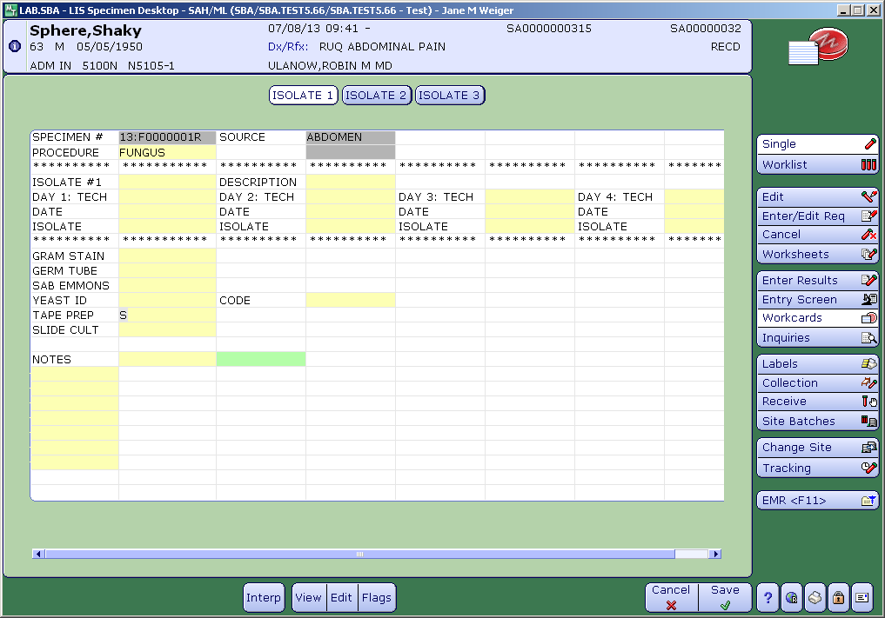
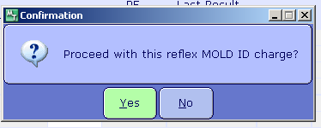

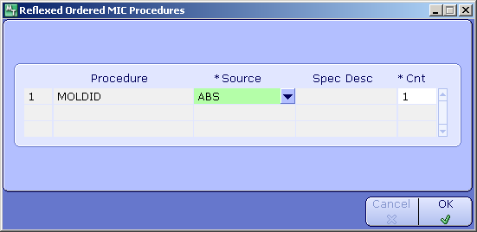

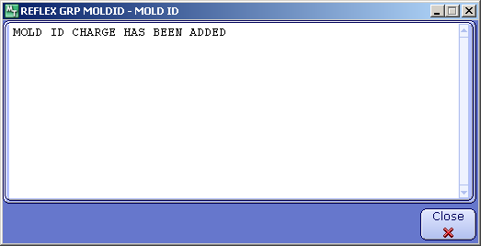

REFERENCES
Package insert, Becton, Dickinson and Company, 2003

