POLICY STATEMENT | Remel RapID Yeast Plus System is a qualitative micromethod employing conventional and chromogenic substrates for the identification of medically important yeast, yeast-like and related organisms isolated from human clinical specimens. The tests used are based upon the microbial degradation of specific substrates as detected by various indicator systems. The resulting pattern of positive and negative test scores is used as the basis for the identification of the test isolate by comparison of test results to activity patterns stored in a database or through the use of a computer-generated Code Compendium.
PURPOSE | This procedure provides technical instruction for the performance of the RapID Yeast Plus Panel.
SCOPE | This procedure applies to testing personnel authorized to perform testing. This group includes, but is not limited to Laboratory Technologists as well as leads and supervisory personnel.
RESPONSIBILITY | All the above personnel are responsible for following the RapID Yeast Plus Panel procedure without exception. In addition, testing personnel are also responsible for evaluating the results and taking proper remedial action.
RELATED DOCUMENTS | MICR 6790 F RapID Yeast QC Chart

SPECIMEN HANDLING
A yeast colony isolated from a Sabouraud-Dextrose Agar (SDA) - Emmons formulation plate that has been incubated at 30°C for 48 hours.

REAGENTS
- RapID Yeast Plus kit: Store at 2° to 8°C until the expiration date on the kit. Do not mix lot components.
- Reagent bottles: Store at 2° to 8°C until the expiration date.
- RapID Inoculation Fluid (2ml): Store at 20° to 25°C until the expiration date.

QUALITY CONTROL
RapID Yeast Plus panel and reagent quality control should be performed on each new kit lot or shipment using the following control organisms.
- Candida albicans (ATCC 14053)
- Candida kefyr (ATCC 2512)

Prior to use, quality control strains should be transferred 2 to 3 times from storage to SDA (Emmons formulation). The final subculture to be used for QC testing should be incubated at 30°C for 48 hours.

PROCEDURE
- Remove the RapID Yeast Plus panel from storage. Do not use if the plastic is cracked or broken or if the lid is compromised.
- Reseal the polybag package after removing the required panels.
- The panels must be used the same day they are removed from storage.
- Inoculum Preparation
  - Cultures used must be from SDA (Emmons formulation) that has been incubated at 30°C for 48 hours.
  - Using a cotton swab or inoculating loop, suspend sufficient growth from the agar plate culture in RapID Inoculation Fluid (2ml) to achieve a visual turbidity that completely obliterates the black lines on the RapID Yeast Plus Inoculation Card.
  - Growth should be added to the inoculation fluid gradually to avoid clumping and over-inoculation.
  - Suspensions should be mixed thoroughly and introduced into panels within 15 minutes of inoculation
  - Suspensions significantly less turbid than the required inoculum density (lines on the Inoculation Card still visible) will result in aberrant reactions. Suspensions SLIGHTLY more turbid than the required inoculum density will not compromise test performance and are recommended for stock cultures and quality control strains. Suspensions that are SIGNIFICANTLY more turbid will result in compromised test performance.
    - Panel Inoculation
      - Peel back to the label over the panel inoculation port by pulling the tab marked "Peel to Inoculate" up and to the left.
      - Using a sterile pipette, transfer the entire inoculum (2 ml) into the upper right hand corner of the panel. Reseal the inoculation port.
      - Keeping the panel on a level surface, tilt back to approximately a forty-five (45) degree angle and rock from side to side to evenly distribute the inoculum along the rear baffles.
      - Maintaining a level position horizontally, SLOWLY tilt the panel forward. The inoculum will flow from the rear baffles along the partitions into the front reaction cavities.
          - Examine the test panel after inoculation to ensure that all cavities appear bubble free and uniformly filled. Slight irregularities in cavity fill are acceptable. Discard any panels that contain GROSSLY misfilled cavities and repeat the inoculation procedure.
          - Do not let the inoculum rest in the back portion of the panel for an extended period of time without completing the procedure.
        - Incubate the inoculated panels at 30°C in an aerobic (non-CO₂) incubator for four 4 hours.
        - Scoring the panels;
- Remove panels from the incubator.
- While firmly holding the panel on the bench top, peel off the label over the reaction cavities by pulling the lower right hand tab up and to the left.
- Add one (1) drop of RapID Yeast Plus Reagent A to cavities 7-14
- Add one (1) drop of RapID Yeast Plus Reagent B to cavities 16-18
- After the addition of Reagent B, allow at least thirty (30) seconds but no more than one (1) minute for color development
- Cavities exhibiting layers of color may be mixed using an applicator stick.
- Read and score the test cavities from left to right using the interpretation guide.
- Record the scores in the appropriate boxes on the report
- Reference the microcode obtained on the report form in ERIC (Electronic RapID Compendium for identification.

REPORTING
Enter the results including the microcode in the workcard and charge for the yeast ID by entering S (setup) in the Yeast ID.
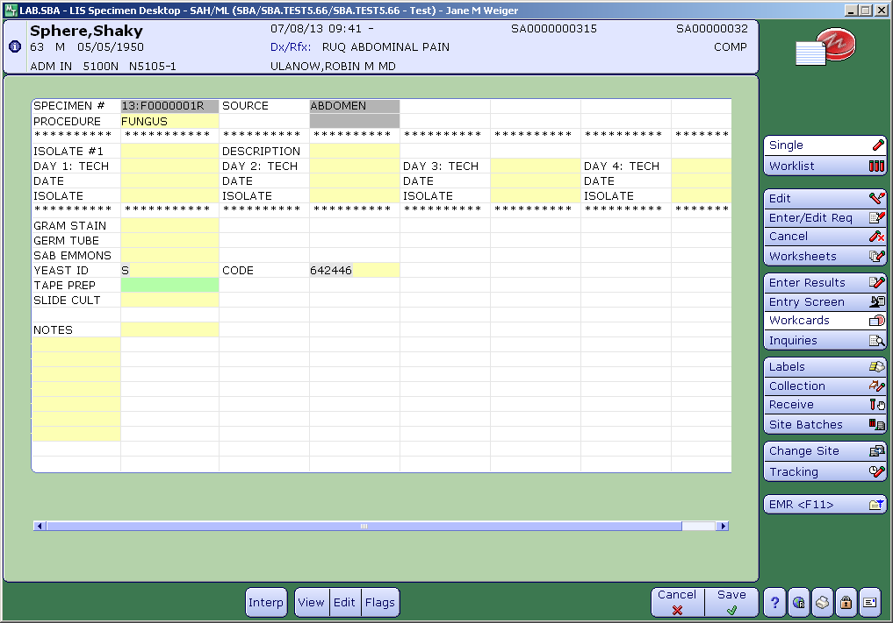

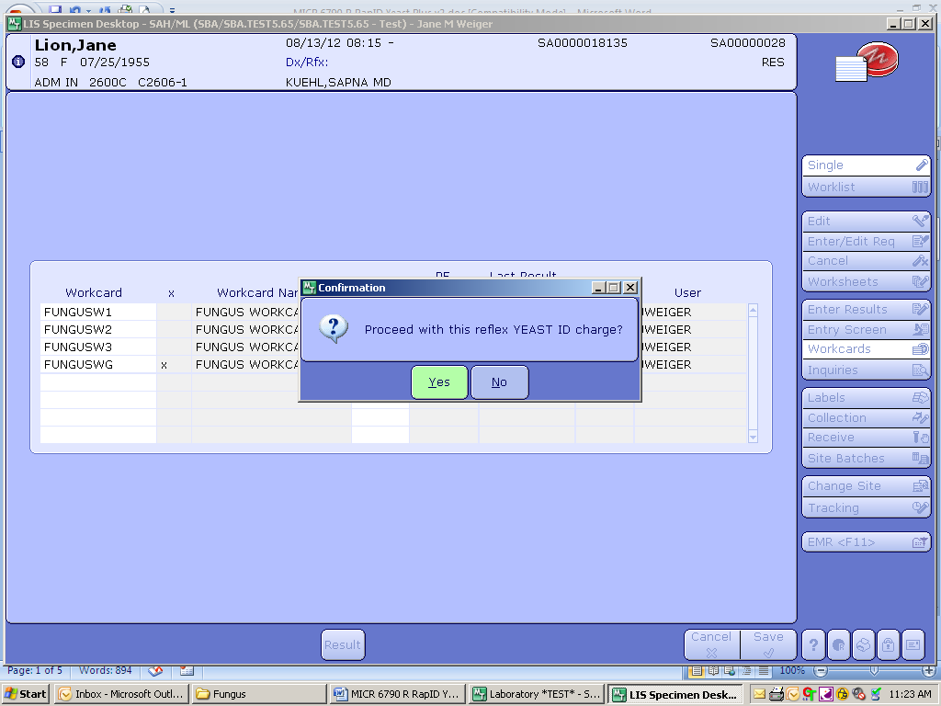
.
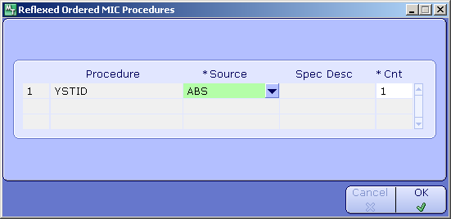

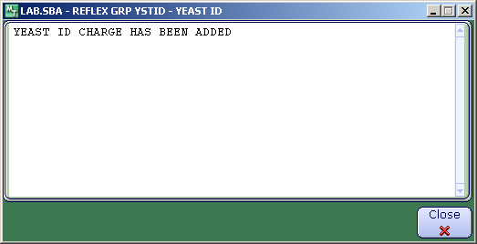

REFERENCES
Remel RapID Yeast Plus System Package Insert, October 20, 2009

