**For Immediate Spin Crossmatch**

Since the patient has a negative antibody screen, select a unit that is compatible with the patient’s ABO type and Rh. Scan unit number in the appropriate field.

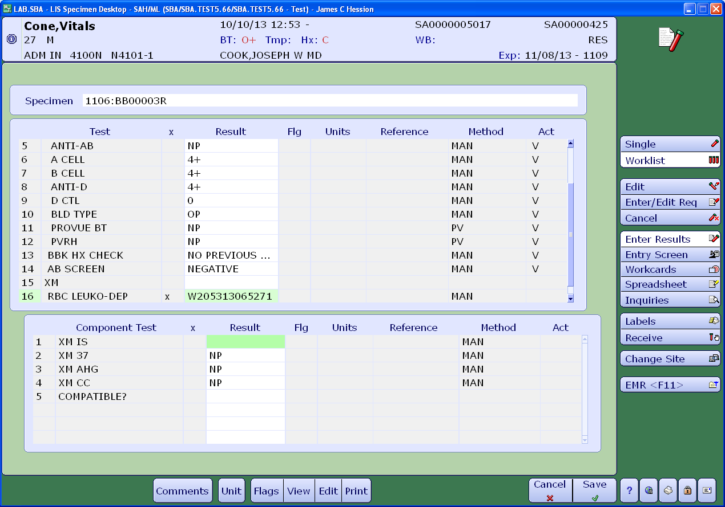

Perform the crossmatch using the immediate spin method. Enter the results of immediate spin crossmatch and verify.

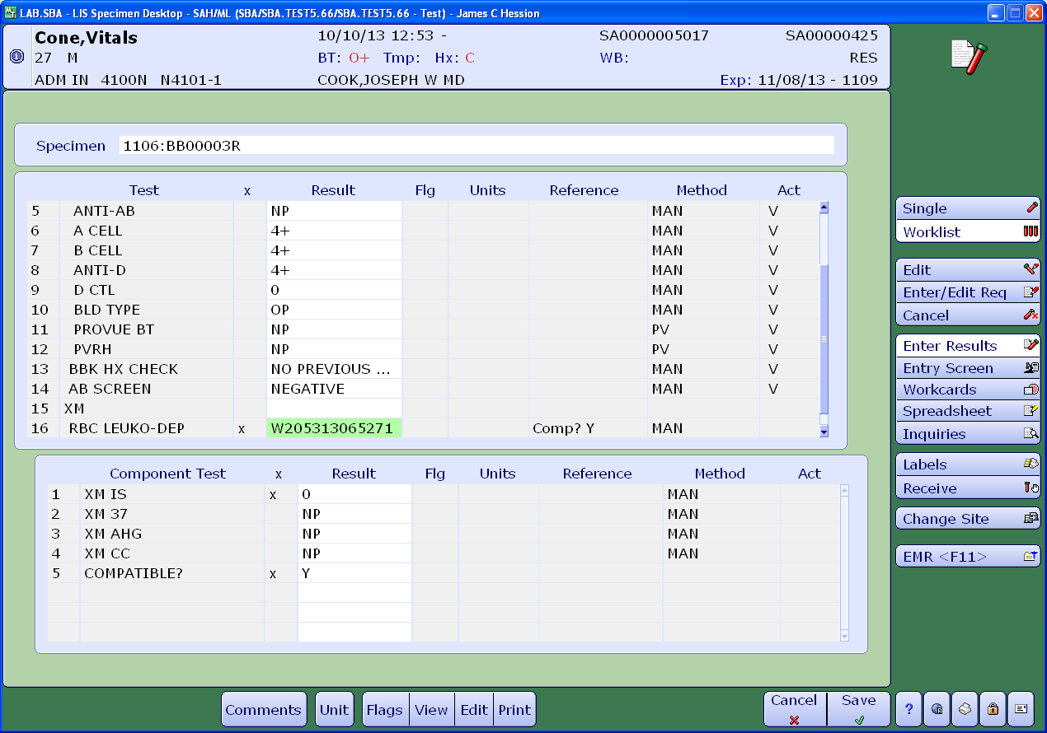

If there is a separate order for a blood product, result as “PRODUCT AVAILABLE.”

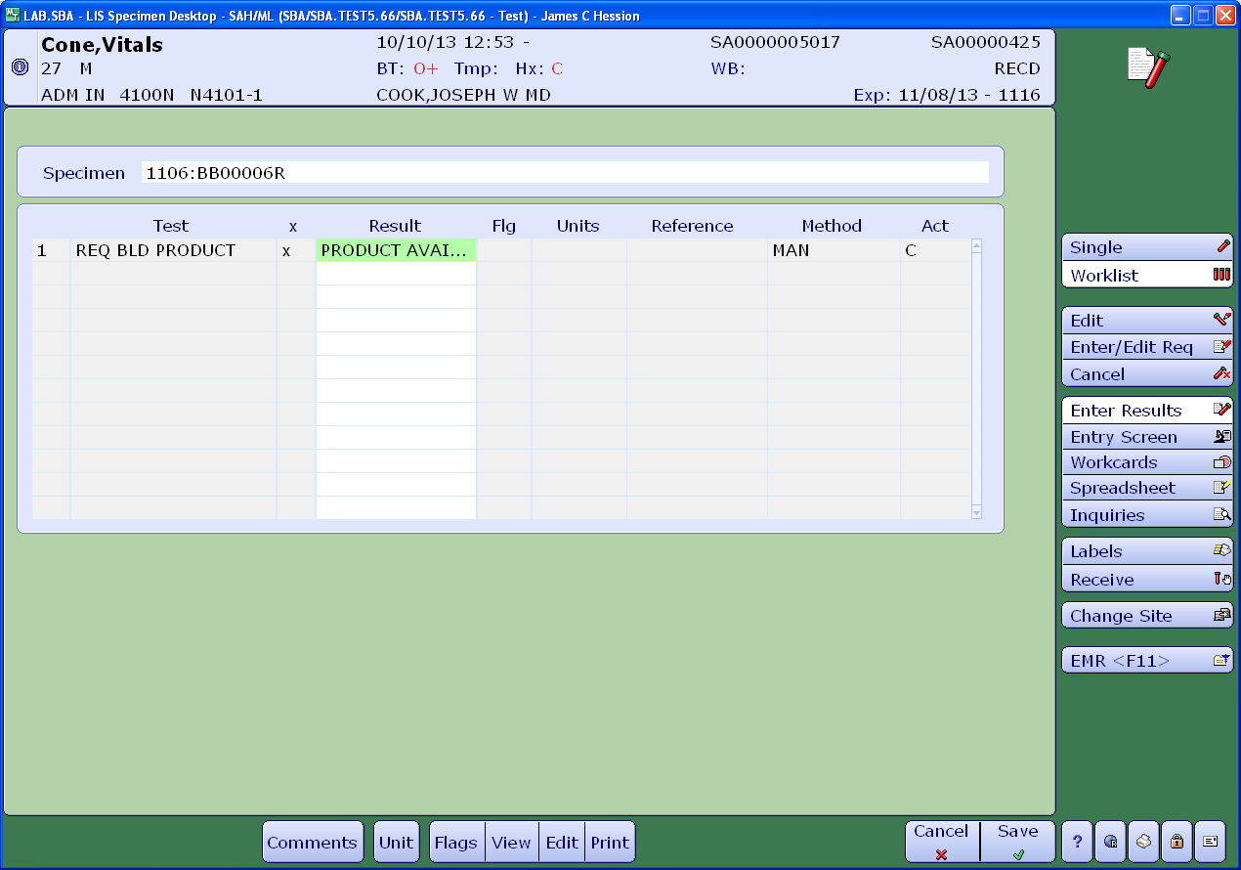

After entering the result as “PRODUCT AVAILABLE”, enter the canned comment “BBNOTE” and record the name of the person notified, usually the patient’s nurse. Verify.

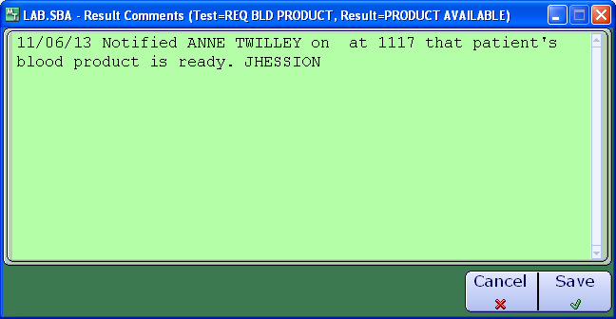

**For Gel Crossmatch**

First, antigen type or locate a unit that is negative for the patient’s antibody. In the example below, that patient has α-E so the unit should be negative for the E antigen. If the unit has not been previously phenotyped, it must be performed. Record the results and the QC on the consult form and in Meditech as shown below.

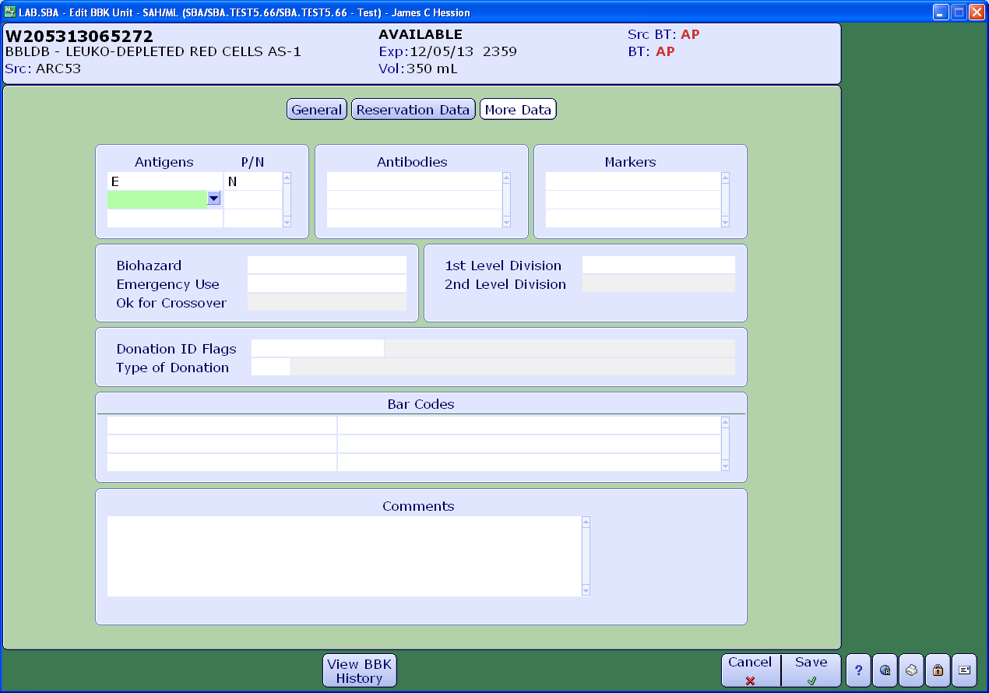

Optionally, you can search for a unit in Meditech. Units that are negative for the appropriate antigen will appear as restrictions in the search criteria.

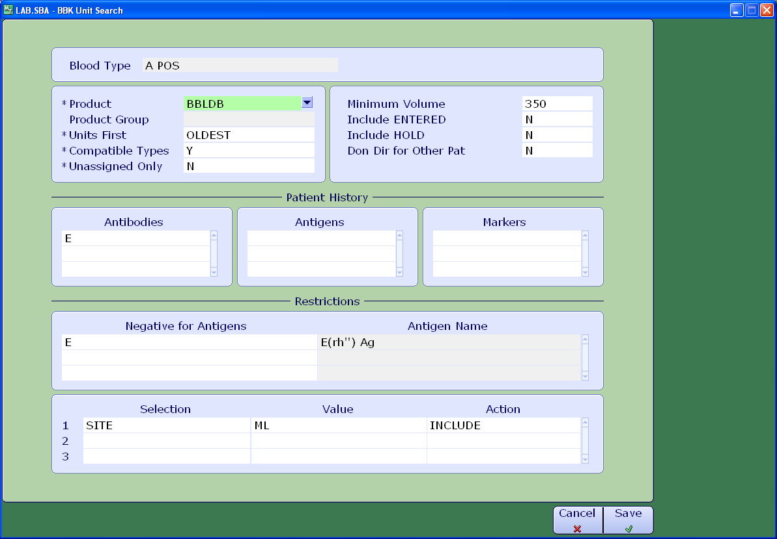

When scanning the unit, notice that the antigen testing results will display.

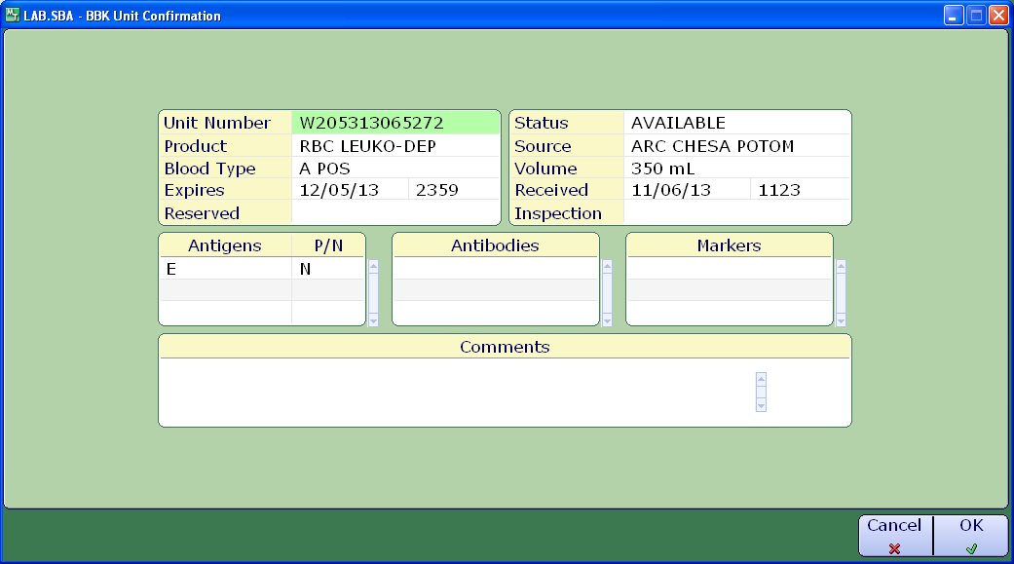

Enter the results for both the immediate spin and the gel crossmatch. Notice that the gel crossmatch results are entered under “XM AHG.”

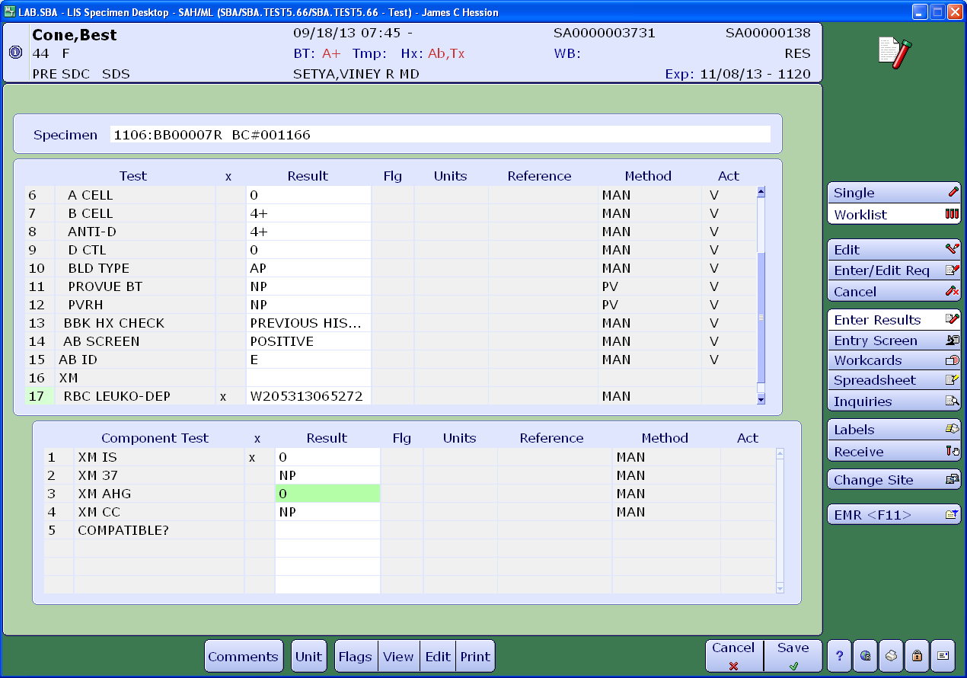

After entering the XM AHG result, enter a comment indicating that gel method was used.

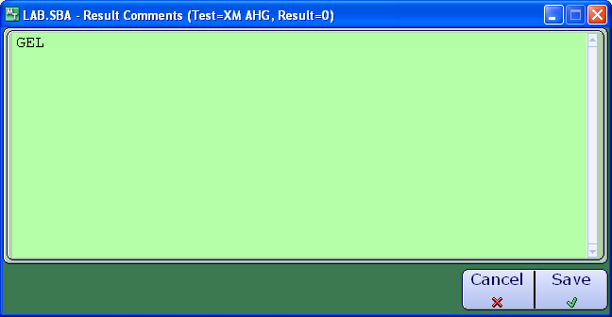

Enter compatibility results.

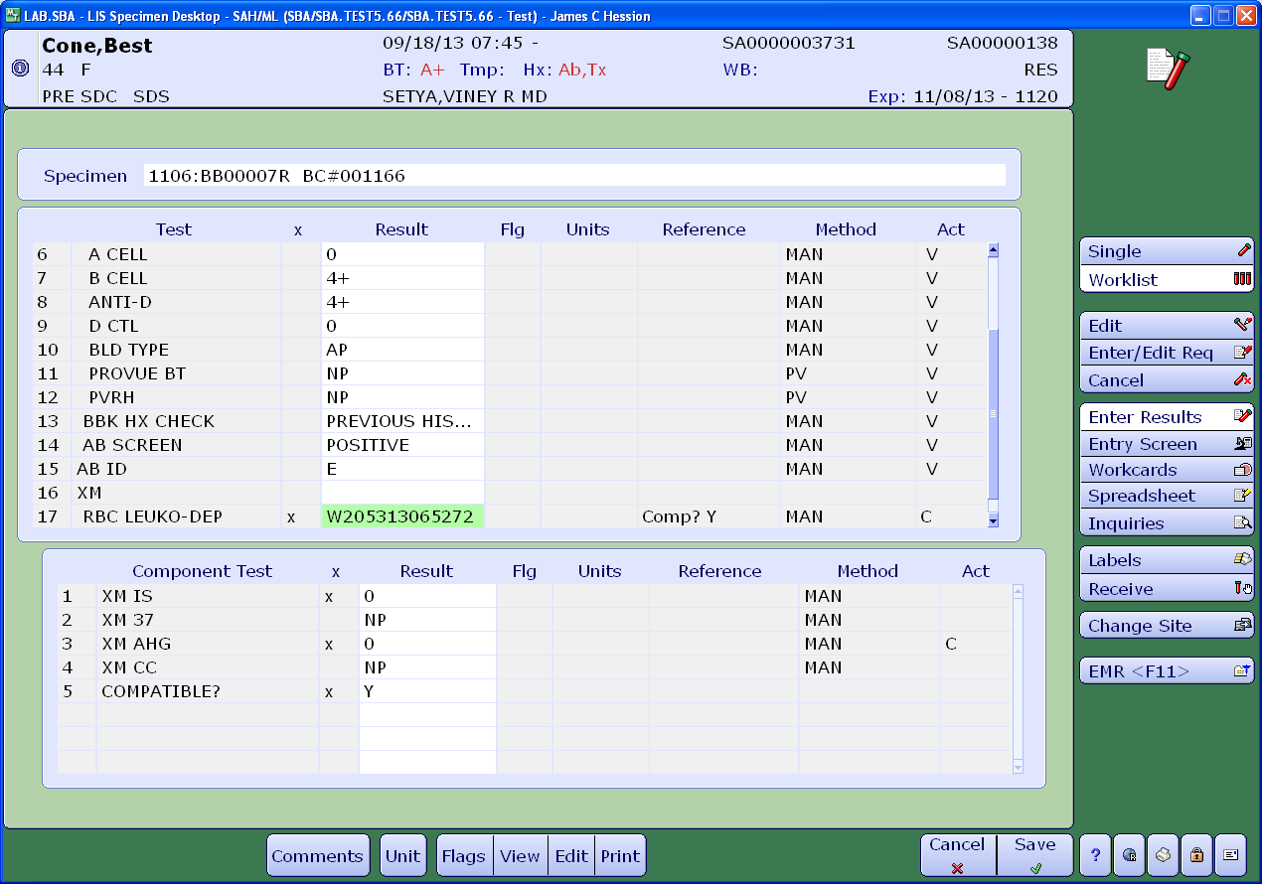

If there is a separate product order, enter result “PRODUCT AVAILABLE.”

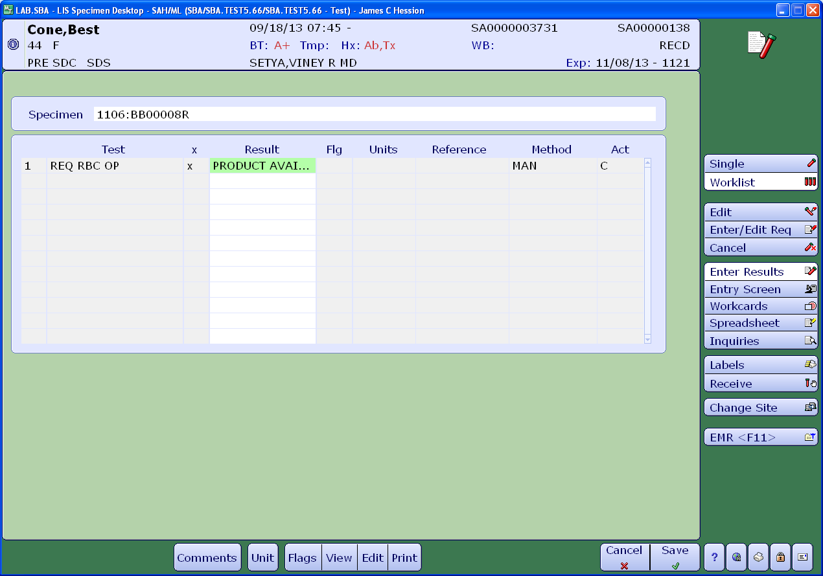

Also, contact the appropriate person to let them know that the blood product is ready using canned comment “BBNOTE.” You should also remind them that the unit must be issued in person.

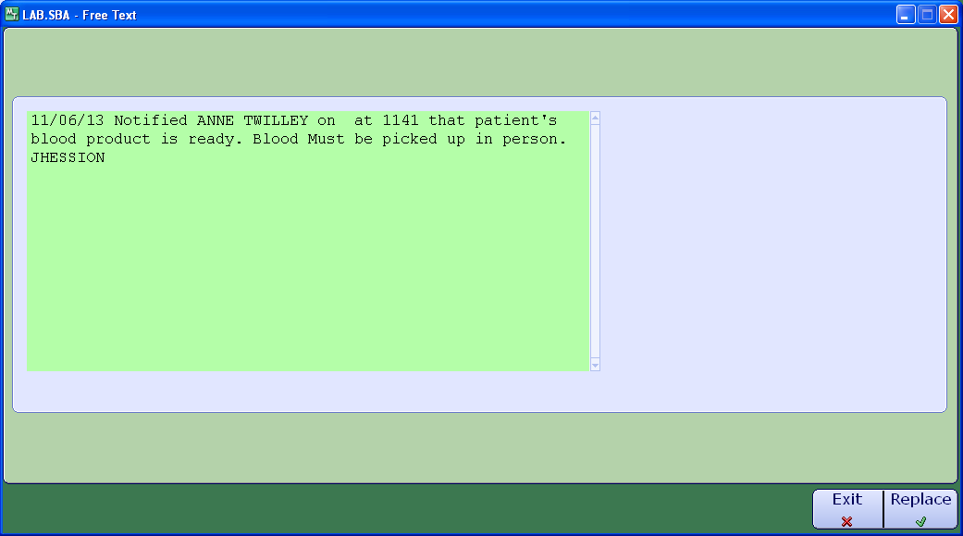

**Using Tube Method**

When using tube method, select the appropriate units as with other methods.

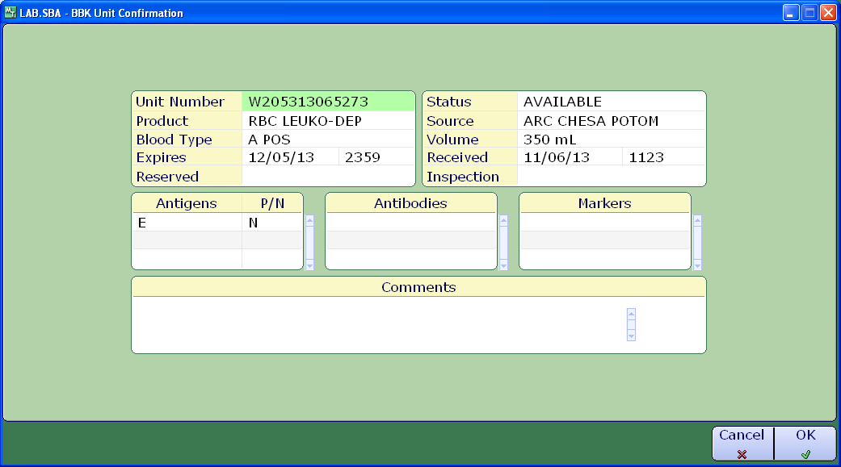

Enter the results in Meditech consistent with the particular tube method. For example, if using LISS, enter results for 37° and AHG phases and check cell results. Enter results for blood product order and notify appropriate individual that product is ready as shown above.

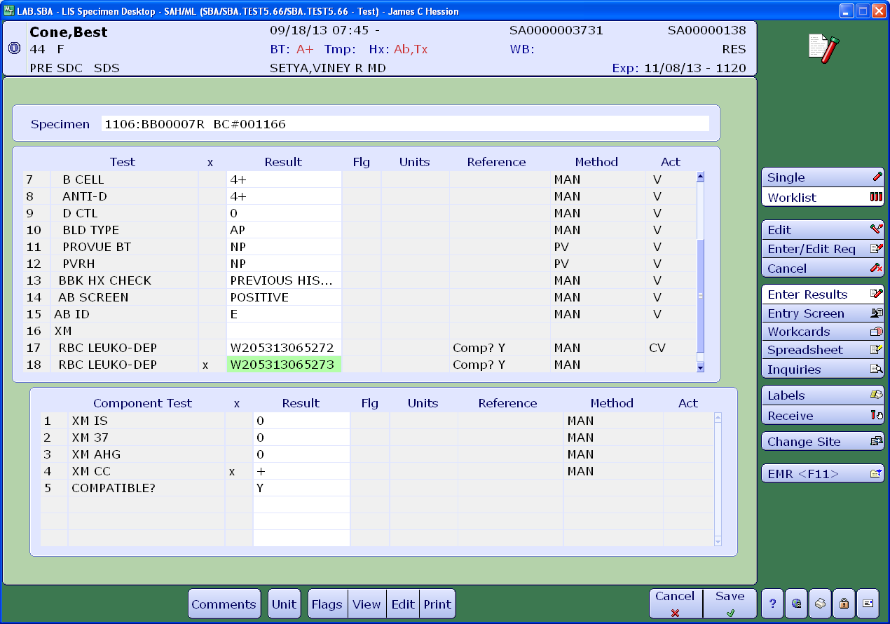

In Meditech, you can also enter the type of enhancement media used as a comment (shown below.)

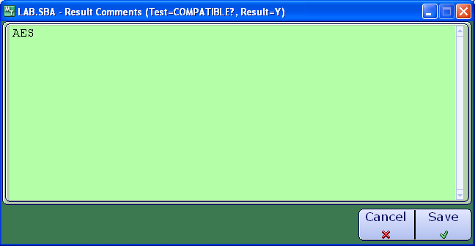

**Performing a Pre-Warm Crossmatch**

For pre-warm crossmatches, a pre-warm crossmatch must be ordered in Meditech as “XMPW.”

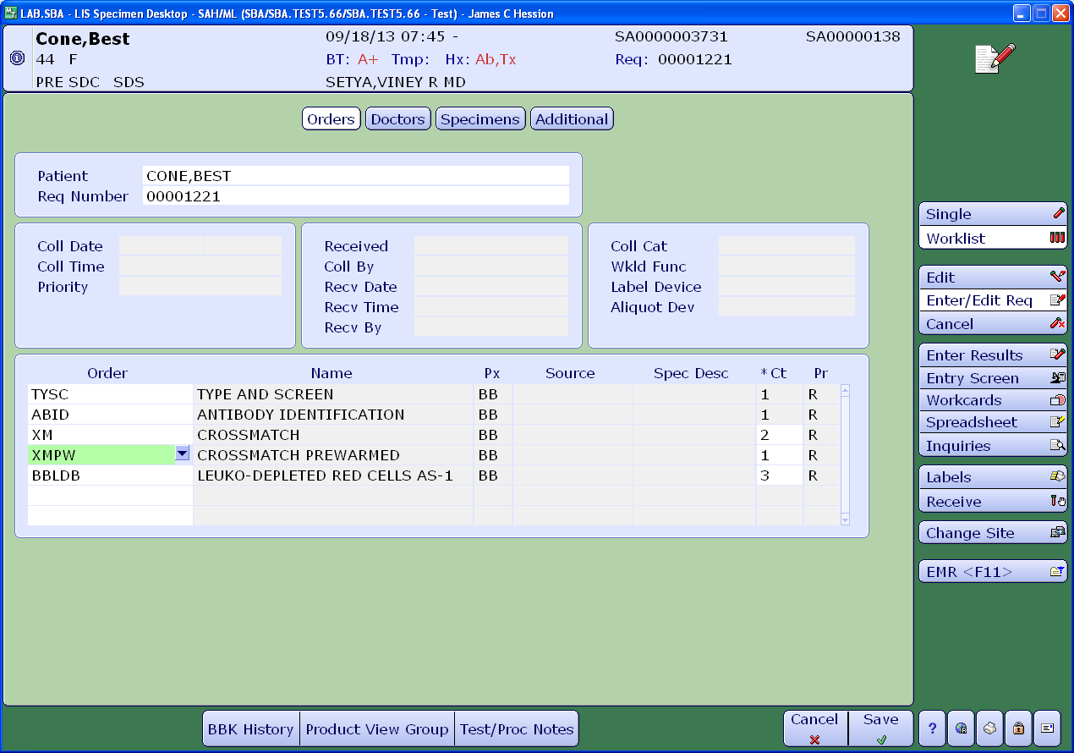

Enter results of pre-warm crossmatch, check cells and compatibility as shown in the example below.

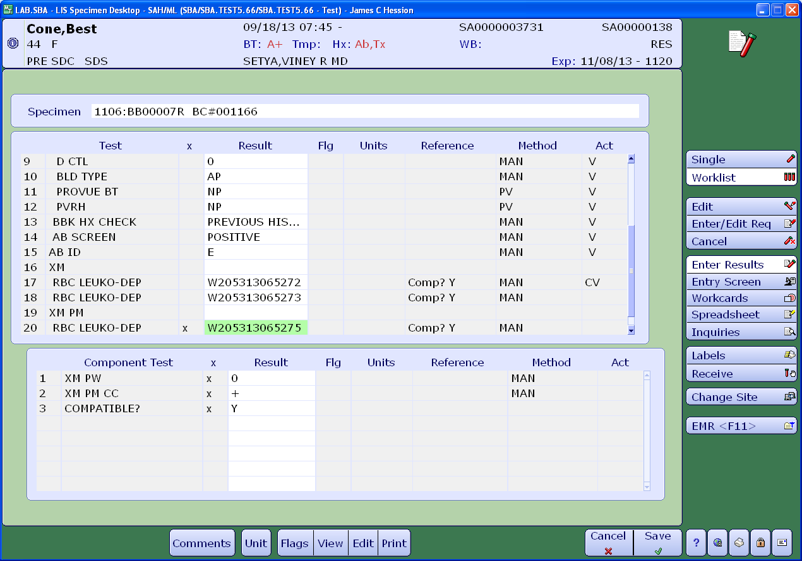

**Warning Flags Encountered When Crossmatching**

If the unit is incompatible and under “Compatible?” a “Y” is entered, this warning will appear.

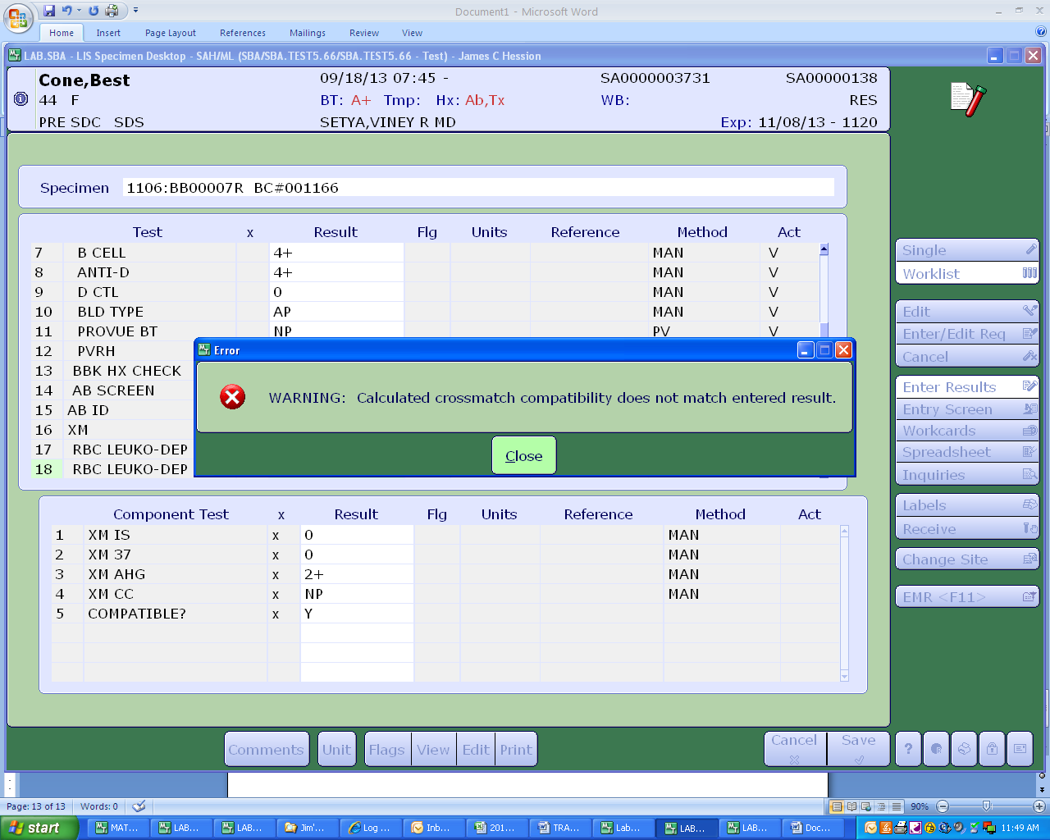

The crossmatch should be resulted as incompatible (“Comp? N”.)

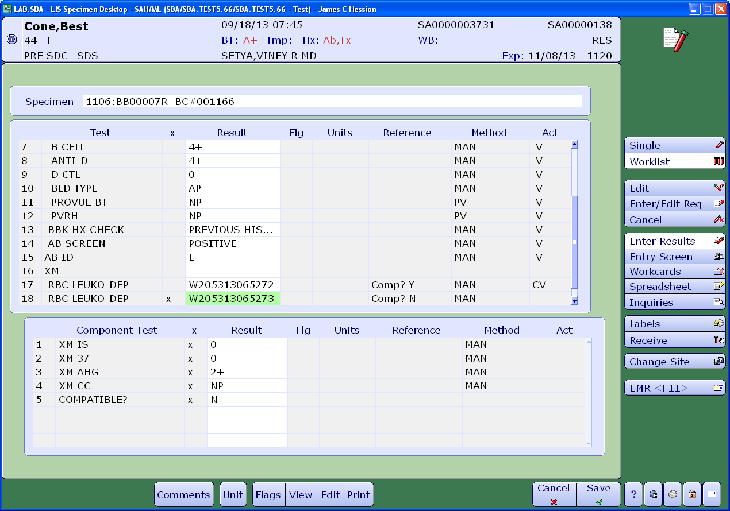

If for example a unit is mistakenly selected that is positive for the patient’s antibody as shown below for the patient with α-E:

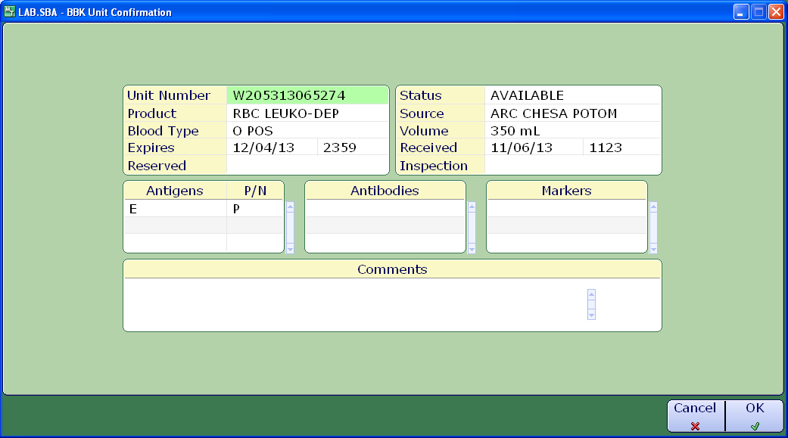

A pop-up warning will appear indicating that an incompatible antigen is present.

