POLICY STATEMENT | ImmunoCard STAT! EHEC is an immunochromatographic rapid test for the qualitative detection of Shiga toxins 1 and 2 (also called Verotoxins) produced by E. coli in cultures derived from clinical stool specimens. ImmunoCard STAT! EHEC is used in conjunction with the patient’s clinical symptoms and other laboratory tests to aid in the diagnosis of diseases caused by enterohemorrhagic E. coli (EHEC) infections.
PURPOSE | This procedure provides technical instruction for the performance of the ImmunoCard STAT! EHEC test.
SCOPE | This procedure applies to technical personnel authorized to perform testing. This group includes, but is not limited to Medical Technologists as well as Leads and Supervisory personnel.
RESPONSIBILITY | All the above personnel are responsible for following this procedure without exception. In addition, testing personnel are also responsible for evaluating the results and taking proper remedial action.
RELATED DOCUMENTS | MICR 6920 F ImmunoCard STAT! EHEC QC chart

PRINCIPLE
ImmunoCard STAT! EHEC is an immunochromatographic lateral flow rapid test utilizing monoclonal antibodies labeled with red-colored gold particles. Any Shiga toxin (ST1 and ST2) antigen present complexes with the gold-labeled antibody and migrates through the pad until it encounters the binding zones in the test (Toxin 1, Toxin 2) area. The binding zones (Toxin 1 and Toxin 2) contain another anti-ST1 or -ST2 antibody, which immobilizes any Shiga toxin-antibody complex present. Due to the gold labeling, a distinct red line is then formed. The remainder of the sample continues to migrate to another binding reagent zone within the control zone, and also forms a further distinct red line (positive control).

SPECIMEN HANDLING
Stool specimens should be collected in Cary-Blair based media and stored at 2-8°C for up to 48 hours.

MATERIALS
- ImmunoCard STAT! EHEC Test Devices, containing immobilized monoclonal anti-ST1 and anti-ST2 antibodies. The devices are packaged in individual foil pouches with desiccants.
- Sample Diluent (Negative Control), a buffered diluent containing 0.094% sodium azide as a preservative. The reagent is supplied in a plastic dropper vial. Use as supplied.
- Positive Control, a solution of formalin-treated ST1 and ST2 toxins in a buffered diluent containing 0.094% sodium azide as a preservative. The reagent is supplied in a plastic dropper vial. Use as supplied.
- 50 µL/175 µL disposable plastic transfer pipettes
- Gram Negative (GN) broth

Storage Requirements: Do not use kit components beyond labeled expiration date.
The expiration date is indicated on the kit label. Store the kit at 2-8°C and return the kit promptly to the refrigerator after each use. Do not mix lot components.

QUALITY CONTROL
Internal controls are contained within the test strip and therefore are evaluated with each test. Daily quality control requires documentation of these procedural controls for each day samples are tested. A PINK-RED band appearing at the Control line serves as a procedural control and indicates the test has been performed correctly, that proper flow occurred and that the test reagents were active at the time of use. A clean background around the Control or Test lines also serves as a procedural control. Control or test lines that are obscured by heavy background color may invalidate the test and may be an indication of reagent deterioration, use of an inappropriate sample or improper test performance.

Positive and Negative Controls are performed with each new lot or shipment of test kits received and weekly thereafter. For each new lot or shipment of kits, run the old kit controls with the new kit to perform a parallel crosscheck before the putting the new kit in use.

PROCEDURE:
Broth Culture
- Use an applicator stick to mix stool thoroughly regardless of consistency.
- Using a pipettor or transfer pipette (supplied with the kit), add 175 µL of the Cary-Blair stool specimen (second mark from tip of pipette) to a GN broth culture tube.
- Incubate inoculated broth with caps loose at 35-39°C for 16-24 hours. (Visually observe the broth tubes for growth). Broths with growth may be held for up to seven days at 2-8°C before testing with ImmunoCard STAT! EHEC
DO NOT PROCEED WITH TESTING if the broth tube does not exhibit growth after incubation as falsely negative results may occur. Repeat the broth enrichment using the same stool sample or with a new sample collected from the patient.
- Using the dropper vial, add five drops (150 µL) of Sample Diluent Buffer to a small test tube.
- Mix broth culture thoroughly by gently swirling the tube.
- Using the transfer pipette supplied with the kit, add 175 µL of sample (second mark from tip of pipette) to the tube containing Sample Diluent.
- Gently mix the contents of the tube with the transfer pipette by squeezing the pipette bulb 3 times. Alternatively, mix using a vortex for 10 seconds. Return the transfer pipette to the tube for later use.
- The diluted stool broth culture can be stored for up to 30 minutes at 20-25°C before testing.

ImmunoCard STAT! EHEC Procedure
- Bring all Test Devices, reagents and samples to room temperature (20-25°C) before testing.
- Controls
- Positive: Add exactly 5 drops of the Positive Control to the sample port of the device marked for the Positive Control.
- Negative: Add exactly 5 drops of the Sample Diluent/Negative Control to the sample port of a device marked for the Negative Control.
- Remove the ImmunoCard STAT! EHEC Test Device from its foil pouch. Label the device with the patient’s identification. The Test Device should be used within 15 minutes after removal from the sealed foil pouch.
- Using the transfer pipette provided in the kit, slowly add 175 µL of the diluted specimen (second mark from tip of pipette) to the sample port of the device.
- Incubate the test at 20-25°C for 20 minutes.
- Read the results within 1 minute after the end of incubation.

INTERPRETATION OF RESULTS;

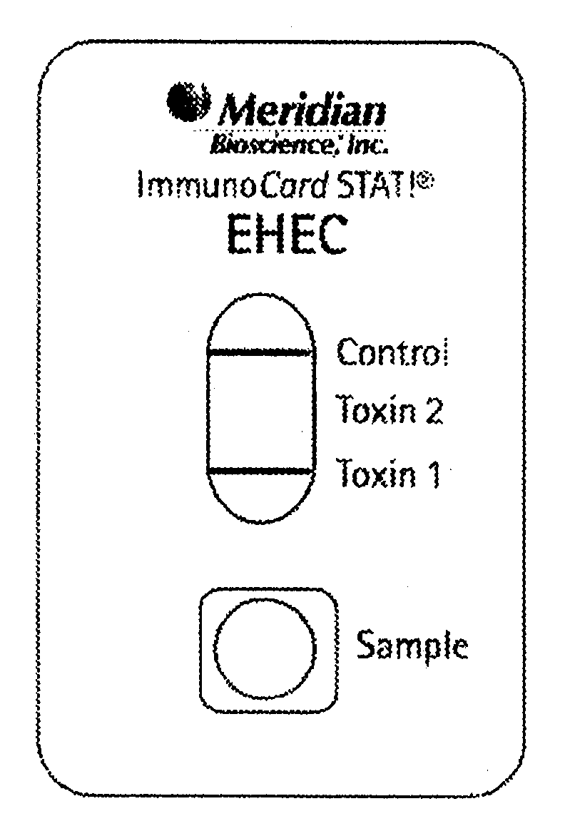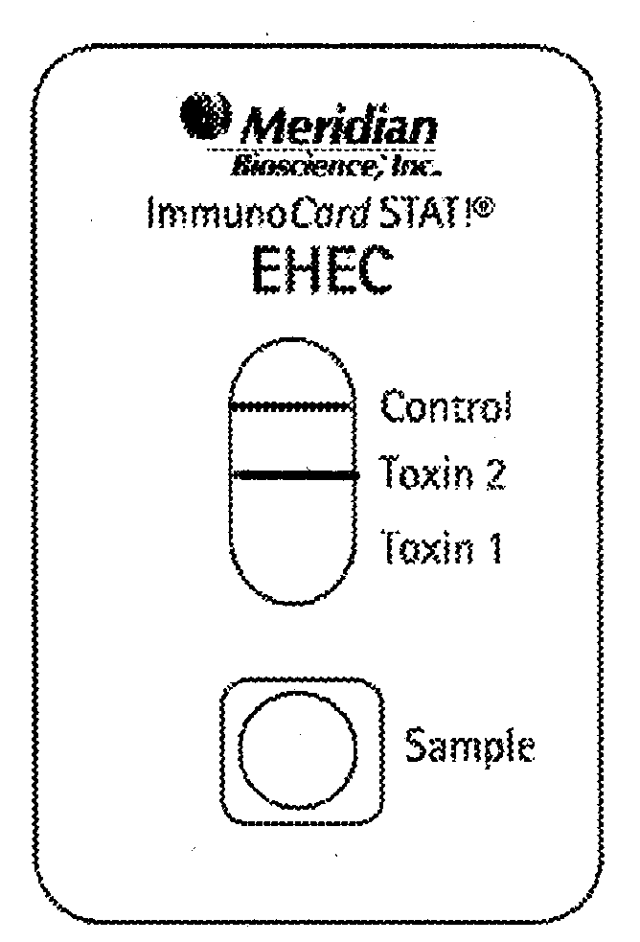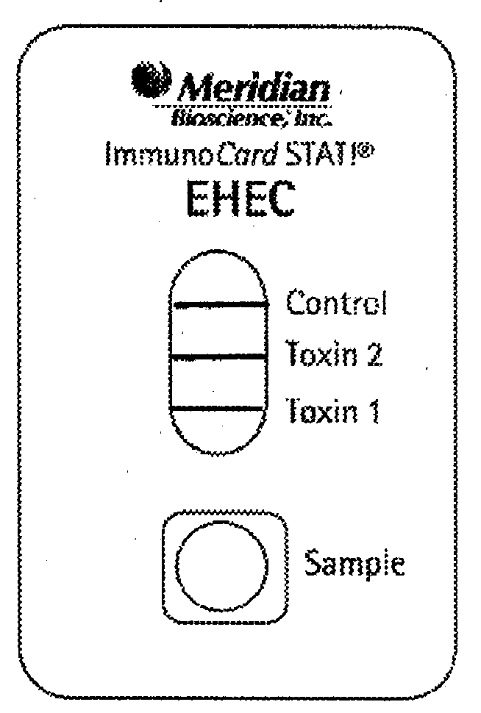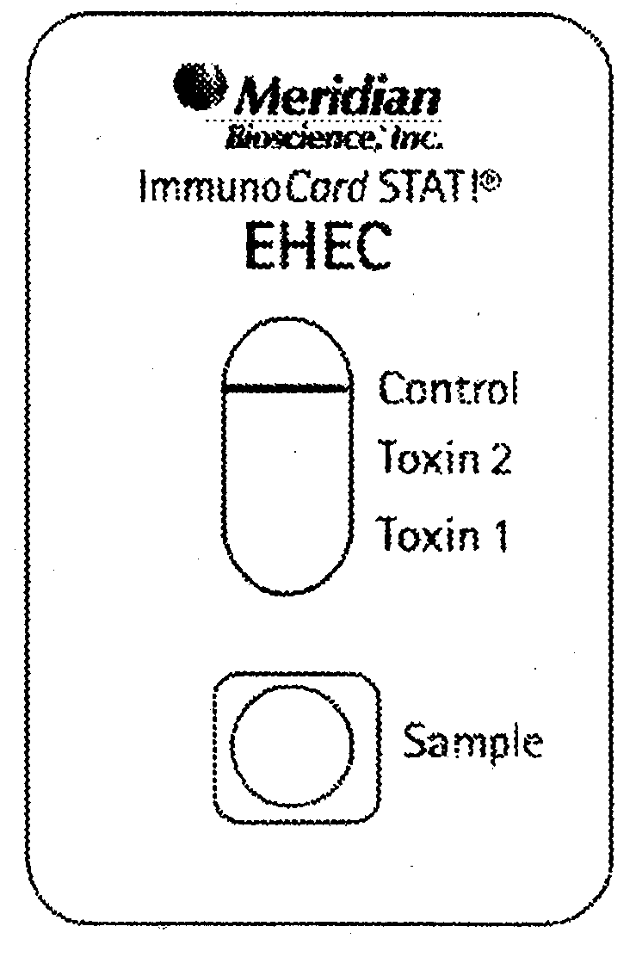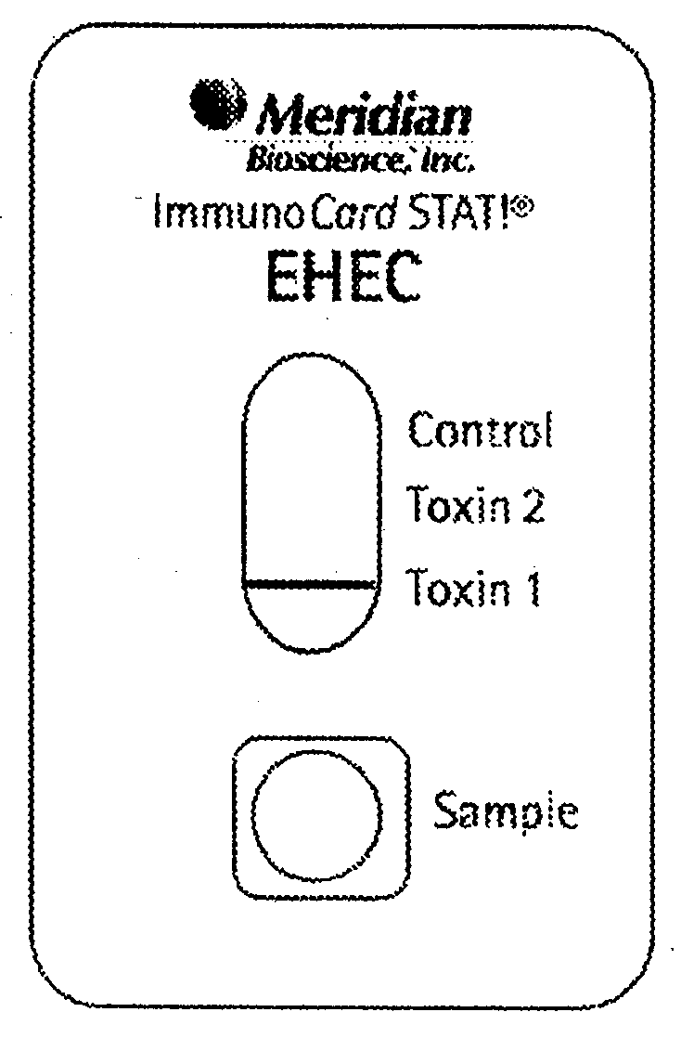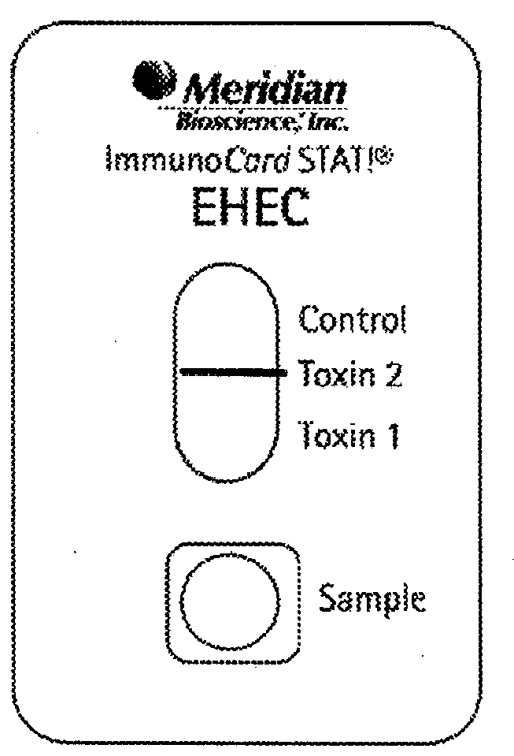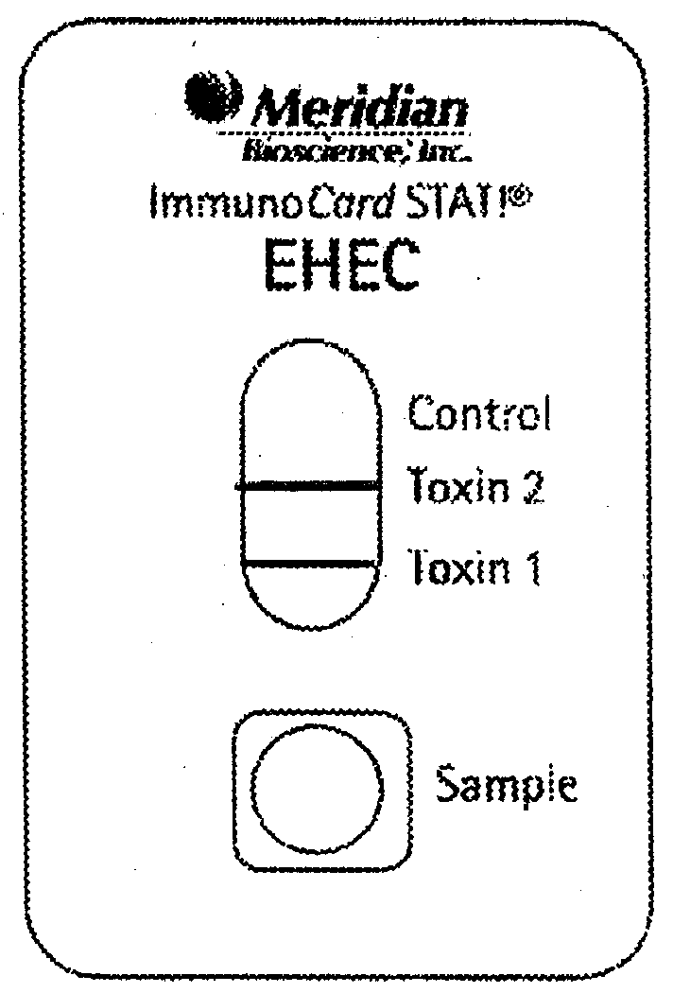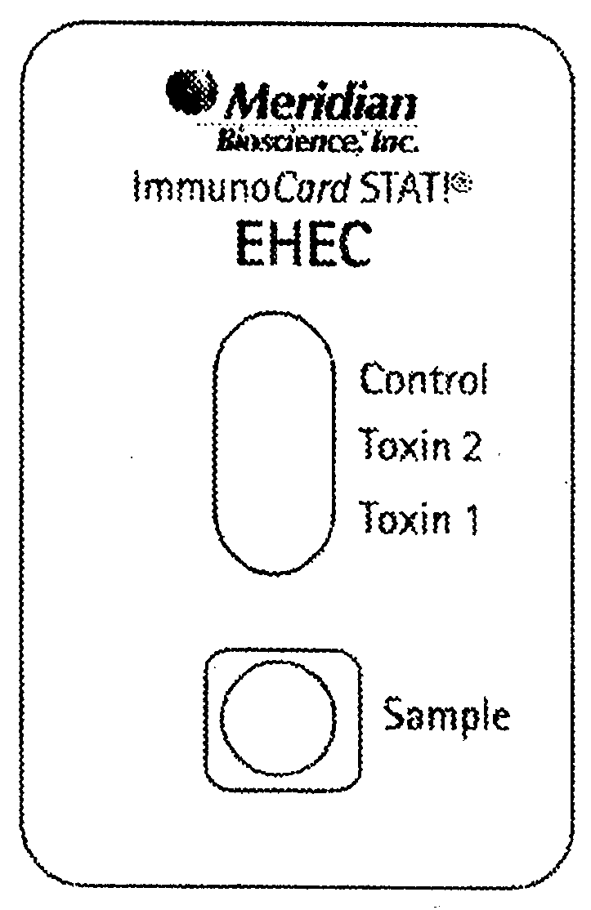
POS T1 POS T2 POS T1&2 NEG INVALID INVALID INVALID INVALID

Positive test for Shiga toxin 1: PINK-RED bands at the Control and Toxin 1 line positions. No bands at the Toxin 2 test line. The appearance of a Toxin 1 test line, even if very weak, indicates the presence of Shiga toxin I. The intensity of the test line can be less that that of the Control line.

Positive test for Shiga toxin 2: PINK-RED bands at the Control and Toxin 2 line positions. No bands at the Toxin 1 test line. The appearance of a Toxin 2 test line, even if very weak, indicates the presence of Shiga toxin 2. The intensity of the test line can be less than that of the Control line.

Positive test for Shiga toxins 1 and 2: PINK-RED bands at the Control, Toxin 2, and Toxin 1 line positions. The appearance of Toxin 2 and Toxin 1 test lines, even if very weak, indicates the presence of Shiga toxins 1 and 2. The intensity of the test lines can be less than that of the Control line.

Negative test: A PINK-RED band at the Control Line position. No other bands are present.

Invalid Test Results:
- No band at the designated position for the Control line. The test is invalid since the absence of a control band indicates the test procedure was performed improperly or that deterioration of reagents has occurred.
- A PINK-RED band appearing at either the Toxin 1 or Toxin 2 Test Line position of the device after the defined incubation limit or a band of any color other than PINK-RED. Falsely positive results may occur if tests are incubated too long.
- Bands with colors other than PINK-RED may indicate reagent deterioration.
- If any result is difficult to interpret, the test should be repeated with the same sample to eliminate the potential for error. Obtain a new sample and retest when the original sample repeatedly produces unreadable results.

REPORTING
Positive test: Report test result as “POSITIVE” for shiga toxin 1 and/or shiga toxin 2.
For all positives, the Cary Blair should be forwarded to DHMH; see MICR 6050 Health Department Notification organisms for FOODNET.

Negative test: Report test results as “NEGATIVE” for shiga toxin 1 and/or shiga toxin 2.

LIMITATIONS OF THE PROCEDURE:
- The test is qualitative and no quantitative interpretation should be made with respect to the intensity of the positive line when reporting the result.
- Test results are to be used in conjunction with information available from the patient clinical evaluation and other diagnostic procedures.
- Over incubation of tests may lead to false-positive test results. Incubating tests at reduced temperatures or times may lead to falsely negative results.
- The performance of ImmunoCard STAT! EHEC HAS NOT BEEN EVALUATED with direct stool samples. It has only been evaluated in SMAC plate culture or GN and MacConkey liquid cultures.
- NOTE: Shiga toxin 1 produced by E. coli and the toxin produced by Shigella dysenteriae type 1 strains are nearly identical. Therefore, ImmunoCard STAT! EHEC may give a positive result with toxins from S. dysenteriae type 1 strains. The two organisms can be differentiated by plating on selective growth media coupled with biochemical analysis.

WARNINGS
- The Positive Control reagent contains formalin-treated (inactivated) shiga toxins ST1 and ST2. It should be handled, however, as a potentially hazardous material.
- Patient specimens may contain infectious agents and should be handled and disposed of as potential biohazards.
- Dispose of all used test materials in an appropriate container. Treat waste as a potential biohazard.

REFERENCES
Meridian Bioscience ImmunoCard STAT® EHEC package insert 04/10

