POLICY STATEMENT | Giardiasis and Cryptosporidiosis are among the most common causes of parasitic intestinal diseases in developed countries. Infection usually occurs through the ingestion of contaminated food or drinking water. Distinguishing between these two causative agents is important for the selection of appropriate treatment. Xpect™ Giardia/Cryptosporidium is an in vitro qualitative immunoassay for the detection of Giardia and Cryptosporidium antigens in preserved and unpreserved fecal specimens. The test is intended as an aid in the laboratory diagnosis of suspected Giardia and Cryptosporidium infections.
PURPOSE | This procedure provides technical instruction for the performance of the Xpect Giardia/Cryptosporidium test.
SCOPE | This procedure applies to testing personnel authorized to perform testing. This group includes, but is not limited to Laboratory Technologists as well as leads and supervisory personnel.
RESPONSIBILITY | All the above personnel are responsible for following the Xpect Giardia/Cryptosporidium procedure without exception. In addition, testing personnel are also responsible for evaluating the results and taking proper remedial action.
RELATED DOCUMENTS | MICR 6925 F Giardia-Crypto Ag QC Chart

PRINCIPLE
The Xpect Giardia/Cryptosporidium antigen test utilizes sample wicking to capture Giardia and Cryptosporidium antigens on discrete test lines containing antigen-specific antibodies for each organism. Conjugate containing colored microparticles linked to murine monoclonal antibodies specific for Giardia and Cryptosporidium is added to the buffered specimen. The mixture is dispensed into the sample well of the device and wicks along a membrane containing capture antibody stripes. If present, the Giardia/Cryptosporidium immune complexes react with anti-Giardia antibody and/or anti-Cryptosporidium antibody at the test line. Antibody-labeled microparticles not bound at the test lines are later captured at the control line containing anti-mouse antibody.

SPECIMEN HANDLING
- Stool specimens collected in Cary Blair should be refrigerated (2°C to 8°C) and tested within 1 week of collection or frozen and tested within 2 months of collection.
- Stool specimens collected in 10% formalin may be refrigerated (2°C to 8°C) or stored at room temperature (20 to 25°C) and tested within 2 months of collection.
- Stool specimens collected in PVA fixatives are not acceptable
- Avoid multiple freeze-thaw cycles
- Do not collect more than 2 to 3 specimens per patient.
- Do not collect specimens on inpatients after 4 days of admission.

REAGENTS
Xpect Giardia/Cryptosporidium antigen test
- Test Devices (20): Membrane striped with rabbit anti-Giardia, rabbit anti-Cryptosporidium, and goat anti-mouse IgG.
- Conjugate (2.5 ml): Dark-blue microparticles coated with anti-Giardia MAb, Red microparticles coated with anti-Cryptosporidium MAb, Dark-Blue microparticles coated with mouse IgG.
- Specimen Dilution Buffer (2.5 ml)
- Disposable Transfer Pipettes (20)
- Dilution Tubes (20)
Store all components at 2 to 8°C. Do not freeze or overheat. This product should not be used beyond the expiration date printed on the outer package label. Allow components to come to room temperature (20 to 25°C) before use. Do not interchange reagents between kits of different lots.

QUALITY CONTROL
The appearance of a control line at the CTRL position verifies that an intact conjugate has been added to the device, that the control line antibody is functionally active, and that adequate capillary flow has occurred.

External Positive and Negative Controls are performed according to the test procedure with each new lot or shipment of test kits received and weekly thereafter. Do not mix lot components.

PROCEDURE
  - Allow all reagents to reach room temperature and mix gently.
  - Remove the required number of devices from their individual foil pouches.
  - Label and place the required number of tubes in a rack.
  - Add 4 full drops of Specimen Dilution Buffer to each tube.
  - Using the provided transfer pipette, transfer 0.1 ml (first molded graduated mark from the tip) of stool specimen to the tube. It is permissible to obtain primarily the liquid fraction of a specimen, avoiding any large pieces of insoluble debris.
  - Mix the sample by aspirating with the transfer pipette.
  - Add 4 full drops of Conjugate to each tube.
  - Mix using a transfer pipette.
  - Using the same transfer pipette, immediately deliver 0.2 ml (second molded graduated mark from the tip) of diluted sample/conjugate mixture into the circular sample well of the test device.
  - Read assay results after 15 minutes. A positive result can be reported upon appearance of a complete control line. (Strong positive results may be apparent sooner than 15 minutes.) Results beyond 15 minutes are invalid.
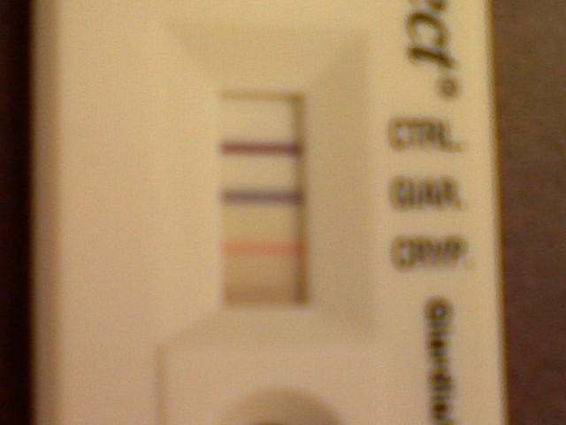
REPORTING
Enter results in Meditech as Positive or Negative for Cryptosporidium or Giardia.
- Positive Results
  - Giardia: The specimen is positive for Giardia if a complete line is present at the CTRL position and a complete, clearly defined blue line of any intensity present at the GIAR position
  - Cryptosporidium: The specimen is positive for Cryptosporidium if a complete line is present at the CTRL position and a complete, clearly defined red line of any intensity (light pink to red) is present at the CRYP position.

Giardia & Crypto. Giardia Cryptosporidium
Positive Positive Positive

CTRL CTRL
GIAR CTRL
CRYP GIAR GIAR
CRYP CRYP

- Negative Result
- Giardia: The specimen is negative for Giardia if a complete line is present at the CTRL position and no line is visible at the GIAR position.
- Cryptosporidium: The specimen is negative for Cryptosporidium if a complete line is present at the CTRL position and no line is visible at the CRYP position.

Negative Invalid Invalid Result
Result Result (incomplete control line)
CTRL CTRL CTRL

GIAR GIAR GIAR

CRYP CRYP CRYP

- Invalid Results
An invalid result occurs when:
- CRYP line is incomplete at 15 minutes.
- GIAR line is incomplete at 15 minutes.
- CTRL line is absent or incomplete at 15 minutes.

If conditions (a), (b), or (c) is present, the specimen should be re-tested as follows:
Highly viscous samples and samples containing significant debris or mucous may display restricted flow along the device membrane and produce invalid test results. These samples should be further diluted and re-tested using the following procedure:
- Combine in a sample tube 0.1 ml (4 drops) of Specimen Dilution Buffer and 0.1 ml of either (a) the primary sample in preservative or (b) the unpreserved sample diluted 1:4 with deionized water.
- Mix the preparation by aspirating with the transfer pipette.
- Use this as the prepared sample and repeat procedural Steps 1-6.

Limitations of the Procedure
- A negative test result does not exclude the possibility of the presence of Giardia or Cryptosporidium, and may occur when the antigen level in the sample is below the detection level of the test. Correlation between the amount of antigen in a sample and clinical presentation has not been established.
- The presence of a Hook Effect in this assay has not been fully established. Samples evaluated containing high levels of target antigen and high number of organisms did not yield a false negative result due to a Hook Effect.
- The analytical sensitivity of this assay has not been established using formed stool specimens.
- Concentrations of 20% (v/v) Imodium® A-D may result in a false negative reaction when low levels of Cryptosporidium antigen are present.
- Reactivity to species of Cryptosporidium other than C. parvum has not been established.

REFERENCES
Remel Xpect Giardia/Cryptosporidium package insert May 16, 2011

