POLICY STATEMENT | The Xpect® Rotavirus is a rapid, membrane-based, immunogold assay for the qualitative detection of rotavirus antigens in human fecal specimens intended for use as an aid in the diagnosis of acute gastroenteritis caused by rotavirus infections.
PURPOSE | This procedure provides technical instruction for the performance of the Rotavirus test.
SCOPE | This procedure applies to testing personnel authorized to perform testing. This group includes, but is not limited to Laboratory Technologists as well as leads and supervisory personnel.
RESPONSIBILITY | All the above personnel are responsible for following the Rotavirus procedure without exception. In addition, testing personnel are also responsible for evaluating the results and taking proper remedial action.
RELATED DOCUMENTS | MICR 6951 F Rotavirus QC Chart

PRINCIPLE
The Xpect® Rotavirus test utilizes a pair of rotavirus-specific antibodies in an immunochromatographic sandwich assay. An extract is first prepared by suspension of the specimen in the provided extraction buffer solution. The buffer containing the extracted specimen is then added to the device’s sample well. The reaction between a positive sample and the colored particle-conjugated antibody will form a complex that migrates along the membrane. An immobilized capture antibody will form a colored line at the S (specimen) area upon reacting with the colored complex. An internal control line C (control) area is built-in to assure that the test has been carried out correctly.

SPECIMEN HANDLING
Fresh stool specimens collected in a clean, dry container. Specimens should be collected as soon as possible after the onset of symptoms. Specimens should be transported at 2-8°C up to 48 hours or frozen at –20°C or below until ready to test for up to 2 weeks.
NOTE: Preserved specimens are unacceptable.

REAGENTS
Xpect® Rotavirus Kit:
- Test Devices: Membrane coated with monoclonal anti-rotavirus antibody that is affinity purified and specific to the capsid protein of rotavirus
- Tubes containing Rotavirus Extraction Buffer
- Disposable Sample Transfer Pipettes (20)

Store the kits at room temperature until the expiration date printed on the box. Do not use the kit beyond its labeled expiration date. Do not mix lot components.

QUALITY CONTROL
Each test device includes a built-in procedural internal control. Correct procedural technique and test device performance is confirmed when a colored line appears in the C (control) area of the device. Daily quality control requires documentation of these procedural controls for each day samples.

External Positive and Negative Controls are performed with each new lot or shipment of test kits received and weekly thereafter. Do not mix lot components.

PROCEDURE
- Allow the kit components and specimens to reach room temperature prior to testing.
- Mix stool specimens thoroughly prior to testing.
- Specimen Extraction:
  - Using a swab, add sufficient stool specimen (30-50 mg) to the provided tube containing the Extraction Buffer.
  - Rub swab meticulously against inner wall of tube in order to release the fecal material.
  - For best results, vortex the tube for 60 seconds. Centrifuge thick or mucoid specimens if needed.
  - Allow the sediment to settle for 2 to 5 minutes.
- Note: do not perform the extraction step for controls or proficiency samples.
- When ready to perform the test, remove test device from foil pouch and place on a flat surface. Note: The test device must remain in the sealed pouch until ready for use.
- Using the provided transfer pipettes, dispense 4 drops (approximately 150 μl) of the supernatant into the round sample well of the device. Wait for colored lines to appear.
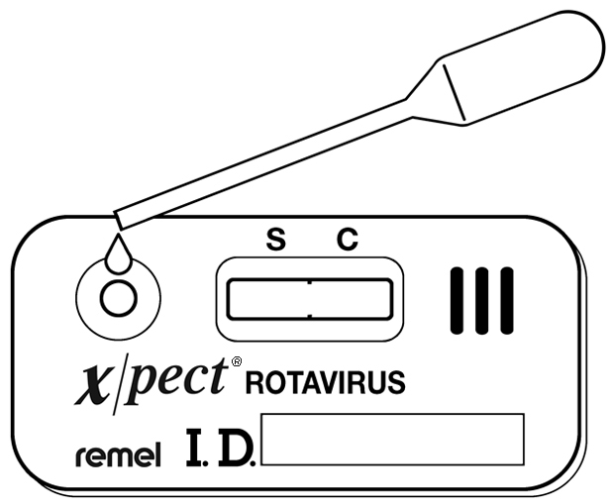

- Read results at 15 minutes. Some positive results may be observed in as short as 30 seconds depending on the concentration of antigen. Do not interpret results after 30 minutes.

REPORTING
Positive Test: Two colored lines appear; one colored line will appear in the S (specimen) area and one in the C (control) area. Any colored line in the S area should be considered positive. Colored lines may be lighter or darker than each other.

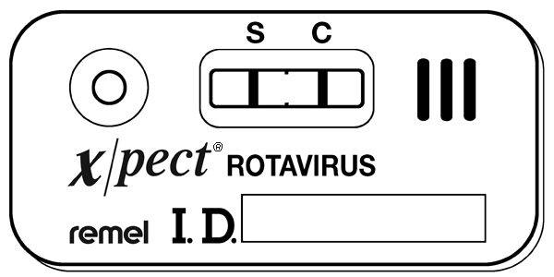

Negative Test: One colored lines appears in the C (control) area.

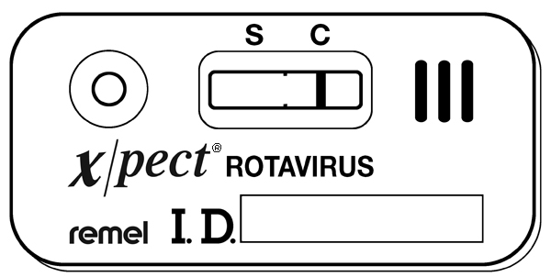

Invalid Results: The test is invalid if no colored line appears in the C (control) area, even if a colored line appears in the S (specimen) area. If this occurs, add 1 to 2 additional drops of sample and wait for 5 minutes. If a colored line does not appear in the C area, the test is invalid and should be repeated. Colored lines, which appear after 30 minutes are not diagnostic and should be ignored.

Enter the results in Meditech.

REFERENCE
Insert Xpect® Rotavirus package insert, April 28, 2008

