POLICY STATEMENT | The LabPro System is use to order patients, print bar code labels, monitor panel processing and exceptions, load panels into the Walkaway plus and list the sequence of events performed by the instrument after panels are loaded.
PURPOSE | This procedure provides technical instruction for the performance of the Microscan WalkAway plus and the autoSCAN-4 instruments.
SCOPE | This procedure applies to testing personnel authorized to perform testing Microscan WalkAway plus and the autoSCAN-4 instruments. This group includes, but is not limited to Medical Technologists as well as leads and supervisory personnel.
RESPONSIBILITY | All above personnel are responsible for following this procedure without exception. In addition, testing personnel are also responsible for evaluating the results and taking proper remedial action.

Enter Patient and QC Order Information
Use the Patient Order Entry window to manually enter patient information and specimen orders into LabPro if the LIS is unavailable.
- The Patient Order Entry window has two required fields: Specimen and Patient ID.
- Each specimen has at least one associated isolate. Each isolate has at least one order. Orders are made up of test groups — such as Positive Combo Panels, Negative Combo Panels, and offline tests. You can add an unlimited number of isolates to a specimen. Each order for the isolate cannot contain overlapping test requests.
- LabPro indicates required in the text boxes where required information is missing for the selected isolate.
- LabPro determines which panels are normally processed in a WalkAway instrument, non-WalkAway panels will be read manually.
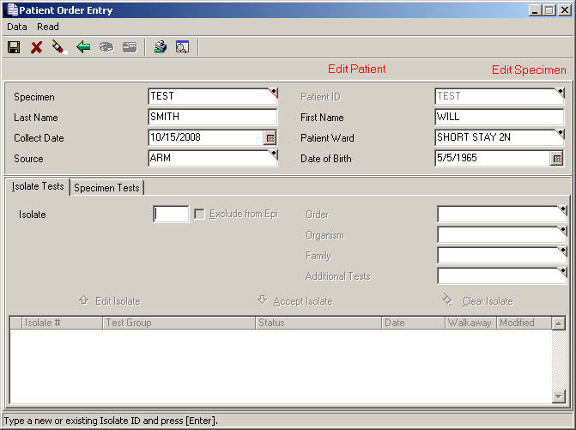

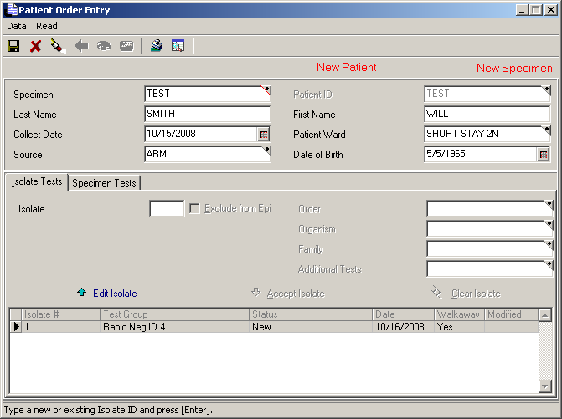

- Use the QC Order Entry window to enter panel lot demographics, such as lot number and panel type, as well as order a QC test battery, which automatically orders ALL recommended ATCC strains for the QC panel. Set up a separate QC panel for each organism in the QC test battery.
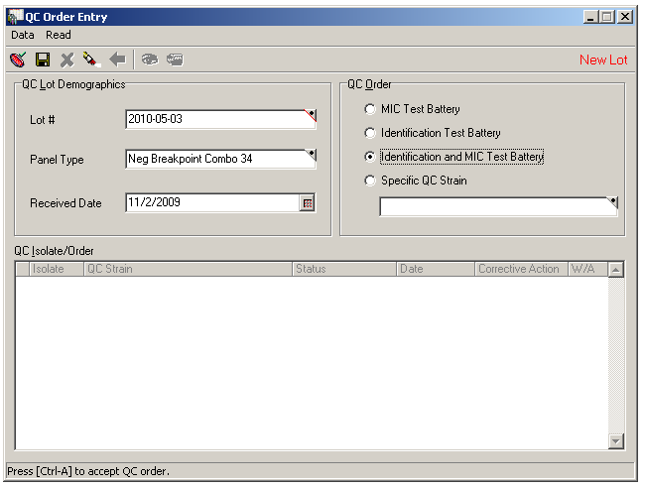

- If the Lot number has been used by another panel type or this is a new shipment, under Data click on New lot/Shipment
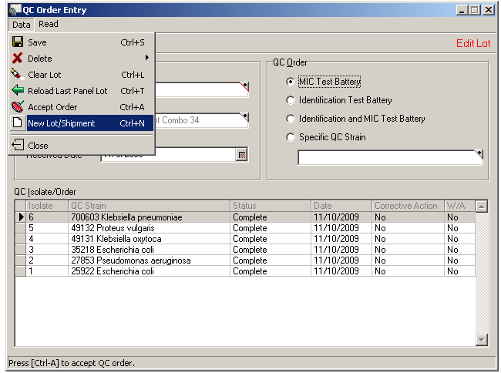
- If this is a new ID/MIC panel, under QC Order select Identification and MIC Test Battery.
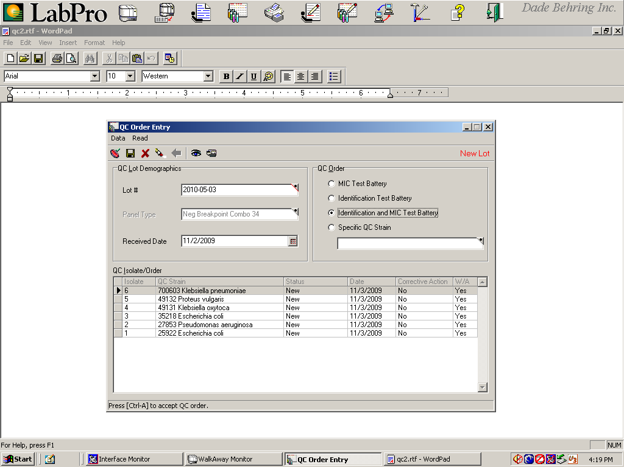
- If this is a new MIC panel or the weekly MIC QC, under QC Order select MIC Test Battery
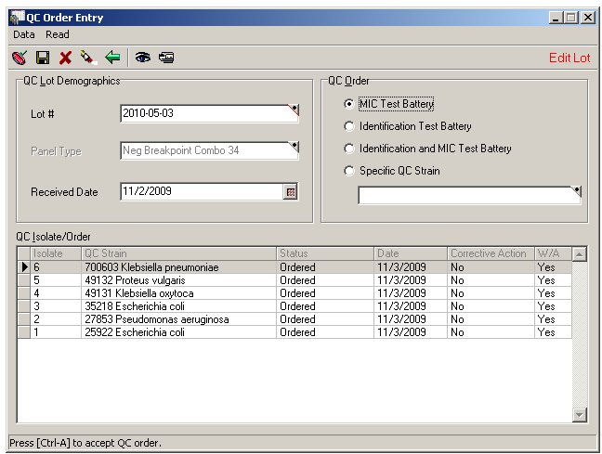
- Click on the. The appropriate QC organisms will be selected
- If the panel needs to be repeated, under QC Order select Specific QC Strain. Only select the organism that needs to be repeated.

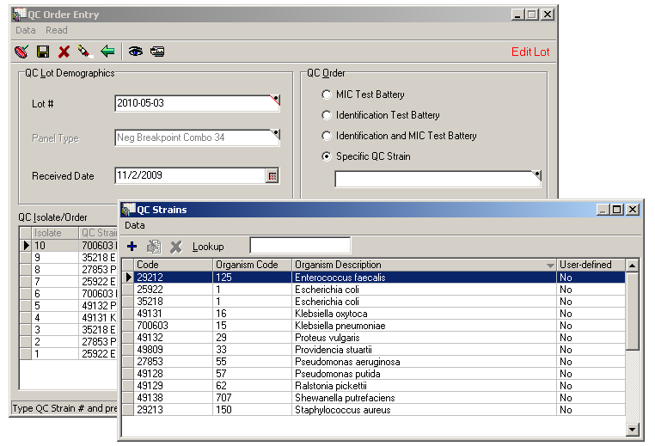

- Save the order and order the bar code labels by clicking on the.
- (DO NOT click on the. This will reorder all panels)

Print Bar Codes and Properly Label Panels
Use the WalkAway Bar Codes window to view a list of isolates that have new WalkAway panel orders AND still need a bar code label printed.
- On the WalkAway Bar Codes window, patient panels appear in black text. QC panels appear in blue text.
- An Ø symbol next to a panel means that LabPro needs additional isolate information before it can process this panel.
- Click Print to print bar code labels. Click Reprint Bar Codes to reprint damaged bar code labels.
- To ensure proper placement of the bar code label, hold the panel with the MicroScan logo on the right side nearest you.

Request Access and Load Panels into the Walkaway Instrument
On the Command Center, click the WalkAway Monitor icon to open the WalkAway Monitor window. Use the WalkAway Monitor window to request access to the WalkAway instrument.
- Because the WalkAway instrument performs time-critical activities, you must always request access before you can open the access door to load or unload panels. If access is granted, the green LED to the right of the panel access door illuminates. Access will not be granted if it will interfere with a scheduled panel processing function.
- Behind the panel access door, eight towers (1 through 8) hold MicroScan panels. For each tower, observe the LED lights next to each panel slot to get more information about processing status:
LED ON/flashing: Processing finished. OK to remove panel.
LED OFF: Panel processing.
LED ON/not flashing: Slot empty.
- After loading panels, close the access door and then click Lock Door. The carousel rotates towers in front of bar code reader. The bar code reader scans bar codes and recognizes that a new panel occupies a tower slot to begin panel processing.

Monitor Panel Processing
Use the WalkAway Monitor window to monitor panel processing.
- The WalkAway Status grid represents the towers in the instrument. Each column is one tower, and each cell is one slot in that tower.
- Use the Legend tab to interpret cells in the WalkAway Status grid to monitor panel processing status. You can also roll your mouse over a cell — panel information such as specimen and isolate number appears — if the instrument has identified the panel.
- The Load Status tab displays more detailed information about panels, such as status message, specimen source, and next read date/time. Symbols identify panels with exceptions, unreviewed critical alerts, and/or time-critical exceptions.
- If no exceptions exist, results are automatically stored to the LabPro database and transmitted to the LIS system.

Resolve Errors, Exceptions, and Alerts
When used with the LabPro Information Manager, LabPro AlertEX System software automates atypical results detection. The extensive database consists of predefined rules recommended by Clinical and Laboratory Standards Institute (CLSI) and industry standards. Automatic notifications direct technologist to take the most appropriate action ensuring appropriate reporting. Unusual or inconsistent results should be verified by checking the following:
- Check for problems with testing supplies, process, and equipment or QC performance.
- Examine the MicroScan panel and purity plate for mixed cultures.
- Check previous reports for this patient for the same organism with the same unusual susceptibility pattern.
- If the problem cannot be detected, repeat the MicroScan Panel. If the panel repeats with the same unusual results, accept the panel.
- Sometimes an alternative test method is necessary to resolve poor identifications.

If LabPro detects instrument errors or alert conditions, a Check Status message appears in the upper-left corner of the Instrument Status area of the WalkAway Monitor window. The specific error appears in the Error conditions area.
- View the WalkAway Status grid to check for bar code read errors. Bar code read errors are also indicated in the Error Conditions area.
- To resolve bar code read errors, click the ID to WalkAway tab to view a list of all unread and missing panels. Manually identify unread panels by clicking and dragging the unread panel from the ID to WalkAway tab to the corresponding cell with the bar code read error in the WalkAway Status grid and SEND.
- After resolving bar code read errors, click Unread List to view a list of all panels for which a bar code label was printed but the instrument did not successfully scan. For example, maybe you forgot to load the panel. Because panels with bar code read errors also appear on this list, it is recommended that you resolve all bar code read errors before investigating other unread panels.
- A red cell in the WalkAway Status grid and New Exceptions Exist message in the Error conditions area indicate that the instrument has completed panel processing but an exception exists. This panel’s results will not be stored in the database until you take appropriate action to resolve the exception.
- To resolve exceptions for patient panels, click the Exception Status tab. Double-click the exception to open the Results Summary and Edit dialog box. Use the Panel tab to view biochemical reactions and antimicrobial results for the panel with the exception. Use the Panel Edit Legend dialog box as a key to understand symbols displayed on the Panel tab. Remove the panel from the instrument and compare actual panel results to instrument results.
- On the Results Summary and Edit dialog box, manually edit panel results as necessary to resolve the exception. To process edits, on the toolbar, click Process. Click Save to store panel results in the LabPro database. Verify that the resolved exception no longer appears on the Exceptions Status tab.
Note: To save edits as well as print a Comprehensive Panel Status Report (CPSR), on the Results Summary and Edit dialog box, click Save and Print CPSR.
- To resolve Out-of-control exceptions for QC panels, click the Exception Status tab. Double-click the exception to open the QC Results Summary and Edit dialog box. Use the Panel tab to view biochemical reactions and antimicrobial results for the panel with the exception. Remove the panel from the instrument and compare actual panel results to instrument results. On the QC Results Summary and Edit dialog box, red hash marks indicate out-of-control results. Also review your panel setup procedure as well as your ATCC organism preparation and maintenance. Use the Corrective Action box to maintain a record of corrective action taken to resolve exceptions. On the toolbar, click Save to store your documentation and resolve the exception.
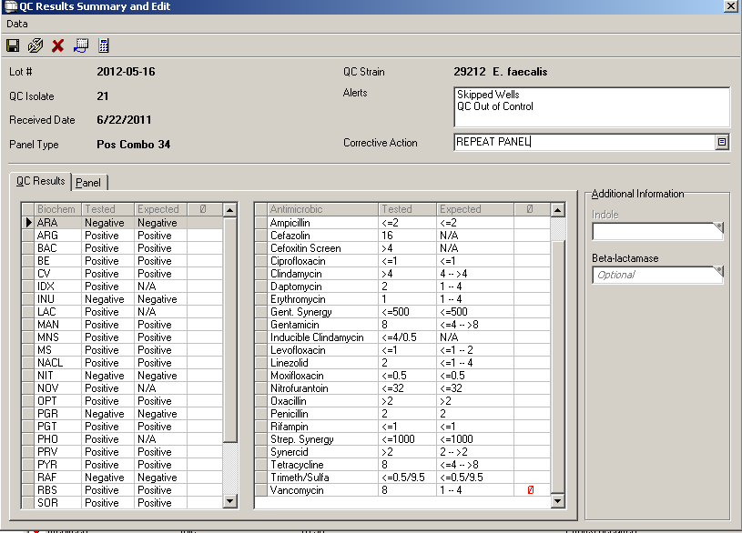

- Alert system messages are generated if unusual test results meet the conditions specified in system- and user-defined alert rules. Alerts are assigned different priorities: Critical, High, Medium, or Low. Critical alerts should be acted upon as soon as possible.
- A yellow icon with an exclamation point on a cell in the WalkAway Status grid indicates that the panel has an unreviewed critical alert. A message in the Error conditions area indicates unreviewed critical alerts exist and new exceptions exist. The WalkAway instrument treats all alerts as exceptions, so the Load Status and Exception Status tabs will also indicate that an exception exists for this panel.
- To resolve critical alerts, double-click the cell with the unreviewed critical alert symbol to open the Results Summary and Edit dialog box. On the Results Summary and Edit dialog box, the Critical Alerts toolbar icon is active and the critical alert message is displayed in the Alerts box. Click + next to the alert message to review Alert System comments.
- Review the instrument results on the Panel tab of the Results Summary and Edit dialog box and compare them to a visual check of the panel results. Manually edit panel results as necessary. Use the Panel Edit Legend dialog box as a key to understand symbols displayed on the Panel tab.
- Take any necessary actions, print a Panel Alert Report. Comments can be added to the Panel Alert by clicking on the Alert Resolution icon on the toolbar.
- To document in LabPro that Alert System messages were reviewed, on the toolbar, click Alert Resolution to display the Alert Resolution dialog box, where you can document action taken.
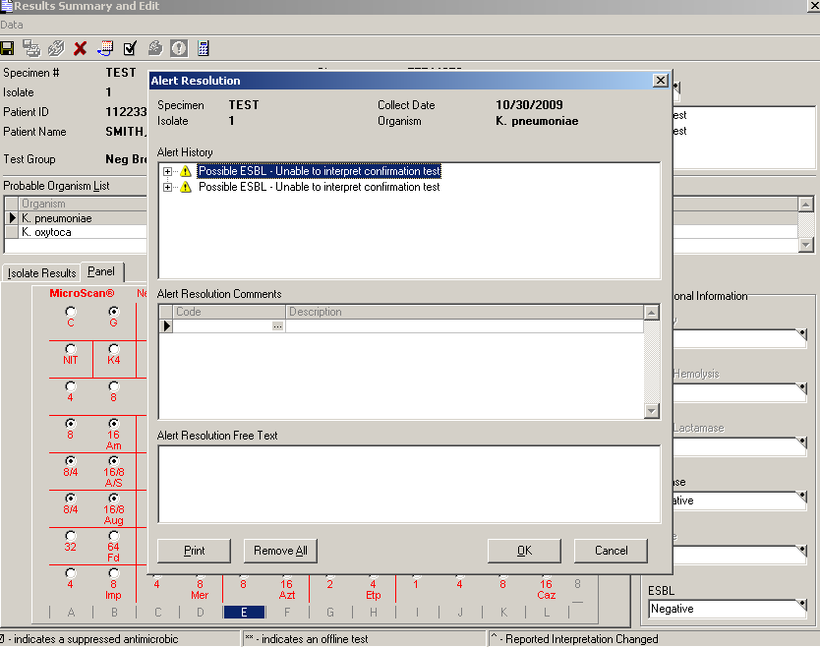

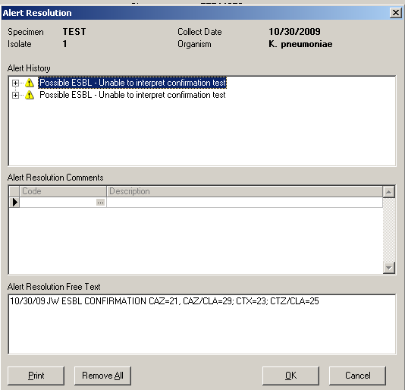
Enter Results Manually, Review and Edit Results, and Print Reports
- To manually enter reviews, or edit panel results, use the Patient Order Entry window to recall the isolate order, which was previously entered, and then select the isolate. On the toolbar, click Manual Read. In the Manual Read dialog box, the only selection available is Final Read. Select Final Read. Use the Panel tab of the Results Summary and Edit dialog box to enter or edit panel results manually. Be sure to click the Growth (G) well to show growth—a black dot indicates growth. To enter MICs, click the first well displaying inhibition of growth (= MIC). All wells with lower antimicrobic concentrations will appear with a black dot. You must process results prior to saving the new isolate data. On the toolbar, click Process, and then click Save to store panel data to the LabPro database.
- Chartable Reports contain microbiology results for all isolates associated with a single specimen, are designed for the physician’s review, and become part of the patient’s chart. Chartable Reports formats include the Long Patient Report–Standard Format (provides LabPro interpretations) and the Long Patient Report–Expert Format (provides LabPro interpretations and Alert System interpretations).
- The Comprehensive Panel Status Report (CPSR) contains panel results obtained directly from the WalkAway instrument and any panel results stored in the LabPro database.
- The Panel Alert Report communicates action that should be taken with regard to panels with alerts.
- The Organism Information Report displays additional tests, footnotes, and special characteristics for all organisms in the Probable Organism List. This information is helpful when resolving Low Probability Alerts, for example.
- The QC Panel Report records the panel lot number, QC organism strain, expected values, actual test values, reagent lot numbers, and any corrective action entered via the QC Results Summary and Edit dialog box.

Read panels using the autoSCAN-4 instrument
- If WalkAway is unavailable the panels maybe read on the autoSCAN-4.
- Before reading a panel, remove the panel from the incubator and examine the growth and control wells. The Growth well (G) should be turbid. The Control well (C) should be clear.
- Then, determine if criteria have been met to add reagents to biochemical wells. (See package insert for criteria). If criteria to add reagents have been met, manually add reagents to the appropriate biochemical wells, select the Final Read panel processing option, and read the panel using the autoSCAN-4 instrument.
- Final Read, ID Hold Read, or 24-Hour Read panel processing options indicate to LabPro if a panel will need to be read more than once. For example, if a panel’s biochemical wells have not yet met the criteria for adding reagents, select ID Hold Read and incubate the panel overnight. The next day, add reagents to appropriate biochemical wells and then read the biochemical wells using the autoSCAN-4 instrument.
- MICs are never read beyond 24 hours. If a Combo panel’s biochemical wells have not met the criteria for adding reagents, select ID Hold Read, read the MIC wells using the autoSCAN-4 instrument, and then incubate the panel overnight. The next day, add reagents to appropriate biochemical wells and then read the biochemical wells using the autoSCAN-4 instrument.
- On the Patient Order Entry window toolbar, click the autoSCAN-4 Read icon to read a panel that you have loaded into the instrument. The autoSCAN-4 Read button on the Patient Order Entry window toolbar “tells” LabPro that the panel will be read in an autoSCAN-4 instrument. The Read button on the autoSCAN-4 instrument initiates the panel read.
- If the autoSCAN-4 Calibration/QC Diagnostics dialog box appears, you must run QC diagnostics before the autoSCAN-4 instrument can read the panel. LabPro requires QC diagnostics to be run at least once during each calendar day, each time you start up the instrument, or if a communication failure or instrument malfunctions occur during operation.
Important: If a calibration is required, make sure that there is no panel in the instrument before you click Calibrate.
- Before loading the panel into the autoSCAN-4 instrument, wipe the bottom of the panel with a non-abrasive, lint-free cloth to remove condensation and fingerprints. Hold the panel with the MicroScan logo in the upper-left corner when loading the panel to properly orient the panel wells for reading.

Resolve Panel Processing and Alert System Messages
- After the panel is read, but before results are available, LabPro may display a panel processing message or dialog box that requires your intervention before processing can continue. For example, if the Manual Call dialog box appears, the instrument was not able to determine the reaction of one or more biochemical. You must remove the panel and visually inspect the biochemical wells indicated on the Manual Call dialog box.
- Alert System messages are generated if unusual test results meet conditions specified in system and user-defined alert rules. Alert System messages appear in the Alerts box on the Results Summary and Edit dialog box, so they are not displayed until after results are available but before results are stored in the LabPro database. Alert System messages usually indicate that user intervention is required, such as editing, reordering, or deleting data.
- To resolve Alert System messages, click + next to the message to review Alert System comments. Review the instrument results on the Panel tab of the Results Summary and Edit dialog box and compare them to a visual check of the panel results. Manually edit panel results as necessary. Use the Panel Edit Legend dialog box as a key to understand symbols displayed on the Panel tab.
- To document in LabPro that Alert System messages were reviewed, on the toolbar, click Alert Resolution to display the Alert Resolution dialog box, where you can document action taken.
- On the QC Results Summary and Edit dialog box, red hash marks indicate out-of-control results. To resolve QC problems, visually compare actual QC panel results to instrument results in LabPro to ensure that the instrument read the results properly. Also review your panel setup procedure as well as your ATCC organism preparation and maintenance. Use the Corrective Action box to maintain a record of corrective action taken. On the toolbar, click Save to store your documentation.

REFERENCES
LabPro Operator’s Guide
WAPLUS OP
LabPro v4 Update DocLibD

