POLICY STATEMENT | The RapID NH System is a qualitative micromethod employing conventional and chromogenic substrates for the identification of medically important species of Neisseria, Hemophilus, and other bacteria isolated from human clinical specimens. The tests used are based upon the microbial degradation of specific substrates as detected by various indicator systems. The resulting pattern of positive and negative test scores is used as the basis for the identification of the test isolate by comparison of test results to activity patterns stored in a database or through the use of a computer-generated Code Compendium.
PURPOSE | This procedure provides technical instruction for the performance of the RapID NH System test.
SCOPE | This procedure applies to testing personnel authorized to perform testing. This group includes, but is not limited to Laboratory Technologists as well as leads and supervisory personnel.
RESPONSIBILITY | All the above personnel are responsible for following the RapID NH System procedure without exception. In addition, testing personnel are also responsible for evaluating the results and taking proper remedial action.
RELATED DOCUMENTS | MICR 6470 F RapID NH QC chart

SPECIMEN HANDLING
- Test organisms must be in pure culture.
- A Gram stain must be performed on each colony that is intended to be used as inoculum.
- Test organisms may be removed from selective (Martin-Lewis Agar) or non-selective (Chocolate Agar, Tryptic Soy Agar with 5% Sheep Blood) media.

  - Test organisms should be 18-24 hours old, preferably. Slow-growing isolates may be tested using 48-hour plates.

REAGENTS
  - RapID NF Plus kit: Store at 2° to 8°C until the expiration date on the kit. Do not mix lot components.
  - Reagent bottles: Store at 2° to 8°C until the expiration date.
- RapID Spot Indole
- RapID Nitrate A Reagent
- RapID Nitrate B Reagent
  - RapID Inoculation Fluid (1ml): Store at 20° to 25°C until the expiration date.

QUALITY CONTROL
RapID NH panel and reagent quality control should be performed on each new kit lot number using the following control organisms:
- Hemophilus influenzae Biotype I (ATCC 9006)
- Moraxella catarrhalis (ATCC 8176)
Refer to QC chart for reactions. Prior to use, quality control strains should be subbed culture 2 to 3 times from storage to nonselective media.

PROCEDURE
- Remove the RapID NH panel from storage. Do not use if the plastic is cracked or broken or if the lid is compromised.
- Reseal the polybag package after removing the required panels.
- The panels must be used the day they are removed from storage.
- Inoculum Preparation
  - Using a cotton swab or an inoculating loop, suspend sufficient growth from the agar plate culture in RapID Inoculation Fluid (1 ml) to achieve a suspension of test organism that is equivalent to a #3 McFarland turbidity standard.
  - Suspensions should be mixed thoroughly and vortexed if required.
  - Suspensions should be used within 15 minutes of preparation.
  - Suspensions that are significantly less turbid than a #3 McFarland turbidity standard will compromise test results.
- Panel Inoculation
- Peel back the label over the panel inoculation port by pulling the tab marked "Peel to Inoculate" up and to the left.
- Using a sterile pipette, transfer the entire inoculum (1 ml) into the upper right-hand corner of the panel. Reseal the inoculation port.
- Keeping the panel on a level surface, tilt back to approximately a 45 degree angle and rock from side to side to evenly distribute the inoculum along the rear baffles.
- Maintaining a level horizontal position, SLOWLY tilt the panel forward toward the reaction cavities until the inoculum flows along the baffles into the reaction cavities. This should evacuate all of the inoculum from the rear portion of the panel. Test cavities should appear evenly filled and bubble free.
- Examine the test panel after inoculation to ensure that all cavities appear bubble free and uniformly filled. Slight irregularities in cavity fill are acceptable. Discard any panels that contain GROSSLY misfilled cavities and repeat the inoculation procedure.
- Do not let the inoculum rest in the back portion of the panel for an extended period of time without completing the procedure.
- Incubate the inoculated panels at 35°C in an aerobic (non-CO₂) incubator for 4 hours
- Scoring the panels
- Remove panels from the incubator
- Without the addition of reagents, read and score the test cavities 1 to 10 from left to right using the interpretation guide.
- While firmly holding the panel on the bench top, peel off the label over the reaction cavities by pulling the lower right hand tab up and to the left.
- Add 2 drops of RapID Spot Indole Reagent to cavity 9
- Add 2 drops of RapID Nitrate A and Nitrate B Reagents to cavity 10
- Allow at least 1 minute but no more than 5 minutes for color development.
- Read and score the test cavities from left to right using the interpretation guide.
- Record the scores in the appropriate boxes on the report
- Reference the microcode obtained on the report form in ERIC (Electronic RapID Compendium for identification.

REPORTING
Enter the results including the microcode in the workcard and charged for the NH ID by entering S (setup) in the RAPID ID.
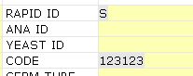

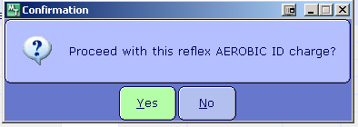

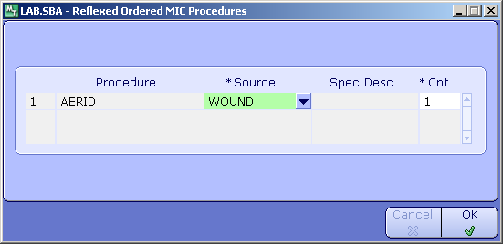

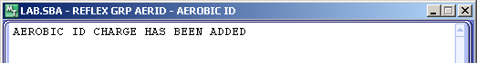

REFERENCES
Remel RapID NH System package insert, January 17, 2012

