POLICY STATEMENT | To insure the accuracy of patient results reported by Microbiology, all results are reviewed daily for accuracy. Any clerical, analytical or procedure errors detected are corrected.
PURPOSE | To Insure that all patient results are correct, accurate and adhere to departmental policies.
SCOPE | This policy applies to all associates that work in the Microbiology Laboratory.
RESPONSIBILITY | Microbiology associates are responsible for insuring the accuracy of all patient results reported by the department.
RELATED DOCUMENTS | MICR 6015 R Corrected Reports

Microbiology and Immunology tests utilizing worksheets:
- Record patient results on the worksheet
- Enter patient results in Meditech
- Reprint the worksheet with the results
- Review the results against the original worksheet
- Correct any errors detected and document
- The worksheets are signed, dated, stapled together and filed in the appropriate notebook

Microbiology Daily Report Review:
Microbiology reports are reviewed daily. Any clerical, analytical or procedure errors detected are corrected.
MIC Management Reports:
- Result Activity Report
- Outstanding Procedure Report
- Outstanding Specimen Report
LAB Management Reports:
- Outstanding Test Report
Select Laboratory > St. Agnes Hospital > ML
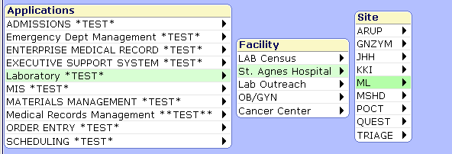

Select Management Reports
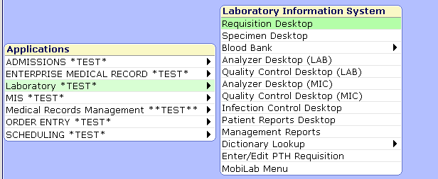

Select MIC Management
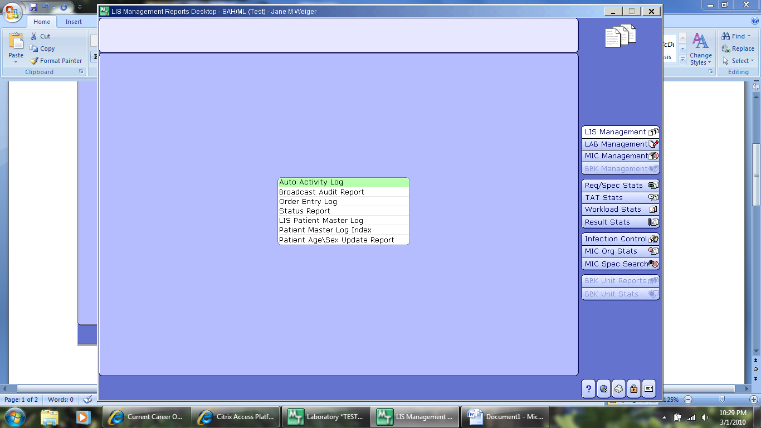

Select Result Activity Report
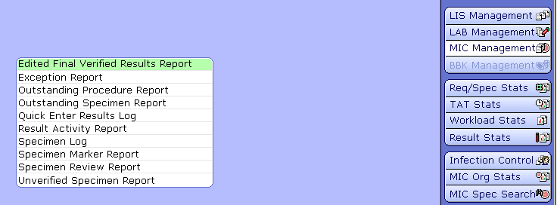

Enter Date Range – from the time yesterdays report was printed until now
Prefix – M for microbiology cultures; AM for anaerobe cultures and BL for Blood culture
Specimen Criteria – Specimens W/ Organisms Only = N (M and AM); Y (BL)
Include unverified results = Y
Complete Specimens only = N
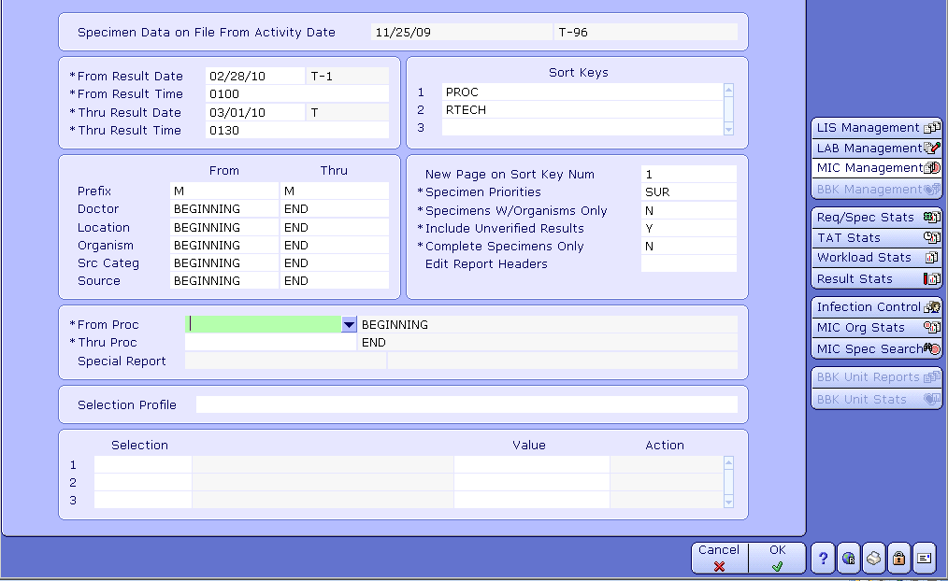
Check for cultures the have not been completed and perform appropriate follow up.
Select Outstanding Procedure Report

Enter Department > Overdue Y > Received
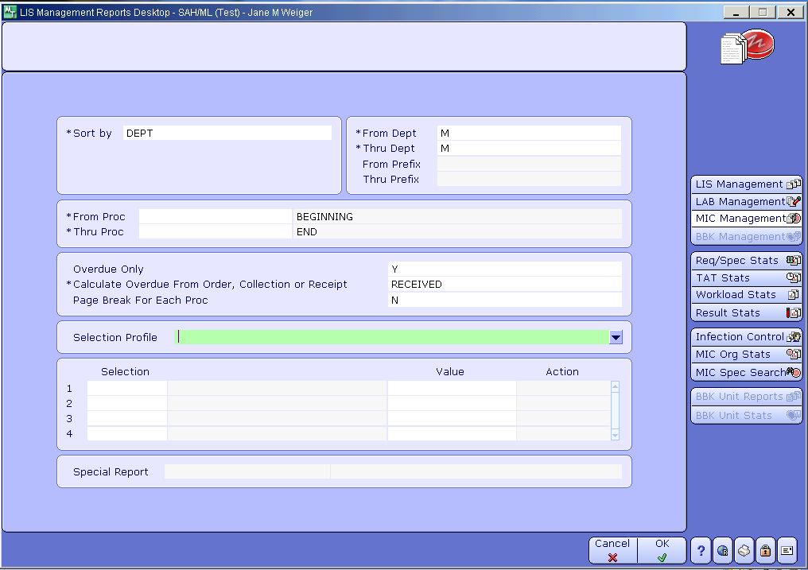

Select Outstanding Specimen Report

Enter Date Range/Time > Add Selection Criteria > OVERDUE = N
- For Urines that are received but not processed:
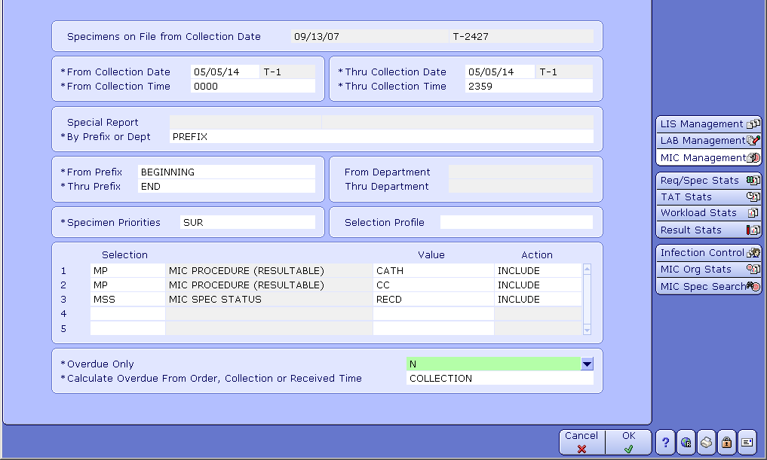

- For Micro ADDONs that have not been received.
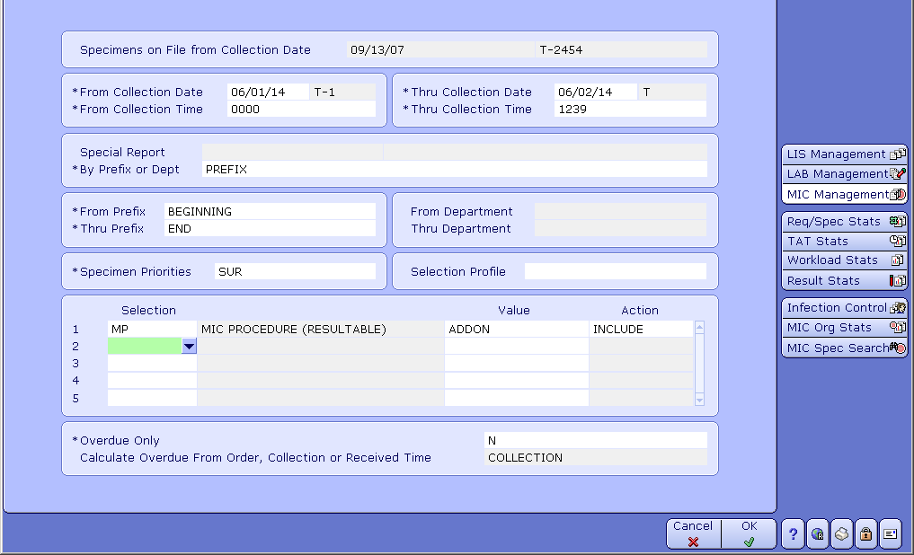
Located the specimen and process the specimen. If the specimen cannot be found or is inappropriate for the request, cancel and complete and ORF.

Check for tests the have not been completed and perform appropriate follow up.

Select LAB Management

Select Outstanding Test Report
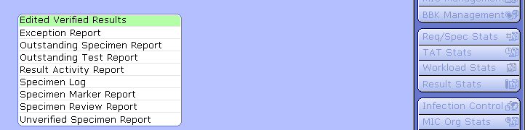

For Micro - Enter Prefix M > Overdue Y > Received
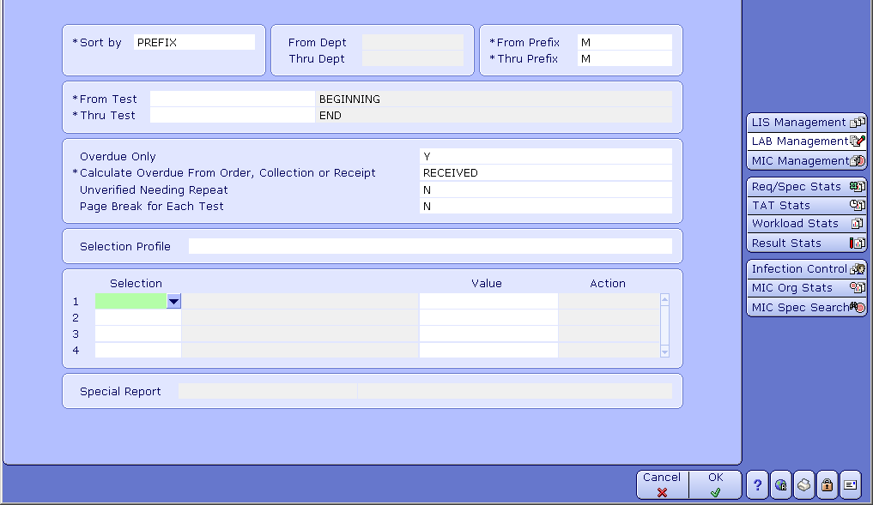

For Immunology - Enter Prefix I > Overdue Y > Received
