Policy Statement | Core Laboratory Personnel are responsible for insuring the specimen submitted for testing is acceptable and the procedure for performing this test is not violated.
Purpose | This procedure provides technical instruction for acceptable performance of the “Sickle Cell Screen” assay.
Scope | This procedure applies to testing personnel authorized to perform testing using the Streck Sickledex test system.
Responsibility | All authorized personnel are responsible for following procedural guidelines and insuring good laboratory practice is followed.
Related Documents | Streck Sickledex package insert  Streck Sickle-Chex control package insert

SICKLE CELL SCREEN

PRINCIPLE

Sickle cell disease is an inherited disease characterized by the presence of an abnormal hemoglobin (HbS). In normal adults, at least 95% of the hemoglobin is hemoglobin A (HbA). Hemoglobin S can be inherited in the homozygous state (SS), which results in sickle cell anemia, a severe, disabling disease. If inherited in the heterozygous state (AS), it is benign and asymptomatic. This heterozygous state is called sickle cell trait. Hemoglobin S can also occur in the presence of other abnormal hemoglobins including HbC (SC), Thalassemia (S-Thal) and HbO (SO). These are called sickle cell variants and can produce symptoms of varying severity.

In 1927, Hahn and Gillespie demonstrated that erythrocyte sickling is a reversible phenomenon which is related to Ph and reduced oxygen tension. Since that time, many tests of varied effectiveness for detection of HbS were developed, culminating in the solubility type tests introduced by Itano and electrophoretic analysis used by Pauling et al in 1949. Since then, numerous modifications of the solubility test and improved electrophoretic methods have been devised. As reported by Itano in 1953, HbS, in the reduced state, is much less soluble than normal hemoglobin (HBA) in 2.24 M phosphate buffer, forming a turbid suspension of hematic liquid tactoid crystals.

REAGENTS – Streck Sickledex

Buffer: 2.3M phosphate buffer. Store at 2-8°C.
Reagent Powder: sodium hydrosulfite and saponin. Store at 2-8°C.
Working Reagent:
- Bring buffer and reagent powder to room temperature before mixing.
- Add one vial of reagent powder to a bottle of buffer and agitate immediately until the powder has completely dissolved. Foaming can be expected.
- Reagent must be used or discarded withing 45 days of reconstitution. Record the expiration date of the reconstituted bottle.
- Keep tightly capped and store at 2-8°C when not in use.
- Bring working reagent to room temperature before using.
Reagents are stored in the Core Laboratory walk-in refrigerator.

MATERIALS

Lined tube rack
Test tubes (12 x 75 mm)
20 uL pipette and tips.

Sickle Controls

NOTE: Materials are stored in the Hematology Laboratory.

SPECIMEN COLLECTION AND PREPARATION

No specific patient preparation is required. EDTA is the anticoagulant of choice and is readily available since a CBC is usually run in conjunction with the sickle cell test procedure. A clotted specimen should not be used. If the hematocrit is less than 15%, double the amount of blood sample in the test procedure. If hematocrit is low and specimen appears to have turbid plasma, centrifuge sample and adjust hematocrit to greater than 15% to avoid false positive test results.

QUALITY CONTROL –Sickle-Trol Sickle Cell Hematoloy Controls, A/A and A/S

Negative and positive controls will be run daily if a sickle cell test is ordered. The controls will be dated, left in the sickle cell control rack and discarded at midnight of the day they were run. The control and patient results will be entered in Meditech.

PROCEDURE

- Dispense 2.0 ml of cold working SICKLEDEX solubility buffer into a 12 x 75 mm tube. Return working buffer to 2º - 10º C immediately after use. Allow working solution in tubes to warm to room temperature.
- Add 20 uL of whole blood or 10 uL of packed red cells to the 2.0 mL working reagent in the tube. When running control samples add 20 uL of control.
NOTE: if the HCT is <15%, centrifuge the sample for 5-10 minutes at 1200rpm.
Pipette 10ul of the packed cell volume from the bottom of tube and add to the
working reagent. Mix
- Incubate for at least 6 minutes at room temperature.
- Observe for turbidity by placing the test tube in the special lined rack which is supplied. Results may be observed for up to 60 minutes.

RESULTS:

Positive test -lines on card cannot be seen through the test solution.
Negative test -lines on card can be seen through the test solution.

After turbidity readings have been made, all tests with questionable results should be centrifuged at approximately 2500 rpm for 10 minutes. Do not use brake.

Results after centrifugation:

Positive test -yellow to light pink solution with red material at the air-Iiquid interface.

Negative test -dark pink to red solution with varying amounts of white to pinkish material at the air-Iiquid interface.

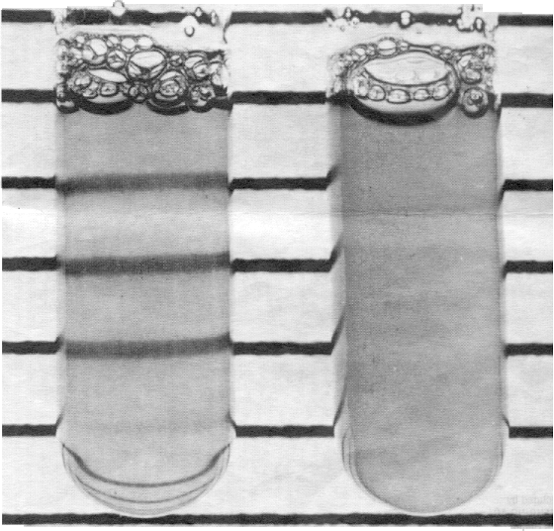

Left side negative result. Right side positive result.

REPORTING RESULTS

Results are reported as positive or negative in the Meditech computer system using standard result entry and test code SCELL. A positive result is a critical value and requires immediate notification to caregiver.

LIMITATIONS OF PROCEDURE

Solubility tests differentiate between sickling and non-sickling hemoglobin. This procedure does not quantitate the amount of sickling and/or non-sickling hemoglobin; therefore, it does not differentiate the heterozygous from the homozygous condition. Hemoglobin types must be further differentiated by electrophoresis or other methods. However, some hemoglobins having identical electrophoretic mobilities may be differentiated by solubility properties.

False negative reactions may be obtained by inadequate quantities of hemoglobin from anemic patients. Quantities of hemoglobin S may also be too small to detect in infants and possibly following transfusions.

False positive reactions may be caused by a polycythemic sample which provides too much hemoglobin to reagent ratio. Dysglobulinemias can also cause false positives.

Since sickle-cell variants give the same results as sickle cell trait, it is of particular importance that heterozygous S results be studied further to determine the possibility of SC, SD, or S- Thalassemia. Nonsickling abnormal hemoglobins are not determined by this test. One should also be aware of nonsickling hemoglobins such as C (Harlem) which, although rare, may react the same as HbS. Due to interference from fetal hemoglobin, samples from patients under six months of age should not be tested except for experimental purposes and in conjunction with other procedures. In addition, HbF is also known to hinder the sickling process of HbS. Hereditary persistency of fetal hemoglobin has been found in 0.1% of the black population and may also cause false negative results.

REFERENCES

Hahn, E.V. and Gillespie, E.V.V. : Arch, Int. Med. 39:233, 1927.

Scriver, J.B. and Waugh, T.R.: Can. Med. Assoc. J. 23:375, 1930.

Neuda, P.M. and Rosen, M.S.: J. Lab Clin. Med: 30:456-458, 1945.

Raper, A.B.: The East African Medical Journal, 31:443-4'49, 1954.
Mahmood, A.: Transaction of the Royal Society of Tropical Medicine and Hygiene, 1:736-738, 1967.

Singer, K. and Robin, S.: JAMA 136:1021-1025,1948.

Yakulis, V.J. and Heller, P.: Blood 4:66, 1964

Ratanbol, K.K. Dyar, J. Schaeffer, J. and Cole, G.W.: Am. J. Clin. Path. 52:705-707,1969.

Itano, H.A. and Pauling, L.: Blood 4:66, 1949.
.
Itano, H.A.: Arch. Biochem, 47:148-159, 1953.

Pauling, L., Itano, H.S., Singer, S.J. and Wells, I.C.: Science 110:543-548, 1949.

Goldberg, C.A.J.: Clin. Chem 4:146-149, 1958.

Loh, W.P.: J. Indiana Med. Assoc. 61:1551-1652,1968.

Loh, W.P.: Am. Clin. Path. 55:55-57, 1971.

Cook, A. and Raper, A.B.: Med. Lab. Technol. 28:373-376,1971.

Ballard, M.S. Radel, E. Sakhadeo, S., and Schoor, J.H.: J. Pediatrics 76:117-119, 1970.

Henry, R.L., Nalbandian, R.M. Nichols, B.M. Camp, F.R. Jr. Conte, N.F. and Wolf, P.L.: Clin. Biochem, 4:196-207,1971.

Huntsman, R.G., Barclay, G. P.T., Canning, D.M. and Yawson, G.I.: J. Clin Path. 23:781-783, 1970.

Miale, J.B.: Laboratory Medicine Hematology, 4th Edition, p 1, 2,3,4, C.V. Mosby, 1972.

Nalbandian, R.M.: In Molecular Aspects of Sickle Cell Hemoglobin, pp 180-181, Charles C, Thomas, Springfield, 1971.

Motulsky, A.G.: New Eng. J. Med. 288:31-33, 1973.

Warren, B. Crosby, G., Evans, G.L.: Am. J. Medical Tech. 41: 317,321,1975

Diggs, L.W., Naumann, H.N., and Diggs, 40, 1975.B.M.: Lab. Med 6:38-
Wilson, S., and Schmidt, R.:Clin Chem. 20:1138 –1140.1974.

