Policy Statement | Antigen – antibody reactions are evaluated and graded based on the degrees of agglutination and hemolysis in blood bank tube testing. Regulatory agencies require that criteria are defined for both.
Purpose | The purpose of this procedure is to pictorially represent both agglutination and hemolysis. In addition, the images will serve as a guide to testing personnel.
Scope | This policy applies to all patient testing done by tube method in the Transfusion Services section of the Laboratory. This includes: ABO Rh, RETYPE, 2TY, DAT, fetal screens, eluate, cross-matches and traditional (non-gel, non-ProVue) antibody screens and panels.
Responsibility | Medical Technologists including Lead Technologist, Med Tech IIs and Quality Coordinators in the Blood Bank.
Related Documents | - TRAN 6001 R Antibody Screen Tube Method  - TRAN 6003 R Serological Testing ABO Rh  - TRAN 6004 P Weak D Testing  - TRAN 6005 R Fetal Screen Testing  - TRAN 6013 R Crossmatch Tube Testing Method  - TRAN 6026 R Direct Antiglobulin Test (DAT)  - TRAN 6031 R Acid Elution Procedure  - TRAN 6101 R Prewarm Antibody Screen
Reference | - Marsh, W.L. Scoring of Hemagglutination Reactions  - Technical Manual

Definitions

Hemagglutination is the clumping of red blood cells in the presence of an antibody. The antibody or other molecule binds multiple particles and joins them, creating a large complex. It is similar to precipitation, but the particles are larger and are in suspension rather than being in solution. For specific agglutination reactions in the various blood groups, refer to the AABB Technical Manual.

Hemolysis is the destruction or dissolution of red blood cells, with release of hemoglobin into the plasma. Hemolysis may occur in antigen-antibody reactions or in a transfusion reaction.

Result Interpretation

Agglutination:

A higher grade of agglutination will usually mean a stronger antigen – antibody reaction and a lower grade, vice-versa. With some procedures this may be clinically significant such as with weak D testing and antibody titers. It may also be of benefit when performing antibody identification since a lower grade may be indicative of dosage.

Hemolysis

Hemolysis can occur in some antigen – antibody reactions. It can be seen in vitro as well as in vivo. In hemolytic transfusion reactions, it can be seen in vitro. This is important to note when working up any transfusion reaction. It should also be recognized that patient specimens which are hemolyzed after centrifugation may mask hemolytic reactions and must be used with caution if a new sample cannot be obtained.

Procedure

When performing any procedure using the tube method, test results show agglutination or hemolysis, record those results in accordance as instructed. These pictures represent the grading of agglutination and the amount of hemolysis. Results should be entered according to what would be seen in the test tube. All results should be documented as they are read.

- No agglutination is graded as “0” or negative reaction.

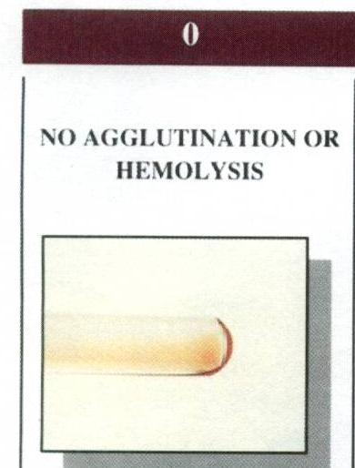

- Tiny agglutinates or small agglutinates with turbid background are graded as W+ (weak) to 1+ reaction.

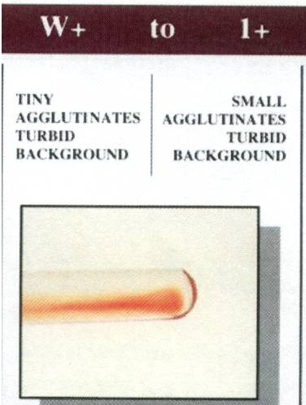

- Medium-sized agglutinates with a clear back ground is graded as a 2+ reaction.

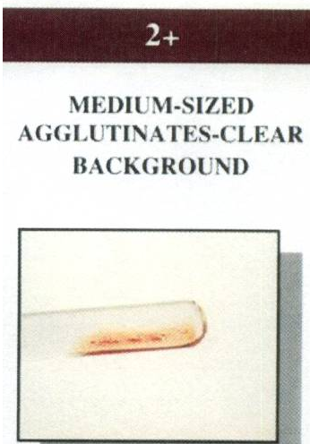

- A few agglutinates under using the microscope is microscopic positive. A negative reaction will be free of agglutination. Always be aware of interference that could look like agglutination. Most enhancements used for antibody detection and AHG phase phenotyping reagents do not recommend looking microscopically. Always consult package inserts.

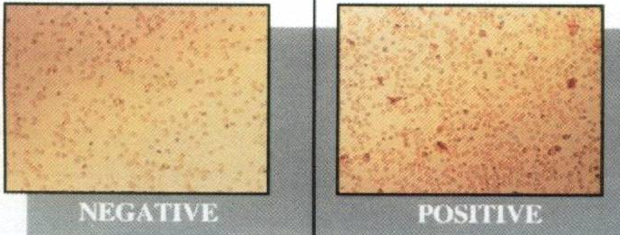

- Several large agglutinates with a clear background is graded as a 3+ reaction.



- A solid agglutinate is graded as a 4+ reaction.

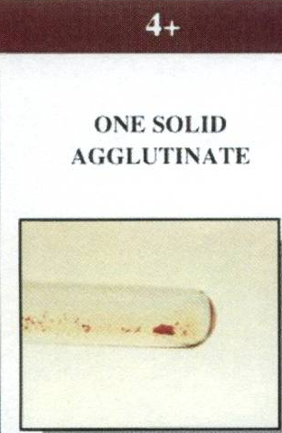
- Pseudo agglutination or Rouleaux has a “stacked coined” appearance under the microscope. Rouleaux reactions will appear the same in all tubes including an auto control.

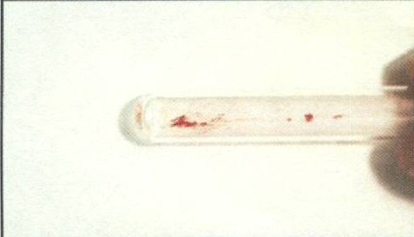

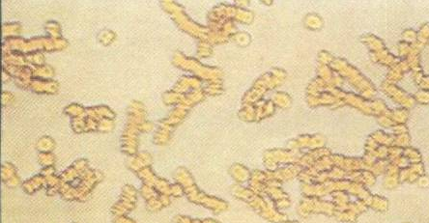

- Hemolysis could be partial or complete is considered a reaction when testing for antibody/antigen reaction of red blood cells. The background will appear as red or red tinge depending on the amount of hemolysis. This reaction should be compared to the original plasma of the patient for better detection. It can also appear with or without agglutination of the red blood cells.

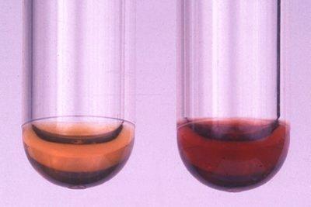

Note: These reactions are also found on the charts at the work stations

