ABL835 Calibration Procedure

1. Principle:

The calibration process determines and checks the accuracy with which the
analyzer measures its parameters. The process is therefore important in ensuring
the reliability of results.

Calibrations are performed using solutions and gases of known concentration, for
each of the measured parameters.

Calibration | Descriptions
1 point | Measures each parameter on one solution and/or gas of known  composition, giving one value per parameter.  Relates the measured values to the theoretical values of a  solution and/or gas of the same composition.  Gives the Drift 1 and status values of the electrode
2 point | Measures each parameter on two different solutions and/or  gases both of known composition, giving two values per  parameter.  Relates the measured values to the theoretical values of  solutions and/or gases of the same composition.  Gives the Drift 1, Drift 2 values and the status or zero point,  sensitivity of the electrodes (two sensitivity values are given  for the Crea B electrode and one for the Crea A electrode of  the ABL8x7 FLEX analyzers).
1 point pH/BG | Measures pCO2 and pO2 on one gas mixture of known  composition and pH on a known solution, giving one value per  parameter  Relates the measured values to the theoretical values of a  mixture/solution of the same composition.  Gives the Drift 1 of the electrodes.
tHb | Calibrates the spectrophotometer

2. Procedure:

The ABL 835 Automatically performs the following calibrations on the following schedule:

1 Point – every 4 hours

2 Point – every 8 hours

1 Point pH/BG cal – every 30 minutes

tHb calibration is performed manually by the operator and is detailed later in this procedure.

All calibration results are automatically recorded in the Calibration Log from
which they can be viewed and printed.

The calibration process and a detailed explanation of the terms are described in the
Reference Manual.

NOTICE: Additional 1-point calibrations are performed on the analyzers with the metabolite electrodes:

• after 11 measurements made one after another, no more than 10 minutes apart
And

• 30 minutes after the last measurement was made.
The additional 1-point calibration does not change the intervals selected for the
scheduled calibrations.

In cases when a scheduled 2-point calibration is imminent, the additional 1-point
calibration will be substituted with the 2-point calibration.

NOTICE: (for the USA only) If an unacceptable pH drift is detected during a 1 point pH/BG
calibration, the ongoing calibration is aborted and a normal 1-point calibration is
performed.

Recalibration:

Recalibration may be necessary in the following circumstances:

- Failed scheduled calibration
- Failed calibration verification/linearity
- Unusual shifts or trends in the QC or Failed QC
- After remembraning and/or replacing electrodes
- After major maintenance or service is performed on the instrument

Manual Calibration:

In the event it is necessary to call a manual calibration of the ABL 835 follow these steps:

The analyzer must be in the Ready mode.
To access Calibration Programs, press the following touch keys:

Menu > Start Programs > Calibration Programs

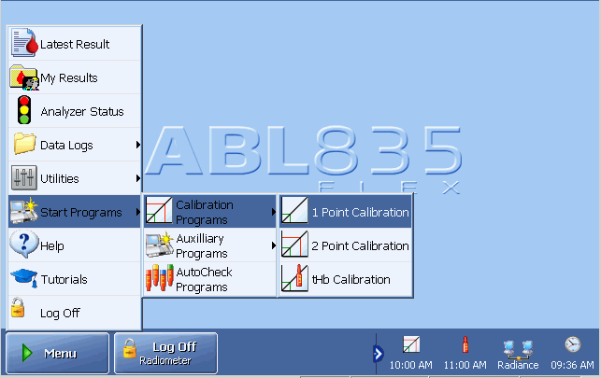

Select desired calibration.

or Select Analyzer Status > Calibrations

- Highlight desired calibration from the list on the right side of screen
- Select desired calibration on the bottom of the screen

3. Calibration results

The following glossary list contains terms specific to the calibration process.

Term | Explanation
Status | Is a measure of zero point of a complete electrode chain.
Sensitivity | Expresses an electrode signal compared with the concentration of calibration material in the calibration solution.
Drift | Is a measure of electrode stability, i.e. the difference measured during two consecutive calibrations.
Zero point | Zero current of the pO₂, Glucose and Lactate electrodes.
Zero point status | Reflects a check of the photodiode current measured on water in the spectrophotometer.
The result is displayed as soon as the calibration is completed. Results from the most recent calibrations can be viewed via the Analyzer Status > Calibration screen or via the Calibration Log.

To recall the result, highlight the desired calibration and press the Result touch key to display the Calibration Result screen.

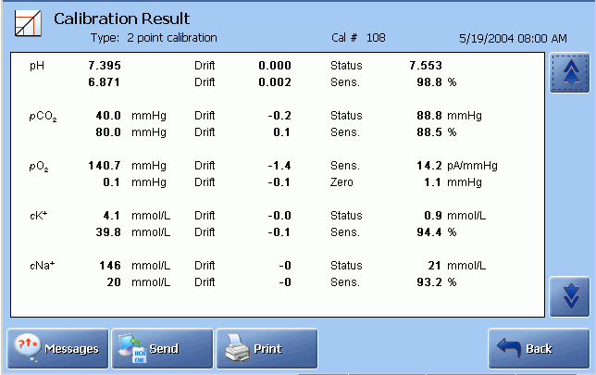

Press touch key:
 | to display the remainder of the calibration result.
Messages | to display interpretation of any detected errors. If none are registered, the touch key is not visible.
Print | to print out the result.
(Send) | to send the result to a connected LIS/HIS system.

The calibration data is grouped together by parameter:

Bold characters | Indicate data updated during this calibration.
Grey characters | Indicate data taken from the previous calibration and not included in this calibration.
"?" | Indicates an error or that the value is outside the recommended range, such as:
 | Drift value = | outside the drift tolerances - see Calibration Setup in chapter 3.
 | Status = | outside the default limits set by Radiometer.
 | Sensitivity = | outside the default limits set by Radiometer.
"….." | Indicates that the value could not be calculated, most likely due to a system error or malfunction. These values for the most part will be accompanied by a “?”. Press the Messages touch key for an explanation of the error.

Calibration Result Messages
Press the Messages touch key on the Calibration Result screen to display the screen below.

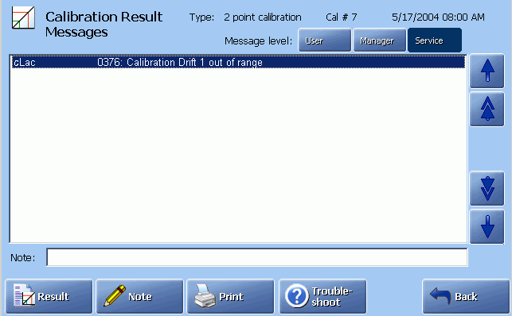
Failing parameter(s), the message number and its interpretation

The following touch keys are available:

Result | To return to the Calibration Result screen.
Troubleshoot | To display the interpretation and operator actions.
Note | A Note can be selected from a list of Notes (made in the User-defined Notes program), typed by pressing the keyboard icon, edited by pressing the Edit Note touch key, or deleted by pressing the Delete Note touch key.
Print | To print out the messages.
Back | To return to the previous screen.

4. tHb Calibration

- Purpose

The tHb calibration is used to calibrate the analyzer’s spectrophotometer and is
performed once every three months on S7770 tHb Calibrating Solution.

- Preparation

• It is recommended to perform the Protein Removal Program before a tHb
calibration in order to remove protein deposits – see Decontamination and
Protein Removal program, chapter 7.

• Check that the analyzer is in the Ready mode.

• Prepare an ampoule of S7770 Calibrating Solution, an H700 Ampoule adapter
and an ampoule opener.

- Performing a tHb calibration

Step Action

- Perform Cal 1 or Cal 2, if not done after the Protein Removal.

2. Press the Menu - Start Programs - Calibration Programs – tHb Calibration.
Enter the barcode from the tHb Calibration Solution insert, using the
barcode reader or the keyboard.

To cancel the program, press Close.

3. When the barcode has been accepted, a screen with requirements
appears. Requirements 1-3 should be fulfilled before you press Start.

4. Tap the top of the tHb Calibration Solution ampoule to collect the
liquid at the bottom and break off the ampoule neck, using the
ampoule opener.

5. Put the ampoule in the H700 Ampoule adapter.

6. Open the syringe inlet flap and place the adapter tip into the inlet.

7. Press Start to aspirate the calibrating solution.

8. When prompted by the analyzer, remove the adapter and close the
syringe inlet flap. Do not discard the S7770 ampoule, as it will be
used for the tHb Calibration verification.

After the measurement a rinse is performed and then the analyzer
returns to the Ready mode.

9. If the calibration results are accepted, perform the tHb calibration
check immediately – see below.

Otherwise remedy the error and perform a new tHb calibration.

- tHb calibration check

To verify the validity of the tHb calibration, perform the following.

Step Action

1. Open the syringe inlet flap and place the adapter with the S7770
solution in the inlet.

2. Select the mode: ABG/Oxi Syringe – S195 μL

3. Press the Start button. Remove the ampoule when prompted and close
the inlet.

4a. If the calibration check value* is within the limits printed in the package insert, the tHb
calibration is accepted.

4b. If the calibration check value* is outside the insert limits, repeat the
tHb calibration and then the calibration check immediately after it.
If the second tHb calibration and the calibration check fail again,
contact a service technician.

NOTICE: If the tHb calibration check has not been performed immediately after the tHb
calibration, repeat the calibration and the calibration check immediately after it.

5. Calibration Verification/Linearity

Calibration Verification/Linearity is performed every 6 months.

6. Troubleshooting

Refer to on-line help guide for troubleshooting repeated failed calibrations. This can be accessed by selecting the Troubleshooting button on the bottom of the screen when in Analyzer Status > Calibrations.

If unable to resolve issue utilizing the on-line help guide call the technical hotline.

7. References:

Operator's Manual for ABL800 FLEX. Publication: 201510, Ed. F. Code No. 994-909.

