 | WORK INSTRUCTION
 | J-W-TS-0216-00
antibody check® software
St. Joseph Medical Center Tacoma, WA St. Clare Hospital Lakewood, WA St. Elizabeth Hospital Enumclaw, WA
St. Francis Hospital Federal Way, WA St. Anthony Hospital Gig Harbor, WA PSC

PURPOSE

To provide instructions for the use of “Antibody Check®” computer software as a tool to aid in rule-outs and identification of antibodies.

BACKGROUND

Antibody Check® is a computer software program that assists technologists in excluding antibodies, interpreting data, and choosing selected cells for further testing.

It is important to note that this software is to be used as a tool to confirm the antibody identified and not as the sole means of antibody identification. Antibodies are ruled out for homozygous positive antigens only. A homozygous rule out will change the column from a gray background to a white background.

RELATED DOCUMENTS

J-PR-TS-0200 Antibody Identification Process Flow Sheet,
J-W-TS-0210 Antibody Panel Selection and Interpretation,
Antibody Check® User Manual

BASIC FUNCTIONS

The basic functions of the software are:
- Opening a Panel
- Using Menu Options
- Entering Results
- Searching for Selected Cells
- Displaying Selected Cells
- Printing Antibody Panels

Opening a Panel

- To open the panel needed. Open the window that lists the files on the computer drive and navigate to the Antibody Check® Clinical Use folder.

- Select the proper manufacturer folder Ortho® or Immucor®.

- Select the appropriate panel by double clicking. Panels are identified by their expiration date, in the YYYYMMDD.html format.

- The following message appears at the top of the screen “To help protect your security, Internet Explorer has restricted this webpage from running scripts or ActiveX controls that could access your computer. Click here for options”

- Click the bar and select “Allow Blocked Content”, click yes to verify you are sure you want to run active content and the panel will appear on the screen. It should look similar to this example:

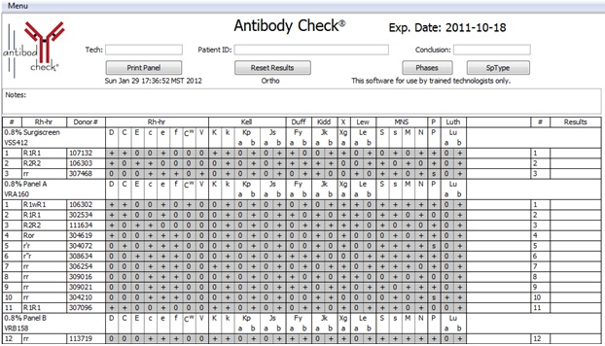

Menu Options

At the top left of the panel there is a “Menu” button. The “Menu” lists the following options:

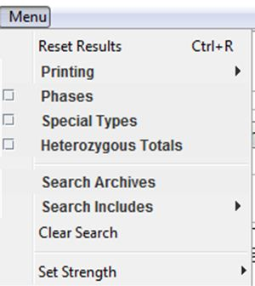

The buttons found on the panel or the “Menu” can be used to reset results, open/close phases, hide or display special types and heterozygous totals, print panels, search or clear searches, and set strength of reactions.

Button Functions

1. Reset Results:

The “Reset Results” button or menu option clears all of the results from the panel returning it to its original configuration. There are three ways to reset results:
- Clicking “Reset Results” at the top of the panel.
- Using the “Menu” button and selecting “Reset Results.”
- Entering “Ctrl-R” on the keyboard.

2. Printing

The “Printing” menu options allow you to view a print preview, insert or clear a Page Break, and change the printing format. See the “Printing Antibody Panel” section for more details.

3. Phases

The “Phases” menu option displays or hides the phases result columns if they are needed. The “Phases” button at the top of the panel can also display or hide these columns. When displayed, these columns are labeled “IS” for Immediate Spin, “37” for 37 degree, “AHG” for Anti-human Globulin, and “CC” for Check Cells. When IS and 37 are blank, and AHG is resulted, the software will rule out antibodies. Hiding the Phases column will not delete previously entered results.

There are also two columns on the right side of the “Phases” area and used for free text information and can be labeled as desired. Theses columns do not rule out antibodies.

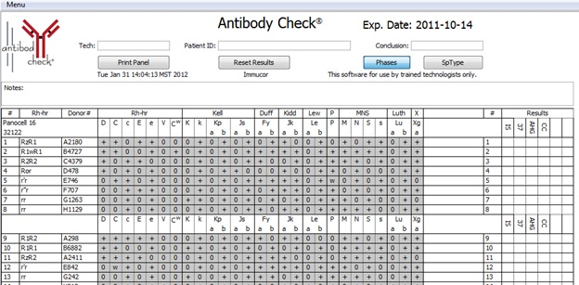

4. Sp Types

The “Sp Type” option displays or hides the special types of the panel or selected cells. The “Sp Type” button also accomplishes this task. Ortho panels also display Extended Antigen Panel data in this column.

5. Heterozygous Totals

The software rules out with homozygous positive antigens only. The “Heterozygous Totals” displays the number of heterozygous rule outs. There is also a “HETEROZ” button that displays and hides the number of rule outs. Cells counted in the homozygous rule out Totals are not counted again in the heterozygous rule out totals.

ENTERING RESULTS

After launching Antibody Check®, Donor numbers are on the left side of the panel with a clear background, and the antigen profile begins with a gray background. As test results are entered, antigen columns change from gray to clear indicating that antibodies are ruled out.

To enter results of a test, the user can click with the mouse in the result box or enter results with the keyboard.

Using the Computer Mouse

If a test is positive, click once in the “Results” column, and a “+” sign is entered. Positive results do not eliminate possibilities. If a test is negative, click twice in the “Results” column and a “0” is entered and the columns with the antibodies that have been ruled out will change from gray to white. A third click of the mouse returns the result box blank. Strength graded results can be entered by right clicking in the result box and selecting the appropriate result option. The user may choose blank, 0, 1+, 2+, 3+, or 4+.

Using the Keyboard

To enter results with keyboard, Use the “space” for blank, “0”, “+”, and numbers 1, 2, 3, or 4 for graded results. When using 1,2,3,4 the “+” will be added automatically.

Totals Row

A “Totals” Row, near the center and at the bottom of the panel, keeps track of the number of times an antibody has been ruled out. As more results are entered, positive results keep the panel as it was, and negative result rule out antibodies. The numbers are color coded to call attention to those antibodies that need additional testing. One rule out is red. 2 rule outs are yellow. 3 or more rule outs are green. See below for example.

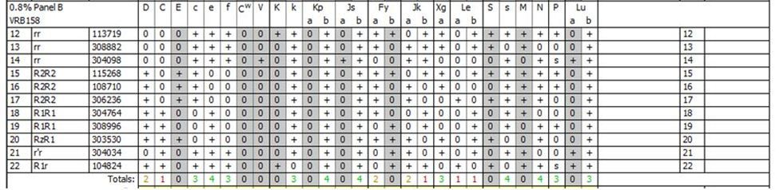

SEARCHING FOR SELECTED CELLS

Antibody Check® searches panels from all manufacturers in the archive for desired cells and chooses them from the most recent to the oldest.

The “Search for Selected Cells” area is at the bottom of the panel. It allows two searches concurrently based on the desired positive or negative antigens. The tech should enter the desired positive or negative antigens as needed. The more entries will narrow the search.

Basic Search

To search for selected cells, the tech should scroll to the search area at the bottom of the panel. There are two lines labeled “Desired Antigen,” the desired search criteria should be entered on these lines. Then click “Search” on the right.

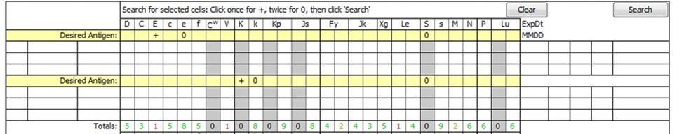

Antibody Check® will list the most recent three donor matches first. Any cell listed in the current panel results or the Display area will not be listed again. If no cells match the specified combination of antigens, the form shows “No Match” and remains blank. Cells that are selected can be transferred to the Display area. When transferred a new search is triggered and the area updates with the new search results. Results on all the search cells that have been entered will be deleted. All search results and data can be removed by clicking the “Clear” button.

Advanced Searches

Searches can be performed to include or exclude certain manufacturers. This can be done by selecting the Menu button and clicking “Search Includes” and verify the desired manufacturer has a check mark. The presence of a check mark indicates that the manufacturer is included in the search. Removing the check mark by clicking the manufacturer excludes it from the search.

Displaying Selected Cells

Cells that are retrieved through the “Search” function of the program can be moved or transferred to the Display Selected Cell area. This area is located above the Search area. The Display area begins as a single line, and a new line is added each time a donor is added to the area. This area can how as many cells form the archives as needed.
To transfer cells from the Search area, right click on the donor number of the cell, and then left click on the work “Transfer”. The cell, with its data, moves to the display area. Cells may also be transferred by using the Click and Drag function. Left click and hold down button on the donor number, then drag it to the display area. Results can be entered for the cells in the Display area and Search area and are counted in the Totals rule out information area. Results that have been entered in the search area will not transfer into the Display area.

This area may also be used for reviewing completed antibody identifications. The reviewer types in donor numbers and the antigen information is displayed.

PRINTING ANTIBODY PANELS

An antibody panel can be printed at anytime by three different methods. The tech can use the “Print Panel” button at the top of the panel to print copies of the antibody panel. There is a few seconds delay. The computer then asks for the user to allow access.

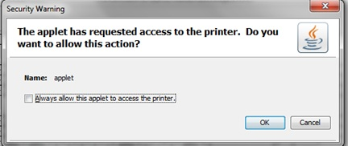

This security feature will appear each time a panel is printed. The user must check the box to “always allow” and click OK. The panel should begin printing. The user can also use “Ctrl+P” to print the panel and follow the same steps. The other method of printing involves using the Menu button option, “Printing”.

When using the Menu button, the Printing option allows the user to print a panel, show a print preview, insert or clear a page break, and to change the page format form landscape to portrait view. “Print Panel” when selected prints the current configuration of the panel following the steps as previously discussed. “Print Preview” displays how the panel will print. “Insert Page Break” allows additional page breaks to the panel. These breaks can be used for clarity as needed and can be removed by clicking “Clear Page Breaks”. The user can change from landscape to portrait for printing purposes by clicking the “Change Page Format”.

OPTIONAL FEATURES

Selected Cell Panel

There may be times when a full antibody panel will be deemed unnecessary. The tech can search for selected cells without beginning with an antibody panel. This can be found in the same Windows folder as the other panels and is entitled SelectedCells.html. This panel can be used with any of the manufacturers. Searches can be performed the same as though it were a full panel. However, three simultaneous searches can be performed that than two.

REFERENCES

Antibody Check® User Manual

Please Complete Review by date: 11/12/12
Reviewer | Approval Required? | Date Reviewed | OK? | Not? | Suggestions
Nuria Adem
Phil DeVault
Roberta Dutcher
Teri Emerson
Linda Guay
Carla Herl
Sally Kramer
Karen Lea
Cecil Dunn
Claudia Willis
Barb Wray
Katie Wilkinson
Linda Burkhardt
Once this document has been approved by the committee, this box should be deleted before saving the final copy. Then reposition the “Document Approval” box to the bottom of the last page and forward the final copy to the Medical Director for approval.

DOCUMENT APPROVAL Purpose of Document / Reason for Change:
11/12/12 To create a document describing how to use the Antibody Check software for rule-outs and antibody identification.

No significant change to process in above revision. Per CAP, this revision does not require further Medical Director approval.
Committee  Approval  Date | Date:  N/A – revision of department-specific document which is used at only one facility | Medical Director Approval  (Electronic Signature)

