**Locating Consent for Services Forms in the Media Tab**

1. Open Chart Review and select the **Media Tab**. User views may vary but everyone who uses EPIC has access to Media.
2. Click the **Load All Records Now** option so that you can view all scanned documents.
3. Click the **Document Type** column and the scans will be sorted alphabetically. You can scroll down until you can view the **Consent for Services** forms.

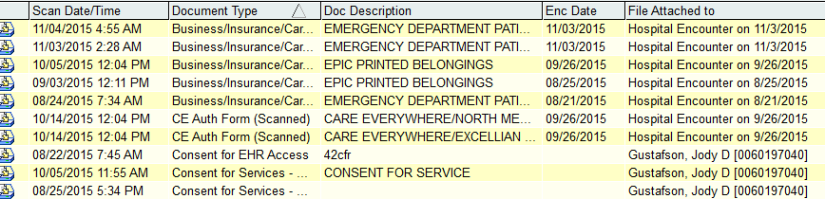

1. Locate the one that covers the date of service of the result you want to release by double clicking the scan so that you can view when it was signed. The Consent for Services documents are valid for 1 year going forward from the date signed. It’s not unusual to find that several consents that have been signed within the same time frame.

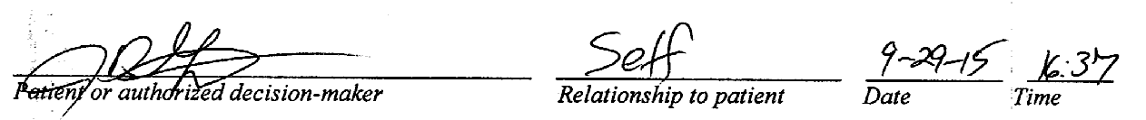

1. Make sure that the patient has not opted out of using this release option. This is the version that you will see for Consent for Services forms signed prior to 1/20/16.

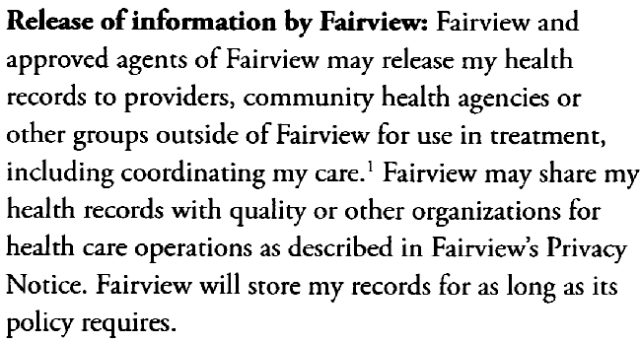

1. This is the new combined form that includes the Consent for Services and the Privacy Notification. You will see this version beginning 1/20/16.

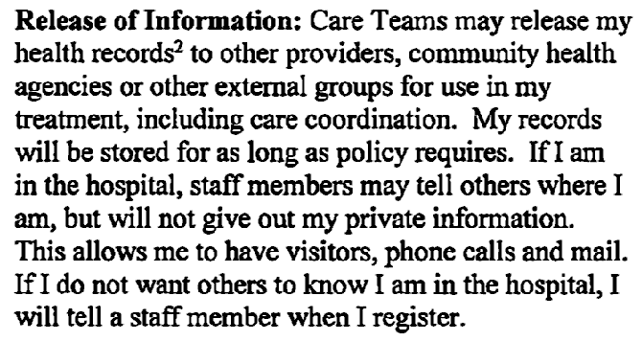

1. If the patient has made changes to the portion of the Consent for Services form or has crossed out this section, you will need a signed authorization from the patient or patient representative.