**Instructions for Accessing MSDS’ On-line**

1. Go to: winnet or Type in winnet into any browser; Google, Bin, MSN, Yahoo, etc.
2. Click on: Login to WinNet/WinNet (see arrow

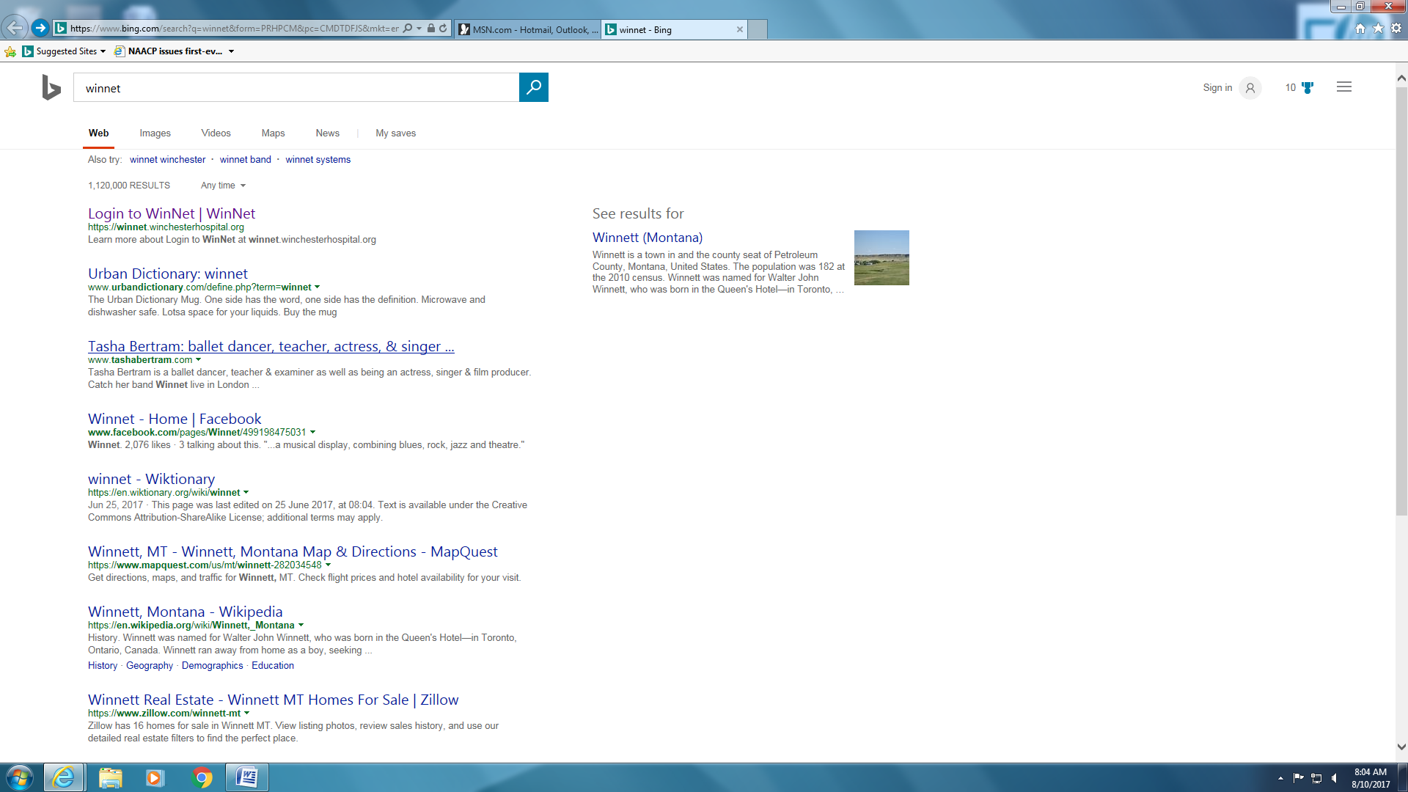

1. On the WinNet home page , on the green bar, in the search box type: MSDS (a)

**a**

or

Click: search for policies, forms, ***MSDS***, employees etc. (b); see arrows



**b**

1. In the dark blue box to the left, where it says “narrow your search”: Click on MSDS (a) or“Type” MSDS in the Search box on the right

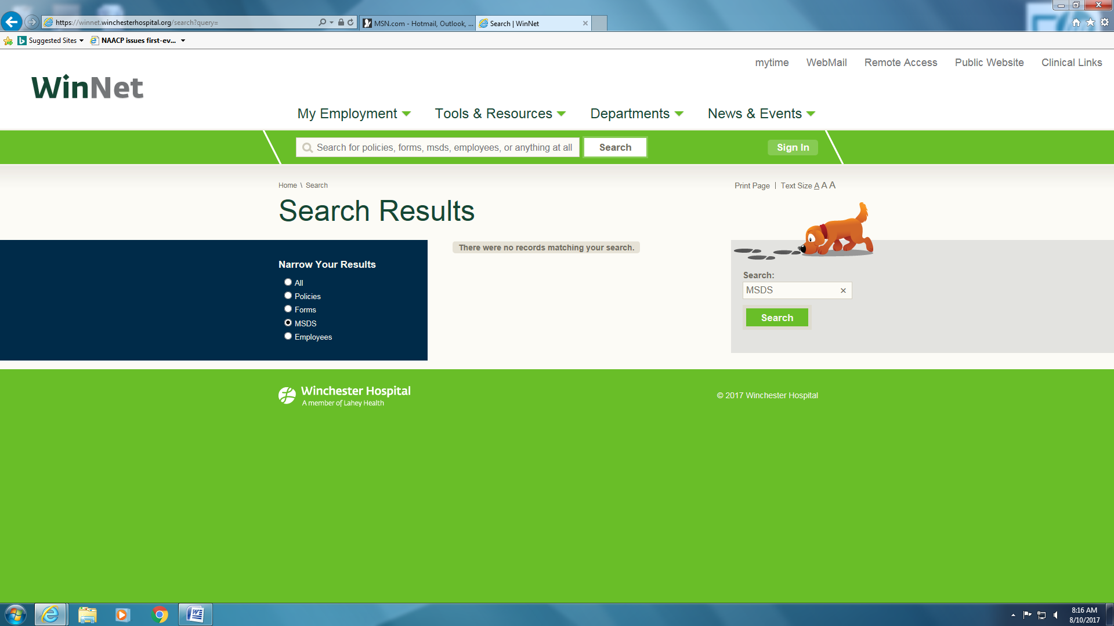

1. Use the Department Index, arranged alphabetically by manufacturer, you can now search all MSDS’ by Product code (a) 1st column (Yellow) or type in a descriptor ,such as creatinine (b)

|  |  |  |  |
| --- | --- | --- | --- |
| 89525 | ARC TSH CALIBRATOR 6C52-01 | ABBOTT | 89525A ARC TSH CALIBRATOR 06C5201.pdf |
| 89526 | ARC TSH CONTROL 06C52-10 | ABBOTT | 89526A ARC TSH CONTROL 06C52-10.pdf |
| 89528 | ARC TSH REAGENT 06C5222 | ABBOTT | 89528A ARC TSH REAGENT 06C52-22.pdf |
|  |  |  |  |

Example: “Type in the product code” (24981) in the search box, to the right, then click: “Search”



a



b

1. “Reagent Creatinine” will appear in the center under Results (see example below)

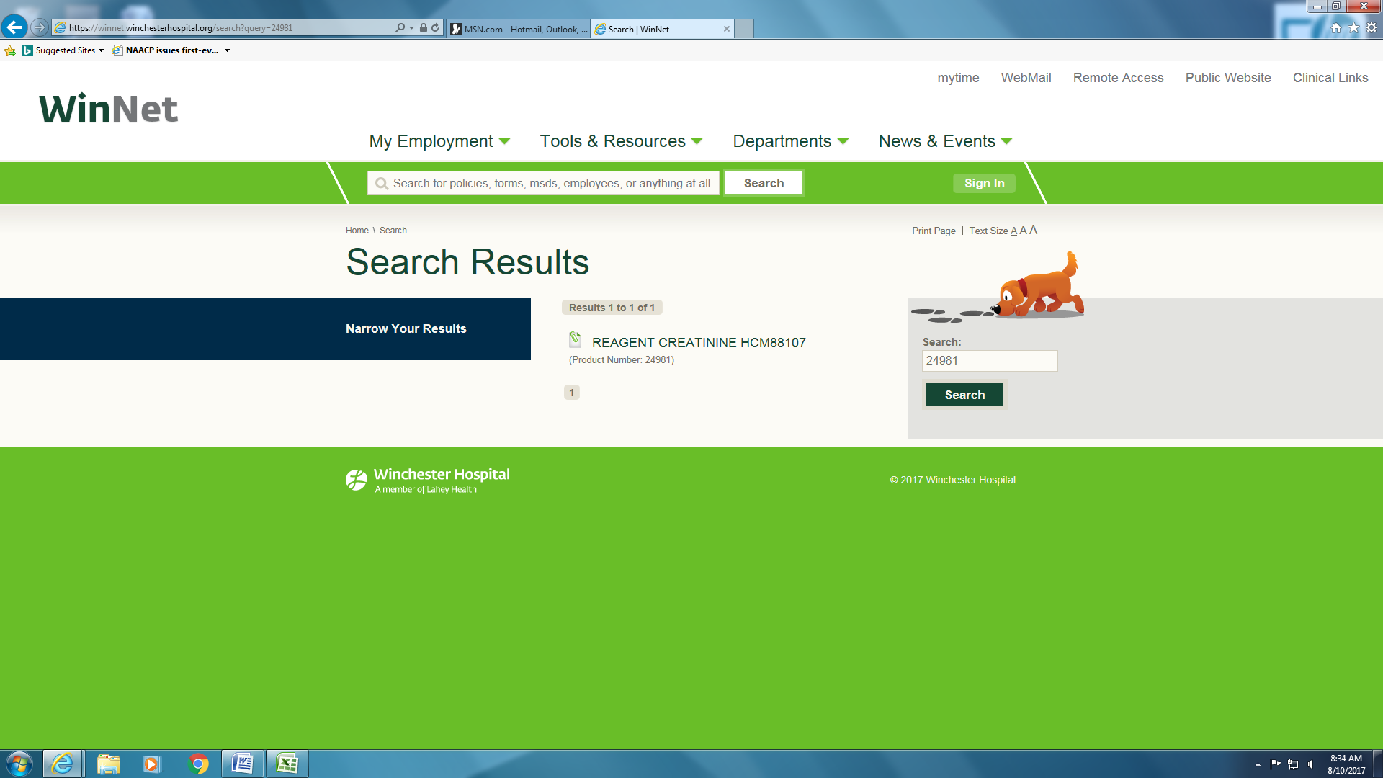

1. “Click” on the name of the chemical or reagent and the MSDS date sheet will appear (see Below)

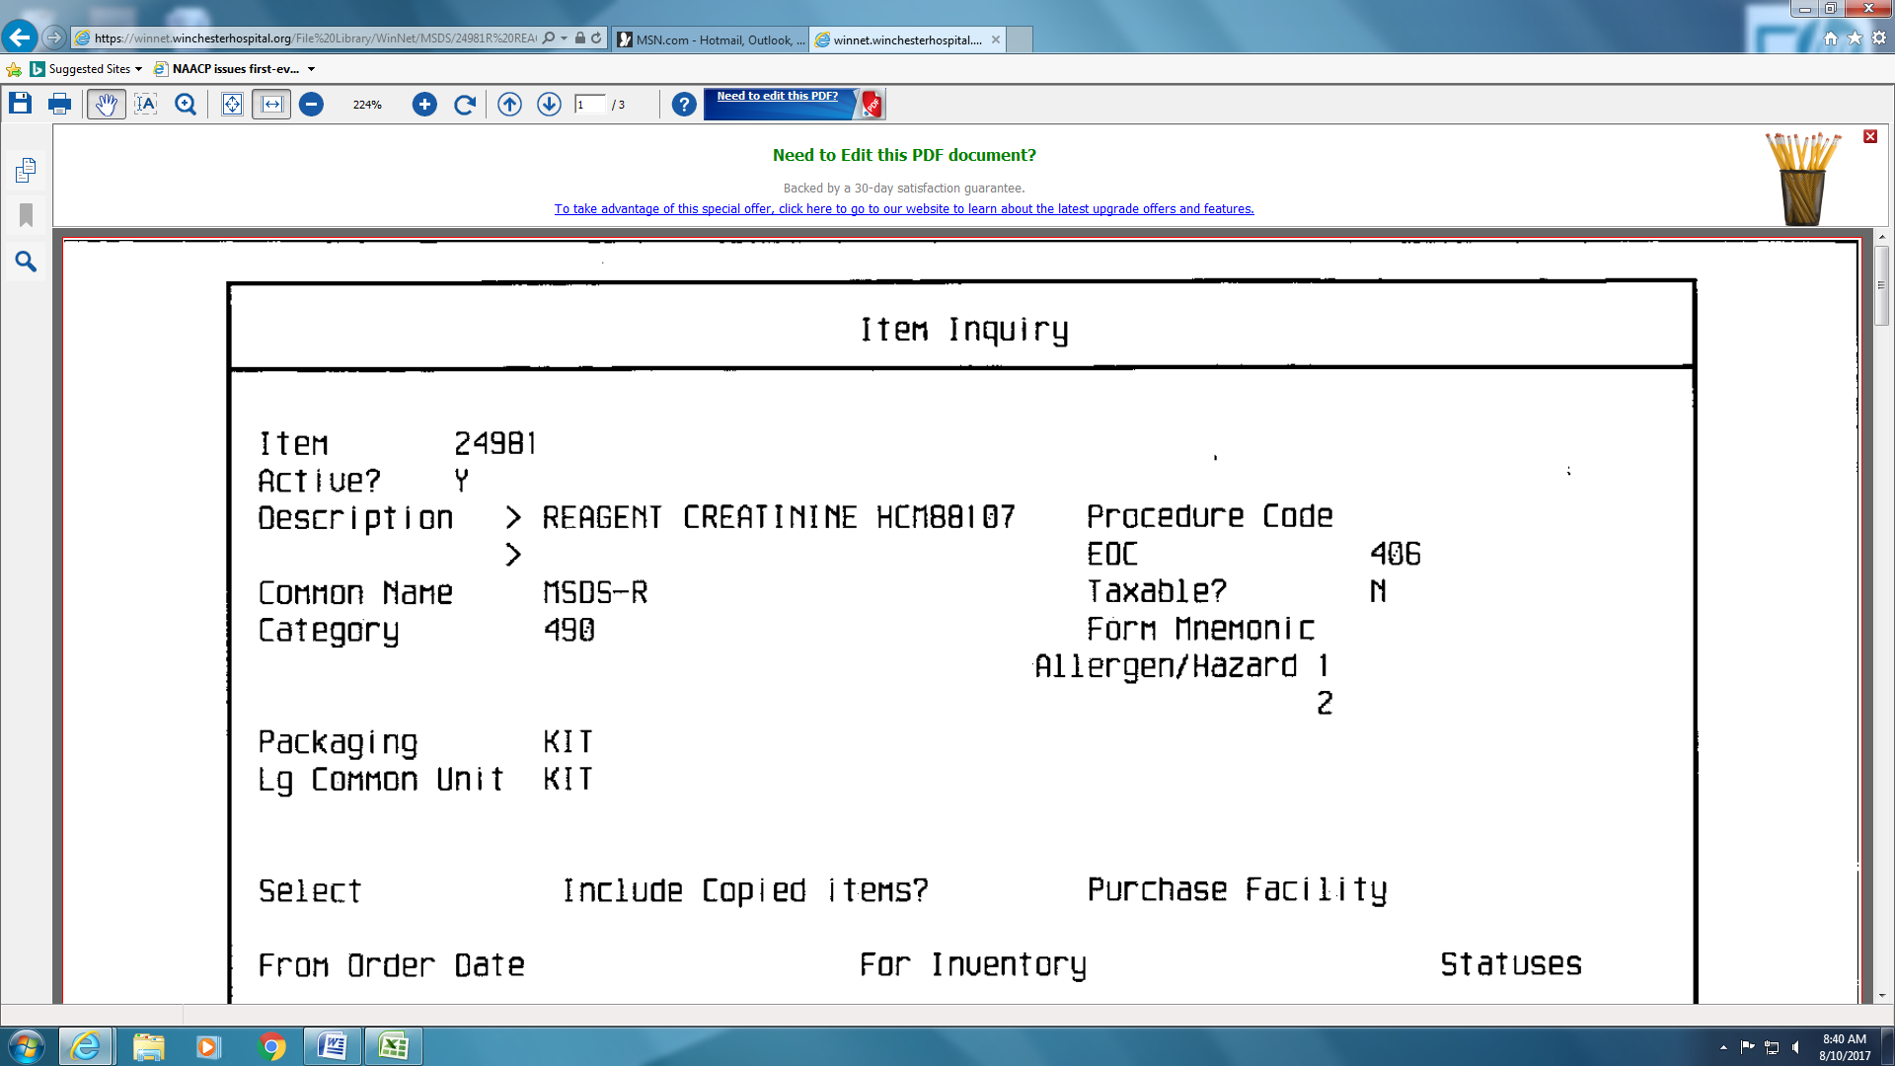

1. Scroll down to the data needed ( most MSDS’ will be 3-5 pages in length

