**Fire Safety 2019**

It is a CAP requirement that all staff demonstrate their fire safety knowledge annually for each work site they are assigned.

1. Review the following fire safety information.
2. Review the location of the fire alarms, the fire extinguisher and the emergency exit route at your specific work site.

**Fire Safety Information:**

* If you smell smoke, see a fire, or hear “Fire Emergency” or “Code Red” announced over the intercom, follow the RACE guidelines on the back of the safety badge given to you along with your ID badge. RACE stands for Rescue, Alarm, Contain and Extinguish.
* Rescue yourself and others from the immediate area.
* If you are located at the hospital, pull the alarm and call 3333 and give the location of the fire.
* If you are located at any of offsite location, pull the alarm and call 911 and give your location.
* Close any doors to contain the fire.
* Ensure that all fire exits are clear of any obstructions.
* Ensure that all fire exits are clear of any obstructions.
* If there is no personal danger, you may attempt to extinguish the fire with a fire extinguisher. Follow PASS to do so.

1. Pull the pin.
2. Aim at the base of the fire.
3. Squeeze the handle.
4. Sweep the spray back and forth.

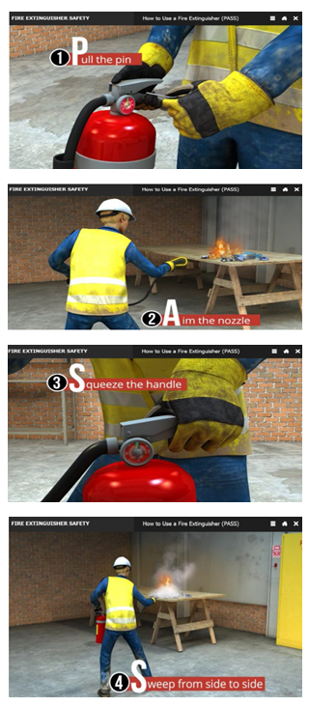

* Remain calm and work efficiently as possible. Remember to follow the RACE protocol as a team. When one person is calling 3333 or 911, another person can pull the alarm and someone else can get an extinguisher. If the fire is larger than a trash can or if you don’t feel safe attempting to extinguish it, leave the room and close the door.
* All employees are required to evacuate. Employees at the hospital should meet in the emergency room parking lot. Employees the Core Lab should meet at the median strip in the parking lot. Employees at all other off sites should evacuate to an area away from the building and should stay with other employees.
* Employees should work as a team. The team should try to account for everyone who is working at the location so no one is left behind. There are clip boards with attendance sheets at the exit doors at the Hospital, the Core Lab and FMC. One person should take the clip board and take attendance once the group has met at a safe location. Notify a supervisor or a fireman if someone is missing.
* No employee should leave the groups after signing the attendance sheet without approval from a supervisor

|  |  |
| --- | --- |
| **Fire Alarm Location** | |
| Core Lab | -By the exit door in the processing area  -At the end of the corridor at the 264 door  -in the gram stain area in Microbiology  Next to the exit door to the 264 loading dock |
| Hospital | -Back wall in chemistry near the doorway to the staircase  -Near the manager’s office between the lab and the processing phlebotomy area  -Near the exit door to the outpatient waiting area |
| Baldwin Park | Corridor going to the back door |
| Oncology | Near the elevators |
| FMC | In the laboratory |
| All other site | You must ask your supervisor |
| **Fire Extinguisher Location** | |
| Core Lab | -Outside offices on the 264 side  -In the gram stain area in Microbiology  -Lounge  -Molecular room  -Between the cytoprep room and the molecular room  -On the ramp in the processing area  -Chemistry processing area  -Bathroom in chemistry lab |
| Hospital | -Blood bank near the window that looks into Hematology  -Near phlebotomy supply room  -Back of chemistry near the stairwell |
| Baldwin Park | Corridor going to the back door |
| Oncology | Phlebotomy room |
| FMC | In the laboratory |
| All other sites | You must ask your supervisor |

Employee Name:___________________________________________

Name of location are you working at today.________________________

Please complete the following:

1. If I am at the hospital and I smell smoke I should pull the alarm and dial ______________.
2. If I am at an offsite location smell smoke I should pull the alarm and dial ______________.

Initial the following statements after you have reviewed the necessary information.

* I have reviewed the evacuation route to a safe location in case of fire today.___________
* I have reviewed the location of the fire alarms at this location._______________
* I have reviewed the location of the fire extinguishers at this location._____________________