Crystals are commonly found in human urinary sediment. It is important to identify crystals which are normally present from crystals, which are associated with disease states. Crystals are identified by their morphological characteristics. Abnormal crystals are most often found in urinary sediments with an acid or neutral pH. Normal crystals found in human sediment may be associated with urinary pH values that range from strongly acid to alkaline.

Some examples of crystals found in urines are:

Amorphous urates are salts of uric acid and are found in acid or neutral urine. These salts frequently precipitate in urine that has been refrigerated or has cooled to room temperature. These urates are pink, tan or yellowish red and appear as amorphous or granular form. Warm saline will dissolve urates.

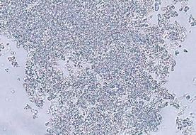

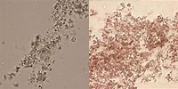

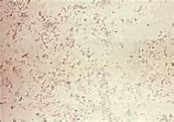

Calcium oxalate crystals are usually found in acid urine but may also be formed in urine having a pH that is slightly alkaline or neutral. These crystals occur in two basic structural shapes, the octahedral and the dumbbell. Oxalate crystals are soluble in dilute hydrochloric acid and in 90% ethyl alcohol but are insoluble in acetic acid. The octahedral form of calcium oxalate crystals occurring in slightly alkaline urine may be easily mistaken for triple phosphate.

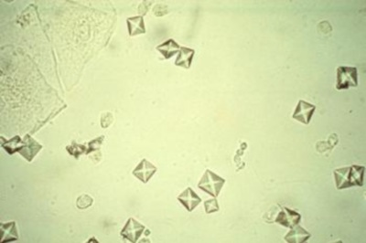

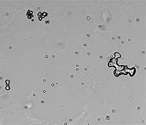

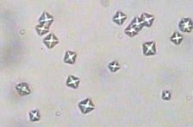

Cystine crystals are observed in urine with an acid pH and are seen as thin, colorless, hexagonal plates, usually with two sides longer or shorter than the other four; occasionally they may assume other configuration. Frequently the plates will overlie one another or fuse into a rosette. They are usually flat or plate like, and when dissolving become wrinkled and somewhat globular. They are ordinarily colorless and display birefringence with polarized light. Cystine crystals are soluble in hydrochloric acid, sodium hydroxide; and insoluble in acetic acid, ether, alcohol and boiling water.

