**What is workplace violence?**

An act or threat occurring at the workplace that can include any of the following:

* Verbal, nonverbal
* Written, or physical aggression;
* Threatening, intimidating, harassing, or humiliating words or actions;
* Bullying, sabotage; sexual harassment; physical assaults;
* Or other behaviors of concern involving staff, licensed practitioners, patients, or visitors.

**Types of Violence (OSHA)**

* Type 1 – Criminal/Stranger

-Unauthorized person in work area

* Type 2 – Patient

-Patient, family, visitor

* Type 3 – Worker

-Worker to worker (Lateral Violence)

* Type 4 – Relationship/Domestic

-Family related

**Types of Violence Situations**

* Elderly patient verbally abused a nurse and puller her hair when she prevented him from leaving the hospital to go home in the middle of the night.
* Agitated psychotic patient attacked a nurse, broke her arm, and scratched and bruised her.
* Disturbed family member, father died in surgery at a hospital, walked into the emergency department and fired a small-caliber handgun, killing a nurse and an emergency medical technician and wounding the emergency physician.
* Violence in hospital usually results from patients and occasionally from their family members who feel frustrated, vulnerable, and out of control

**What do we have to reduce violence risk**

* Card access
* IDs for all staff, visitors and vendors
* Lighting and emergency call boxes in parking lots
* Security escorts
* Emergency phone number 3333
* Panic alarms
* Limited building access
* Patient watches
* Security tours

**Myths about violence**

* “Totally out of the blue…”
* “He just snapped…”
* “If left alone, events will resolve themselves…”
* “I can’t do anything to stop it…”
* “It couldn’t happen here…”
* “It’s part of the job…”

**Domestic violence**

* Pattern of behavior in which one intimate partner controls another through the use of:

-Physical violence

-Coercion

-Intimidation

-Threats

-Isolation

-Emotional, sexual, or economic abuse

* Affects nearly one out of four women in today’s workplace

**Assault cycle of an individual**

* Triggering event – loss of job, delay in treatment/medication, unexpected bill, relationship ended
* Escalation – prepares to fight, argue
* Crisis – verbal or physical violence happens
* Recovery – person gets under control
* Post crisis – depression, crying

**Healthcare violence risk factors**

* Working directly with volatile people, especially, if they are under the influence of drugs or alcohol or have a history of violence or certain psychotic diagnoses
* Long waits for service
* Overcrowded, uncomfortable waiting rooms
* Working alone
* Poor environmental design
* Limited security
* Lack of staff training and policies for preventing and managing crises with potentially volatile patients
* Drug and alcohol abuse
* Poorly lit areas corridors, rooms, parking lots

**Signs and symptoms of stress**

* Change in facial expression
* Altered eye contact
* Change in speech
* Increasing nervousness
* Confusion, distraction
* Pacing, fidgeting
* Abnormal breathing

**Violent behavior actions**

* Keep your distance from an agitated person.
* Talk in a calm voice. Share that you are trying to help.
* Try to validate the person’s feelings, even if you do not agree with them.
* Make their person aware that you bring to harm.
* Stay near a door so you can exit quickly.
* ***Never approach an agitated person alone or in an isolated part of the hospital.***
* Call Security x 2560 at the 1st sign of violence.
* If situation is **out of control** call 3333 and report “Security Emergency” and location; offsite call 911.

**Communication when faced with a violent situation**

* 55% of Communication is non-verbal
* 38% is verbal – tone and inflection
* 7% are the actual words used
* Body language is over 50% of in-person communication

**Violence communication**

* Active listening – critical; focus on what is said
* When talking use his/her preferred name
* Assert your understanding of the situation
* Influencing helps direct the situation
* Persuade the person to do what is needed
* Empathy for the person creates trust
* Sensitivity to the situation strengthens communication
* Diplomacy creates opportunity for resolution

**De-Escalation actions**

* Turning body at a 45 degree angle vs. being directly in front of the person
* Control your voice – slow, quiet tone, confident in what you say
* Stay in control – Quit Taking It Personally (QTIP)
* Use names yours and the other person
* Never touch the person
* Break eye contact if needed
* Use attentive listening
* Don’t make promises you can’t keep
* Clarify the concern, be direct
* Let the person know you are there to help
* Adjust TV, lighting, move to another location
* Redirect the discussion
* Always evaluate the environment and stay away from the person
* Give options
* Don’t be defensive
* Don’t make threats
* Ignore challenges
* Use “we” and “us”
* Set boundaries you can enforce

**AFTER A VIOLENCE EVENT**

* Always fill out an OAR after you experience a violence event.
* Always tell your Supervisor or Manger about any violent event.

**Reporting Adverse Events**

* Electronic Occurrence Assessment Report (EOAR) System used to report any unexpected, actual or near miss event, or an event related undesired outcome to a patient, visitor or the building.
* The Patient Advocate is available to help resolve complaints that you or your supervisor are unable to resolve or that you need assistance with.



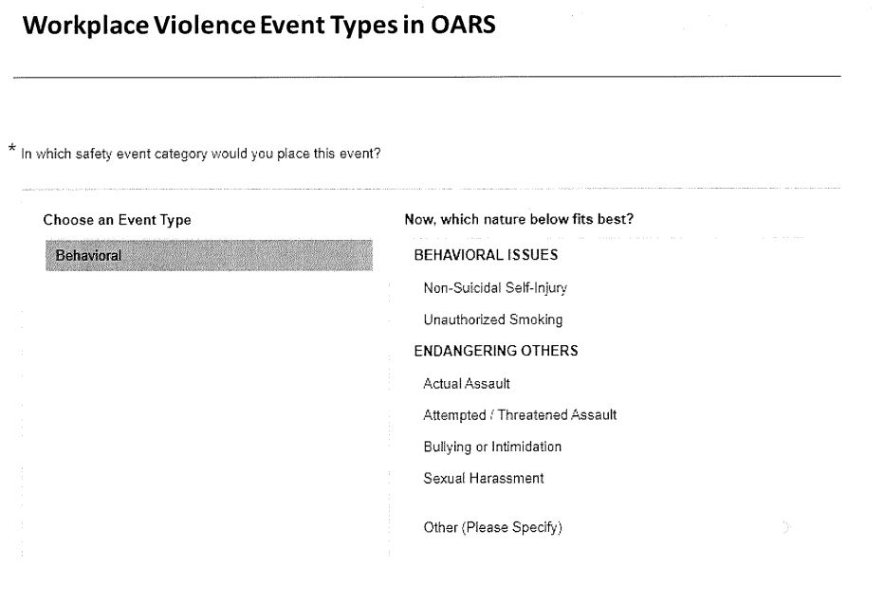

**Report all work-related injury**

* Report injury to your **Supervisor** immediately.
* Fill out **Occupational Injury/Illness Report.**
* Tell Emergency Department/healthcare provider your **injury is work-related.**  Medical bills will be paid by the hospital.
* If you are out of work, contact **Employee Health immediately.**
* Follow the recommendations of your medical provider.

**Tailgating is the process when an authorized person enters a secure area and an unauthorized person enters behind them.**

* Sometimes a visitor or an employee enters a department by mistake.
* If at times you “feel things just aren’t right.” Trust your instincts. Never ever hesitate to STOP and ASK.

**ARMED INTRUDER**

What should I do if I am confronted by a person looking to harm me with a weapon?

(Handguns, rifles, knives, explosive devices, or anything else that is intended to be used to inflict bodily harm).

RUN

HIDE

FIGHT

**Run**

* You have the right to protect yourself from harm.
* Know where to run to.
* Where is the nearest exit?
* Ifan armed intruder is in your area your safety is most important.
* Go even if others choose to stay.
* Help others to run if time allows.
* Do not try to move injured people.
* Call 911, when it is safe to do so.
* **Call 3333, state “Armed Intruder” and location.**

**Hide**

* If you cannot or choose not to run find a place to hide.
* Go in a room and lock the door.
* Place a bed, desk, file cabinets in front of the door.
* Turn off cell phone, pagers, and lights and remain quiet.
* Do not come out until your hear the overhead all clear.

**Fight**

* If your life is at risk and you cannot run or hide then you must protect yourself in any way possible.
* Fight to save your life by yelling or throwing things at the intruder or trying to disarm or incapacitate the intruder by using available items such as IV poles, medication carts, fire extinguishers, books, telephones, stretchers etc. to save your life.

**Infant Abduction**

* “Infant Abduction” is the Hospital’s code phrase for a possible infant or toddler abduction.
* Go to the nearest exit and let no one in or out.
* Stay at exit until you hear the all clear.
* Look for any suspicious activity and report it to Security STAT.

**Impact of Lost Patient Belongings**

* Lost Personal Assistive Devices (PAD’s) – effect how patient safely perform activities of daily living. Ex: eyeglasses, hearing aids, dentures, canes
* Lost Personal items – effect patient’s comfort, communication, memories/sentimental value of item. Ex: clothing, blankets, cellphones, jewelry
* Effects patients and families hospital experience, trust and finances for items not reimbursed.
* Effects staff’s time, energy and finances spent reviewing, recovering, and replacing lost items.

**Patient Belongings & Valuables Process**

Steps to secure patient belongings & valuables

1. Encourage patients to send items home.
2. Take inventory and document all patient belongings.
3. Label ALL patient belongings bags.
4. Utilize the safe in registration for all valuable (wallets, $$).
5. Utilize over the bed signs to let the team know what belongings patients have with them.
6. Upon discharge or unit transfer, document items were sent with the patients.

**Securing Belongings Safely**

**Properly Label ALL Bags**

Upon admission staff should affix an identification label or hand write patient’s full name and MR# on each bag. **Unlabeled bags can’t be successfully reunited back to patients**.

**FIRE – RACE**

* In case of smoke/fire think RACE.
* R = Rescue: remove any person threatened by fire of smoke.
* A = Alarm: pull the fire alarm box **and dial 3333** (Off-site call 911 or 9-911) report a Fire Emergency and give the location and description of the fire. For cell phones use 911 and say both the **Town and State** for your location, such as Woburn, MA)
* C = Contain: close doors and windows throughout the area, if the fire is on your unit or on the same floor as your unit, clear the corridors of equipment. If the fire is not on your floor, move the equipment in the corridor to one side.
* E = Extinguish: if there is no personal danger, attempt to extinguish the fire.

**Fire/Smoke Issues**

* Smoke doors at times do not latch, ceiling tiles break and other fire safety concerns exist.
* 92% of 41 Highland Ave. building has sprinkler coverage. Fire risk is low.
* Know evacuation route in a fire.
* Know where you will take patients. Ask your manager if you are unsure.
* Sprinklers cannot be blocked. Keep all items 18 inches below a sprinkler hear.
* Do not block pull stations and extinguishers.

**How to use a Fire Extinguisher**

While holding the extinguisher upright:

P – Pull out the pin between the two handles.

A - Aim the nozzle at the base of the fire.

S – Squeeze the handles together.

S – Sweep the extinguisher from side to side until the fire is out.

**What if I see a Chemical Spill**

1. **C**ontain the spill
2. **L**eave the area
3. Get **E**mergency treatment if exposed
4. **A**ccess the Safety Data Sheet (SDS)
5. **N**otify your Manager/Supervisor
6. Fill out an OAR

**Safety Data Sheets – SDS**

**Safety Data Sheets (SDS)** are documents that provide safety information about chemicals.

* To locate a SDS, follow the steps below:
* Obtain the name of the chemical/product, example PURELL
* Go into Google Chrome
* Type Winnet Winchester
* Click on “Log into Winnet-Winchester Hospital
* Click on Tools and Resources
* Click on SDS Finder on the left side
* Click on Access the SDS Finder at the bottom of the list and you will be into the site.
* Type in the name of the chemical/product you would like to view
* Print the Safety Data Sheet
* Review the safety actions needed when using the chemical

**Protection from Radiation**

* “X-ray in Use” sign, **DO NOT ENTER**
* Any container leaking radioactive materials is cleaned up by trained staff.
* Wear lead shielding with X-ray procedure, or if not directly assisting, stay at least six feet away.
* Wear disposable gloves when handling radioactive waste.
* Minimize time spent in a patient’s room receiving radionuclide therapy. Signs must be posted if a patient is receiving this therapy.
* If pregnant and your job involves radiation exposure, notify your supervisor.

**Safe Patient Handling**

* Evidence based practice shows that safe body mechanics alone is not enough to keep healthcare workers safe from the physical demands of lifting, pushing, pulling and moving dependent patients.
* Statistically, the cumulative weight a nurse lifts during and 8 hour shift is 1.8 tons! This risk factor is compounded by awkward working postures such as bending, twisting and reaching.
* Patient ceiling lifts and mobile safe patient handling equipment should be utilized to reduce this risk of patient and staff injuries.
* Evaluate the patient’s motility level prior to movement and utilize the proper safe patient handling equipment for the task.
* Adjust the bed to the optimal height before patient care and clear space to reduce obstructions and awkward postures.
* Obtain proper SPH equipment, staff and communicate with the patient and team prior to the lift.

**Broken Equipment?**

* **STOP DO NOT USE IT!!**

-Pull equipment out of service

-Place Red tag on it and call x2025

-If injury, secure equipment and call the Risk Manager On-Call

-Broken door, light and ceiling tiles and non-patient equipment, and other repair issues call SRC at x2500

**Do you want to fall? NO**

* Report fall risks to SRC x2500
* Watch where you are stepping
* Report ice risks in parking lots to the Shuttle Drivers
* When responding to a bed alarm do not run (if Patient Falls start Fall protocol)
* See a spill on the floor take action to reduce the fall risk, towels, floor sign, call for help
* Tie your shoes!
* Frequent intentional rounding for precautions reduces patient falls

**Interpreter Services**

* Interpreter services are provided to the non-English/limited English speaking or hearing impaired patient who requires who or requests an ASL interpreter.
* Upon registration the patient is asked what language they prefer to receive their medical information.
* Staff documents in the medical record:

1. the use of interpreter services
2. if an interpreter is used, the name of the interpreter and language used
3. If applicable, the Declination of Interpreter Services form must be filed in the paper medical record.

* If a staff member has any concerns, they should notify their manager of the Nursing Supervisor.
* How to access Interpreter Services, refer to policy #1523-CA
* Video remote interpreting and telephone interpretation is to be used when it can be documented by medical/hospital staff that there is either no reasonable way to anticipate the need for in person interpreters, or where it is more reasonable for the delivery of timely, safe patient care to use the video or telephonic interpreter.

**Family of Friends as Interpreters**

* Family/friends can interpret for nonmedical information, such as registration.
* Do not suggest patient to use family/friends as interpreters for medical information.
* Minors (under 18) are NOT to be used as interpreters.
* If patient declines Interpreter Services and requests a family member, staff will communicate to the patient that Interpreter Services are legally guaranteed and free of charge.
* If patient declines services, staff will have the patient sign the Declination of Interpreter Services Form.
* Staff has the right to request the use of an interpreter to perform professional linguistic services for optimal communication **even if the patient declines interpreter services**.

**MRI**

* MRI stands for **M**agnetic **R**esonance **I**maging (MRI).
* MRI’s create images of patients without utilizing ionizing radiation.
* MRI scanners are more powerful than the earth’s magnetic field!
* MRI scanners are ALWAYS ON…EVEN WHEN NOT IN USE!
* **THE MAGNET IS ALWAYS “ON”!**

**Safety in the MRI Suite: Non MRI Personnel**

* Access to the MRI Department is strictly controlled. ONLY MRI personnel will be permitted in the MRI suite without supervision.
* A MRI Ferromagnetic Screening Form is required for ALL Non MRI personnel entering Zone III. This completed form must be reviewed by an MRI Technologist, prior to Zone III admittance.
* All Non MRI personnel entering Zone III must remove ALL extraneous items from his/her person.
* These items will be placed in a secure bin, while the individual is present in Zone III.
* Those individuals entering the scan room, (Zone IV), must undergo further metal detection screening.

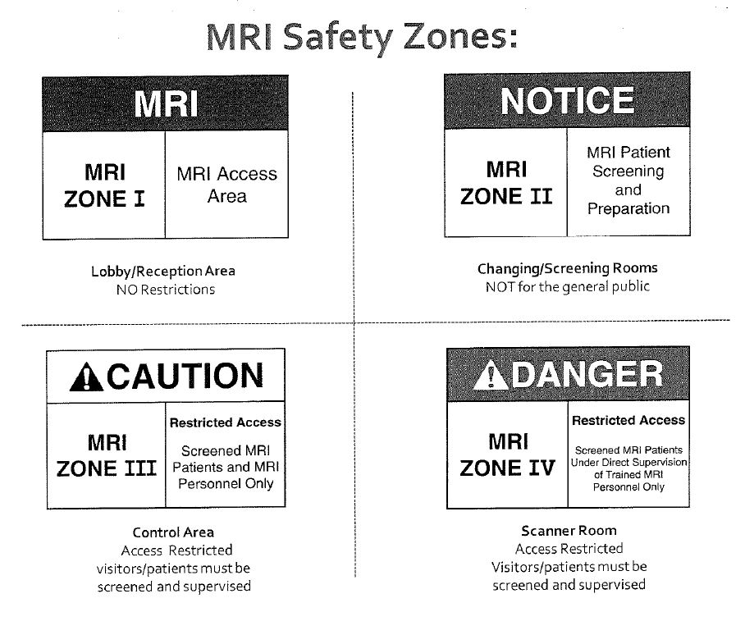

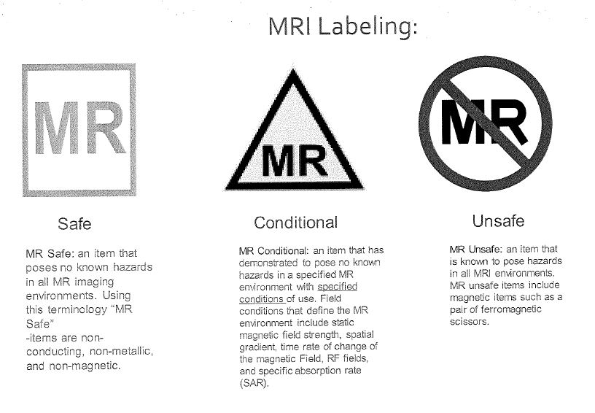

**PROMISE**

* In every encounter with patients, co-workers, and the community, think PROMISE.
* **P**romoting Teamwork
* **R**espect
* **O**wnership
* **M**aintaining a Positive attitude
* **I**nitiative
* **S**afety and Quality
* **E**mpathy