**Case History CMP-04 through CMP-06**

This urine sample is obtained from a 46 year old man with MRSA pneumonia and vancomycin-induced acute tubular necrosis. Laboratory data include: specific gravity = 1.012; pH = 6.5; protein, blood and leukocyte esterase = positive; glucose, ketones, and nitrate = negative.

CMP-04

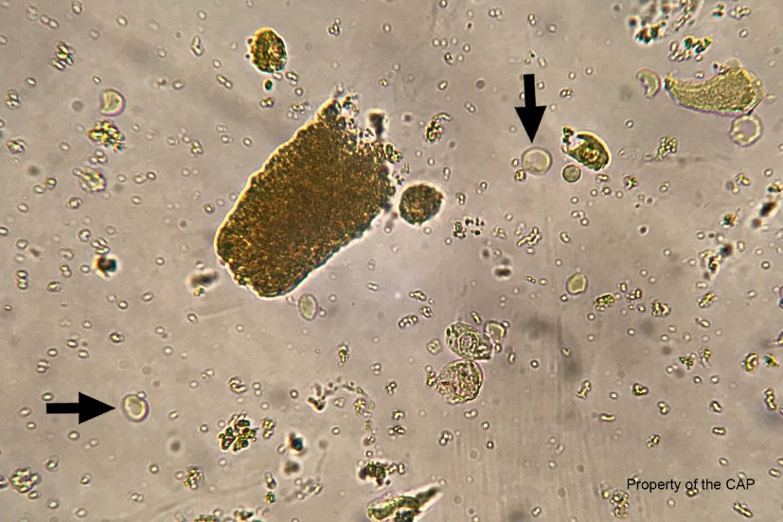

The arrowed cells are erythrocytes. The cells are non-nucleated cells approximately 7 µm in diameter with the classic biconcave disc shape. A central zone of pallor is seen in both cells due to the biconcavity of the cell which is most prominent in the lower left arrowed cell.

CMP-05

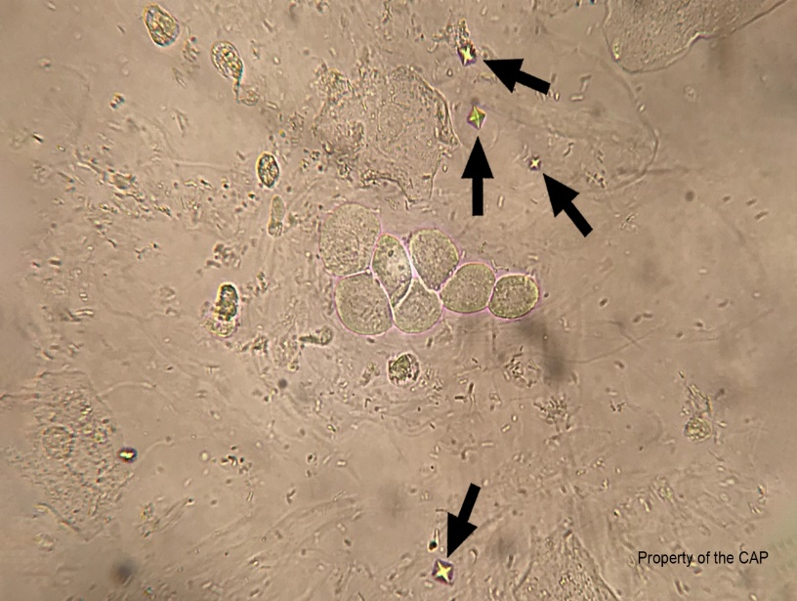

The arrowed crystals are calcium oxalate crystals. Their appearance as squares with a cross is due to the eight-sided octahedron shape often described as envelopes. Although calcium oxalate crystals are sometimes mistaken for red blood cells, they are typically smaller than red blood cells and are colorless. The crystals seen in this image are the common dehydrate form which are usually not an abnormal finding, although they can suggest the cause of renal calculi.

CMP-06

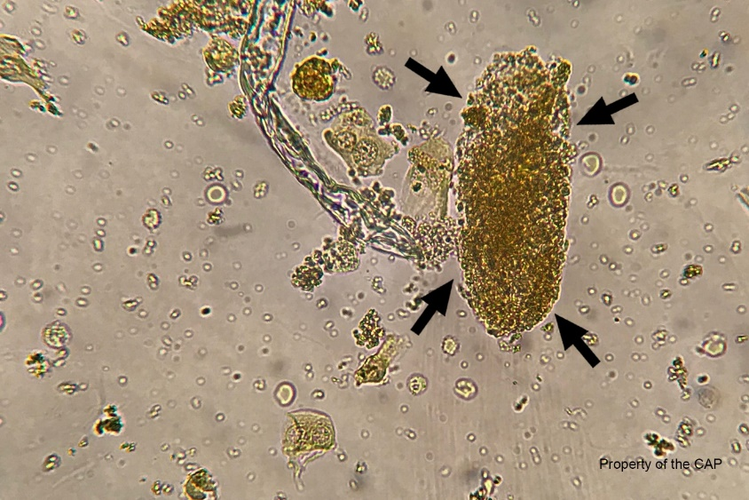

The arrowed element is a granular case. The granules within the cast are coarse and evenly dispersed over the cast. This cast has taken the form of a renal tubule usually indicating a pathological process within the kidney. For this patient, the finding is consistent with vancomycin-induced acute tubular necrosis which can help confirm the diagnosis. The granules seen within the cast are from degenerated cells within a matrix of aggregated protein. In this case, the cells have degraded to a point where the cell type can no longer be identified and therefore is referred to as a granular cast. This cast is not a RBC/muddy brown cast because it does not contain intact erythrocytes covering a hyaline or granular matrix.

----------------------------------------------------------------------------------------------------------------------------------------

**Case History CMP-07 through CMP-09**

This patient is a 60 year-old man with HIV with a suspicion of a cryptococcal infection. Cerebrospinal fluid sample laboratory findings include: TNC = 58 cells/µl; RBC = 891 cells/µl.

CMP-07

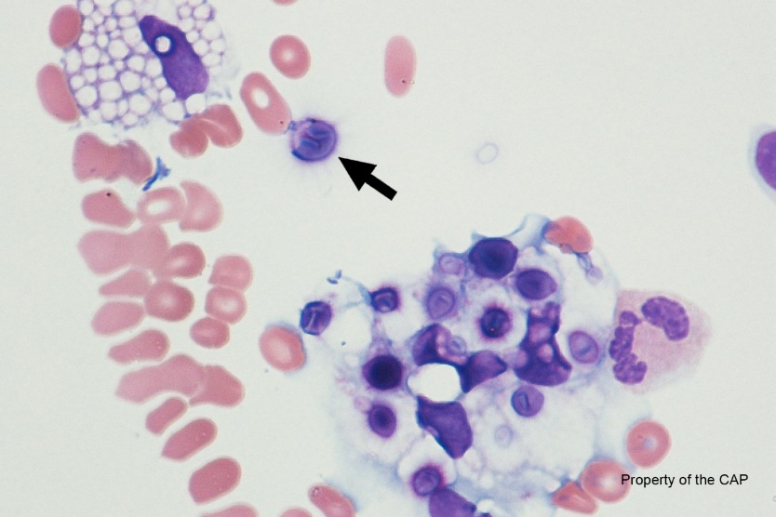

The arrowed cell is Cryptococcus fungal form. The microorganisms can be identified as single or multiple, uniform, cytoplasmic inclusions with a central basophilic core and surrounding capsule, all of which are classic featured of Cryptococcus.

CMP-08

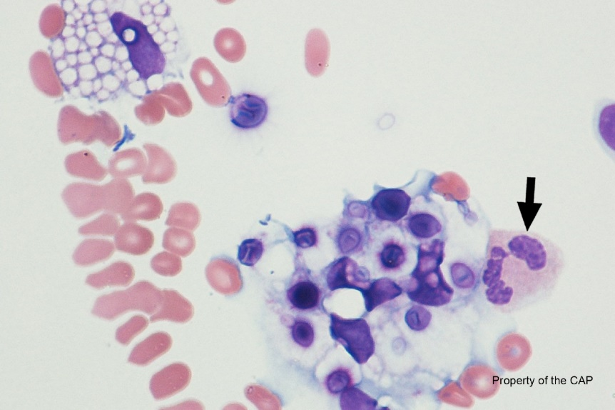

The arrowed cell is a neutrophil, segmented or band. Neutrophils are 10 – 15 µm in size and contain moderate pale pink cytoplasm with specific granules. The nucleus is segmented or lobated (with a normal range of 3 – 5 lobes). The lobes are connected by a think filament that contains no internal chromatin, giving it the appearance of a solid, dark thread-like line. The appearance of neutrophils in body fluids may be similar to those seen in peripheral blood, although in some cases degenerative changes may also be present.

CMP-09

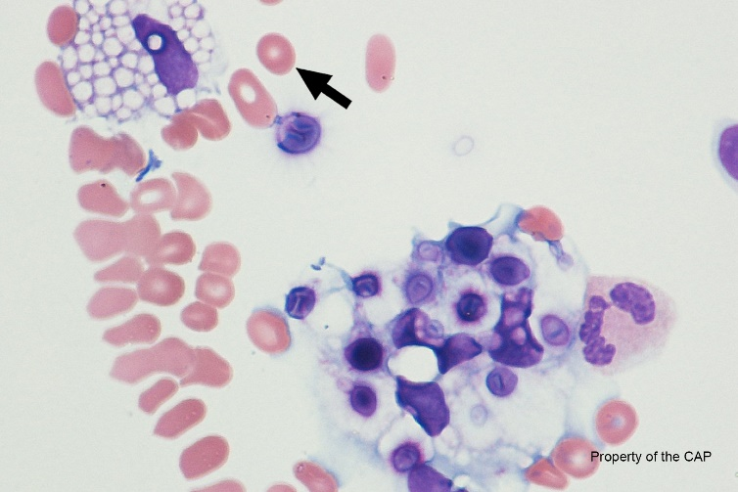

The arrowed cell is an erythrocyte. Erythrocytes are aneucleate and are the most mature cell in the lineage of erythroid elements. While in peripheral blood smears, they show central pallor that comprises a third of the diameter of the cell, there is more variable morphology in fluids. The red blood cell morphology in fluids is not a reliable feature since the cytospin process can introduce artifacts. There is no feathered edge in body fluids for morphologic evaluation.

------------------------------------------------------------------------------------------------------------------------------------------

**Case History USP-01 – USP-03**

This urine sample is obtained from a 77 year old man with chronic kidney disease and history of bladder cancer. Laboratory data include specific gravity = 1.014, pH = 8.0; protein, glucose, and leukocyte esterase = positive; ketones, blood, and nitrate = negative.

USP-01

The arrowed cells in this image are leukocytes. The cells are round nucleated cells with granular appearance approximately 10 – 12 µm in diameter. Leukocytes are larger than red blood cells and smaller than renal tubular cells. The presence of 5 or more leukocytes per high power field indicates inflammation in the urinary tract and is termed pyuria. The combined presence of both leukocytes and bacteria is an important indicator of bacterial urinary tract infection.

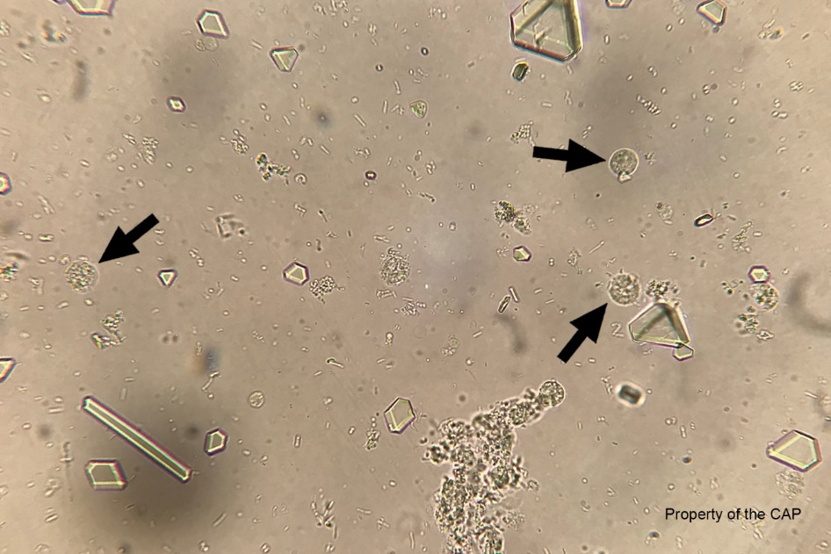

USP-02

The arrowed crystals in this image are triple phosphide crystals. They are seen in a variety of colorless forms including a large long prism (right arrow) and a smaller shorter prism (left arrow). These varied forms are commonly seen. The classic form described as a coffin-lid is not seen but the smaller prism on the left is approximating that shape. Triple phosphate crystals consist of ammonium, magnesium and phosphate and are also called struvite crytstals because they are components of large urinary struvite stones. These crystals are associated with urease-positive bacterial infect and neutral or alkaline urine pH.

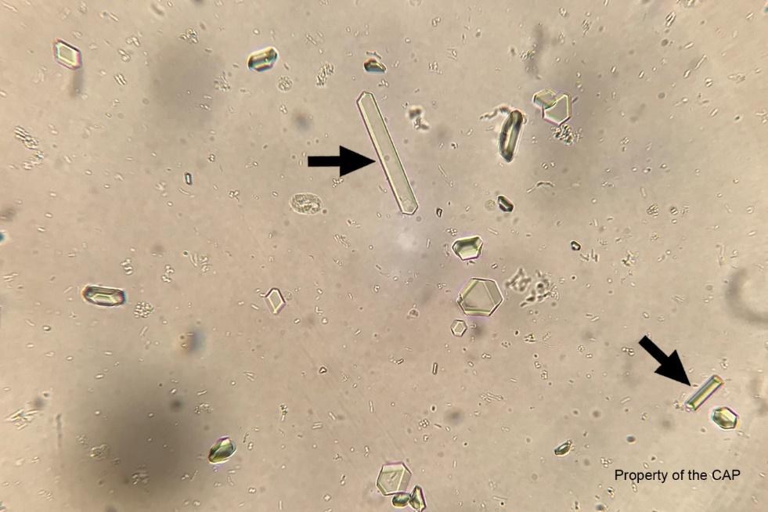

USP-03

The arrowed images are bacteria. The medium to long rod shaped organisms are bacilli that can be seen in urine as the causative agent in a urinary tract infection. These bacteria can also be seen in the urine as a contamination to inadequate urine collection. Urine sample collected for urinalysis and urine culture should be a clean urine sample that is collected mid-stream. The presence of bacteria with squamous cells and the absence of white cells is typical of contaminated collection and will often lead to mixed flora on urine culture.

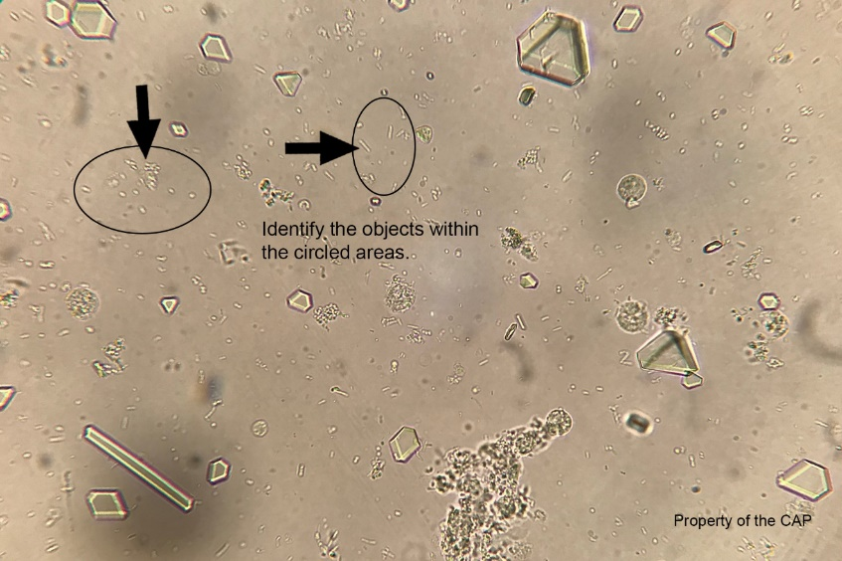

------------------------------------------------------------------------------------------------------------------------------------------

**Stool for WBC**

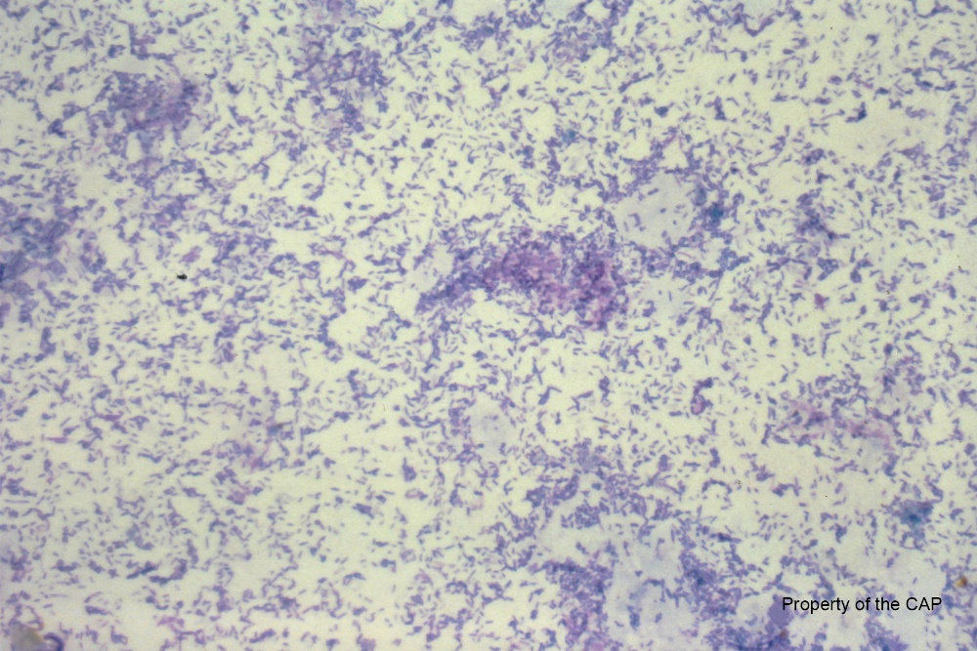

This specimen is negative for neutrophils. The presence of neutrophils is consistent with a bacterial infection, the findings are not specific. Stool cultures are more sensitive and specific for the evaluation of enteric pathogens.