How to Approach ECGs
..................................................................
- IF IT WALKS LIKE A DUCK, AND QUACKS LIKE A DUCK, IT'S A DUCK
This manual will enable you to learn the basics of 3-lead ECG interpretation so you can start immediately. Its focus is on teaching you the most important and frequently encountered rhythms. Later, you can master the subtle distinctions that become important for more advanced ECG monitor interpretation. While not wanting to offend purists, this book leans in the direction of simplifying concepts whenever possible and not distracting the learner with every conceivable outcome or variation.
ECG monitor interpretation is a serious medical science. This book and careful practice provide an excellent starting place for those who desire to learn ECG interpretation. It is also helpful to those in need of a basic review.
2. MEANING-NOT MEMORIZATION
You can interpret almost any 3-lead ECG with an understanding of a few basic concepts. The exercises in this book are meant to be done as you go along, open-book style. As in crocheting, after you master a few basic stitches, you can make an entire blanket.
3. TRUSTYOURSELF
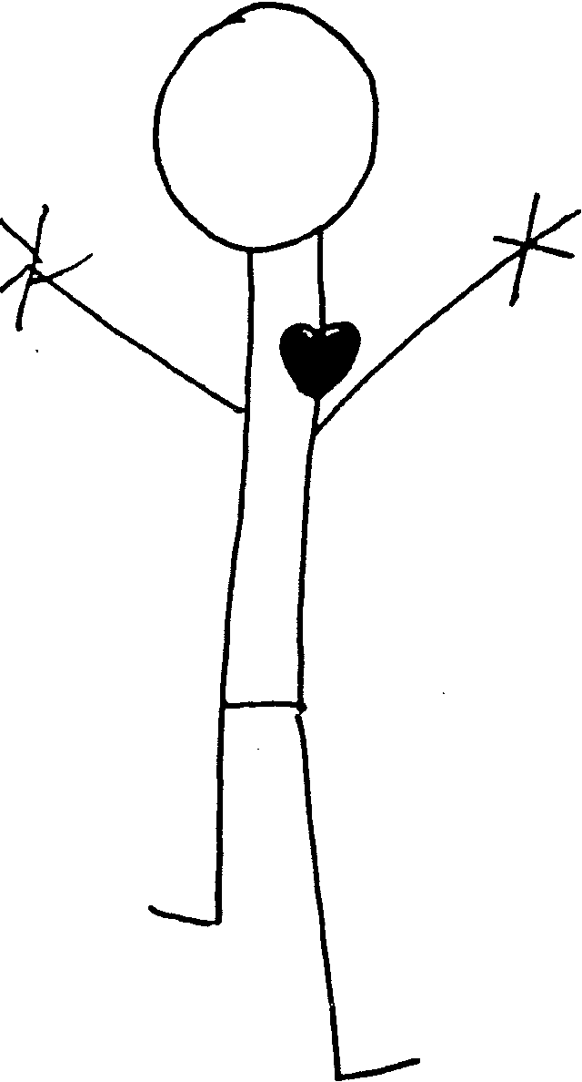
Relax, and enjoy this book. You can read and interpret 3-lead ECGs. Everything you need to know is contained in this handbook. This method has been successfully used to teach classes of nurses, paramedics, and medical students. Based on this success, we tried it on neighbors, friends, parents, and people who have not even been examined by a doctor in 12 years, and they were all confidently reading 3-lead ECG in less than 2 hours.
The Heart
LOCATlON
The scar that open-heart surgery leaves is a long, vertical, thick red line that runs down the full length of a patient's chest.
I was assigned to obtain an apical pulse on a man who had just been rolled out of surgery. You take an apical pulse by placing your stethoscope directly over the heart and counting the number of beats you hear in 1 minute.
I confidently stepped up to the patient's bedside and lifted his gown. I stared down at this fresh thick, long scar and gray chest hair, shaved from the operation. Now all I needed to do was listen directly over the heart.
I thought that the patient would be sore from having his chest peeled back like the skin of an orange; so I wanted to be especially careful to gently place the bell of my stethoscope directly over the heart, but my hand froze:

Where exactly is the heart located? 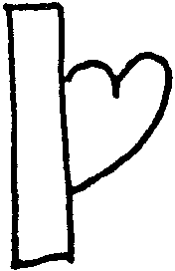
I placed my stethoscope down carefully, about 1 inch below the left nipple and in toward the center (sternum). Quietly I listened to the lub-dub beat of his heart.
The heart lies in the center of the chest, under the sternum and in between the lungs. Two-thirds of it lies to the left of the sternum. It is approximately the size of your fist and weighs about 10.6 oz.
ANATOMY (STRUCTURE) 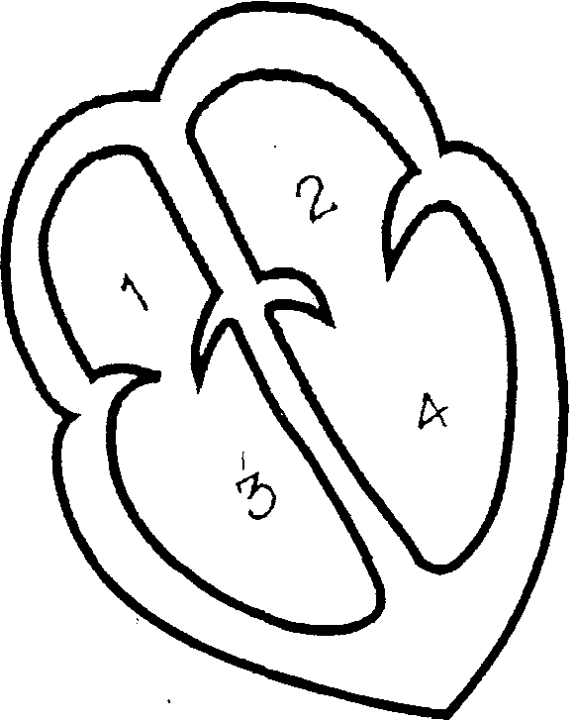
The heart is divided into four chambers.
The two top chambers are called the atria. The two bottom chambers are called the ventricles. The heart is actually a two- sided pump. The left side pumps oxygenated blood, and the right side pumps deoxygenated blood. When the atria contract, blood is pushed into the ventricles through valves. When the ventricles contract, blood is pumped out into the body and the lungs. The septum is cartilage that separates the two sides of the heart. One-way valves located between the atria and the ventricles keep the blood flow headed in the right direction.
1. Divide the heart into four quadrants.
- Label the right and left sides.*
- Label the atria and the ventricles.
- Draw arrows indicating blood -flow from the atria to the ventricles and out to the body and lungs.
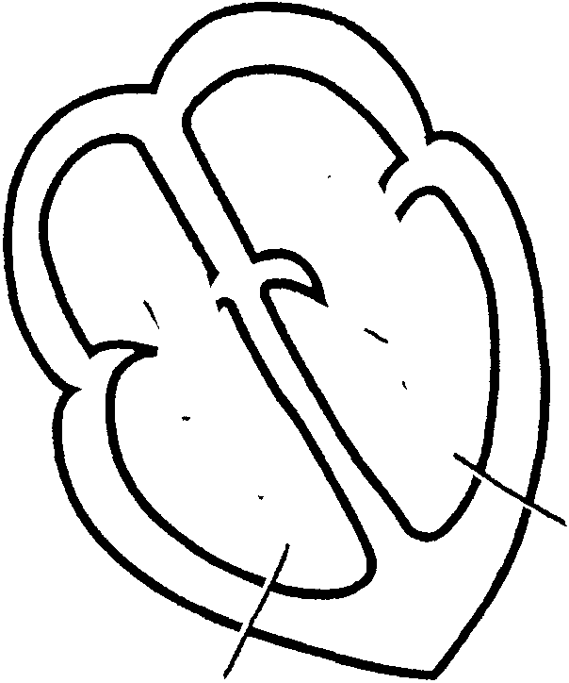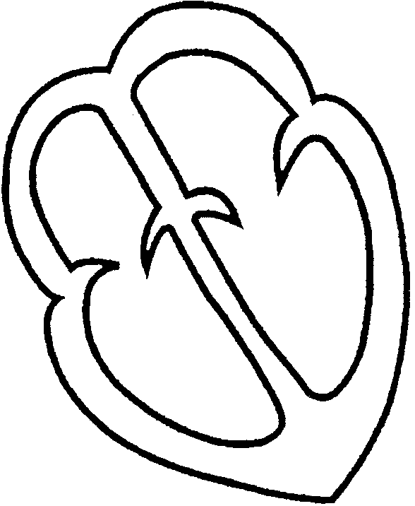

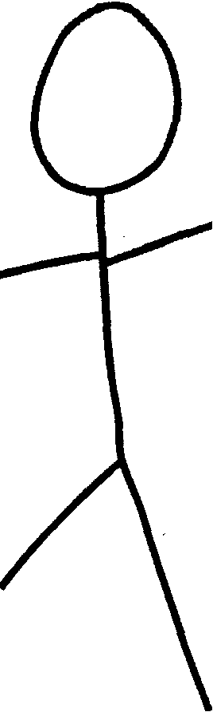
*In medicine, the anatomical position is used to designate the location of body parts. It is the patient's right and left sides.

The anatomical position.

The blood that flows through the heart is the blood used to nourish the body. The heart muscle itself has its own blood supply furnished by the coronary arteries.
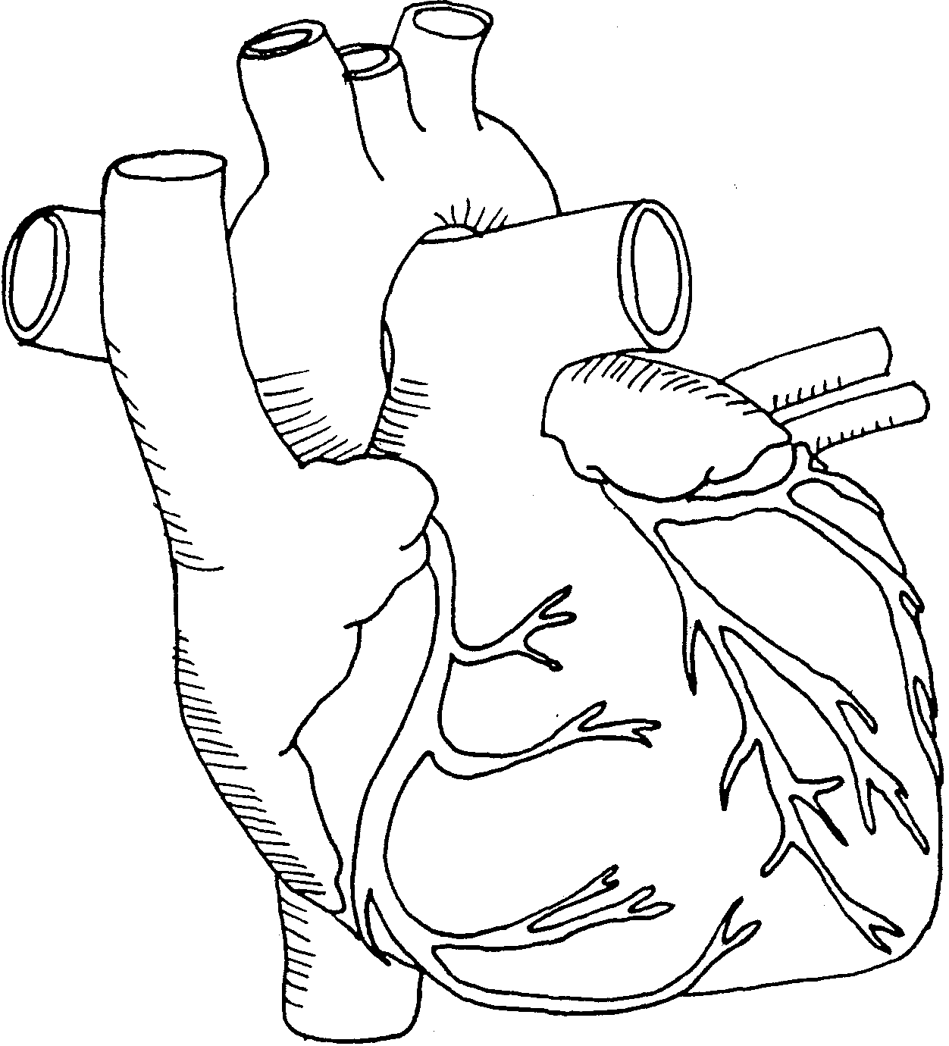
PHYSIOLOGY (Function)
The function of the heart is to circulate blood to all the tissues of the body. The blood supplies the tissues with oxygen and removes carbon dioxide and waste products. The heart can also be divided into a right and a left side. These two sides expand and contract simultaneously but receive blood flow from two separate areas of the body.
Cardiac Cycle
The cardiac cycle consists of two phases: contraction and relaxation. It is as if you squeezed a sponge in a bowl of water. "When the heart contracts, it is squeezing blood out to the body. As the heart relaxes, it is expanding and refilling. These are known as the systolic (the heart squeezing) and the diastolic (the heart relaxing) phases of the cardiac cycle.
The contraction (depolarization) and relaxation (repolarization) of the heart is actually a mechanical process initiated by an electrical "spark." When the heart is resting, the cells are negatively charged inside and' positively charged outside. When an electrical impulse is introduced, there is a wave of activity, and the cells become positively charged on the inside and negatively charged on the outside. This action causes the muscle to contract.
Think of it as a "wave" at a baseball game. One person in the bleachers starts the wave by standing up and throwing his or her hands in the air. As the person sits down, the next person stands up, and the next person continues, and the next, until it goes all the way around the stadium.
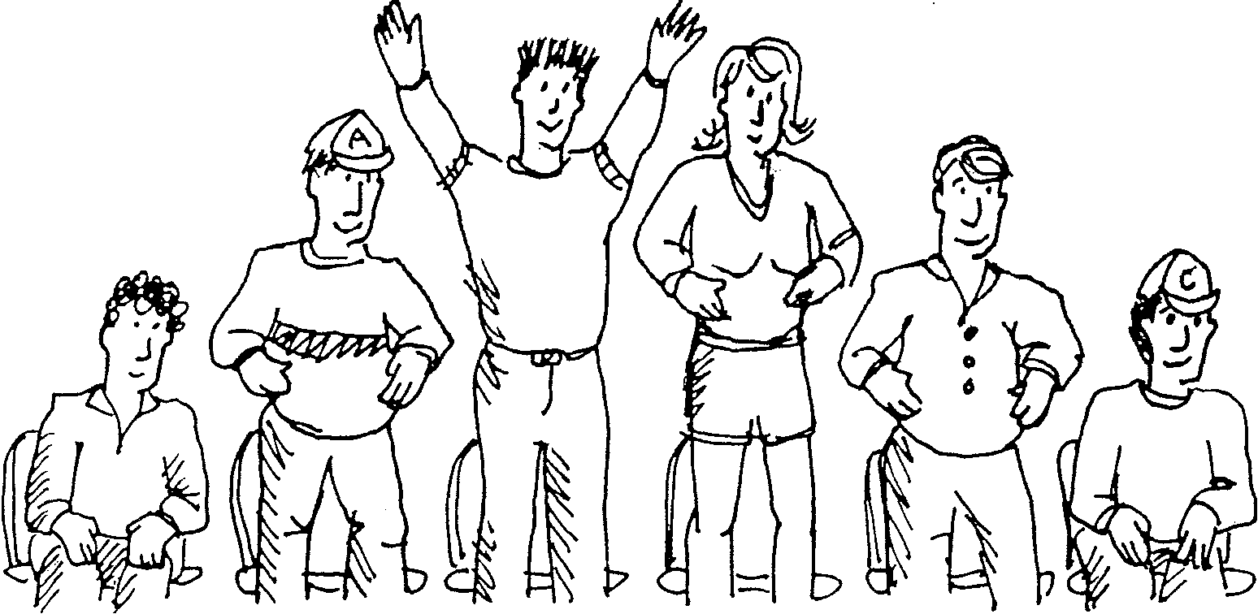
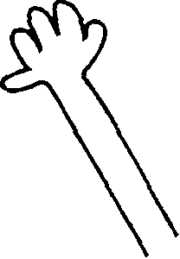 EXCUSE ME:What does all this have to do with ECGs?

Answer:______________________________________________________________________________________
Let’s review: The contraction and relaxation of the heart is a mechanical event prompted by an electrical impulse. When the myocardial cells receive this electrical impulse, the heart depolarizes, changing from a negative charge inside the cells to a positive charge, and the impulse spreads through the muscle, causing the muscle to contract.
The heart cells then repolarize, returning to a negative charge on the inside and a positive charge on the outside, and are now ready for the next stimulus.
After a contraction, there is a rest period for the heart. During these periods of repolarization, the heart goes through two stages: absolute refractory, when the heart cannot receive any stimulation, no matter how strong the impulse, and relative refractory, when the heart is susceptible to strong stimulation.
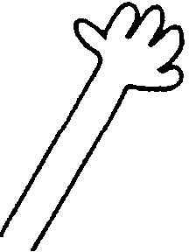EXCUSE ME : When does the heart do all this?
All this electrical activity can be recorded on paper. That recording is known as an electrocardiogram, or ECG or EKG.

Conduction Pathways
Ode to a Node
Have a heart, and have no fear,
The SA node is over here.
Beating at a constant rate 60-100 is really great.
The A V node can make a show if SA node has gone too slow.
40-60 is not too bad
If it's all you've got you will be glad.
Should the whole thing drop its speed?
His and bundle branches will take the lead.
And that, my friend is the whole and part,
Of the conduction system of your heart.
The electrical stimuli for the heart can be created by any myocardial cell, but usually it is created by primary pacemaker sites that are located throughout the heart. These sites are known as
- sinoatrial (SA) node (responsible for atrial contraction)
- atrioventricular (AV) node (the gatekeeper)
- bundle of His (named for its discoverer)*
- right and left bundle branches *
- Purkinje fibers *
*Responsible for ventricular contraction.
SINOATRIAL NODE
The SA node is located in the upper right wall of the right atrium. The SA node is the primary pacemaker for the healthy heart for two reasons:
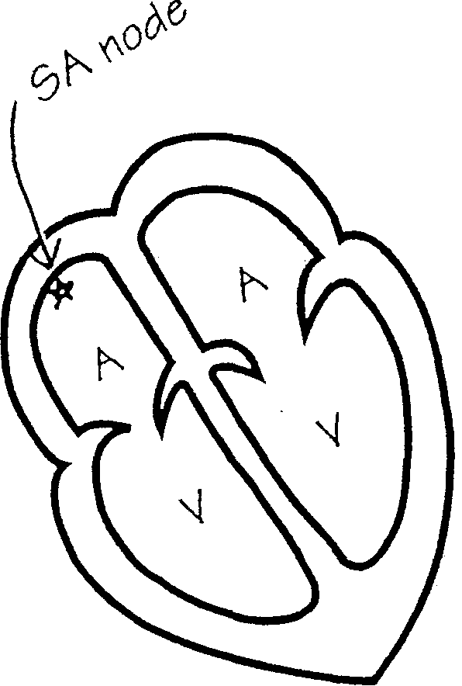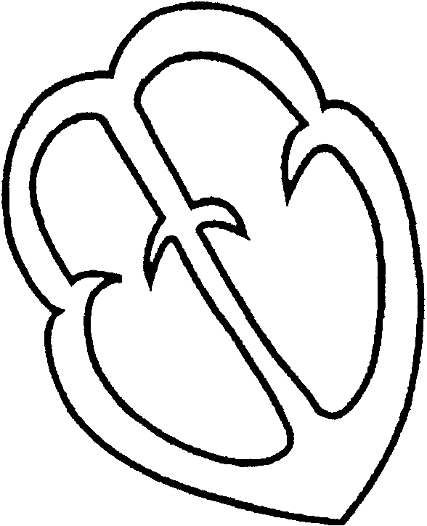
- Label the atria and the ventricles.
- Place a star at the SA node.

  - It is located highest in the heart, on the upper right wall of the atrium.
  - It has the fastest intrinsic firing rate: 60-100 beats per minute. As long as the SA node continues to conduct impulses at this rate, no other pacemaker site feels the need to fire an impulse to pace the heart.
The intrinsic rate of the SA node is ___ beats per minute.
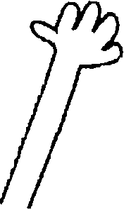 EXCUSE ME: What do you mean by "intrinsic rate"?
ANSWER:

The SA node fires impulses that contract the atria.
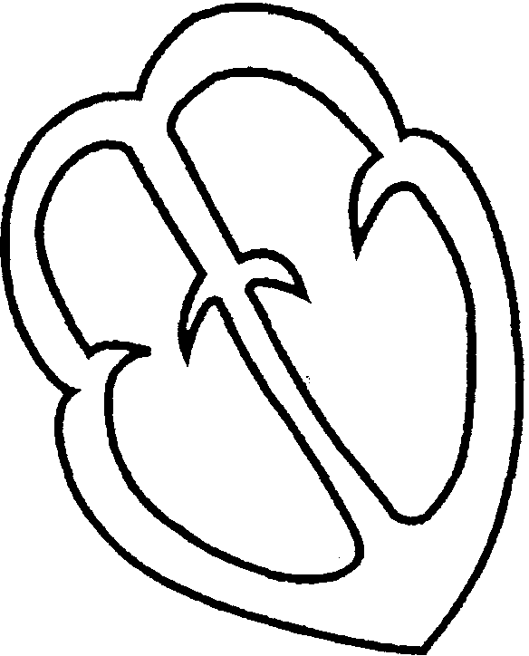
- Place a star at the SA node.
- Shade the atria.
- Fill in the intrinsic firing rate: _____ beats per minute.
- The function of the SA node is to contract the _________

ATRIOVENTRICULAR NODE 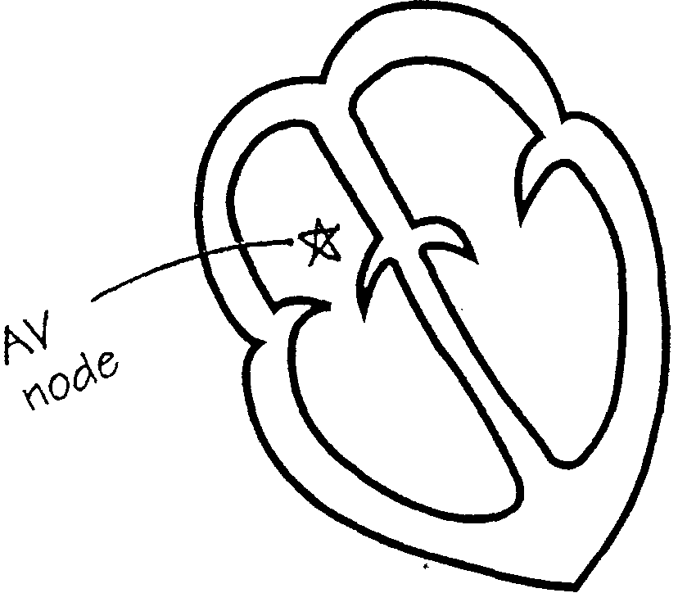
The A V node is located on the floor of the right atrium just above the ventricles.
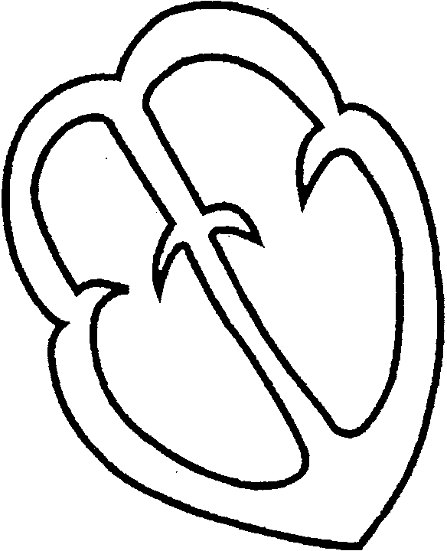Place a star on the AV node.

The function of the A V node is to act as a gatekeeper and briefly delay the impulses coming from the SA node, to allow the atria to contract completely and empty all of the blood into the ventricles.
If impulses are coming too fast, the AV node slows them. If impulses from the SA node are blocked or absent, the A V node can generate impulses to keep the heart beating.
Provided that the SA node does all it is supposed to do, the A V node just conducts impulses sent from above. The AV node has an intrinsic rate of 40-60 beats per minute-slower than the SA node, but better than nothing.
Extra Credit
If the SA node was not firing and the AV node took over, what would be the heart rate (pulse) of the patient? It is a range of _____beats per minute.
The A V node further conducts electrical impulses to the bundle of His. The bundle of His carries impulses from the A V node to the right and left bundle branches and eventually to the Purkinje fibers. These three systems together-the bundle of His, the left and right bundle branches, and the Purkinje fibers-are responsible for contracting the ventricles.
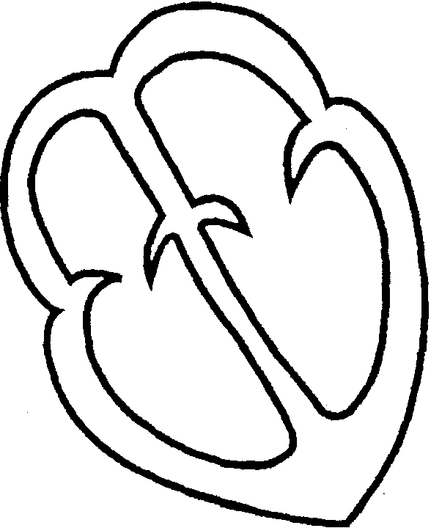

- Divide the heart into the four chambers.
- Star and label the SA node.
- Star and label the AV node.
- Draw and label the bundle of His.

To contract fully, the ventricles require the assistance of the right and left bundle branches and the Purkinje fibers. The excitation or passage of an electrical impulse, along these pathways causes the ventricles to contract.
- Outline the bundle of His. the right and left bundle branches. and the Purkinje fibers.
- Shade the ventricles to show them contracting.
- Fill in the intrinsic firing rate of the AV node: ______ beats per minute.
- The function of the bundle of His, the left and right bundle branches. and the Purkinje fibers are to contract the ________.

The cells of the ventricles have the slowest intrinsic firing rate in the heart. They fire at 20-40 beats per minute. The final phase of each heartbeat is the relaxation phase. In this relaxation or refractory phase, the heart relaxes and repolarizes.
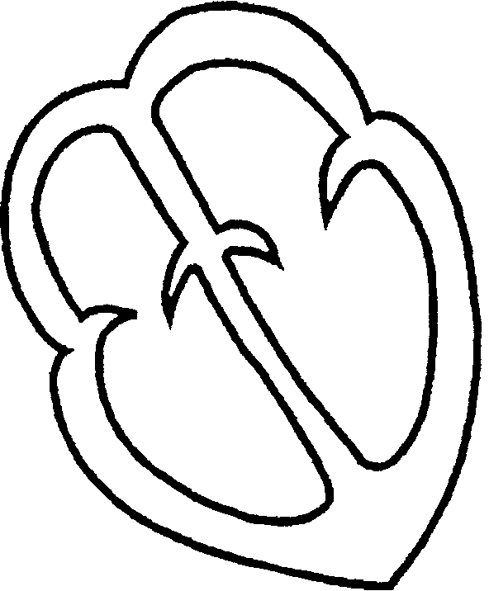
During the absolute refractory phase, the ventricles cannot receive further stimulation. As with other organs in the body, there is a period of time after stimulation when the ventricles cannot get excited again.
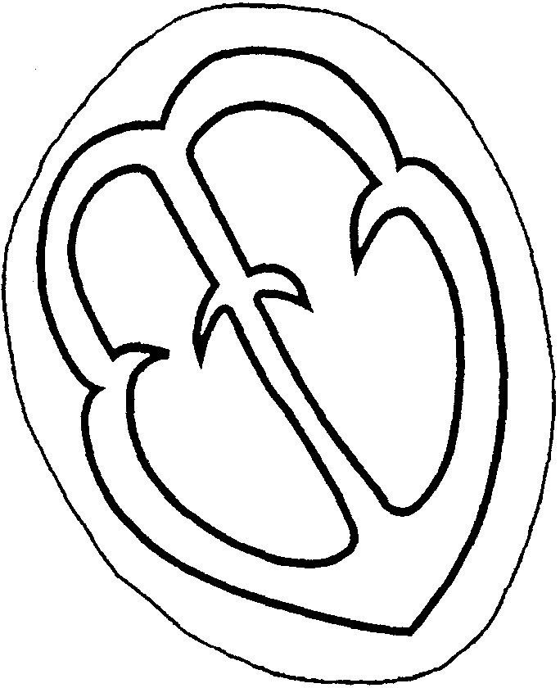Circle the entire heart to show the heart relaxing and repolarizing.

Let's review:
- The SA node is located in the upper right atrium. It has an intrinsic firing rate of 60-100 beats per minute and is the primary pacemaker for the heart.
- The AV node is located on the floor of the right atrium. It has an intrinsic firing rate of 40-60 beats per minute and is known as the gatekeeper of the heart because it regulates impulses coming from the SA node.
- The bundle of His, the left and right bundle branches, and the Purkinje fibers are located down the septum and in the lining of the ventricles. They have an intrinsic firing rate of 20-40 beats per minute. These three work together to contract the ventricles.

The ECG
Before Einthoven invented the electrocardiogram machine, patients had to be cut open to see what their heart was doing. This resulted in a generally poor prognosis. Now, we can monitor the heart's electrical activity through electrodes placed on intact skin. The ECG records electrical conduction through the heart. Electrode pads placed on the patient's chest can detect the electrical activity generated by the myocardial cells. They are attached by cables to an ECG monitor. The ECG monitor has one positive electrode, one negative electrode, and one ground electrode.
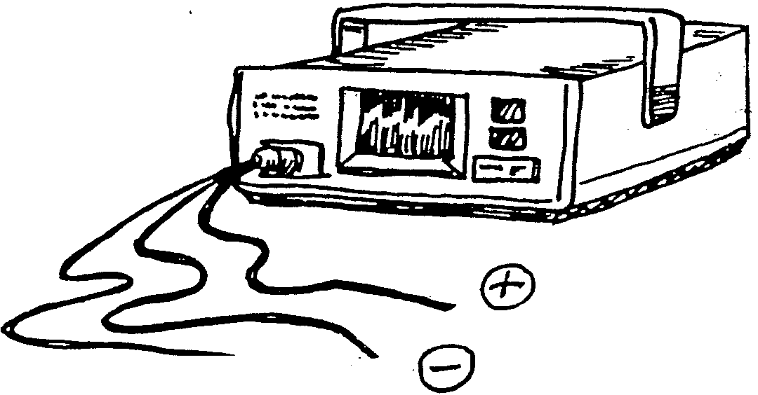

READING ECGs: P WAVES. QRS Complexes, T WAVES
Atrial and ventricular depolarization and repolarization are electrical events that are seen as waves on an ECG monitor or on ECG paper. As the electrical impulse is conducted downward through the heart, we can watch its path on the ECG monitor. Each wave on the ECG represents the path of an electrical impulse as it is conducted through the heart.
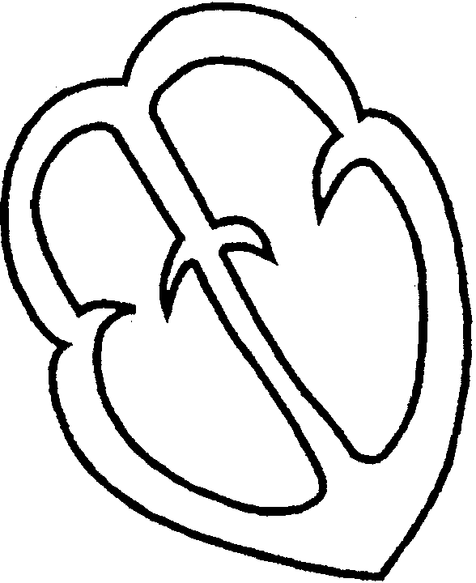
P wave
The P wave represents the depolarization (contraction) of the atria.
- Place a star on the SA node.
- Shade the atria.
- The function of the SA node is to contract the__________.

Draw and label a P wave.

P-R Interval
The P-R interval is the time it takes for an electrical impulse to be conducted through the atria and the AV node. The P-R interval is measured' from the beginning of the P wave to a small tail that extends just past the P wave. It is called the P-R interval, but it includes the entire P wave. It represents depolarization of the heart from the atria through the AV node. A normal P-R interval indicates that conduction through the AV node has followed a regular, unobstructed course.
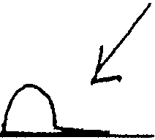 ____________________________
A P wave with a P-R interval, Draw and label a P wave with a P-R interval.

QRS Complex
The QRS complex represents the depolarization (contraction) of the ventricles.
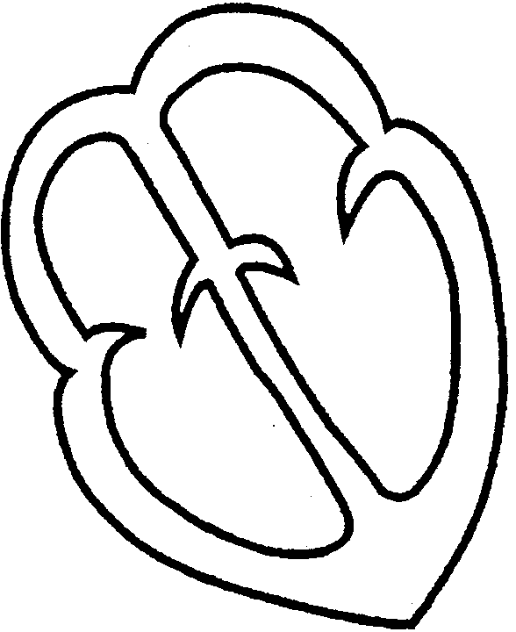
- Place a star on the bundle of His; draw the right and left bundle branches and the Purkinje fibers.
- Shade the ventricles.
- The function of the bundle of His, the right and left bundle branches, and the Purkinje fibers is to contract the __________.

The QRS complex consists of
- The Q wave, which is the first negative or downward deflection of the complex. The Q wave is often not seen.
____________________________ ____________________________
First downward deflection Draw and label a Q wave.
The R wave, which is the first upward deflection.

Draw and label a Q wave and an R wave, __________________________________________________
The S wave, which is the rest of the complex, the next downward and upward deflection.

Draw and label a QRS complex. ______________________________________________________________________
P wave & QRS complex
Draw and label a P wave, a P-R interval, and a QRS complex.
___________________________________________________
T wave
The T wave represents the heart repolarizing (relaxing). This is called the refractory period.
Draw and label a T wave. _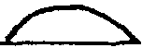______________________

The T wave is rounded. It is usually larger and more equally rounded than a P wave. Think of the shape of a turtle shell.
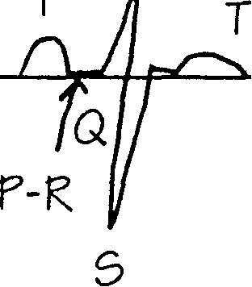_____________________________________________Draw and label a P wave, a P-R interval, a QRS complex, and a T wave.

What would you see if the SA node didn't -Are? Draw and label answer .Answer: ________________________________________

What would you see if the SA node -fired but the impulse was blocked at the AV node? Draw and label answer.
_________________________
What would you see if there was a delay at the AV node? Draw and label answer. ________________________________________
A Helpful Hint
Every patient's P waves, QRS complexes, and T waves look slightly different. If you are ever stuck and cannot distinguish which are the P waves and which are the T waves, try this: Find the QRS complex, and look before it: that should be a P wave. Look after it: that should be a T wave. Find another complex and try it again to check your first finding. This method works for most basic rhythms. To determine if a rhythm is regular, check the R-R interval. The R-R interval is measured from the peak of one R wave to the peak of the next (top of the QRS complex to top of the next QRS complex).
ECTOPIC ACTIVITY
All the cells in the heart can create electrical activity on their own. Usually, there is no need for this aberrant behavior, and cells quietly conduct impulses from the primary pacemaker sites. Occasionally, a little oxygen-deprived, irritable, frustrated cell goes off and fires on its own. This is known as ectopic or aberrant activity. Ectopic means outside of the usual pacemaker sites.
When this happens, the ectopic beat is recorded on the ECG as a different-looking complex. An oxygen-deprived, irritable cell is known as an irritable focus, or the plural, irritable foci.
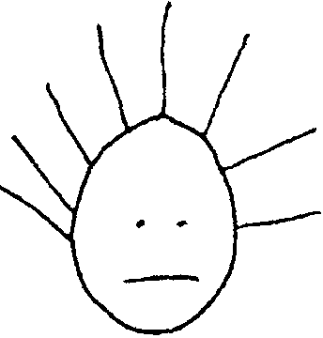
If the ectopic beat is originating in an irritable focus close to the SA node, the beat looks almost like a normal P wave and conducts a normal looking QRS complex. There are two clues to recognizing an ectopic beat:
- It looks slightly different.
- It comes at an unexpected time.
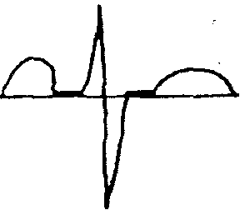A complete complex. Now it’s your turn!!

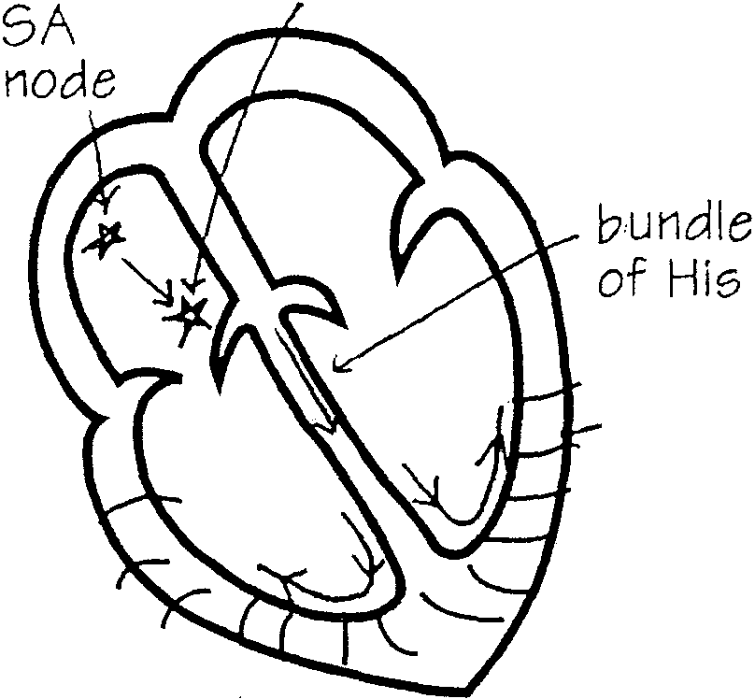
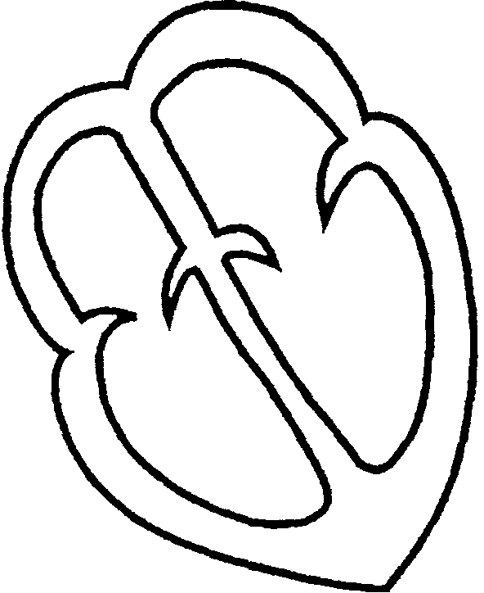
Outline the path of a regular path of conduction.

Draw an ectopic focus in the atria.

An ectopic focus in the atria,
Outline the path of conduction for this ectopic beat, The path of conduction for this ectopic beat.
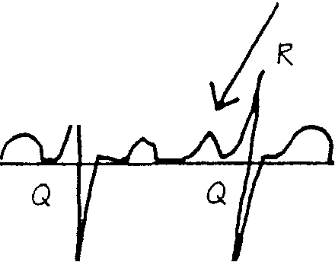
unusual-looking P wave
Draw a complete complex followed by an unusual-looking P wave, a ORS complex, and a T wave.

Premature Atrial Contraction
The beat just depicted is called a premature atrial contraction:
Premature meaning early or before the SA node was expected to fire.
Atrial meaning from the atria.
Contraction meaning beating or contracting of the heart. It is from the atria because the impulse originated in the atria and it created a complex that looked like a P wave but not exactly like the other P waves, and it conducted a normal-looking QRS complex.
Two interesting facts to note:
- The closer the irritable focus is to the SA node, the more the premature atrial contraction will resemble a P wave.
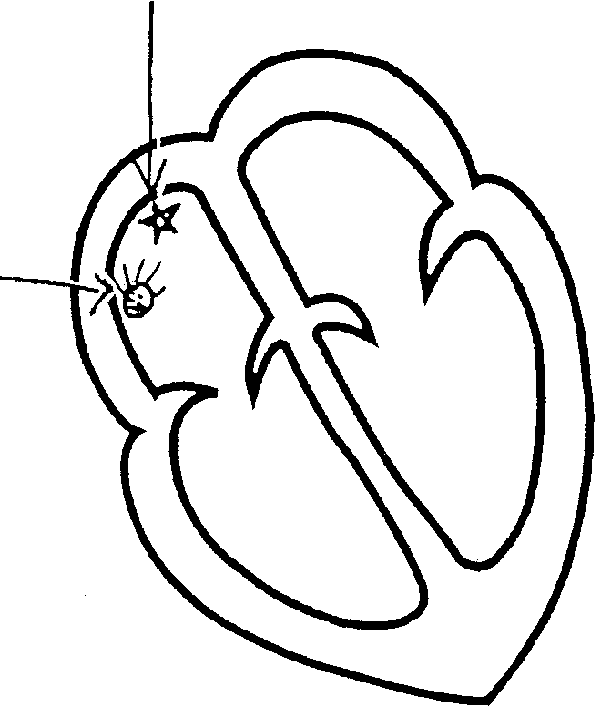
2. The closer the irritable focus is to the AV node, the shorter the P-R interval.
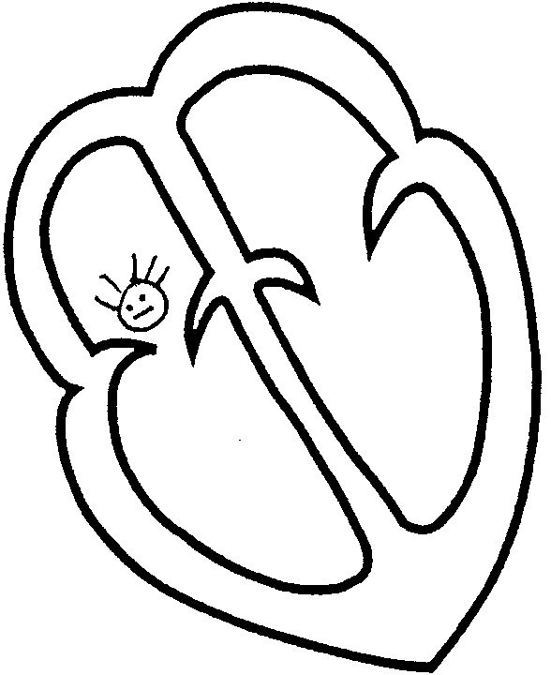

P wave looks like a P wave, only a little different
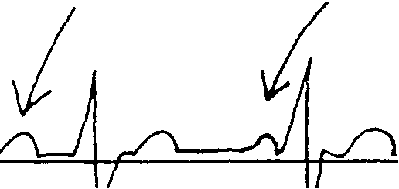 Close to the SA node, the premature atrial contraction looks like a P wave.
P wave
shortened P-R interval
Close to the AV node, the premature atrial contraction shortens the P-R interval.
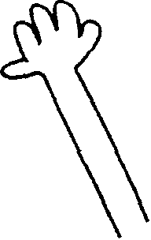
EXCUSE ME: Why does the heart conduct these ectopic beats?

Premature Junctional Contractions*
When the AV node fires on its own, there may be no P wave or there may be an inverted P wave (retrograde conduction).
*Also known as premature nodal contractions.
Draw the AV node firing.
Shade the ventricles.
Shade upward toward the bottom of the atrium.
1 . The AV node Bring independently. 2. The shaded area contracts.

AV node

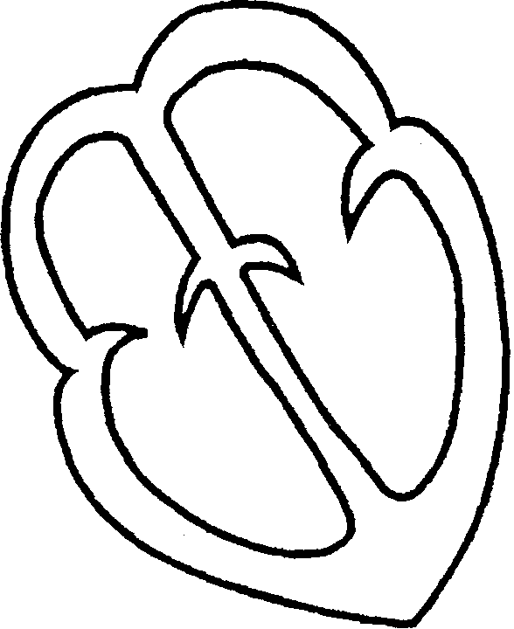

no P wave______________________
inverted P wave from retrograde conduction _______________________________
A normal complex followed by a premature Junctional contraction. Draw a normal complex followed by a premature Junctional contraction.
________________________________________________________________________
If the A V node becomes irritable or fussy and sends out a spark on its own, it results in
- An inverted P wave or no P wave.
- A stand-alone QRS complex and T wave.
This is called nodal or Junctional because it originates in the AV node, also known as the A V junction.
If the impulse is conducted backwards up through the atrium, it may appear as an inverted P wave on the ECG.
Premature Ventricular Contractions
When an irritable or ectopic focus in the ventricle fires independently, it is called a premature ventricular contraction.
Draw an irritable focus in the ventricles.
Shade the ventricles to show them contracting.
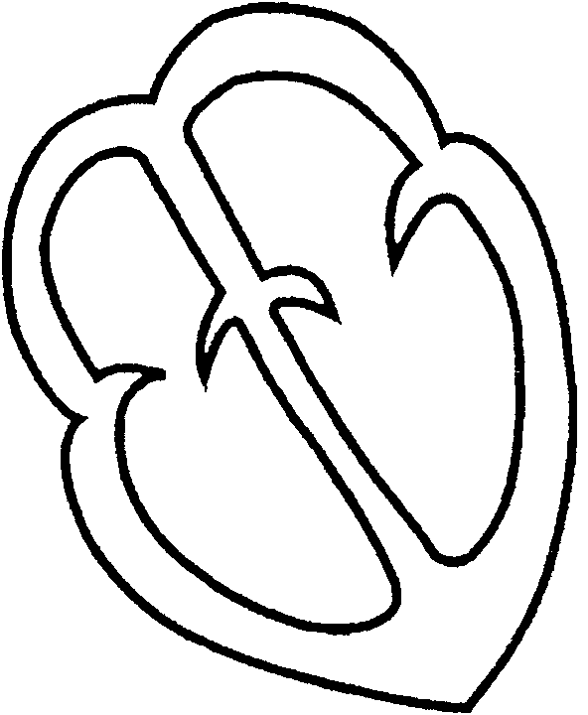An irritable focus in the ventricles.

Because of the conduction pattern of a premature ventricular contraction, the complexes appear as wide and bizarre on the 3-lead ECG.
Wide
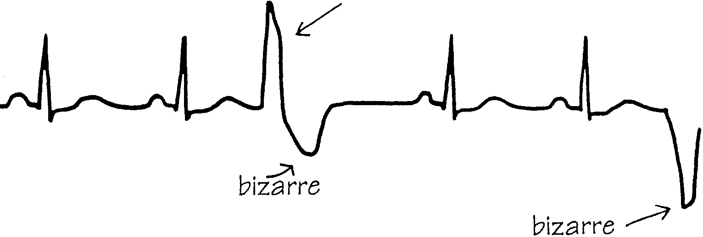
A normal complex followed by a premature ventricular contraction.
Draw a normal complex followed by a PVC:

There can be more than one ectopic focus in the ventricles. If so, the premature ventricular contractions look different from each other.
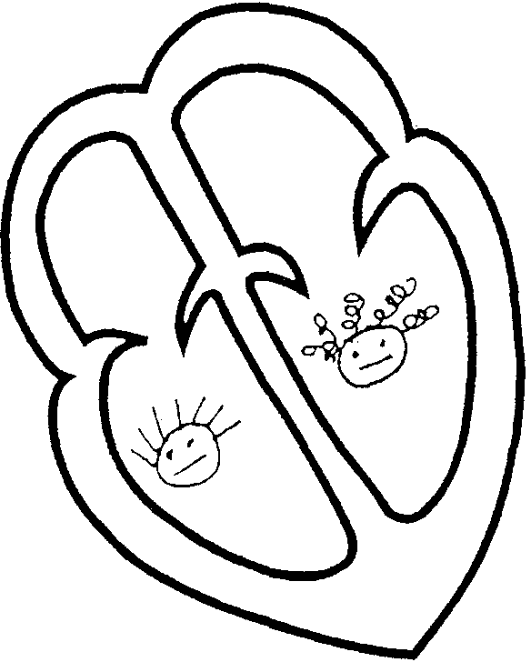

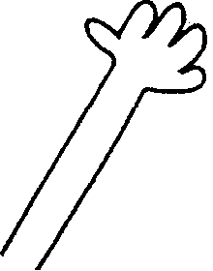

EXCUSE ME :How do I know if complexes are wide or thin or long or short? What does a normal complex look like?
Answer:

Introduction to the Rhythms
ATRIAL FLUTTER
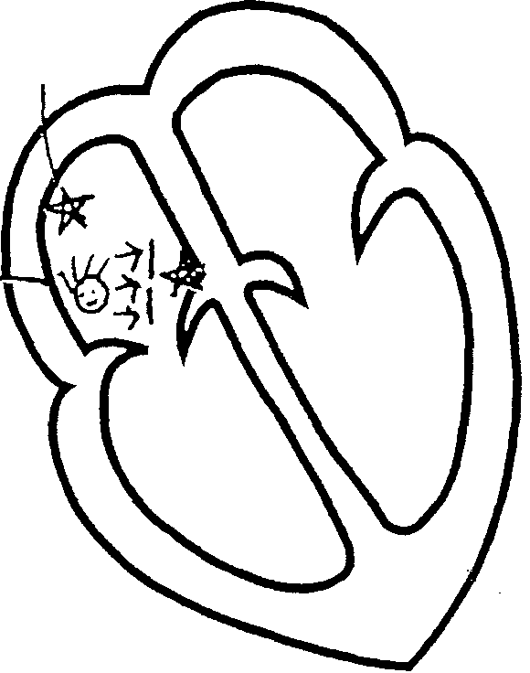
In atrial flutter, a single strong ectopic focus in the atrium starts to beat fast, 240-360 beats per minute. The AV node acts as a gatekeeper in this rhythm, allowing only some impulses through to the ventricles .

SA node with a strong ectopic atrial focus

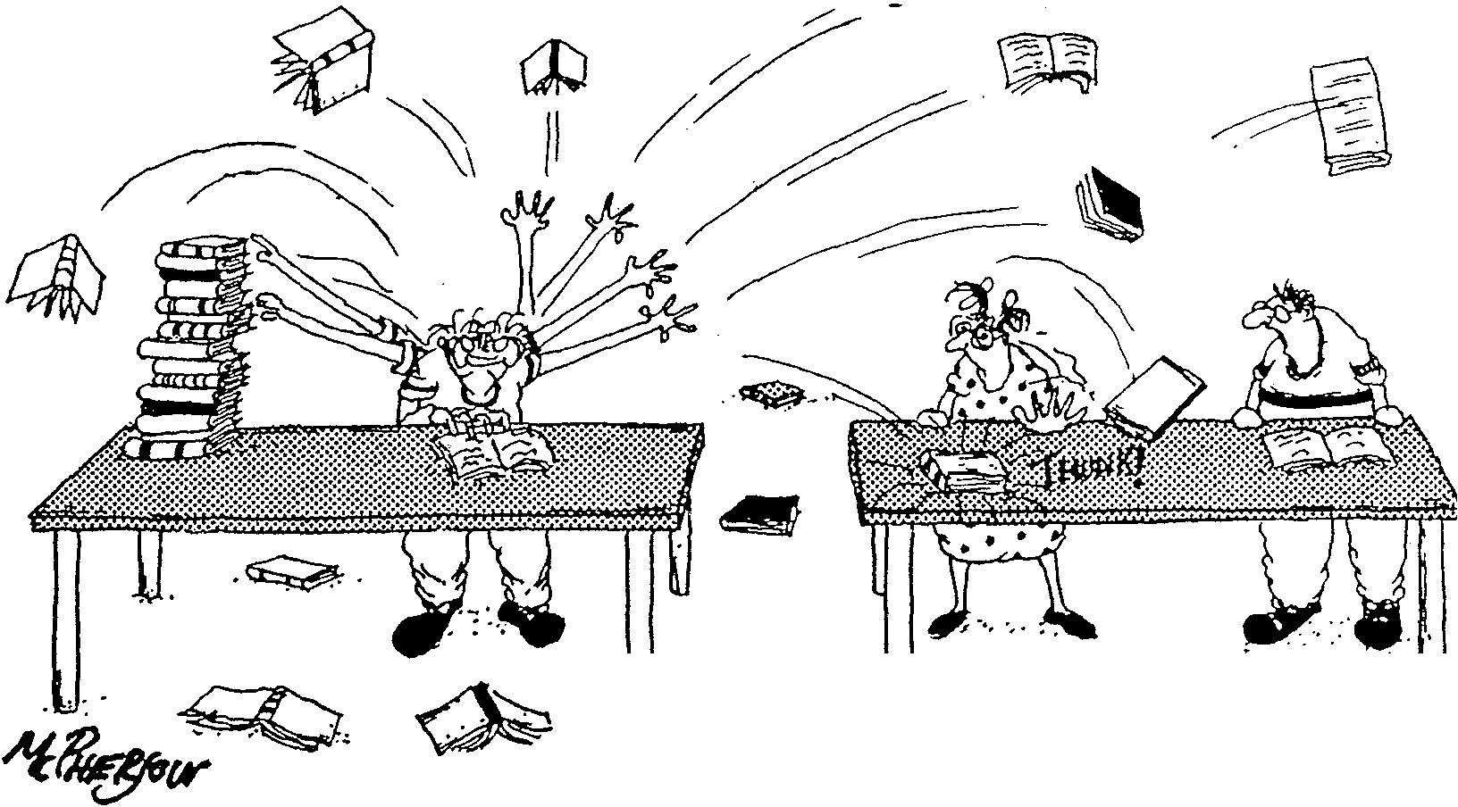

"He's been getting on my nerves ever since he took that speed reading course."
In atrial flutter, a single strong ectopic focus is sending out rapid impulses.
ATRIAL FIBRILLATION 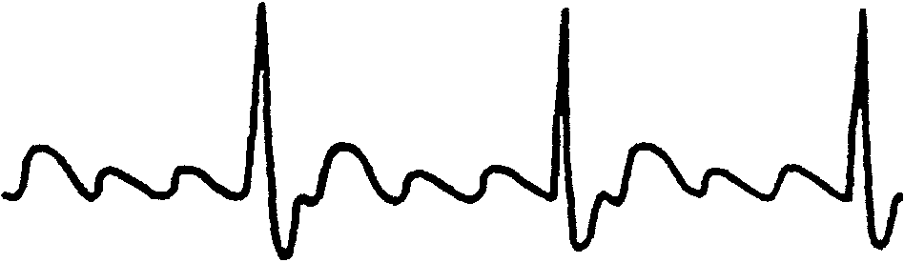
In atrial fibrillation, many weak ectopic foci in the atria beat in an uncoordinated pattern, resulting in an uneven baseline of many tiny P waves known as fibrillatory (f) waves. Eventually the ventricles receive enough electrical stimulation to contract, or they contract on their own. This rhythm is characterized by a coarse baseline and an irregular distance between the QRS complexes.
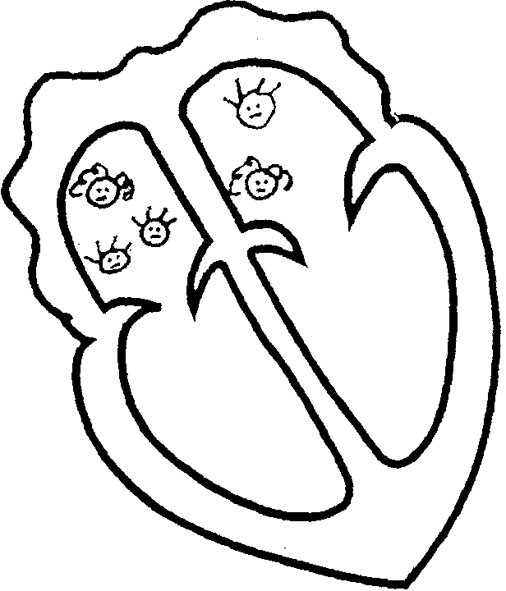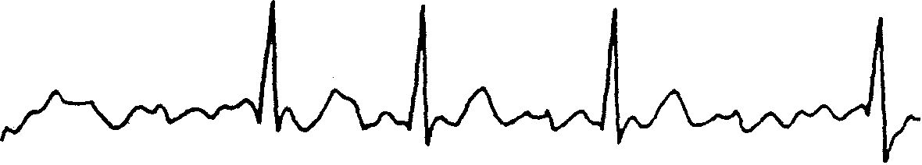

In atrial fibrillation, many weak ectopic foci in the atria all fire at different times, causing an uncoordinated effort and confusion.
SUPRAVENTRICULAR TACHYCARDIA
This rhythm occurs when there is a fast, strong stimulus from an ectopic focus above the ventricles and below the SA node, and the heart conducts every beat. In supraventricular tachycardia the heart rate is 160-250 beats per minute.
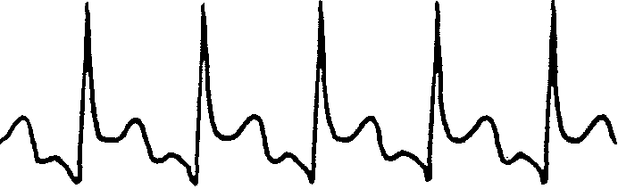
This can result in an inadequate refilling time, similar to squeezing a sponge fast under water and never allowing it to open or fill completely. This rapid action can result in low blood pressure. Additionally a person's heart cannot sustain this rhythm for long because the muscle itself gets tired.
In supraventricular tachycardia, the impulses are conducted very fast, but it is almost impossible to sustain this rhythm.
VENTRICULAR -TACHYCARDIA
Ventricular tachycardia is the result of one strong ventricular ectopic focus that hijacks the conduction system of the heart. This rhythm cannot sustain life for long. Ventricular tachycardia can be "stable," meaning with a pulse, or "unstable," meaning the patient is hemo-dynamically compromised, or pulse less.
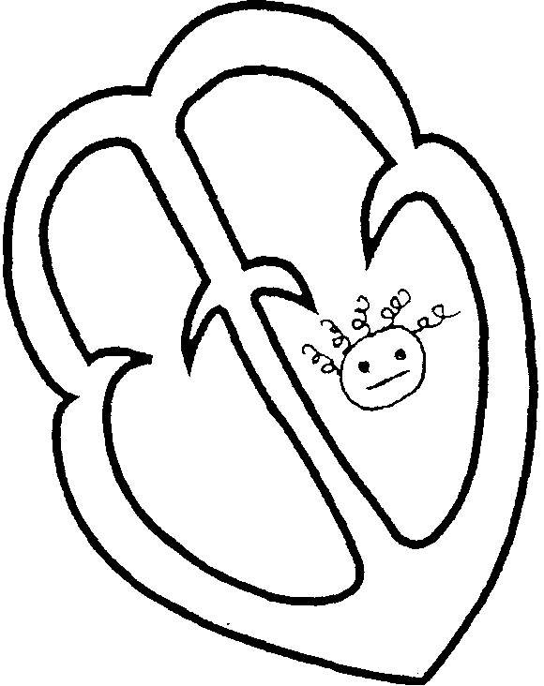Ventricular tachycardia has one strong ventricular focus.
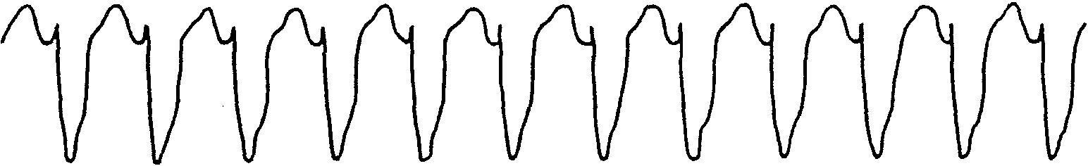

VENTRICULAR FIBRILLATION
Ventricular fibrillation is the result of many weak ectopic foci in the ventricles, resulting in an uncoordinated undulation instead of a coordinated contraction. It is a rhythm that cannot circulate blood and is not compatible with life. If you could see the ventricles, they would resemble a squirming bag of worms.
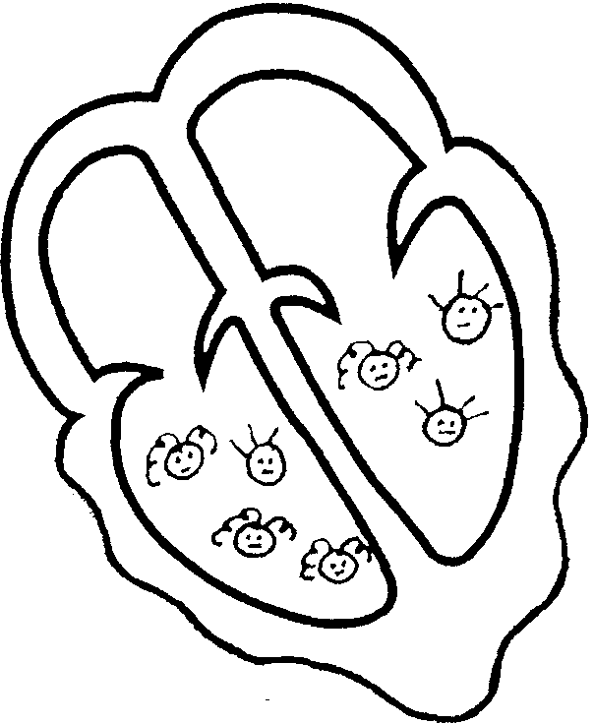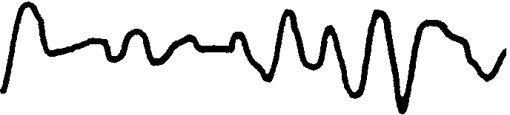
Ventricular fibrillation is the result of the uncoordinated beating of many weak ectopic ventricular foci

ASYSTOLE
Asystole, or a flat line, is not a rhythm but the absence of all electrical activity and is indicative of clinical death. 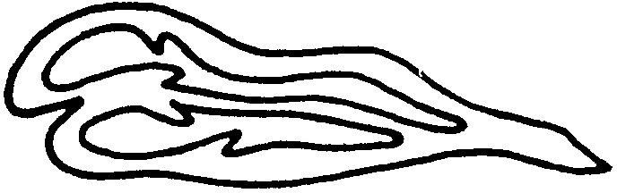
ARTIFICIAL PACEMAKERS
Pacemakers are battery-operated electrical devices that can fire either "on demand," meaning when the heart rate drops below a certain speed, or at a pre-set rate. They can be located anywhere in the heart but are usually placed in the ventricles.
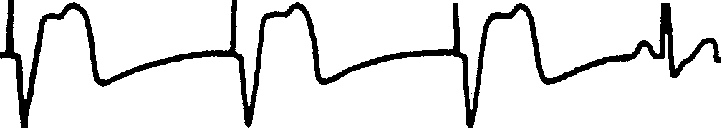
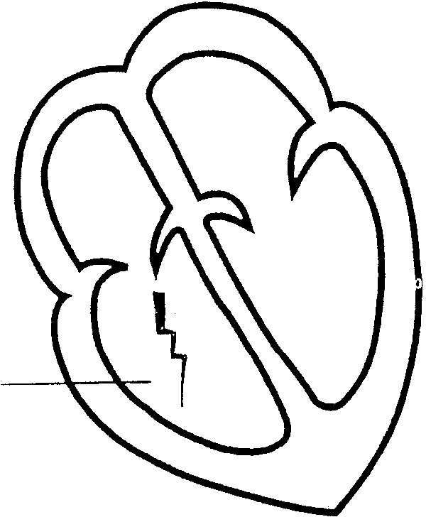
pacemaker spike
Electrical pacemakers are placed in the heart to keep the rate and rhythm regular and to keep it from dropping

ECG Paper
The complexes measure the events; the paper measures time.
The ECG paper rolls out of the machine at a pre-set speed of 25 mm or 1 inch per second. The paper is marked off in a grid, with each line 1 mm apart. Every fifth line is darker and thicker. This is designed to help you count these very small boxes.

The small boxes represent 0.04 second. Each large box is made of five small boxes and represents 0.20 second .
.04
.20
An event that takes 0.08 second would create a line two small boxes long .
.08-
Draw a line representing 0.08 second (or two small boxes). 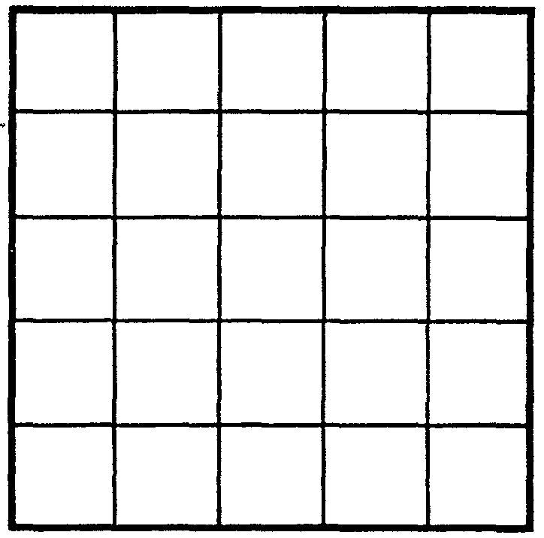
Draw a line representing 0,20 second (or one large box),
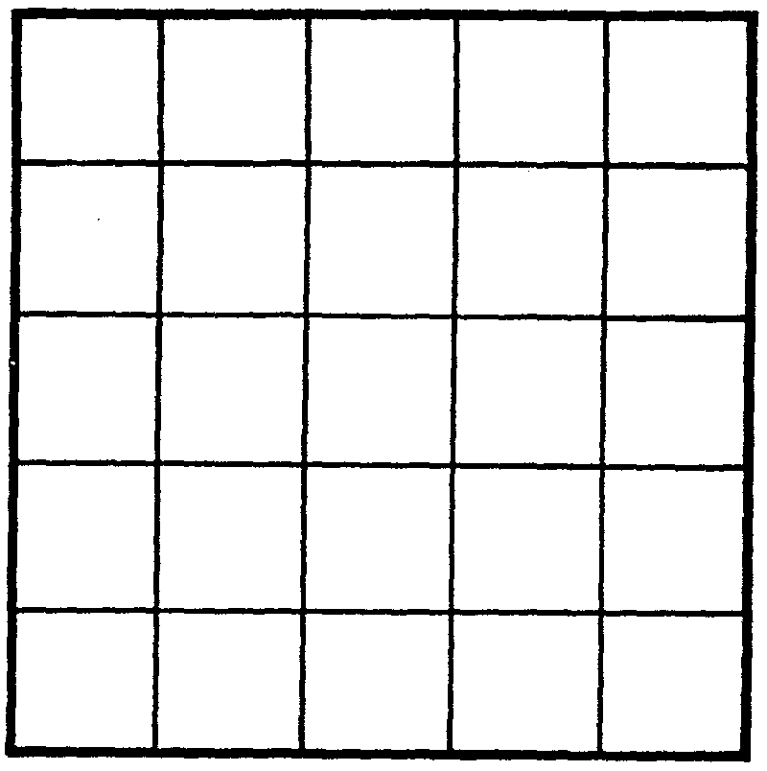
Draw a line representing 0,12 second, (How many boxes?)
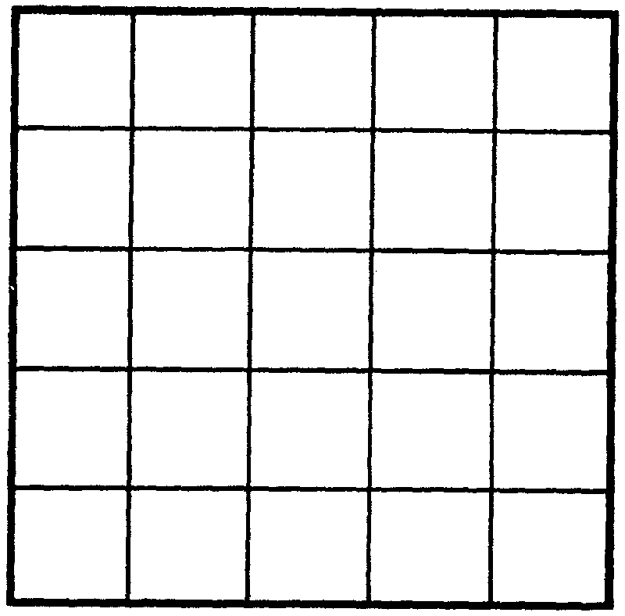
ANSWER:
Normal ECG
What is normal?
The criteria for a normal ECG are reproduced on the back of
Cohn's Pocket Guide to ECG Interpretation and are as follows: one small box-O.04 second - one large box-0.20 second
- P wave-3 small boxes or 0.12 second wide
- P-R interval-(count from the beginning of the P wave to the beginning of the R wave) 3-5 small boxes or 0.12-0.20 second wide
- QRS complex-1-2! small boxes or 0.04-0.10 second wide The height of the QRS is adjustable on each machine.
- T wave-upright, well rounded, and less than half the height of the QRS complex
If it usually takes you 20 minutes to get to work and you are delayed in traffic, it will take you longer. You will use more gas and more time, even though you have traveled the same distance. Someone tracking you on radar would see a dot moving slowly across the screen.
In ECGs, if the complex is wider than normal, it means that the electrical impulse was slowed somewhere in the heart. If the complex is narrower than normal, it means that the impulses are passing more quickly through the heart.
The ECG is a graphic representation of the electrical activity in the heart. By counting the boxes, we can establish the time the complex took to travel. By counting the number of complexes in 1 minute, we can establish a rate.
Calculating Rate
It is unwieldy and cumbersome to count 60 seconds of ECG strip. There are a number of methods that have been established to count rate. Rulers are also available to assist in this calculation.
The easiest, most accurate method is called the 6-second strip method. Instead of counting the number of complexes in 60 seconds, we count the number of complexes in 6 seconds and multiply by 10 (or just add a zero).
Six seconds of strip is equal to
- thirty large boxes (6 seconds) or
- six I-second markers (6 seconds) or
- two 3-second markers (6 seconds) or one 6-second marker (6 seconds) depending on design of the ECG strip you are using.
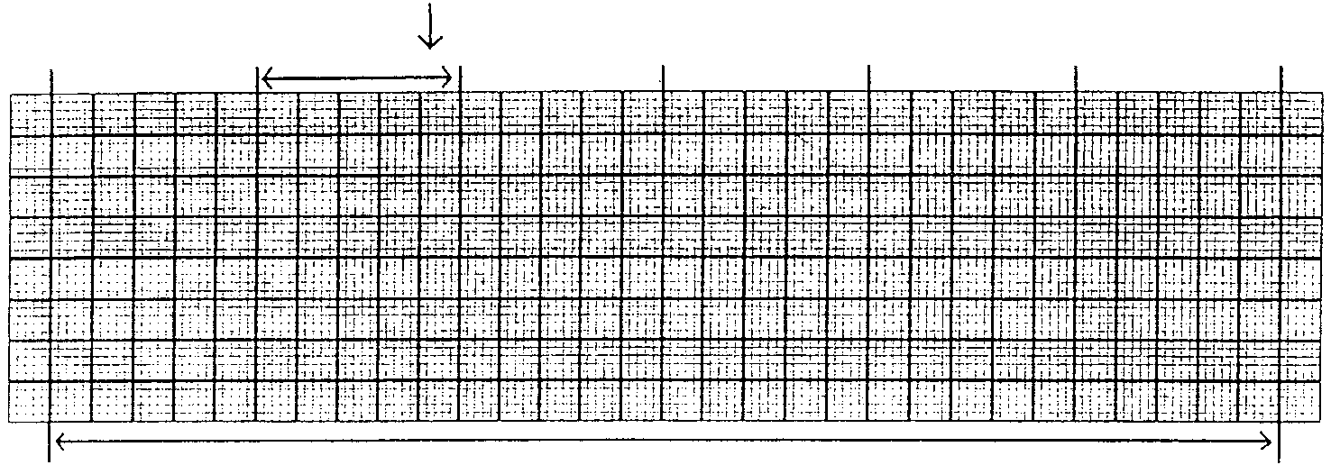six 1-second markers, one 6-second marker. or 30 large boxes
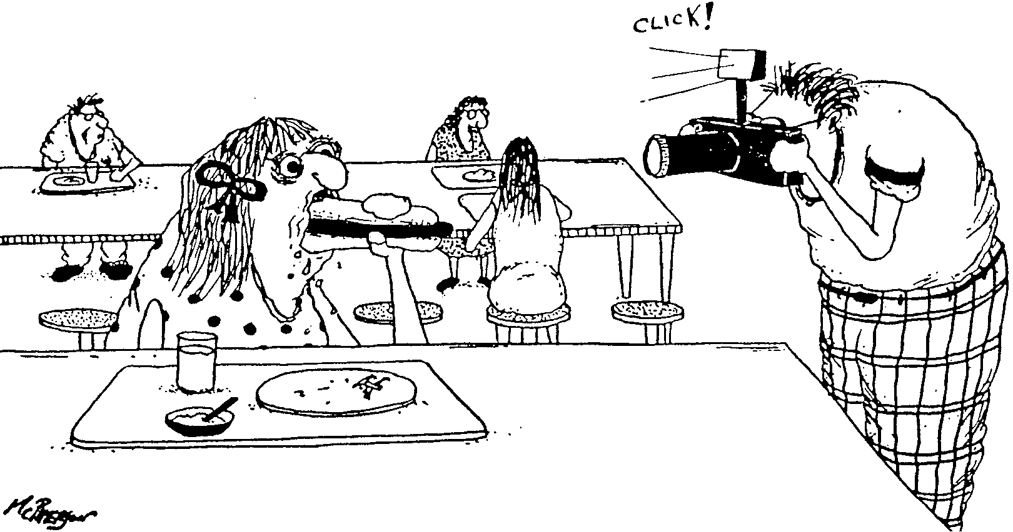Timing is an essential part of being a yearbook photographer.
In ECG interpretation, timing is everything.
Practice calculating rate.

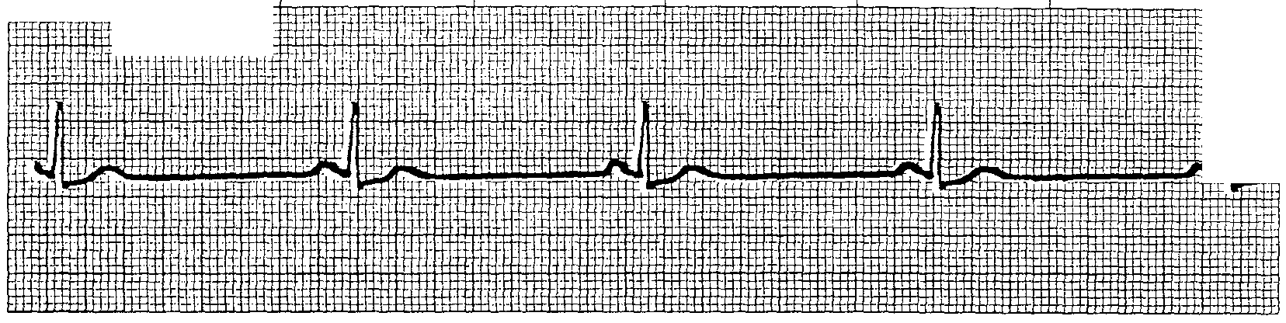

Rate is beats per minute.

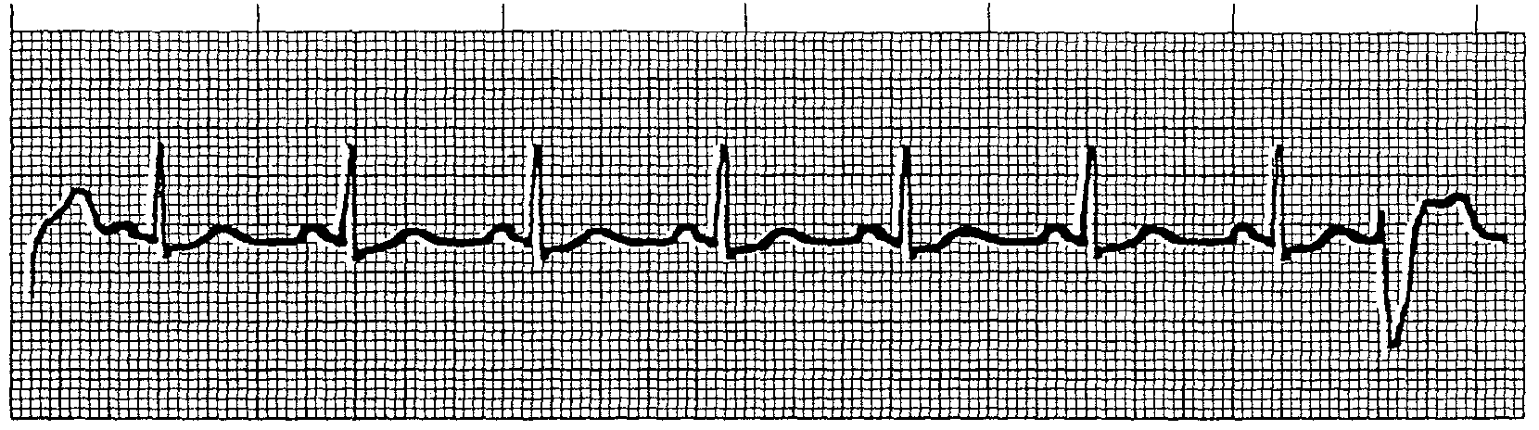

Rate is ______beats per minute.
Answer:
Hint: Do not count the premature ventricular contraction.

Summary
Contraction and relaxation of the heart are mechanical events launched by electrical activity. The ECG is usually a good reflection of the current status of the heart. But not always .
You must confirm that what you see on the monitor is what is happening inside the patient; you should feel a pulse each time you see a complex on the monitor and should perform frequent blood pressure checks. In all cases, you should always treat the patient and not the monitor.
The ECG records the electrical activity of
- The atria as they depolarize (the P wave).
- The ventricles as they depolarize (the QRS complex).
- The relaxation phase of the ventricles (the T wave); when the entire heart rests, relaxes, and repolarizes.
In most cases, the electrical activity of the heart accurately reflects the mechanical action inside.
The ECG records any and all electrical impulses in the heart. It records complexes that originate from primary pacemaker sites: the SA node, the AV node, the bundle of His, the left and right bundle branches, and the Purkinje fibers. It also records untoward, unwelcome impulses from elsewhere. The primary pacemaker sites usually lead to a regular rhythm, in which the R-R interval (the measure from R wave peak to R wave peak) remains constant.
Because all the cells of the heart can create their own electrical impulses, a phenomenon known as automaticity, we occasionally see ectopic pacemaker sites. Ectopic means outside or away from the usual pacemaker sites, as an ectopic pregnancy is one that is outside the uterus.
Complexes that look the same come from the same place in the heart. That place can be either a primary pacemaker such as the SA node or an ectopic pacemaker such as one small irritable, oxygen-deprived cell in the atria.
If the heart is ready to receive an electrical stimulation, it conducts any impulse that comes along and the ECG monitor or paper records it.
Naming Rhythms
To have success in naming rhythms, you'll need the following vocabulary:
sinus-normal
brady--slow
tachy--fast
-cardia-pertaining to the heart
regular-the R-R interval is equal
irregular-the R-R interval is irregular premature-the complex came earlier than expected compensatory-pause when the heart holds a beat atrial-originating in the atria ventricular-originating in the ventricles
contraction-an electrical impulse was conducted and contracted the heart muscle
ECGs are generally named for the pattern they represent.
It is like being a detective in a mystery game. All the clues are right here on the strips.
- Step 1-relax and get comfortable.
- Step 2-fiip to the front of this book and pick up Cohn's Pocket Guide to ECG Interpretation.
- Step 3-read and answer the questions as they are listed on the pocket guide, and you'll be interpreting ECGs in the next 10 minutes.
Clues to Identifying Rhythms
The best approach to identifying rhythms is to use a systematic method, or a process that you repeat each time. One such system is presented by Cohn's Pocket Guide to ECG Interpretation. You should use that guide each time you identify a rhythm. Listed here are further pointers in ECG recognition.
- Look for complete complexes. The QRS complex is the tallest complex. Find the QRS complex; before it is the P wave and after it, the T wave. This doesn't always work, but it is always a good start.
- Presence of P waves. Rhythms are usually named for their site of origin. Almost all rhythms with upright P waves originate in the atria.
- Rate is the other clue to the origin of a rhythm. For example, a rate of 40-50 may be Junctional because 40-50 beats per minute is the intrinsic firing rate of the A V junction. A rhythm strip with a rate of 44 and no P waves is Junctional in origin.
- Review the strip for wildly abnormal beats; calculate rate and name based on the underlying rhythm, not the abnormal beats. The presence of those beats may be the problem .
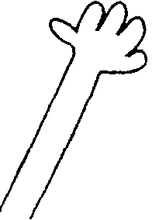EXCUSE ME
What causes the heart to change rhythms?
Answer:
There are two basic kinds of rhythm disturbances:
- Rate disturbances: too fast or too slow
- Conduction problems, including :
- delays in conduction
- alternative pathways of conduction
- conduction of ectopic impulses
- metabolic imbalances

