Memorandum

To: Specimen Processing Staff

CC: File

From:Wendell R. McMillan II

Date:

Re: Sure Swab Urine Specimens

All,

If you receive a specimen in a container matching the picture below (a TMA collection container from Aptima), order test code 11363 for send out to Chantilly. The Psyche code is CTAP for gonorrhea/chlamydia.

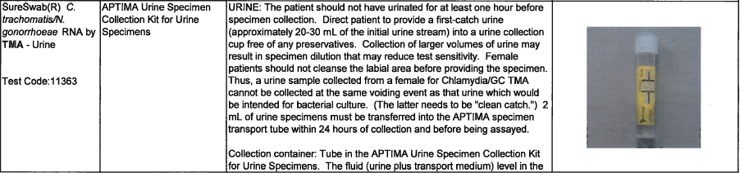

Confidential

Wendell R. McMillan II