Technical SOP
Title | Coulter DxH800 Operation  For Complete Blood Count and Reticulocyte Automated Tests
Prepared by | Ruben Layug | Date: 1/3/2013
Owner | Ruben Layug | Date: 1/3/2013
Laboratory Approval | Local Effective Date:
Printed Name | Signature | Date
Refer to the electronic signature page for approval and approval dates.
Review
Print Name | Signature | Date

TABLE OF CONTENTS
1. TEST INFORMATION 2
2. ANALYTICAL PRINCIPLE 3
3. SPECIMEN REQUIREMENTS 4
4. REAGENTS 6
5. CALIBRATORS/STANDARDS 7
6. QUALITY CONTROL 9
7. EQUIPMENT and SUPPLIES 13
8. PROCEDURE 14
9. CALCULATIONS 15
10. REPORTING RESULTS AND REPEAT CRITERIA 15
11. EXPECTED VALUES 17
12. CLINICAL SIGNIFICANCE 17
13. PROCEDURE NOTES 18
14. LIMITATIONS OF METHOD 24
15. SAFETY 25
16. RELATED DOCUMENTS 25
17. REFERENCES 25
18. REVISION HISTORY 26
19. ADDENDA 26

TEST INFORMATION

Assay | Method/Instrument | Local Code
Hemogram (WBC, RBC, HGB, HCT, MCV, MCH, MCHC ,RDW PLT, MPV) | Coulter Automated Hematology Analyzer, DXH 800 | CBCN
CBCN + ADIF or MDIF | Coulter Automated Hematology Analyzer, DXH 800 | DCBC
Automated Differential Count Only | Coulter Automated Hematology Analyzer, DXH 800 | ADIF
Platelet Count | Coulter Automated Hematology Analyzer, DXH 800 | PLTC
Reticulocyte Count |  | RETC
Manual Differential Count |  | MDIF
Manual Reticulocyte Count |  | RETM

Abbreviation | Term | Abbreviation | Term
WBC | White Blood Cell | MCHC | Mean Corpuscular Hemoglobin Concentration
RBC | Red Blood Cell | MCHC | Mean Corpuscular Hemoglobin Concentration
HGB | Hemoglobin | RDW | Red Cell Distribution Width
HCT | Hematocrit | DIFF | Differential Count
MCV | Mean Cell Volume | PLT | Platelet
MCH | Mean Corpuscular Hemoglobin | MPV | Mean Platelet Volume
RETIC | Reticulocyte Count
Department
Hematology

ANALYTICAL PRINCIPLE
2.1 CBC
Automated complete blood counts (CBCs) and leukocyte differential are performed using the Coulter DXH 800 system. The DXH 800 analyzers are both modular systems that consist of a Power Supply, Diluter, Analyzer, Workstation, Printer, and Handheld Scanner.

Automated complete blood counts (CBCs) are performed using the Coulter method, which counts and sizes cells by detecting and measuring changes in electrical resistance when a particle (such as a cell) in a conductive liquid goes through a small aperture. Each cell suspended in a conductive liquid (diluent) acts as an insulator. As each cell goes through the aperture, it momentarily increases the resistance of the electrical path between two submerged electrodes, one located on each side of the aperture. This causes an electrical pulse that can be counted and sized. While the number of pulses indicates particle count, the size of the electrical pulse is proportional to the cell volume.

Differential analysis and classification occurs in the flow cell, where:
- Low-frequency current measures volume
- High-frequency current senses cellular internal content through measuring changes in conductivity
- Light from the laser bouncing off the individual WBC cells characterizes cellular surface, shape and reflectivity.

2.2 Reticulocyte
The DxH 800 Reticulocyte function is a procedure for obtaining in vitro quantitative determination of Reticulocytes.

Reticulocyte analysis is performed using a supravital dye, New Methylene Blue, which is incubated with whole-blood samples. The dye precipitates the basophilic RNA network found in reticulocytes. Hemoglobin and unbound stain are removed by adding a clearing reagent, leaving clear spherical mature RBCs and darkly stained reticulocytes. Stained reticulocytes are then differentiated from mature RBCs and other cell populations by light scatter, direct current measurements, and opacity characteristics.

2.3 Determination of Parameters
Type of Measurement | Parameter | Source of Data
Direct | RBC (Red Blood Cell) | Coulter principle
Direct | WBC (White Blood Cell) | Coulter principle
Direct | HGB (Hemoglobin) | Photometric absorbance
Direct | MCV (Mean Cell Volume) | Coulter principle
Direct | PLT (Platelet ) | Coulter principle
Direct | Automated Differential, five-part | Light scatter, volume & conductivity (VCS technology)
Direct | RET% (Reticulocyte) | VCS Technology
Derived from Histograms | RDW (RBC Distribution Width) | RBC Histogram
Derived from Histograms | MPV (Mean Platelet Volume) | PLT Histogram
Derived from Histograms | NRBC% | WBC Histogram and VCS technology
Calculated | HCT (Hematocrit) | HCT = RBC x MCV  10
Calculated | MCH (Mean Corpuscular Hemoglobin) | MCH = HGB x 10  RBC
Calculated | MCHC (Mean Hemoglobin Concentration) | MCHC = HGB x 100  HCT
Calculated | DIFF # parameters | DIFF as % x WBC  (i.e. 0.77 x 5800)
Calculated | Absolute Neut | (Neut% + Band% + Meta% + Myelo% + Promyelo %) X WBC
Calculated | Absolute Lymph | (Lymph% + Reactive Lymph %) X WBC
Calculated | Absolute Monocytes | Mono% X WBC
Calculated | Absolute Eosinophils | Eos% X WBC
Calculated | Absolute Basophils | Baso% X WBC

SPECIMEN REQUIREMENTS
3.1 Patient Preparation
Component | Special Notations
Fasting/Special Diets | Not applicable
Specimen Collection and/or Timing | None defined
Special Collection Procedures | None defined

3.2 Specimen Type & Handling
Criteria
Type -Preferred  -Other Acceptable | K₃EDTA or K₂EDTA Whole Blood  Sodium Citrate – for platelet counts only
Collection Container | Lavender Top Tube  Tri-Potassium or Di-Potassium EDTA Anticoagulant
Volume | Tube |  |  | Minimum |  |  |  | Optimum
 | K₃EDTA or K₂EDTA (non-pediatric) |  |  | 1.0 mL |  |  |  | Full tube
 | Pediatric K₃EDTA or K₂EDTA tube |  |  | 0.5mL |  |  |  | Full tube
 | Microtainer tube |  |  | 0.5mL |  |  |  | Full tube
 | Sodium Citrate |  |  | 1.0 mL |  |  |  | Full tube
Transport Container and Temperature | Same as above. Transport at room temperature or refrigerated.
Stability & Storage Requirements | Room Temperature (18-25ºC): 48 hours  Refrigerated: After analysis, specimens are stored for a minimum of 2 days at 2-8°C.  Frozen (-20ºC and below): Not Acceptable
Timing Considerations | N/A
Specimen Quality Table | Condition | Slight |  |  | Moderate |  | Marked
Specimen Quality Table | Icterus | OK |  |  | OK |  | Orange-Brown = see section 13.8
Specimen Quality Table | Hemolysis | Slight pink OK |  |  | Pink  OK |  | Cherry Red  Unacceptable
Specimen Quality Table | Lipemia | OK |  |  | OK |  | Milky = see section 13.8
Other Interfering Specimens Factors | CBC  Indicated by CBC results (see Addendum 2)  Fibrin, bacterial contamination, platelet clumps, abnormal proteins, cold agglutinins, extreme temperature conditions, resistant hemoglobin, abnormal chemistries and specimens older than 48 hours.  RETIC  Extreme temperatures, other erythrocyte inclusions that stain by new methylene blue dye, some hemoglobinopathies (SS, SC), and specimens older than 72 hours.
Actions to Take for | Condition |  | Code |  |  | Comment
Specimens Message Codes & Notes | QNS  (Less than the minimum volume in Section 3.2) |  | QNS |  |  | Quantity not sufficient to perform test.  Notify caregiver.  (Document in the LIS)
 | Clotted |  | CLT |  |  | Specimen is clotted, unable to perform test.  Notify caregiver.  (Document in the LIS)
 | Spurious results that will not duplicate |  | ISP  or  UNSAT |  |  | Possible interfering substance.  or  Unsatisfactory specimen.  Notify caregiver.  (Document in the LIS)
 | Gross hemolysis |  | HMT |  |  | Markedly hemolyzed.  Notify caregiver.  (Document in the LIS)

REAGENTS
Refer to the Material Safety Data Sheet (MSDS) supplied with the reagents for complete safety hazards. Refer to the section in this procedure covering “SAFETY” for additional information.

4.1 Reagent Summary
Reagents / Kits | Supplier | Catalog Number
DxH Diluent | Beckman Coulter | 628017
DxH Cell Lyse | Beckman Coulter | 628019
DxH Diff Pack | Beckman Coulter | 628020
DxH Retic Pack | Beckman Coulter | 628021
DxH Cleaner | Beckman Coulter | 628023

4.2 Reagent Preparation and Storage
NOTE: Date and initial all reagents upon opening. Each container should be labeled with (1) substance name, (2) lot number, (3) date of preparation, (4) expiration date, (5) initials of tech, (6) any special storage instructions; check for visible signs of degradation.

Refer to the Material Safety Data Sheet (MSDS) for a complete description of hazards. If a specific hazard is present, it will be noted in this procedure when the hazard is first encountered in a procedural step.

NOTE: All reagents are received ready for use.

COULTER® DxH Diluent: COULTER DxH Diluent is a cyanide-free, isotonic buffered saline solution which is stable at 2-25°C until the expiration date posted on the container. Once opened, DxH Diluent is stable for 60 days.

Note: The DxH 800can sample from multiple reagent containers. Do not mix the diluent lot numbers.

COULTER® DxH Cell Lyse: COULTER DxH Cell Lyse is a cyanide-free CBC lytic reagent which is stable at 2-25°C until the expiration date posted on the container. Once opened, the DxH Cell Lyse reagent is stable for 60 days.

COULTER® DxH Diff Pack: The COULTER DxH Diff Pack consists of the Erythrolyse™ Lytic Reagent and StabiLyse™ Preservative Reagent, which is stable at 2-25°C until the expiration date posted on the container. Once opened, the DxH Diff Pack reagent is stable for 60 days.

COULTER® DxH Cleaner: DxH Cleaner is a cyanide-free, aldehyde-free cleaning agent which is stable at 2-25°C until the expiration date posted on the container. Once opened, DxH Cleaner is stable for 90 days.

COULTER® LYSE S® III Diff Lytic Reagent- is a lytic reagent, which is stable at 2-25°C until the expiration date posted on the container. Once opened, the Lyse S III Diff Lytic reagent is stable for 60 days.

COULTER® CLENZ®- is a cleaning agent, which is stable at 2-25°C until the expiration date posted on the container. Once opened, COULTER CLENZ® is stable for 90 days.

CALIBRATORS/STANDARDS

5.1 Calibrators/Standards Used
Calibrator | Supplier and Catalog Number
Coulter® S-Cal® Calibrator Kit | Beckman Coulter 628026

5.2 Calibrator Preparation and Storage
NOTE: Date and initial all calibrators upon opening. Each container should be labeled with (1) substance name, (2) lot number, (3) date of preparation, (4) expiration date, (5) initials of tech (6) any special storage instructions; check for visible signs of degradation.

Calibrator | Coulter® S-Cal® Calibrator Kit
Preparation | Bring to room temperature prior to testing. Use within one hour.
Storage/Stability | Store refrigerated (2-8°C).  Use within expiration date from manufacturer.  For further details refer to the package insert.  Check for visible signs of degradation prior to use, i.e. color change or clotting.

  - Calibration Procedure
Criteria | Special Notations
Frequency | At least every six months, and when indicated by the following:  - New installation.  - New set of apertures, BSV and electronics are installed.  - When recommended by the manufacturer & when ambient temperature changes more than 12°C from calibrating temperature.  - When multiple levels of commercial controls are consistently out or biased for one or more parameters.
Tolerance Limits | IF … | Then …
Tolerance Limits | - results fall within the specifications,  - calibration status is displayed as acceptable  - Quality Control (QC) values are within acceptable limits. | Proceed with analysis.
Tolerance Limits | - results fall outside of specifications  - the calibration status is displayed as failed  - the QC values are outside acceptable limits. | Troubleshoot the assay and/or instrument and repeat the calibration.
Procedure | Select Menu>QA>CBC Calibration  The screen will have the results of the last calibration run that was performed.
Procedure | Select Calibration Setup on the CBC Calibration Screen.  You will be prompted by a dialog box which states:  Existing Data will be deleted.
Procedure | Select OK to continue.  Type “10” in the Number of Aspirations text box.
Procedure | Select Cassette Presentation Mode from the drop-down list.  Select BCI from the Calibrator Type drop-down list.
Procedure | Select Upload and use the handheld bar-code scanner to scan the 2D bar code  on the product insert or type/select the following information:  Lot#  Expiration Date  Reference Values
Procedure | Select OK and follow the screen prompts.  Place the calibrator in a cassette and place it in the input buffer.  Select OK.  Review the calibration results.
Select the Finish button at the bottom of the screen.
If a parameter needed to be calibrated, perform calibration verification by running the 6C controls.

5.4 Documentation

All Calibration and/or Calibration Verification processes (with commercial material) are documented. Calibration and/or Calibration Verification processes are signed and dated by performing staff. Calibration and/or Calibration Verification documents are reviewed, dated, and signed by supervisory staff. Calibration and/or Calibration Verification documents are QC documents and maintained according to guidelines published in the Quest Diagnostics Records Management Program Reference Guide.

QUALITY CONTROL
6.1 Controls Used
Caution: Controls contain sodium azide (<0.1%) and potential biohazardous materials. Use with good laboratory practices to avoid skin/eye contact or ingestion. Consult MSDS for a complete list of hazards.

Commercial Controls | Supplier & Product Number
6C Abnormal I  6C Normal  6C Abnormal II | Beckman Coulter # 628027  12 x 3.5 mL each level
RETIC – X (Level I, II, III) | Beckman Coulter # 628028  12 x 3.5 mL each level
Latron CP X Control Kit | Beckman Coulter # 628024  8 x 4.2 mL each

6.2 Control Preparation and Storage
NOTE: No control preparation is necessary. Date and initial all controls upon opening. Each container should be labeled with (1) substance name, (2) lot number, (3) date of preparation, (4) expiration date, (5) initials of tech, and (6) any special storage instructions; check for visible signs of degradation. Follow the procedure in the Reagent Parallel testing procedure for checking new lots or shipments of reagents.

Control | Storage & Stability & Preparation
6C Abnormal I  6C Normal  6C Abnormal II  RETIC-X (Levels I, II, III) | - Store refrigerated at 2-8°C.  - Bring to room temperature prior to testing.  - Observe expiration date.  - Open vial stability = 16 days Coulter 6C Cell Control  = 16 days Retic-C Cell Control
Latron CP-X | - Store at 2-25°C.  - Bring to room temperature prior to testing.  - Observe expiration date.  - Open vial stability = 30 days

6.3 Frequency
A. All three commercial control levels must be tested each shift. Data from this control run is part of the Coulter IQAP program.
B. Latron Control will be tested as part of start-up procedure only. Refer to Coulter DXH 800 help screen for Control for procedure.
C. Multi-mode sampling
- Each day both closed-mode and open-mode sampling using the commercial control must be performed on each shift, as per CLIA and CAP requirements.
- Typically, most testing is done in closed mode.
- When samples are tested using the closed-mode, a control (Commercial) must be tested for each shift.
D. New Reagent or diluent: One level of Commercial control will be run when all new DXH 800 reagents and diluents are changed. A background check MUST be done and the report stored in the reagent change QC folder in hematology.
E. See Addendum 4 for the Daily Quality Control Schedule for the Beckman Coulter DXH 800.

6.4 Tolerance Limits
The laboratory’s QC program is set up with mean values provided in the package insert for the respective lot# of QC that have been verified per laboratory procedure. For tracking QC in the DXH 800 database, Standard Deviations (SDs) used for acceptable limits must not exceed the Max SD or the SDc (determined from the Coulter QC Range), whichever is greater.

QC Level | Parameter | Max. Total Allowable Error | Max CV, % | Max SD | SDc = Coulter Range / 3
Abnormal I | WBC | +/- 15% | 3.0 | 0.60 | 0.37
Abnormal I | RBC | +/- 6% | 1.2 | 0.05 | 0.04
Abnormal I | Hemoglobin | +/- 7% | 1.4 | 0.18 | 0.13
 | Hematocrit | +/- 6% | 1.4 | 0.52 | 0.63
 | MCV | +/- 6% | 1.2 | 1.0 | 1.0
 | Platelet Count | +/- 25% | 5.0 | 17 | 13
 | Neutrophils (%) | +/- 2SD | 1.5 | 1.0 | 1.67
 | Lymphocyte (%) | +/- 2SD | 3.0 | 0.43 | 1.67
 | Monocytes (%) | +/- 2 SD | 4.0 | 0.6 | 1.0

QC Level | Parameter | Max. Total Allowable Error | Max CV, % | Max SD | SDc = Coulter Range / 3
Normal | WBC | +/- 15% | 3.0 | 0.27 | 0.27
 | RBC | +/- 6% | 1.2 | 0.06 | 0.06
 | Hemoglobin | +/- 7% | 1.4 | 0.23 | 0.20
 | Hematocrit | +/- 6% | 1.4 | 0.67 | 0.90
 | MCV | +/- 6% | 1.2 | 1.0 | 1.0
 | Platelet Count | +/- 25% | 5.0 | 8.7 | 8.5
 | Neutrophils (%) | +/- 2SD | 1.5 | 0.8 | 1.67
 | Lymphocyte (%) | +/- 2SD | 3.0 | 0.79 | 1.67
 | Monocytes (%) | +/- 2 SD | 5.0 | 0.5 | 1.0

QC Level | Parameter | Max. Total Allowable Error | Max CV, % | Max SD | SDc = Coulter Range / 3
Abnormal II | WBC | +/- 15% | 3.0 | 0.10 | 0.13
 | RBC | +/- 6% | 1.2 | 0.022 | 0.027
 | Hemoglobin | +/- 7% | 1.4 | 0.07 | 0.10
 | Hematocrit | +/- 6% | 1.4 | 0.21 | 0.50
 | MCV | +/- 6% | 1.2 | 1.0 | 1.0
 | Platelet Count | +/- 25% | 5.0 | 3.0 | 5.0
 | Neutrophils (%) | +/- 2SD | 2.4 | 1.0 | 1.67
 | Lymphocyte (%) | +/- 2SD | 2.2 | 1.0 | 2.0
 | Monocytes (%) | +/- 2 SD | 8.0 | 0.7 | 1.0

QC Level | Parameter | Max. Total Allowable Error | Max CV % | Max SD | SDc = Coulter Range / 3
Level I | Retic | +/- 2SD | 15.4 | 0.17 | 0.2
Level II | Retic | +/- 2SD | 3.2 | 0.1 | 0.4
Level III | Retic | +/- 2SD | 4.2 | 0.4 | 0.8

Maximum total allowable error is based on CLIA 88 criteria, which also are the CAP evaluation criteria.
Max CV is established by QC BPT to be consistent with recommended QC rules in order to detect changes in the assay that would cause an error that exceeded the maximum allowable total error.
Max SD is determined by multiplying the maximum CV assay value. The assay value changes slightly for each new lot, however, it is expected that the precision will remain constant for each new lot of material...
RUN REJECT CRITERIA: The QC procedure for this assay will employ established Westgard rules. Refer to PHQ.020. The 2SD limit will be identical to the Coulter QC limit. Runs where this QC rule is violated will be rejected.

Each time one control exceeds the criteria for rejection, the run is out of control (failed), and patient results must not be reported. Refer to SOP PHQ.020 for corrective action(s) if the values fall outside of the published limits.

Corrective Action
- Rejected runs must be effectively addressed by corrective action. Steps taken in response to QC failures must be documented. Patient samples in failed analytical runs must be reanalyzed according to the Laboratory QC protocol. Supervisor may override rejection of partial or complete runs only with detailed documentation that follows criteria that is approved by the Medical Director.
- Corrective action documentation must include the following: QC rule(s) violated, the root cause of the problem, steps taken to correct the problem, how patient samples were handled, resolution, and the date and initials of the person recording the information.

Review of QC
- Upon weekly and monthly review of QC by the Lead Technologist or designee, if the Quality Control data is showing a shift or trend. Investigate the cause for the imprecision and document corrective actions. Monthly QC files are printed, compiled in a log and reviewed by the department supervisor/manager or designee.
- All daily shift QC must be submitted with 5 days of outdating to Coulter’s IQAP program for interlaboratory comparison.

6.6 Review Patient Data
Review patient results for unusual patterns, trends or distributions, looking for an unusually high percentage of abnormal results.

6.7 Documentation
    - QC results for each control level and each test mode for an instrument are recorded and stored in the instrument.
    - QC records are printed monthly and maintained and available for a minimum of two (2) years.
    - Patient results are reviewed and released to the patient file via the LIS system.

6.8 Quality Assurance Program
    - Refer to the QA / QC policy for other quality assurance activities applicable to this procedure.
    - Training must be successfully completed and documented prior to performing this test.
    - The laboratory participates in CAP proficiency testing.
    - All techs that perform differential reviews will be required to perform automated and manual differential correlations

6.9 Other QA Tools – XB Moving Averages
IF … | THEN …
XB shows a characteristic pattern of an upward or downward drift | - Check patient population to eliminate the possibility of an increased number of patients with a specific disease state. If this is found, then continue to run instrument.  - Check patient population, if an increased number of patients with a specific disease state are not found; check commercial material for similar trends/shifts.
If commercial control material is in control | The instrument can continue to be operated.
If the commercial control material shows a similar trend/shift | Troubleshoot the instrument and calibrate if necessary.

Hints For XB Troubleshooting
When Measurement | Then …
 | MCV | MCH | MCHC
HGB Decreased | No change | Decreased | Decreased
HGB Increased | No change | Increased | Increased
RBC Decreased | Increased | Increased | No change
RBC Increased | Decreased | Decreased | No change
HCT Decreased | Decreased | No change | Increased
HCT Increased | Increased | No change | Decreased

EQUIPMENT and SUPPLIES

7.1 Assay Platform

Beckman Coulter DxH 800
Brand | Instrument Model | Distributor
Coulter Electronics | DxH 800 | Beckman-Coulter, Inc.  200 S Kraemer Blvd, Brea, CA 92822  1-800-697-0099  Technical Support 1-800-526-7694

7.2 Equipment
Item | Supplier and Catalog Number
Microscope | None specified
Slide Stainer | None specified
Refrigerator, 2-8°C | None specified

7.3 Supplies
Item | Supplier and Catalog Number
Biohazard wipes | None specified
Immersion Oil | None specified
Printer | None specified
Applicator sticks | None specified
Glass Slides | None specified
Lens Paper | None specified
Optical lens cleaner | None specified

PROCEDURE
NOTE: For all procedures involving specimens, buttoned lab coats, gloves and face protection are required minimum personal protective equipment. Report all accidents to your supervisor.

8.1 Preventive Maintenance
Daily and weekly maintenance will be performed and documented on the maintenance log by assigned personnel in the day shift. Please refer to the DXH 800 help screen.

8.2 Start-up/Shut down Procedure
Refer to the DxH 800 help screen.

  - Loading Cassettes
Prior to loading cassettes, mix specimens on a mechanical rocker for 2-5 minutes
Step | Action
1. | IF: Specimen received in standard tube containing optimum amount. | THEN: Load cassettes making sure all bar code labels are positioned appropriately.
2. | IF: Specimen received in Microtainer tube or contains minimum amount of blood. | THEN: Run the specimen in the open mode.
3. | Place the cassettes on the loading bay.
4. | The instrument will start automatically all counts ordered will be performed.
5. | When load is completed, remove cassettes from instrument.

  - Review of Patient Result
Step | Action
1. | Review each patient result before it is released.
2. | Check for delta check flags and critical values.
3 | Call and document all critical values
4. | Release all values that do not need to be repeated for delta values, critical values, or are not flagged on the DxH 800 printout for review.
5. | Pull all specimens that need rerun or slide scan as indicated in Addendum 2.
6. | Store normal specimens.
7. | Rerun tests (those needing repeat analysis as indicated in Addendum 2).
8. | For those specimens that are flagged for scan smear or manual diff, release the hemogram after taking out the manual diff. Refer to Addendum 3.
9. | Make slide for scan smear.

  - Pathologist/ (or designee) slide review
Abnormality | Path.
Prolymphs > 5% | X
Reactive and/or atypical lymphocytes >20% | X
Bands > 25% | X
Meta/Myelos/Promyelo >10% | X
Any blast cell | X
Any unidentifiable cell | X
Any parasite or micro organism | X
Lymphocyte > 70% | X
Review by physician request (PRSM) | X
WBC < 1.5 > 40.0 with abnormal cells | X
NRBC with varying stages of maturity and /or morphological variances | X
RBC morphology: 3+ spherocytes, RBC inclusions, suspect HGB-C crystals, Pappenheimer bodies and bizarre morphology. | X

NOTE: The above guidelines are for new and recurring patients performed initially and
Over each subsequent hospital encounter (ED visit, OP visit or admission).

CALCULATIONS
MCV, MCH, MCHC and absolute differential results are released from the DXH 800analyzer.

The absolute differential results are released from either the analyzer or the LIS, depending upon the differential type:

  - Automated differentials have the absolute values calculated by the DXH 800.
  - Manual differentials have the absolute values calculated by the LIS.

There are instances when results are above assay range or interfering substances require manual correction of assay parameters. These calculations are verified at least annually as well as whenever a change is made to the LIS that could impact a calculation. See Addendum 5 for calculation formulas.

REPORTING RESULTS AND REPEAT CRITERIA

10.1 Interpretation of Data
None required

10.2 Rounding
Any result rounded is performed at the interface level.

10.3 Units of Measure
Parameter | Units
WBC | 103/µL
RBC | 106 /µL
HGB | g/dL
HCT | %
MCV | FL
MCH | Pg
MCHC | g/dL
PLT | 103/µL
MPV | FL
RDW | %
Differential Absolute Values | 103/µL
Differential Counts | %
Reticulocyte | %

10.4 Clinically Reportable Range (CRR)
Parameter | Clinical Reportable Range
Parameter | DxH 800
WBC | 0-800 x 10³
RBC | 0-16.00 x 10⁶
HGB | 0-25
HCT | Calculated and limited by direct measurement reportable ranges
MCV | 0-150
MCH | Calculated and limited by direct measurement reportable ranges
MCHC | Calculated and limited by direct measurement reportable ranges
PLT | 0-3,000 x 10³
% NEUTS | 0-100
% LYMPHS | 0-100
% MONO | 0-100
% EOS | 0-100
% BASO | 0-100
Reticulocyte Percentage | 0.0-30.0 %

10.5 Repeat Criteria and Resulting (Refer to Addendum 2)
Parameter | Repeat Tolerance Limits
WBC | ± 0.8
RBC | ± 0.25
HGB | ± 0.6
HCT | ± 1.7
MCV | ± 3.0
MCH | ± 1.2
MCHC | ± 1.2
PLT | ± 10%
NE% | ± 5.0
LY% | ± 5.0
MO% | ± 3.0
EO% | ± 2.0
BA% | ± 1.0

EXPECTED VALUES

11.1 Reference Ranges
Refer to Addendum 1.

11.2 Priority 1, 2 & 3 Results
Refer to the Critical Value Policy and Procedure.

CLINICAL SIGNIFICANCE
- CBC – The quantitative and qualitative analysis of the cellular elements of blood will identify imbalance between cell production, cell release, cell survival, or cell loss. This information increases the accuracy and specificity of diagnosis based on pathogenesis and is also used to monitor the effectiveness of therapy.
- Automated Differential – The Differential distribution of white blood cells will, when correlated with the absolute white cell count, identify imbalances between cell production, cell release, cell survival and/or cell loss. This information increases the accuracy and specificity of diagnosis based on pathogenesis and is also used to monitor the effectiveness of therapy.
- Platelet Count – Platelets must be present in adequate numbers and have proper function to aid in hemostasis. A normal bleeding time is dependent on adequate platelet number and function.
- Reticulocyte Count - The enumeration of reticulocytes provides an effective means of determining red cell production and regeneration. Elevation is seen in patients with Hemolytic anemia, hemorrhage (acute and chronic), treatment of iron-deficiency anemia and megaloblastic anemia and uremia. Decreased counts may be seen in aplastic anemia, Aplastic crisis of hemolytic anemias and ineffective erythropoiesis as seen in thalassemia, pernicious anemia and sideroblastic anemia.

PROCEDURE NOTES
- FDA Status: Approved
Validated Test Modifications: None

13.1 Manual versus Automated Differential Counts 95% Comparison Confidence Limits
- This table can be used for two purposes:
- To show the tolerance limits of a manual differential at various levels of counting (100-cell diff, 200-cell diff, etc.)
- To determine the tolerance allowed for a technologist performing a 100-cell diff verifying an automated differential with a 95% confidence limit. (If the instrument reports 20% monocytes, the technologist would be expected to find 12-30% monocytes in the100-cell differential count in order to verify the instrument count.)
- “A” is the percentage of cell type counted, e.g. lymphocytes.
- “N” is the size of the manual differential performed.
A = % of a cell type | N = 100 | NN = 200 | N = 500
0 | 0 - 4 | 0 - 2 | 0 - 1
1 | 0 - 8 | 0 - 4 | 0 - 3
2 | 0 - 8 | 0 - 6 | 0 - 4
3 | 0 - 9 | 1 - 7 | 1 - 5
4 | 1 - 10 | 1 - 8 | 2 - 7
5 | 1 - 12 | 2 - 10 | 3 - 8
6 | 2 - 13 | 3 - 11 | 4 - 9
7 | 2 - 14 | 3 - 12 | 4 - 10
8 | 3 - 16 | 4 - 13 | 5 - 11
9 | 4 - 17 | 5 - 14 | 6 - 12
10 | 4 - 18 | 6 - 16 | 7 - 13
15 | 8 - 24 | 10 - 21 | 11 - 19
20 | 12 - 30 | 14 - 27 | 16 - 24
25 | 16 - 35 | 19 - 32 | 21 - 30
30 | 21 - 40 | 23 - 37 | 26 - 35
35 | 25 - 46 | 28 - 43 | 30 - 40
40 | 30 - 51 | 33 - 48 | 35 - 45
45 | 35 - 56 | 37 - 53 | 40 - 50
50 | 39 - 61 | 42 - 58 | 45 - 55
55 | 44 - 65 | 47 - 63 | 50 - 60
60 | 49 - 70 | 52- 67 | 55 - 65
65 | 54 - 75 | 57 - 72 | 60 - 70
70 | 60 - 79 | 63 - 77 | 65 - 74
75 | 65 - 84 | 68 - 81 | 70 - 79
80 | 70 - 88 | 73 - 86 | 76 - 84
85 | 76 - 92 | 79 - 90 | 81 - 89
90 | 82 - 96 | 84 - 94 | 87 - 93
91 | 83 - 96 | 86 - 95 | 88 - 94
92 | 84 - 97 | 87 - 96 | 89 - 95
93 | 86 - 98 | 88 - 97 | 90 - 96
94 | 87 - 98 | 89 - 99 | 91 - 96
95 | 88 - 99 | 90 - 98 | 92 - 97
96 | 90 - 99 | 92 - 99 | 93 - 98
97 | 91 - 100 | 93 - 99 | 95 - 99
98 | 92 - 100 | 94 - 100 | 96 - 100
99 | 94 - 100 | 96 - 100 | 97 - 100
100 | 96 - 100 | 98 - 100 | 99 - 100

13.2 WBC Estimate
IF | Then
Using the 50X objective | Calculate the average WBC in 10 fields. Multiply by 3,000.
- cellular interference is flagged  - WBC estimate does not equal the Coulter WBC within ±20%  - Platelet clumps are present on diff slide review  - NRBCs and/or megakaryocytes or giant platelets present  - No apparent cause | - Investigate the cause by performing a WBC estimate.  - add to the report  - perform the manual diff and correct the WBC  - Have the test redrawn

13.3 Platelet Estimate
IF | Then
In the presence of a platelet flag, | Perform a platelet estimate using the 100X objective  Count the PLT in each of 10 microscopic fields in areas of the slide where the RBCs are evenly dispersed.  Divide the total # of platelets by 10 to establish the mean and multiply by 20,000.
The Coulter platelet count and the platelet estimate do not agree within ±20% | Repeat the platelet estimate and/or platelet count.  If counts still do not agree, consult the supervisor or designee.

13.4 RBC Morphology
- Microcytosis, Macrocytosis and Anisocytosis will be quantitated using the DXH 800criteria.
- The morphology will be quantitated by smear evaluation.
- All clinically significant findings such as specific cell types, inclusions, polychromasia, etc., will be reported from the smear evaluation.

IF | Then
There are NO clinically significant findings to be added to a patient report. | Result as Normal.
There are ANY additions to be made to the patient report, such as RBC morphology, cell differential, PLT morphology, etc. | Report all clinically significant findings.

- For consistent morphological reporting, the following criteria are recommended. They serve only as a guideline for evaluating slight, moderate, or marked degrees of abnormal morphology.

Variation | Mean Range per 10 Fields (100x) of RBCs | Then
Poikilocytosis | 0 | Normal
 | 1-5 | 1+
 | 6-15 | 2+
 | Over 15 | 3+
Anisocytosis | 0-5 | Normal
 | 6-15 | 1+
 | 16-30 | 2+
 | Over 30 | 3+
Polychromasia | 0-2 | Normal
Polychromasia | 3-4 | 1+
Polychromasia | 5 - 6 | 2+
Polychromasia | Over 6 | 3+
Hypochromia | 0-5 | Normal
Hypochromia | 6-15 | 1+
Hypochromia | 16-30 | 2+
Hypochromia | Over 30 | 3+
Listed below is a guideline for abnormal shapes based on mean range/10 fields of RBCs.

Abnormal Shape | Normal | 1+ | 2+ | 3+
Spherocyte, Acanthocyte Sickle cell, Rouleaux | 0 | 1-5 | 6-15 | Over 15
Helmet cell | 0-1 | 1-5 | 6-15 | Over 15
Tear drop, Target cell, Schistocyte, Ovalocyte, Elliptocyte, Burr cell, Stomatocyte, Blister cell | 0-1 | 2-5 | 6-15 | Over 15

13.5 Potential Causes of Erroneous Results with Automated Cell Counter
Parameter | Causes of Spurious Increase | Causes of Spurious Decrease
WBC | Cryoglobulin, Cryofibrinogen, Heparin, Monoclonal Proteins, Nucleated RBC, PLT Clumps, Lyse-resistant RBC | Clotting, Smudge Cells, Uremia, Immunosuppressants
RBC | Cryoglobulin, Cryofibrinogen, Giant PLTs, High WBC (>50,000/μL) | Auto-agglutination, Clotting, in vitro Hemolysis, Microcytic RBC
Hemoglobin | Carboxyhemoglobin (>10%), Cryoglobulin, Cryofibrinogen, in vitro Hemolysis, Heparin, High WBC (>50,000/μL), Hyperbilirubinemia, Lipemia, Monoclonal Proteins | Clotting, Sulfhemoglobin
Hematocrit (Automated) | Cryoglobulin, Cryofibrinogen, Giant PLTs, High WBC (>50,000/μL), Hyperglycemia (Glucose >600 mg/dL) | Autoagglutination, Clotting, in vitro Hemolysis, Microcytic RBC
MCV | Cryofibrinogen, Autoagglutination, High WBC (>50,000/μL), Hyperglycemia, Reduced RBC Deformability | Cryoglobulin, Giant Platelets, in vitro Hemolysis, Microcytic RBC, Swollen RBC
MCH | High WBC (>50,000/μL), Spuriously High HGB, Spuriously Low RBC | Spuriously Low HGB, Spuriously High RBC
MCHC | Auto-agglutination, Clotting, Lipemia, in vitro Hemolysis, Spuriously High HGB, Spuriously Low HCT | High WBC (>50,000/μL), Spuriously Low  HGB, Spuriously High HCT
Platelets | Cryoglobulin, Cryofibrinogen, Hemolysis (in vitro and in vivo), Microcytic RBC, RBC Inclusions, WBC Fragments | Clotting, Giant PLT, Heparin, PLT Clumping, PLT Satellitosis

  - Platelet Clumps
If | Then
If PLT count ≤130 with significant PLT clumps found during slide scan. | Remove the PLT count number and result with the comment !PLC = Clumped platelet  Request for a redraw on a blue top.
If the redraw is still clumped | Remove the platelet count number and comment, “unable to quantitate due to significant platelet clumping, slide estimate appears increased or decreased depending on the technologist review”.

13.7 Sodium Citrate for Platelet Count
Usually reserved for patients who are known to have a platelet clumping phenomena associated with EDTA anticoagulant. The specimen of choice is both an EDTA and a sodium citrate tube. The EDTA is used for the CBC results. The sodium citrate tube is used for the citrate Platelet count. Run samples as per the DXH 800 protocol. Multiply the Na citrate platelet count by 1.1 to correct for dilution effects.

13.8 MCHCs greater than 36.5 or less than 29.0
If the MCHC is ≤29.0 or ≥36.5, it should be repeated one more time on the DxH 800 to rule out random error. If the MCHC is still greater than 36.5, a slide should be made and examined to determine the integrity of the specimen. The smear review should indicate to the technologist which category the specimen falls into cold agglutinin, lipemia, hemolysis, or the situation where the results are accurate due to the presence of spherocytes.

IF | Then
Spherocytes are noted on the slide scan. | Report the MCHC with a comment reflecting the presence of spherocytes.
Resistant hemoglobin, marked sickle cells or target cells noted on the slide scan | Specimens with lyse resistant RBCs should be repeated on dilution using bottled, distilled water. Prepare a 1:2 dilution with equal parts of blood and water. Allow to sit three minutes. Resuspend and process through the analyzer. Using the HGB result, multiply the results by 2 to determine the corrected hemoglobin result. Use the corrected HGB to recalculate the MCH and the MCHC.
If significant RBC clumping is noted on the slide scan. | Warm specimen in a 37°C water bath or heat block for 30 minutes and rerun. If necessary, make a warmed slide for morphology evaluation
If significant RBC clumping is noted on the slide scan. | IF After Incubation | Then
If significant RBC clumping is noted on the slide scan. | The MCHC is within normal range | Report results with the appropriate comment.
If significant RBC clumping is noted on the slide scan. | The MCHC is still outside 36.5  (strong cold agglutinins) | Perform the following Plasma Replacement Procedure
If hemolysis is suspected on the slide scan, ie schistocytes | Examine the specimen for visual hemolysis. If gross hemolysis is observed, cancel the specimen with the appropriate comment
If lipemia is suspected on the slide scan. | Examine the specimen for visual lipemia. If lipemia is observed perform a plasma hemoglobin blank. If there is sufficient specimen, mix well and pour off a portion into a plastic specimen tube. Spin the tube for 5-10 minutes at 1200 RCF. If the specimen is short, spin the lavender tube for 5-10 minutes at 1200 RCF. In secondary mode run an Isoton blank. Verify a “0” hemoglobin value. In the secondary mode, aspirate plasma portion of spun specimen to determine the plasma hemoglobin blank value. Using the following formula:  Correct Hgb = OH – [PB x (1 – HCT/100) ]  Where OH = original hemoglobin  PB = plasma hemoglobin blank  HCT = original hematocrit  Calculate corrected HGB. Enter the corrected HGB on the report and recalculate the indices and enter the correct results...  With comment (HGBL)RESULTS WERE OBTAINED BY REPEAT ANALYSIS TO INCLUDE RUNNING A PLASMA BLANK TO ELIMINATE INTERFERENCES CAUSED BY EITHER WBCS, LIPEMIA, OR PROTEIN ENTITIES.

13.9 Correction for Nucleated RBCs and/or Megakaryocytes and/or when a Cellular Interference flag is received.
- Whenever the DxH 800 instrument gives a cellular interference flag a slide WBC estimate has to be done. If the estimate does not match within 20% of the DxH 800 WBC count a WBC correction has to be done. See section 13.2. Use the following calculation if this correction has to be done manually:
Corrected WBC
Uncorrected WBC x 100
100 + # NRBCS and/or Megakaryocytes

=

- Whenever the DxH 800 instrument numerates NRBC’S a slide MUST be reviewed for the presents of NRBC. If no NRBC is seen on the smear the Coulter DxH 800 NRBC count should be removed.

13.10 Slide Preparation
When making a smear always check the specimen for clots. This can be done by visual inspection or by the use of an applicator stick when appropriate.

13.11 Coulter Repeats
(See Addendum 2) Results must be reported with the comment.

REP = RESULTS CONFIRMED, TEST REPEATED.

13.12 Smear Scan
If immature/abnormal cells are noted or in the presence of a “Diff verification” flag, manual differential must be performed and reported.

13.13 Correction of RBC & HGB in the presence of a WBC counts greater than 400,000.
a) Subtract the WBC count from the RBC count to obtain a corrected RBC Count.
b) Spin an aliquot of specimen for 3-5 minutes at 1200 RCF.
c) Remove an aliquot of the red cell portion, and dilute it 1:2 with Isoton.
d) Run the “RBC only” suspension as a sample on the Coulter to obtain an accurate MCH and MCV.
e) Calculate the corrected HGB: Hgb = MCH x RBC (corrected) / 10
f) Calculate the HCT: Hct = MCV x RBC (corrected) / 10
g) Calculate the MCHC: MCHC = Corrected Hgb x 100
Corrected Hct

13.14 Special Reticulocyte Precautions
Specimens with verify retic flag must be Repeated with the Second Instrument, If the Flag Persist, Send the Specimen to Chantilly. Order RETM.

13.15 Alternative Procedures
None

LIMITATIONS OF METHOD
14.1 CBC-Line Linearity
- CBC-Line Linearity is an assayed material used to establish the Analytical Measurement Range and verify the calibration of the DxH 800. This product allows Quest Diagnostics to comply with CLIA 88 Regulations and CAP requirements.
- Analytical Measurement ranges should be performed at installation and when necessary to verify linearity.
Recommended CVA, Linearity Kit | Supplier & Catalog Number
STRECK CBC-Line Linearity Kit  STRECK Retic-Chex Linearity Kit  (Follow manufacturers requirements for storage and stability) | STRECK Systems –Cat.# 291712 (DxH 800)  STRECK Systems –Cat.# 285535 (DxH 800)
Follow Manufacturers requirements for storage and stability.

14.2 Analytical Measurement Range (AMR)
Parameter | Analytical Measurement Range
Parameter | DXH 800
WBC | 0-400 x 10³
RBC | 0-8.00 x 10⁶
HGB | 0-25 g/dL
MCV | 0-150 fL
Reticulocyte | 0.0 – 30.0 %
PLT | 0-3,000 x 10³

14.3 Precision
Inter-Run
Analyte | Level | Mean | 1SD | CV%
WBC | LOW | 1.15 | 0.08 | 6.90
WBC | MID | 20.01 | 0.18 | 0.90
WBC | HIGH | 94.57 | 1.28 | 1.36
PLATELET | LOW | 4.82 | 0.48 | 10.06
PLATELET | HIGH | 647.29 | 20.69 | 3.20
HEMOGLOBIN | LOW | 5.16 | 0.08 | 1.53
HEMOGLOBIN | HIGH | 16.76 | 0.13 | 0.76

Intra-Run
Analyte | Mean | 1SD | CV%
WBC | 7.40 | 0.10 | 1.33
RBC | 4.87 | 0.03 | 0.62
HEMOGLOBIN | 15.21 | 0.09 | 0.62
PLATELET | 235.86 | 8.15 | 3.46
% NEUTS | 63.85 | 0.42 | 0.33
% LYMPHS | 27.30 | 0.43 | 1.57

14.4 Interfering Substances
See 13.5

14.5 Clinical Sensitivity/Specificity/Predictive Values
Not applicable.

SAFETY
You, the employee, have a direct responsibility to avoid injury and illness at work. Nearly all-harmful exposures to infectious substances and chemicals, and other injuries, can be avoided with effective training and consistent safe work practices.
Become familiar with the Environmental, Health and Safety (EHS) Manual to learn the requirements on working safely and protecting the environment from harm. Although lab work typically focuses on the hazards of working with specimens and chemicals, we must also control other important hazards.
Report all accidents and injuries to your Supervisor or the Environmental Health and Safety Coordinator.

RELATED DOCUMENTS
- Material Safety Data Sheets
- DxH 800 Reference Manual
- S-Cal package insert
- Critical Alert Policy
- QC / QA Policy
- Procedure Validation Package

REFERENCES
1) COULTER® UniCel DxH 800 Instructions for Use. Beckman Coulter, Inc.
Miami, Fl. March 2009.
2) Coulter Counter Model DxH 800 Operator’s Guide (PN 4277249B), May 2002. Coulter Counter Model GENS Operator’s Guide (PN 4237222), November 1996. Coulter Counter Model STKS Operator’s Guide (PN437188B), March, 1995.
3) Coulter Counter Model GENS, Special Procedures and Troubleshooting (PN 4237223), November 1996. Coulter Counter Model STKS, Special Procedures and Troubleshooting (PN4237187B), March 1995.
4) “Hematology Procedures for Abnormal Bloods” (PN 4206695A), April, 1999, Coulter Education Center, Miami Lakes, Fl
5) Bull, B.S. and Korpman, R. “Interlaboratory quality control using patient’s data.” In Carell, I., Ed., Quality Control, Churchill Livingston, 1982.
6) “Differential Leukocyte Counting”, CAP Conference, Aspen 1977, John A. Koepke, M.D., Ed., Published by College of American Pathologists.
7) Color Atlas of Hematology CAP Hematology and Clinical Microscopy Resource Committee Distinction between megakaryocyte and giant platelets in the section “Megakaryocyte Maturation”.
8) Hematology: Principles and Procedures by Barbara A. Brown, 2nd Edition, 1976, pp 77-81.
9) Gulah, Asselta, Chen. Using a Vortex to Disaggreate Platelet Clumps. Laboratory Medicine, Oct 1997 Volume 28. 665-557.
10) A Color Atlas & Instruction Manual of Peripheral Blood Cell Morphology, O'Connor Bartera, 1984.
11) Nathan, David G. & Oski, Frank A. “Hematology of Infancy and Childhood”, 3rd edition, 1987.
12) Lanzkowsky, Philip, “Pediatric Hematology-Oncology, a Treatise for the Clinician”, 1980.
13) Miller, Dennis R. Ed. “Blood Diseases of Infancy and Childhood”, 5th edition, 1984.
14) Henry, J B, ed. “Clinical Diagnosis and Management by Laboratory Methods”, 20th edition, 2001.

REVISION HISTORY
Version | Date | Section | Reason | Reviser | Approval
000 | 8/6/2013 | 19 | Addendum 2: Added Pediatric rules. | R. Layug | R. Levy
 |  |  | Addendum 3: Action should be “Mix Sample Well.”

ADDENDA

Addendum | Title
1 | Reference Ranges
2 | Repeat Criteria
3 | DxH 800 Decision Rules and Criteria
4 | Daily Quality Control for DxH 800
5 | Calculation Formulas
6 | Processing a DCBC Order

ADDENDUM 1

CBC AND DIFFERENTIAL REFERENCE RANGES

Male reference ranges Female reference ranges
Parameter/Units of measurement
WBC/ 103/µL | 4.0-10.2 |  | 4.0-10.2
RBC/ 106/µL | 4.5-6.0 |  | 4.0-5.0
HGB/ g/dL | 13.0-16.8 |  | 11.5-16.0
HCT/ % | 40-54 |  | 37-47
MCV/ fL | 77-98 |  | 77-98
MCH/ pg | 24.6-32.5 |  | 24.6-32.5
MCHC/ g/dL | 32.2-35.5 |  | 32.2-35.5
RDW/ % | 11.6-14.7 |  | 11.6-14.7
PLT/ 103/µL | 140-400 |  | 140-400
Neutrophils/ % | 50-70 |  | 50-70
Lymphs % | 20-40 |  | 20-40
Monocytes % | 4-13 |  | 4-13
Eosinophils % | 0-6 |  | 0-6
Basophils | 0-2 |  | 0-2
Bands | 0-6 |  | 0-6
Nucleated RBC  % | 0 |  | 0
Retic – Automated  % | 0.6-2.7 |  | 0.6-2.7
MPV/fL | 7.5-11.2 |  | 7.5-11.2

ADDENDUM 2
CBC SCAN ACTIONS AND REPEAT CRITERIA

 | KEY
RPT – | Repeat CBC on DxH 800
SCAN – | Microscopically scan smear & manual differential if required

Parameter | Condition | Immediate Action | Action Required
WBC | ≤1.0 | RPT, SCAN | - Re-analyze, verify count within + 15% Add the comment that the result was checked.  - Check sample for clots. If clotted, cancel the test and notify the ordering doctor or unit.  - Refer to WBC <1.5  - If unable to evaluate 100 cells, do a 50-cell diff and multiply the results by 2.
WBC | ≤1.5 | RPT, SCAN | - Re-analyze, scan to verify count verify count within + 15%. Add the comment that the result was checked.  Rule out erroneous decrease due to:  - Presence of fibrin. Check microscopically and macroscopically by using applicator stick to rim specimen. If fibrin is present, add the comment and request for a redraw.  - Excessive number of small WBCs below the 35 fL threshold
WBC | ≥30.0 | SCAN | Scan to verify count. Rule out erroneous increase due to:  - 2-3+ presence of large/giant platelets. Add appropriate message code.  - Presence of abnormal protein/cryoglobulin (blue streaks in smear).  - Presence of NRBC. Correct WBC. Add appropriate message code.  - Presence of unlysed particles above WBC threshold of 35 fL (crystals, lyse-resistant RBC).
WBC | ≥ 400.0 | RPT by Dilution, SCAN | - Re-analyze by dilution. Refer to AMR limits. Add comment RESULTS VERIFIED BY REPEAT ANALYSIS.  - Refer to WBC >30.0
WBC | WBC R or * flag with an NRBC flag or Cellular Interference | SCAN | - Remove the WBC count before releasing the hemogram  - Scan to verify diff and WBC estimate.  - Rule out erroneous results due to the presence of NRBC, PLT clumps or giant PLTs.
RBC | ≥ 8.00 | RPT by Dilution  SCAN | - Re-analyze by dilution. Refer to AMR limits. Add comment REP = RESULTS CONFIRMED, TEST REPEATED
RBC | RBC Morphology Flag | SCAN | - Scan to verify morphology. Report morphology.
HGB | ≤6.0 | RPT, SCAN | - Re-analyze, verify count. Add comment.  - Check for good H&H match.  - Check sample for clots.
 | ≥20.0  ≥25.0 (AMR) | RPT  SCAN  SCAN | - Re-analyze if greater than 20.0. Add comment.  - If greater than 25.0 repeat by dilution.  - Rule out hemoconcentration. (Pour off)  - Check age of patient.
HGB (con’t) |  |  | Refer to supervisor or designee if this is not a pediatric newborn. Another quick check is to view the clot tubes on the patient for visibly high HCT level.
MCV | ≤50.0 | RPT  SCAN | - Verify by repeat analysis. Add comment.  - Verify value consistent with morphology review. See Action needed on ≤70.0.
MCV | ≤70.0 | SCAN | - Verify value consistent with morphology review. Denote any Target Cells, Sickle Cells, Schistocytes or Spherocytes. For 2+ or greater RBCs below threshold, evaluate accuracy of RBC count, consult supervisor if necessary.
MCV | ≥130.0 | SCAN | - Verify that value is consistent with morphology review.  - Denote any rouleaux or RBC agglutinins, apply message codes, and consider holding quantitative values. If necessary, consult supervisor.  - Pathologic conditions include macrocytic anemias such as pernicious anemia (oval macrocytes with hypersegmented neutrophils) and other megaloblastic anemia.  - Check for presence of cold agglutinins or cryoglobulins. Usually see elevation of MCHC also. Warm specimen to 37°C, 30 minutes and retest.  - Apply message codes.
MCV | ≥150.0 | RPT  SCAN | - Verify by repeat analysis.  - Verify that the value is consistent with morphology review. See action needed on >130.
MCHC | ≥36.5  ≤29.0 | RPT (warmed)  SCAN | Refer to Section 13.8.
RDW | > 19.0 | Scan | - Verify value consistent with morphology review.  - Review smear for RBC abnormalities.
Platelet | ≤30 | RPT, SCAN, check for clot | - Verify by repeat analysis. Add comment  - Be suspicious if occasional fields on morphology review have 2-3 platelets/hpf. Check closely for fibrin, >2+ large/giant platelets, platelet satellitism or platelet clumps. Check tube for clot.
Platelet | ≤100 | SCAN  Check for clot | If clotted, cancel test and request for a redraw.
Platelet (cont) | ≤130 with Platelet Clumped suspect flag | SCAN, check for clot | - Remove the PLT count before the hemagram is released  - Perform scan to rule out interferences caused by ≥2+ large or giant platelets, platelet clumps, platelet satellitism, fibrin, NRBCs, RBC fragments, or old blood/excessive degeneration, WBC fragments or clumps.  - Re-result as in section 13.6 if significant platelet clumping is noted.
Platelet (cont) | ≥ 3000 | RPT by dilution, SCAN | - Re-analyze by dilution. Correlate with morphology review. Add comment REP = RESULTS CONFIRMED, TEST REPEATED
Platelet (cont) | Platelet Flags | SCAN | Scan diff to verify flag. Report noted observation.
Lymphocytes % | ≤1% | SCAN | Perform scan to verify % lymph count and to check immature or blast cells.
 | ≥70%  >50% in presence of 1 of the following flags: blasts, variant lymph, or NRBC | SCAN | Perform scan to rule out immature, variant, atypical or blast cells.
Neutrophil | ≤1% | SCAN | Perform scan to verify % segmented neutrophil count and to check for presence of immature or blast cells.
 | ≥80% in the presence of 2 or more of the following flags: variant lymph, Ig2, blasts, or NRBC | SCAN | - Perform scan to rule out left shift, signs of inflammation or leukemic processes.  - Perform manual diff if one or more of the following are noted: Band count appears >8%, any Meta, myelo, pro or blasts. If blasts present and appear myeloid check for Auer rods. Note any megaloblastic processes such as abnormal nuclear/cytoplasmic maturation, hypersegmentation of neutrophils, hypogranular neutrophils pyknotic nuclei.
% Monocytes | ≤1.0  ≥15% | SCAN | Scan to verify monocytes. Rule out immature monocytes or precursors.
% Eosinophils | ≥15% | SCAN | Scan to verify eosinophils. Rule out presence of parasites.
% Basophils | ≥3.5% | SCAN | - Scan to verify presence. If suspect artificial increase, retrieve blood and check by repeat analysis, if still elevated, perform manual count.  - If smear review reveals increase in basophils, check for leukemic picture.
Reticulocytes | >30% | RPT | - Repeat on different analyzer.  - If flags persist, send specimen to Chantilly.
Pediatric Rules | Special “No flag” DIFF Rule | Manual DIFF | - Perform manual DIFF all patients <1yr.  - For patients <12 years old, perform manual DIFF if the count is inverted (Lymphocytes% >Neutrophil %).  (Patients >12 years old with no flags as outlined in addendum 2 and 3, release auto-differential).

ADDENDUM 3

DxH 800 DECISION RULES AND CRITERIA
Condition (IF) | Action Required (THEN)
Eosinophilia, Leukocytosis, Lymphocytosis, Monocytosis, Netrophilia, WBC aH, NE aH, LY aH, MO aH, EO aH | SCAN SLIDE. PEFORM MANUAL DIFF IF DO NOT AGREE WITH DXH
No read | CHECK SAMPLE ID AND MAKE SURE BARCODE IS FACING SCANNER
Basophilia % | Make a slide and Scan Smear
NE Blast or LY Blast or MO Blast | Perform Manual Differential, Path review if Blast seen first time
WBC ----- or RBC ----- or HGB ---- or PLT -- | Aspiration Error: Check for clots with a stick and rerun sample
WBC cL or WBC cH or PLT cL | Repeat Sample ,Call and document results
HCT cL or HCT cH or HGB cL or HGB cH | Repeat Sample ,Call and document results
IMMGRANS | Scan for Immature Granulocytes. Perform Manual Diff if present
VARLYM | Scan Smear, If Atypical/Reactive Lymphs present, Do Manual Diff
NE% --- or LY% --- or MO% --- or  EOS% --- | Perform Manual Differential
MCHC aL > 36 | Check the Age of the Specimen and normal instrument operation
MCV ≤70.0 or MCV ≥110.0 or MCH ≤20.0 or RDW ≥20.0 | Perform RBC Morphology
Anemia | Perform RBC Morphology
Large Platelets | Make a slide and Scan Smear for large Platelets
MPV ----- | Check platelets and rerun
Part. ASP. | Check for clots, Volume of sample, and rerun.
Giant Platelets or Platelet Clumps or Thrombocytopenia or (PLT R ) | Remove PLT result before releasing CBC, Make a slide Perform PLT Estimate
Dimorphic RBC or Red cell Agglutination | Make a slide and Perform RBC Morphology
Abnormal Retic Pattern or Verify Retic or Reticulocytosis or Ret % aL | Confirm Result with the Second Instrument. If the Flag Persist, Send the Specimen to Chantilly. Order RETM.
Leukopenia | Low WBC. Repeat Specimen. Report if no FLAGS present.
NRBC % aH or NRBC % R | EVALUATE SMEAR TO CONFIRM NRBC FROM DXH. ESTIMATE WBC FROM DXH.
Cellular Interference or (WBC R ) | ESTIMATE WBC FROM DXH. SCAN SEMAR FOR NRBC, PLT CLUMPS
Sys. Alarm | Repeat Sample and Verify Result
H & H Check Failed | Verify RBC Indices Check HCT 3x HGB If not Warm Sample for 30 Min
BA % or ≥3.0 or H&H Check Failed | Mix Sample Well

ADDENDUM 4
DAILY QUALITY CONTROL FOR DXH 800

All controls must be run per shift at the designated time +/- 30 minutes.

A. NIGHT SHIFT

0001 Run a 6C Control on DxH 800-1 before shutdown. Rotate the level used each day.

0030 Shutdown DxH 800-1. Leave in shutdown for 30 minutes.

0100 Automatic startup will commence after shutdown. If Daily Checks pass, run the Latron CPX control.
Then run all three levels of 6C and Retic controls.
Review all results. Perform corrective actions as needed.

0300 Run a 6C Control on DxH 800-2 before shutdown. Rotate the level used each day.

0330 Shutdown DxH 800-2. Leave in shutdown for 30 minutes.

0400 Automatic startup will commence after shutdown. If Daily Checks pass, run the Latron CPX control.
Then run all three levels of 6C and Retic controls.
Review all results. Perform corrective actions as needed.

B. DAY SHIFT
0800 Run all three levels of 6C and Retic controls on both DxH 800-1. Run a 6C Control on DxH 800-2. Rotate the level used each day.

1200 Run all three levels of 6C and Retic controls on both DxH 800-2. Run a 6C Control on DxH 800-1. Rotate the level used each day.

C. EVENING SHIFT

1600 Run all three levels of 6C and Retic controls on both DxH 800-1. Run a 6C Control on DxH 800-2. Rotate the level used each day.

2000 Run all three levels of 6C and Retic controls on both DxH 800-2. Run a 6C Control on DxH 800-1. Rotate the level used each day.

- It is critically important that each time any of the levels of the quality controls fail to follow the troubleshooting protocol. When all levels of the quality controls are in range, document what was done to correct problem and assess patient impact.
- NEVER report patients when quality controls fail. Call the supervisor if necessary.

ADDENDUM 5

Calculation Formulas

MCV = (Hct x 10) / RBC

MCH = (Hgb / RBC) x 10

MCHC = (Hgb / Hct) x 100

Absolute neutrophil count = (neutrophil % /100) x WBC

Absolute lymphocyte count = (lymphocyte % /100) x WBC

Absolute monocyte count = (monocyte % /100) x WBC

Absolute eosinophil count = (eosinophil % /100) x WBC

Absolute basophil count = (basophil% / 100) x WBC

ADDENDUM 6

Processing a “DCBC” Order

If you receive an order for a Blood Count that uses the code “DCBC”, use the following procedure if you need to perform a manual differential:

- In Labweb, go to Utilities and click on LabWeaver.
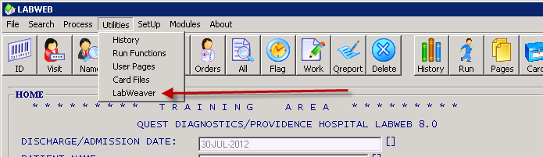

- In LabWeaver, enter ~-ADIF and press ENTER.
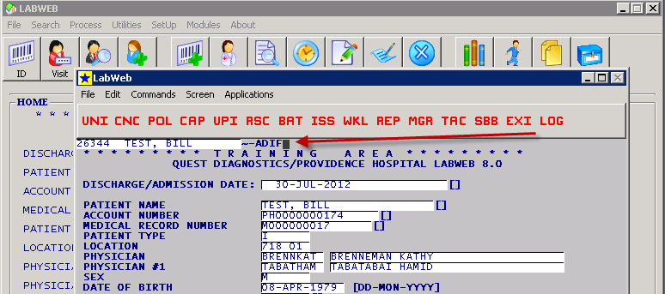

- On the next screen, enter Y and hit ENTER.
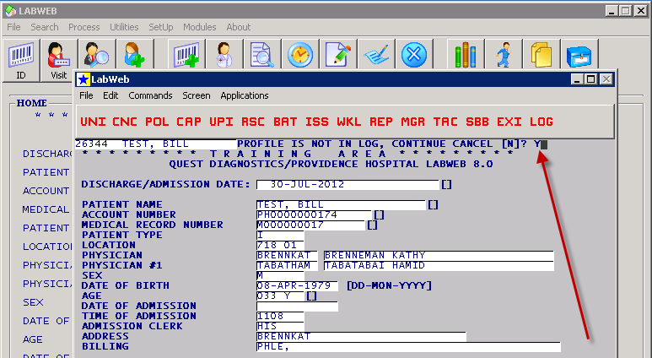

- On the next screen, hit ENTER only, do not press any other key.
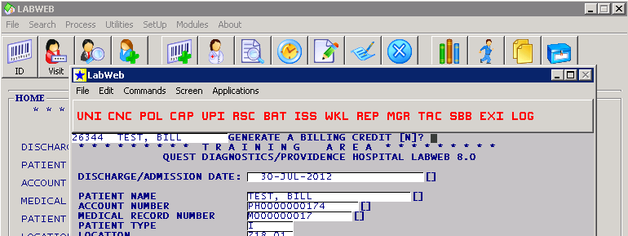

- Repeat for the next screen.
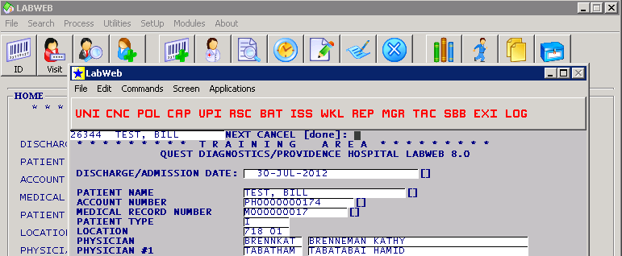

- Hit Return to Home
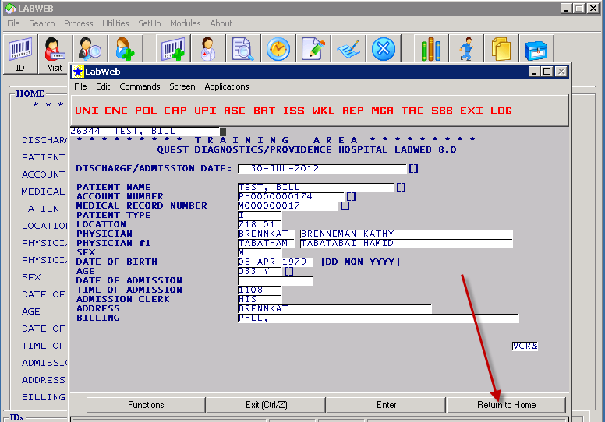

- The ADIF should now be removed.
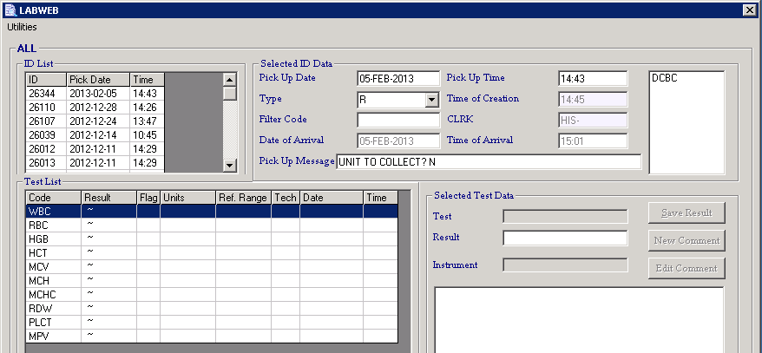

- Under the orders tab, order an MDIF, hit enter and then click Save.
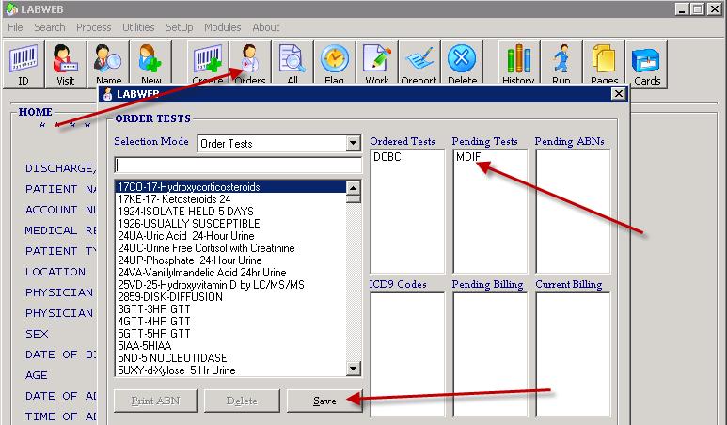

- You should now be able to enter the results of your Manual Differential
