## Instructions for entering CAP survey results into the [www.cap.org](http://www.cap.org) website at Providence Hospital.

1. **Log on to the CAP website.**
2. **Click on “Proficiency Testing/Quality Management”**

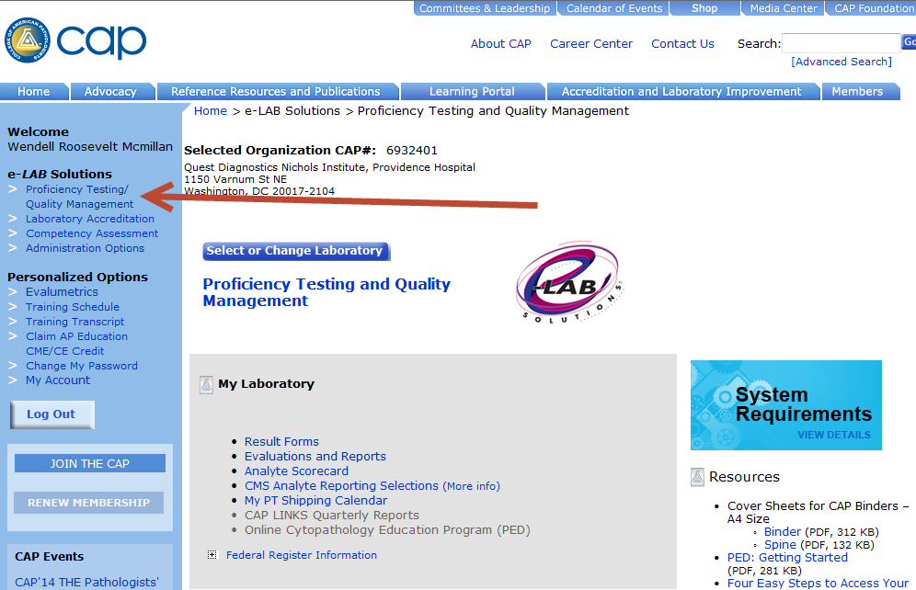

1. **Click on “Result Forms”**

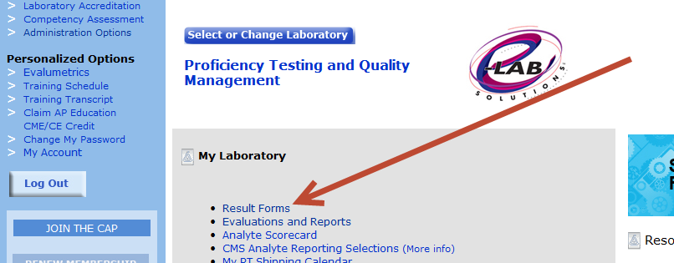

1. **Click “view” on the survey that you are working on.**

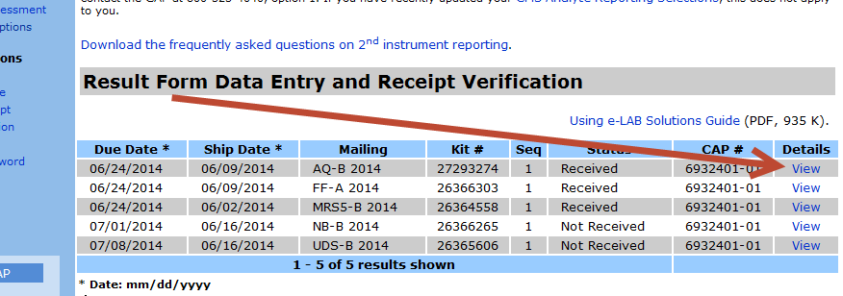

1. **Click on “Enter Data” for the first page.**

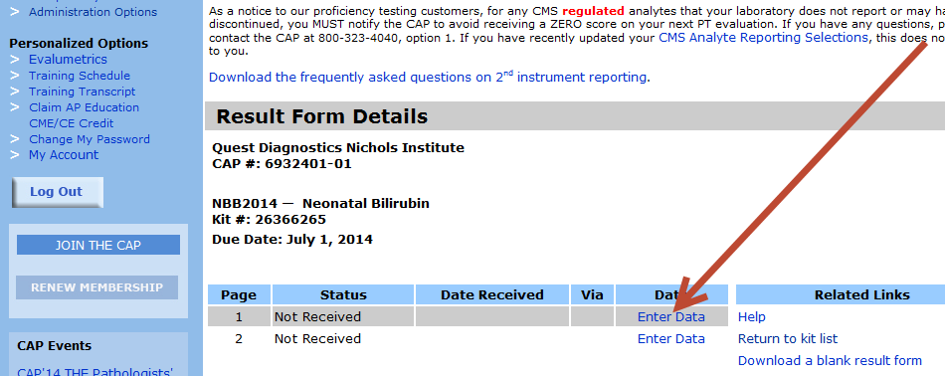

1. **Enter the results for each analyte. This page will look exactly like the pages in the kit. Make sure the Method Codes, Instrument Codes and Unit of Measure (UOM) are filled in correctly. Click “Save” at the bottom of the page. Even if the page does not have any data on it, click “Save” at the bottom.**

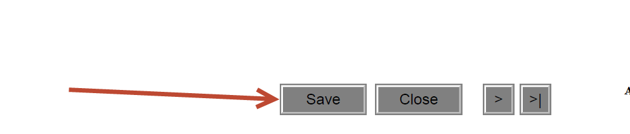

1. **Repeat step 5 for each page.**
2. **On the last page, type your name in the “Testing Personnel” section.**

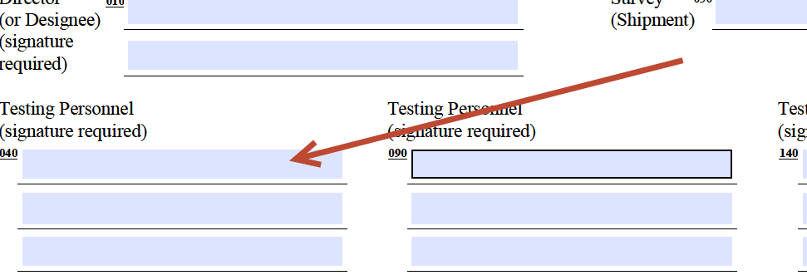

1. **Make sure to click “Save” at the bottom of the last page.**
2. **Print all of the result pages after the data has been entered and give all of the sheets, including raw data to the Supervisor or designee.** 