Technical SOP
Title | Thrombo-TIC Method of Platelet Enumeration
Prepared by | Wendell R. McMillan II | Date: 05/20/2013
Owner | David C Rajamonickam | Date: 06/29/2015
Laboratory Approval | Local Effective Date:
Print Name and Title | Signature | Date
Refer to the electronic signature page for approval and approval dates.
Review
Print Name | Signature | Date

TABLE OF CONTENTS
1. Test Information 2
2. Analytical Principle 3
3. Specimen Requirements 3
4. Reagents 4
5. Calibrators/Standards 5
6. Quality Control 5
7. Equipment And Supplies 6
8. Procedure 6
9. Calculations 8
10. Reporting Results And Repeat Criteria 10
11. Expected Values 10
12. Clinical Significance 10
13. Procedure Notes 11
14. Limitations Of Method 11
15. Safety 11
16. Related Documents 12
17. References 12
18. Revision History 12
19. Addenda 12

TEST INFORMATION

Assay | Method/Instrument | Local Code
Platelet Count: Thrombo-TIC® | Manual | MPLE

Synonyms/Abbreviations
Manual Platelet Count
Department
Core Laboratory

ANALYTICAL PRINCIPLE
This system is used for the microscopic counting of platelets (PLT) after lysis of red blood cells (RBC) and disaggregation of platelets (separation and shape change). Platelets appear nearly round with a darker rim and are about 30% the size of red blood cells (RBC). Platelets can then be enumerated using an optical counting chamber such as a Neubauer improved counting chamber.

SPECIMEN REQUIREMENTS

3.1 Patient Preparation
Component | Special Notations
Fasting/Special Diets | N/A
Specimen Collection and/or Timing | N/A
Special Collection Procedures | N/A
Other | N/A

3.2 Specimen Type & Handling
Criteria
Type -Preferred | Whole Blood (K₃EDTA or K₂EDTA)
-Other Acceptable | None
Collection Container | Finger stick samples are collected with the 10µL capillary pipette that is included in the kit. These should be submitted in the Thrombo-TIC reservoir. Also, any size Lavender top tube (K₃EDTA or K₂EDTA) is acceptable.
Volume - Optimum | 2.5mL, 3.0mL, 5.0mL, or 7.0mL depending on the tube used.
- Minimum | 10µL
Transport Container and Temperature | Same as above, room temperature
Stability & Storage Requirements | Room Temperature: | 4 hours
Stability & Storage Requirements | Refrigerated: | 24 hours
Stability & Storage Requirements | Frozen: | Not acceptable
Timing Considerations | Process immediately
Unacceptable Specimens & Actions to Take | - Specimens that are not properly labeled or do not meet the stated criteria are unacceptable.  - Clotted specimens: Test not performed.  - Gross Hemolysis: Test not performed.  - Stability and/or Storage exceeded: Test not performed.  - For any of the situations noted above, request recollection of the sample after cancelling the test. Document the request for recollection in the LIS.
Compromising Physical Characteristics | - Hemolysis: Slight to Moderate acceptable. Gross unacceptable  - Lipemia: Acceptable.  - Icterus: Acceptable.
Other Considerations | None defined.

REAGENTS
Refer to the Material Safety Data Sheet (MSDS) supplied with the reagents for complete safety hazards. Refer to the section in this procedure covering “SAFETY” for additional information.

4.1 Reagent Summary
Reagents | Supplier & Catalog Number | Quantity
Thrombo-TIC® Reservoir | Bioanalytic, Ref # 004015-0007 | 100 Reservoirs, 100 End-to-end volume capillaries 10µL, 100 Chamber filling capillaries
Capillary holder | Bioanalytic, Ref # 099920-0001 | One holder

4.2 Reagent Preparation and Storage
NOTES: Date and initial all reagents upon opening. Each container must be labeled with (1) substance name, (2) lot number, (3) date of preparation, (4) expiration date, (5) initials of tech, (6) any special storage instructions; check for visible signs of degradation.
Refer to the Material Safety Data Sheet (MSDS) for a complete description of hazards. If a specific hazard is present, it will be noted in this procedure when the hazard is first encountered in a procedural step.

Reagent | Thrombo-TIC® (990µL of 1% oxalate buffer pH=6.0)
Storage | 15-25°C, store vials in a dark place (closed box) and upright in the package.
Stability | Stable until the manufacturer’s imprinted expiration date. Do not use if reagent is not clear, colorless and free of particles or if there are any crystallizations.
Preparation | None

CALIBRATORS/STANDARDS

5.1 Calibrators/Standards Used
N/A

QUALITY CONTROL

6.1 Controls Used
Choose a normal patient with a platelet count in the range of 140,000 to 400,000 that was run on the DxH instrument. The control patient should not have any platelet flags.

6.2 Control Preparation and Storage
N/A

6.3 Frequency
Run one Normal Patient for QC once per shift, per tech before releasing patient results and with each new lot number or shipment of Thrombo-TIC reservoirs.

6.4 Tolerance Limits
The manual result should be within 25% of the DxH result and each side of the chamber should match within 10%. If the result does not meet these criteria, repeat the testing and record all results in the Manual Platelet Log. If the result still does not meet the criteria, have another technologist perform the testing. Record all results and actions in the manual Platelet Log.

6.5 Review Patient Data
Review patient data for unusual patterns, trends or distributions in patient result, such as an unusually high percentage of abnormal results.

6.6 Documentation
Record the QC results on the Manual PLT Log.

6.7 Quality Assurance Program
- New Lots and New Shipments: Place one drop of diluent from each new lot on a glass slide. Cover with a cover slip and examine the diluting fluid under the microscope for the presence of bacterial or other microscopic contamination. Record the results in the Manual PLT Log Book.
- This laboratory participates in CAP proficiency testing.

EQUIPMENT and SUPPLIES

7.1 Assay Platform
N/A

7.2 Equipment
- Microscope with 40x and 50x (high dry) lenses
- Neubauer (or improved) hemacytometer and coverslip
- Transfer capillary tubes
- 10µL pipette (Calibrated)
- Slide Stainer

7.3 Supplies
- Petri dish lined with damp, absorbent material
- Biohazard wipes
- Optical lens cleaner
- Lens paper
- Pipette tips
- Slides

PROCEDURE
NOTE: For all procedures involving specimens, buttoned lab coats, gloves, and face protection are required minimum personal protective equipment. Report all accidents to your supervisor.
The package insert for a new lot of kits must be reviewed for any changes before the kit is used.

8.1 | Test Run
1. | If using a lavender top tube, mix the patient specimen on a rocker or rotator for at least 10 minutes.
2. | Make a slide from the patient specimen. Label and stain the slide as normal. Perform a platelet estimate to compare with the hemacytometer count.  Procedure for the platelet estimate:  Count the platelets in 10 microscopic fields in areas of the slide where the RBCs are evenly distributed. Divide the total number of platelets to get the mean and multiply the mean by 20,000. The platelet count and platelet estimate must agree by 25%. Record the results on the Manual Platelet Logsheet.
3. | Label with reservoir vial with two forms of identification, sit the reservoir vial on a secure holder and open the cap. Fill the capillary tube that is included in the kit with blood from the well mixed lavender top tube. A calibrated 10µL pipette can also be used. The illustration below illustrates filling the capillary tube from a finger stick:  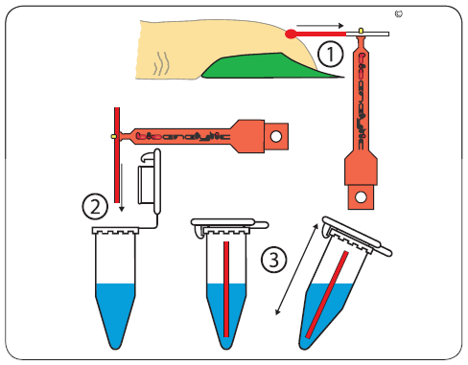
4. | Wipe the excess blood from the exterior of the capillary tube or pipette making sure that you do not wick sample from either one.
5. | Place the wiped capillary tube or pipetted sample into the TIC reservoir vial.
6. | Seal the TIC reservoir and mix well.
7. | Let the mixture sit for at least 5 minutes at room temperature for complete lysing of RBCs to occur. The mixture may sit undisturbed for up to 6 hours at room temperature.
8. | Mix the reservoir well. Carefully charge the clean and dry hemacytometer with the diluted sample as illustrated below. Be sure to fill both chambers.  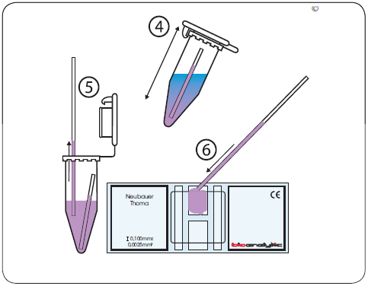
9. | Place the hemacytometer in a Petri dish with moistened paper towel or filter paper on the bottom.
10. | Cover the Petri dish and leave it standing undisturbed for 10 minutes to allow the cells to settle. Using the 40X magnification, count all of the platelets in the 25 small squares within the center square (green area in the illustration in section 9) in both chambers.  Notes on counting:  - With results of more than 400,000, it is possible to count only 5 group squares. The calculation factor would be 5,000.  - With results less than 50,000, count all 9 large squares in both chambers. The average count is divided by 9 and then multiplied by 1000 to obtain the total count.

CALCULATIONS
Average the number of platelets that were counted on both sides of the chamber and multiply the average by 1000.
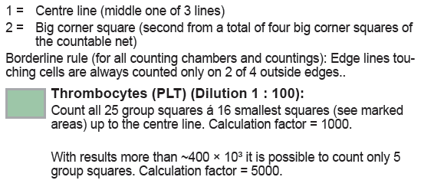
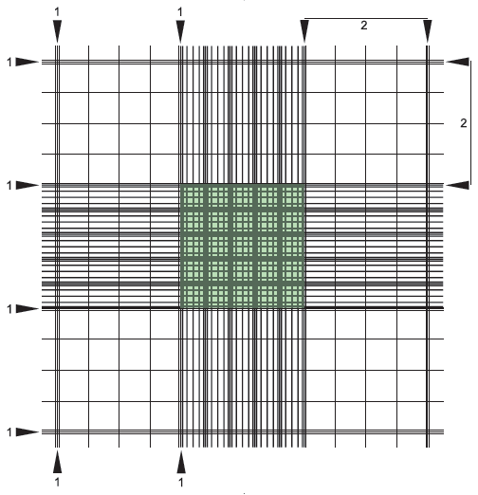
Example: 54 platelets counted on one side of chamber
51 platelets counted on one side of chamber
Average platelet count = 52.5
52.5 platelets x 1000 = 52,500 platelets/mm³

REPORTING RESULTS AND REPEAT CRITERIA

10.1 Interpretation of Data
N/A
10.2 Rounding
N/A
10.3 Units of Measure
Platelets/µL
10.4 Clinically Reportable Range (CRR)
0-3,000,000/µL
  - Repeat Criteria and Resulting
    - Duplicate counts should agree within 10%. If they do not agree, clean the chamber, reload and then recount the platelets.
    - The platelet count is reported as a whole number.
    - If you observe platelet clumps in the chamber, the count is unreliable. Have the specimen recollected using a hot pack.
    - All Manual Platelet counts must be reviewed by a second technologist prior to resulting. Calculations and % differences must be rechecked and documented on the worksheet.

EXPECTED VALUES

11.1 Reference Ranges
140 – 400 10³/µL (Adult)

11.2 Critical Values
<30 and >1,000 10³/µL

11.3 Priority 3 Limit(s)
None

CLINICAL SIGNIFICANCE
During megakaryocyte maturation, micro vesicles form in the cytoplasm, dividing the cell into subdomains that become platelet territories. Dense core granules, lysomes, and other proteins are synthesized within the territories. Eventually, the cytoplasm resembles one large jigsaw puzzle, composed of thousands of pieces that will eventually break off and become circulating platelets.

The primary function of platelets is to prevent excessive internal or external bleeding after an injury. Platelets help to temporarily seal off the site of a wound by breaking away from other platelets and sticking to the exposed, damaged edges of blood vessels. The process by which platelets adhere to vessel walls is known as hemostasis

PROCEDURE NOTES
- FDA Status: FDA Approved
- Validated Test Modifications: None

LIMITATIONS OF METHOD

14.1 Analytical Measurement Range (AMR)
N/A
14.2 Precision
Each side of the chamber must match within 10%. The Quality Control must match between the DxH800 and Thrombo-TIC by 25%.
14.3 Interfering Substances
Bacteria and other debris can interfere with platelet counts. Care must be taken to differentiate platelets from extrinsic particles under bright-light microscopy.
14.4 Clinical Sensitivity/Specificity/Predictive Values
N/A

SAFETY
The employee has direct responsibility to avoid injury and illness at work. Nearly all harmful exposures to infectious substances and chemicals, and other injuries, can be avoided with effective training and consistent safe work practices.

Become familiar with the Environmental Health and Safety (EHS) Manual to the learn requirements on working safely and protecting the environment from harm. Although lab work typically focuses on the hazards of working with specimens and chemicals, we must also control other important hazards.
- Slips, trips, and falls cause many serious injuries. Please ensure that spills are cleaned quickly (to avoid slippery floors) and that you can see and avoid obstacles in your path.
- Ergonomic injuries result from performing tasks with too much repetition, force, or awkward position. Ergonomic injuries include strains and back injuries. Learn about ergonomic hazards and how to prevent this type of injury.
- Scratches, lacerations, and needle sticks can result in serious health consequences. Attempt to find ways to eliminate your risk when working with sharp materials.
Report all accidents and injuries immediately to your supervisor or the business unit Environmental Health and Safety Manager or Specialist.

RELATED DOCUMENTS
Current Bioanalytic Thrombo TIC® System package insert.

REFERENCES
- Laboratory Quality Control Program PHGL.005.000
- Automated Hematology manual PHH.030.000
- Bioanalytic Thrombo TIC® System package, 05/13/2010.

REVISION HISTORY
Version | Date | Section | Reason | Reviser | Approval
0 | 06-29-15 | Page 1 | Updated Owner, BU Name in Header, Added PRO in SOP Number in footer and removed leading zeros to the Version | David Rajamonickam | Wendell McMillan
0 | 06-29-15 | Section 1 | Local Code Updated | David Rajamonickam | Wendell McMillan

ADDENDA
- Manual Platelet Patient and QC Log (See attachment tab of infocard)
- Thrombo-TIC Diluent Check Log (See attachment tab of infocard)

