Technical SOP
Title | C. DIFF QUIK CHEK COMPLETE™
Prepared by | Ron Master | Date: 02/10/2010
Owner | David Rajamonickam | Date: 09/15/2014
Laboratory Approval | Local Effective Date:
Print Name and Title | Signature | Date
Refer to the electronic signature page for approval and approval dates.
Review
Print Name | Signature | Date

TABLE OF CONTENTS
1. TEST INFORMATION 2
2. ANALYTICAL PRINCIPLE 3
3. SPECIMEN REQUIREMENTS 3
4. REAGENTS 4
5. CALIBRATORS/STANDARDS 6
6. QUALITY CONTROL 6
7. EQUIPMENT and SUPPLIES 8
8. PROCEDURE 8
9. CALCULATIONS 10
10. REPORTING RESULTS AND REPEAT CRITERIA 10
11. EXPECTED VALUES 12
12. CLINICAL SIGNIFICANCE 12
13. PROCEDURE NOTES 13
14. LIMITATIONS OF METHOD 13
15. SAFETY 14
16. RELATED DOCUMENTS 15
17. REFERENCES 15
18. REVISION HISTORY 16
19. ADDENDA 16

TEST INFORMATION

Assay | Method/Instrument | Order Code
GDH and C. difficile toxin A&B | Manual, Rapid membrane EIA | CDIF

Synonyms/Abbreviations
GDH, C. difficile antigen, C. difficile toxin A&B
Department
Microbiology

ANALYTICAL PRINCIPLE

The C. DIFF QUIK CHEK COMPLETE™ test uses antibodies specific for glutamate dehydrogenase and toxins A and B of C. difficile. The device contains a Reaction Window with three vertical lines of immobilized antibodies. The antigen test line (“Ag”) contains antibodies against C. difficile glutamate dehydrogenase. The control line (“C”) is a dotted line that contains anti-horseradish peroxidase (HRP) antibodies. The toxins A and B test line (“Tox”) contain antibodies against C. difficile toxins A and B. The Conjugate consists of antibodies to glutamate dehydrogenase and antibodies to toxins A and B coupled to horseradish peroxidase. To perform the test, the sample is added to a tube containing a mixture of Diluent and Conjugate. The diluted sample-conjugate mixture is added to the Sample Well and the device is allowed to incubate at room temperature for 15 minutes. During the incubation, any glutamate dehydrogenase and toxins A and B in the sample bind to the antibody-peroxidase conjugates. The antigen-antibody-conjugate complexes migrate through a filter pad to a membrane where they are captured by the immobilized glutamate dehydrogenase-specific and toxins A and B-specific antibodies in the lines. The Reaction Window is subsequently washed with Wash Buffer, followed by the addition of Substrate. After a 10 minute incubation period, the “Ag” reaction is examined visually for the appearance of a vertical blue line on the “Ag” side of the Reaction Window. A blue line indicates a positive test. If the “Ag” is positive, then the “Tox” reaction should be examined visually for the appearance of a blue line on the “Tox” side of the Reaction Window. A blue line indicates a positive test. A positive “C” reaction, indicated by a vertical dotted blue line under the “C” portion of the Reaction Window, confirms that the test is working properly and the results are valid.

SPECIMEN REQUIREMENTS

CAUTION: Pathogenic microorganisms, including hepatitis viruses and Human Immunodeficiency Virus may be present in clinical specimens. “Standard Precautions” and institutional guidelines should be followed in handling all items contaminated with blood and other body fluids.

3.1 Patient Preparation
Component | Special Notations
Fasting/Special Diets | N/A
Specimen Collection and/or Timing | Standard collection and handling procedures used in-house for fecal specimens are appropriate.
Special Collection Procedures | None
Other | N/A

3.2 Specimen Type & Handling
Criteria
Type -Preferred | Raw stool (no preservative)
-Other Acceptable | None
Collection Container | Clean airtight container
Volume - Optimum | N/A
- Minimum | 2 mm diameter sized portion for solid stool  50 µl for liquid or semi-solid stool
Transport Container and Temperature | Same as above. Transport refrigerated or frozen.
Stability & Storage Requirements | Room Temperature: | Not Recommended
Stability & Storage Requirements | Refrigerated: | Acceptable: 2-8ºC for up to 72 hours
Stability & Storage Requirements | Frozen: | -20ºC or colder if sample cannot be tested within 72 hours.
Timing Considerations | Ideally samples must be tested within 24 hours, otherwise the storage requirements above must be  observed.
Unacceptable Specimens & Actions to Take | Stool samples with preservatives. Reject sample and request an unpreserved sample from client.
Compromising Physical Characteristics | N/A
Other Considerations | Store specimens frozen (≤  -10°C) if the test cannot be performed within 72 hours of collection, but note that freezing and thawing of the specimen may result in loss of activity due to degradation of the toxins. If using frozen specimens, thaw at room temperature.  A single freeze thaw cycle should not affect results. Repeated freezing and thawing of samples should be avoided. Storing fecal specimens in the Diluent is NOT recommended.

REAGENTS
Refer to the Material Safety Data Sheet (MSDS) supplied with the reagents for complete safety hazards. Refer to the section in this procedure covering “SAFETY” for additional information.

4.1 Reagent Summary
Reagents / Kits | Supplier & Catalog Number
Wampole C. DIFF QUIK CHEK COMPLETE™ Kit | Inverness Medical Catalog Number: 30525C 30550C

4.2 Reagent Preparation and Storage
NOTES: Date and initial all reagents upon opening. Each container must be labeled with (1) substance name, (2) lot number, (3) date of preparation, (4) expiration date, (5) initials of tech, (6) any special storage instructions; check for visible signs of degradation.
Refer to the Material Safety Data Sheet (MSDS) for a complete description of hazards. If a specific hazard is present, it will be noted in this procedure when the hazard is first encountered in a procedural step.

Storage Instructions: This product is ready for use and no further preparation is necessary. Store product in its original container at 2-8°C until used. Allow product to equilibrate to room temperature before use.

Kit Components | Container | Storage/  Stability | Preparation
Membrane Devices | Each pouch contains 1 device | Store at 2-8ºC. Stable until expiration date on vial label. | Ready for use.
Diluent | 22 mL per bottle | Store at 2-8ºC. Stable until expiration date on vial label. | Ready for use.
Wash Buffer | 12 mL per bottle | Store at 2-8ºC. Stable until expiration date on vial label. | Ready for use.
Substrate | 3.5 mL per bottle | Store at 2-8ºC. Stable until expiration date on vial label. | Ready for use.
Conjugate | 2.5 mL per bottle | Store at 2-8ºC. Stable until expiration date on vial label. | Ready for use.
Positive Control | 1 mL per bottle | Store at 2-8ºC. Stable until expiration date on vial label. | Ready for use.
Disposable plastic transfer pipettes | 50 per kit | N/A | N/A

Warnings and Precautions:
- Reagents from different kits should not be mixed or interchanged. Do not use a kit past the expiration date.
- Bring all components to ROOM TEMPERATURE BEFORE USE!
- Caps, tips and dropper assemblies are color-coded; do NOT mix or interchange!
- Do not freeze the reagents. The kit should be stored between 2°C and 8°C.
- The pouch containing the Membrane Device should be at room temperature before opening, and opened just before use. Keep the membrane devices dry before use.
- Use fecal specimens within 72 hours of collection to obtain optimal results. Specimens that are frozen may lose activity due to freezing and thawing. If using frozen specimens, thaw at room temperature.
- Do not use specimens that have been preserved in 10% Formalin, merthiolate formalin, sodium acetate formalin or polyvinyl alcohol.
- Specimens in transport media such as Cary Blair and C&S can be used as specified in the specimen preparation protocol.
- Hold reagent bottles vertically to dispense reagents to ensure consistent drop size and correct volume.
- Specimens and membrane devices should be handled and disposed of as potential biohazards after use. Wear disposable gloves when doing the test.
- Membrane devices cannot be reused.
- The test has been optimized for sensitivity and specificity. Alterations of the specified procedure and/or test conditions may affect the sensitivity and specificity of the test. Do not deviate from the specified procedure.
- Microbial contamination of reagents may decrease the accuracy of the assay. Avoid microbial contamination of reagents by using sterile disposable pipettes if removing aliquots from reagent bottles.
- Be attentive to the total assay time when testing more than one fecal specimen. Add Diluent first, and then add the Conjugate to each tube of Diluent. Then add specimen to the tube of Diluent/Conjugate. Thoroughly mix all of the diluted specimens, and transfer to the Membrane Device. The 15-minute incubation step begins after the last diluted sample-conjugate mixture has been transferred to the final Membrane Device.
- If the Substrate reagent changes to a dark blue/violet color call technical services for replacement.

CALIBRATORS/STANDARDS
N/A

QUALITY CONTROL

6.1 Controls Used
Internal: A dotted blue line must be visible in the middle of the Reaction Window, below the “C” on every Membrane Device that is tested. The appearance of the blue control dots confirms that the sample and reagents were added correctly, that the reagents were active at the time of performing the assay, and that the sample migrated properly through the Membrane Device. A clear background in the result area is considered an internal negative control. If the test has been performed correctly and reagents are working properly, the background will be white to give a discernible result.

External: The reactivity of the C. DIFF QUIK CHEK COMPLETE ™ kit should be verified upon receipt using the Positive Control and negative control (Diluent). The Positive Control is supplied with the kit (gray-capped bottle). The Positive Control confirms the reactivity of the other reagents associated with the assay, and is not intended to ensure precision at the analytical assay cut-off. Diluent is used for the negative control.

6.2 Control Preparation and Storage
NOTE: Date and initial all controls upon opening. Each container should be labeled with (1) substance name, (2) lot number, (3) date of preparation, (4) expiration date, (5) initials of tech, and (6) check for visible signs of degradation on of all items received.

6.3 Frequency
- Internal procedural controls are automatically performed with each test. The internal control confirms that the sample and reagents were added correctly, that the reagents were active at the time of performing the assay, and that the sample migrated properly along the Membrane Device. The results of these internal controls must be documented each time the test is performed.

- Positive and negative external controls are run and documented on each day of testing.

- Positive and negative external controls are run and documented with each new kit lot number.

- Positive and negative external controls are run and documented with each new shipment is received.

- Positive and negative external controls are run and documented if the test kit storage falls outside of 2°-8°C.

6.4 Tolerance Limits
Control | Expected Result
Internal Positive Control | A blue dotted line is visible in the middle of the Reaction Window
Internal Negative Control | Clear background in the result area
External Positive Control | Blue lines on the “Ag” and Tox” sides of the Reaction Window
External Negative Control (Diluent) | A single blue dotted line is visible in the middle of the Reaction Window, below the “C” and no test lines are visible on the “Ag” side or the “Tox” side of the Reaction Window

6.5 Review Patient Data
If expected results are not obtained, do not use the media and contact Technical Services. Notify Supervisor and document corrective action in the Corrective Log.

6.6 Documentation
Refer to local policies and procedures for QC documentation and to Quest Diagnostics records management program for record retention requirements.

6.7 Quality Assurance Program
Quality Control cross-checks must be done with each new lot/shipment of kit using both internal and external controls.

EQUIPMENT and SUPPLIES

7.1 Assay Platform
N/A
7.2 Equipment
N/A
  - Supplies
Small test tubes (e.g., plastic tubes or glass tubes)
Applicator sticks
Timer
Vortex mixer
Disposable gloves for handling fecal samples
Disposable plastic pipettes

PROCEDURE
NOTE: For all procedures involving specimens, buttoned lab coats, gloves, and face protection are required minimum personal protective equipment. Report all accidents to your supervisor.
The package insert for a new lot of kits must be reviewed for any changes before the kit is used.

8.1 | Sample Preparation
1. | Bring all reagents and the required number of devices to room temperature before use.
2. | Set up and label one small test tube for each specimen and external controls as necessary.
3. | Using the black graduated dropper assembly, add 750 µL (2nd graduation from the tip) Diluent to each tube for fecal specimens and the external Positive Control.
4. | Add one drop of Conjugate (red capped bottle) to each tube (one drop is equivalent to 25 µL).
5. | Obtain one disposable plastic transfer pipette (supplied with the kit) for each sample – the pipettes have raised graduations at 25 µL, 400 µL and 500 µL.
6. | Mix all specimens thoroughly regardless of consistency- it is essential that the specimens be evenly suspended before transferring.  Liquid/Semi-solid specimens – pipette 25 µL of specimen with a transfer pipette (graduated at 25 µL, 400 µL and 500 µL) and dispense into the Diluent/Conjugate mixture. Use the same transfer pipette to mix the diluted specimen.  Formed/Solid specimens – Care must be taken to add the correct amount of formed feces to the sample mixture. Mix the specimen thoroughly using a wooden applicator stick and transfer a small portion (approximately 2 mm diameter, the equivalent of 25 µL) of the specimen into the Diluent/Conjugate mixture. Emulsify the specimen using the applicator stick.  NOTE: Transferring too little specimen, or failure to mix and completely suspend the specimen in the Diluent mixture, may result in a false-negative test result. The addition of too much fecal specimen may cause invalid results due to restricted sample flow.
7. | External Control Samples:  External Positive Control - add one drop of Positive Control (gray-capped bottle) to the appropriate test tube.  External Negative Control - add 25 µL Diluent to the appropriate test tube.

8.2 | Procedure
1. | Obtain one Membrane Device per specimen, and one device per optional external positive or negative control as necessary. The foil bags containing the devices should be brought to room temperature before opening. Label each device appropriately and orient it on a flat surface so the “C. DIFF COMPLETE” print is at the bottom of the device, and the small Sample Well is located in the top right corner of the device.
2. | Mix each tube of diluted specimen thoroughly. Proper mixing can be achieved by vortexing or by repeated aspirations with the transfer pipette. Once a patient sample or Positive Control has been diluted in the Diluent/Conjugate mixture, it may be incubated at room temperature for any period of time up to 24 hours prior to addition to the Membrane Device.
3. | Using a new transfer pipette, transfer 500 µL of the diluted sample-conjugate mixture into the Sample Well (smaller hole in the top right corner of the device) of a Membrane Device, making certain to expel the liquid sample onto the wicking pad inside of the Membrane Device. When loading the sample into the sample well, make sure that the tip of the transfer pipette is angled towards the Reaction Window (larger hole in the middle of the device).
4. | Incubate the device at room temperature for 15 minutes – the sample will wick through the device and a wet area will spread across the Reaction Window.  NOTE FOR SAMPLES THAT FAIL TO MIGRATE:  Occasionally, a diluted fecal specimen cannot be tested because it clogs the membrane and the Reaction Window does not wet properly. If the diluted fecal specimen fails to migrate properly within 5 minutes of adding the sample to the Sample Well (i.e. the membrane in the Reaction Window does not appear to be completely wet), then add 100 µL (4 drops) of Diluent to the Sample Well and wait an additional 5 minutes (for a total of 20 minutes).
5. | After the incubation, add 300 µL of Wash Buffer to the Reaction Window using the graduated white dropper assembly (or equivalent). Allow the Wash Buffer to flow through the Reaction Window membrane and be absorbed completely.
6. | Add 2 drops of Substrate (white-capped bottle) to the Reaction Window. Read and record results visually after 10 minutes.

CALCULATIONS
N/A

REPORTING RESULTS AND REPEAT CRITERIA

10.1 Interpretation of Results
1. Interpretation of the test is most reliable when the device is read immediately at the end of the 10 minute reaction period. Read the device at a normal working distance in a well-lit area. View with a line of vision directly over the device.
2. Observe device for the appearance of blue dots in the middle of the Reaction Window representing the internal positive control. The appearance of any control dot(s) represents a valid internal control. Observe device for the appearance of blue lines on the “Ag” and Tox” sides of the Reaction Window representing the test lines. The lines may appear faint to dark in intensity.
3. Positive Antigen (“Ag”) Result: A positive antigen result may be interpreted at any time between the addition of Substrate and the 10-minute read time. For a positive antigen result, the blue “Ag” line and the dotted blue control line below “C” are visible (Figure 1a). The lines may appear faint to dark in intensity. An obvious partial line is interpreted as a positive result. Do not interpret membrane discoloration as a positive result. A positive result indicates the presence of C. difficile.
4. Positive Antigen and Toxin (“Tox”) Result: If the antigen result is positive (i.e., a blue “Ag” line and a dotted blue control below “C” are visible), proceed to the interpretation of the toxin result. A positive toxin result may be interpreted at any time between the addition of Substrate and the 10-minute read time. For a positive toxin result, a blue “Tox” line is visible (Figure 1b). The line may appear faint to dark in intensity. An obvious partial line is interpreted as a positive result. Do not interpret membrane discoloration as a positive result. A positive result indicates the presence of C. difficile toxin.
5. Negative Result: A test cannot be interpreted as negative or invalid until 10 minutes following the addition of Substrate. A single blue dotted line is visible in the middle of the Reaction Window, below the “C” and no test lines are visible on the “Ag” side or the “Tox” side of the Reaction Window (Figure 1c). A negative result in the antigen portion indicates C. difficile antigen is either absent in the specimen or is below the detection limit of the test. A negative result in the toxin portion indicates C. difficile toxin is either absent in the specimen or is below the detection limit of the test.
6. Invalid Result: No lines are visible in the Reaction Window (Figure 1d). The test result is invalid if a blue dotted line is not present below the “C” at the completion of the reaction period (Figures 1e, 1f, 1g).
7. A low percentage of specimens may test negative for antigen but positive for toxin. These samples should be considered indeterminate and retested using a fresh specimen (Figure 1h).

FIGURE 1: C. DIFF QUIK CHEK COMPLETE ™ INTERPRETATION OF RESULTS
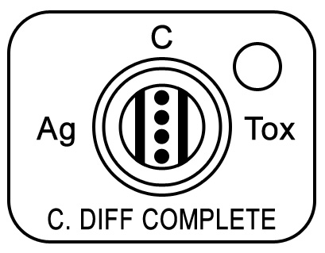
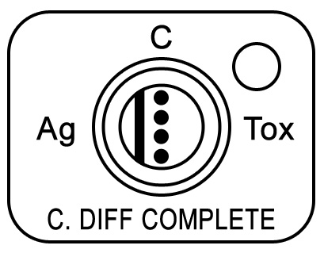
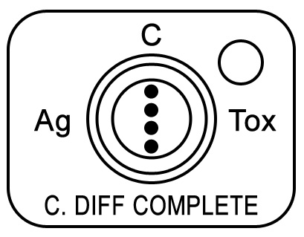
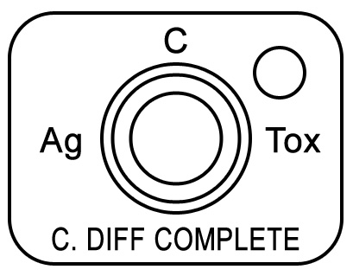
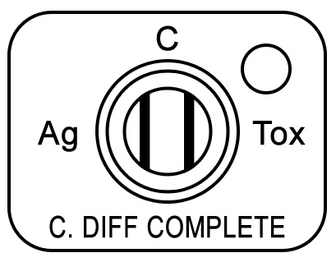
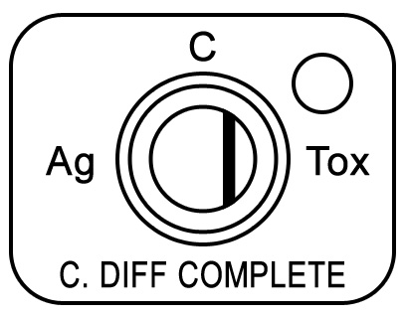
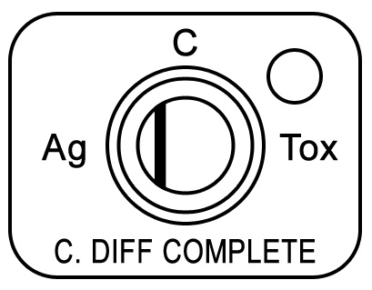
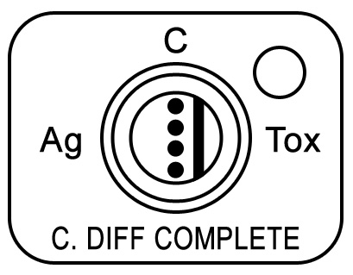

Figure 1a Figure 1b Figure 1c Figure 1d
Positive Antigen Result Positive Antigen Negative Result Invalid Result
and Toxin Result

Figure 1e Figure 1f Figure 1g Figure 1h
Invalid Result Invalid Result Invalid Result See #7 for Interpretation

10.2 Rounding / Units of Measure / Clinically Reportable Range (CRR)
N/A

- Resulting
Test | Psyche Code | Result
Clostridium difficile antigen | GDH | Negative
Clostridium difficile antigen | GDH | Positive
Clostridium difficile toxins A/B | CDAT | Negative
Clostridium difficile toxins A/B | CDAT | Positive
Interpretation | IN18 | Negative
Interpretation | IN18 | Positive
Interpretation | IN18 | Equivocal

Interpretation
If Results are: | Code | Then Report Interpretation as:
Antigen-negative,toxin-negative | !N | Negative for Clostridium difficile
Antigen-positive, toxin-positive | !CDP | Positive for toxin-producing Clostridium difficile
Antigen-positive, toxin-negative | !EQ | Results equivocal. Confirmation test by PCR to follow.

EXPECTED VALUES

11.1 Reference Ranges
Clostridium difficile antigen - Negative
Clostridium difficile toxins A/B - Negative

11.2 Priority 1 & 2 Limits
Positive for Clostridium difficile toxins A/B (Priority 2)

11.3 Priority 3 Limit(s)
None established

CLINICAL SIGNIFICANCE

After treatment with antibiotics, many patients develop gastrointestinal problems
ranging from mild diarrhea to severe pseudomembranous colitis. Many cases of the
milder forms of gastrointestinal illness and most cases of pseudomembranous colitis are
caused by toxigenic strains of Clostridium difficile (1). This organism is an opportunistic
anaerobic bacterium that grows in the intestine once the normal flora has been altered
by the antibiotic. Toxigenic strains of C. difficile carry the genes encoding the toxins
while non-toxigenic strains do not carry the toxin genes. Disease onset is associated
with the toxins that are produced by the toxigenic organism. The clinical symptoms
associated with the disease are believed to be primarily due to toxin A, which is a tissue damaging enterotoxin (2,3). C. difficile also produces a second toxin, designated toxin
B. Toxin B, which has been referred to as the cytotoxin of the organism, is the toxin
detected by the tissue culture assay currently used by many laboratories. Toxigenic
C. difficile strains produce both toxins, or only toxin B (4-7). The glutamate dehydrogenase
of C. difficile is a good antigen marker for the organism in feces because it is
produced in high amounts by all strains, toxigenic or non-toxigenic (8-10). The antigen
can be detected in fecal specimens by using the C. DIFF QUIK CHEK COMPLETEä
test. A positive result in the test for the glutamate dehydrogenase of C. difficile confirms
the presence of this organism in a fecal specimen; a negative result indicates the
absence of the organism. A positive result in the test for toxins A and B confirms the
presence of toxigenic C. difficile.

PROCEDURE NOTES

- FDA Status: Approved
- Validated Test Modifications: None

LIMITATIONS OF METHOD

1. The C. DIFF QUIK CHEK COMPLETE ™ test is used to detect C. difficile antigen and toxin(s) in fecal specimens. The test confirms the presence of toxin in feces and this information should be taken under consideration by the physician in light of the clinical history and physical examination of the patient. The C. DIFF QUIK CHEK COMPLETE ™ test will detect levels of toxin A at ≥0.63 ng/mL, toxin B at ≥0.16 ng/mL, and glutamate dehydrogenase at ≥0.8 ng/mL.
2. Fecal specimens are extremely complex. Optimal results with the C. DIFF QUIK CHEK COMPLETE ™ test are obtained with specimens that are less than 24 hours old. Most undiluted specimens can be stored between 2°C and 8°C for 72 hours before significant degradation of the toxin is noted. If specimens are not assayed within this time period, they may be frozen and thawed. However, repeated freezing and thawing may result in loss in the immunoreactivity of antigen and toxins A and B.
3. Some specimens may give weak reactions. This may be due to a number of factors such as the presence of low levels of antigen and/or toxin, the presence of binding substances, or inactivating enzymes in the feces. Under these conditions, a fresh specimen should be tested. Additional tests that may be used in conjunction with the C. DIFF QUIK CHEK COMPLETE ™ test include culture with toxigenic testing or tissue culture cytotoxicity assay for the detection of C. difficile or its toxin(s).
4. Fecal specimens preserved in 10% Formalin, merthiolate formalin, sodium acetate formalin, or polyvinyl alcohol cannot be used.
5. The C. DIFF QUIK CHEK COMPLETE ™ test is qualitative. The intensity of the color should not be interpreted quantitatively.
6. Some isolates of C. sordellii may react in the C. DIFF QUIK CHEK COMPLETE ™ test due to the production of immunologically related toxins (1).
7. Colonization rates of up to 50% have been reported in infants. A high rate has also been reported in cystic fibrosis patients (1,3).
8. The only non-C. difficile organism to react in the toxin portion of the C. DIFF QUIK CHEK COMPLETE ™ test was Clostridium sordellii VPI 9048. This strain produces toxins HT and LT, which are homologous to toxins A and B, respectively.

14.1 Analytical Measurement Range (AMR)
N/A
  - Precision
N/A
14.3 Interfering Substances
The following substances had no effect on test results when present in feces in the
concentrations indicated: mucin (3.5% w/v), human blood (40% v/v), barium sulfate (5% w/v), Imodium® (5% v/v), Kaopectate® (5% v/v), Pepto-Bismol® (5% v/v), steric/palmitic acid (40% w/v), Metronidazole (0.25% w/v), Vancomycin (0.25% w/v).

  - Clinical Sensitivity/Specificity/Predictive Values/Performance Characteristics
Refer to Wampole C. DIFF QUIK CHEK COMPLETE ™ package insert.

SAFETY
The employee has direct responsibility to avoid injury and illness at work. Nearly all harmful exposures to infectious substances and chemicals, and other injuries, can be avoided with effective training and consistent safe work practices.

Become familiar with the Environmental Health and Safety (EHS) Manual to the learn requirements on working safely and protecting the environment from harm. Although lab work typically focuses on the hazards of working with specimens and chemicals, we must also control other important hazards.
- Slips, trips, and falls cause many serious injuries. Please ensure that spills are cleaned quickly (to avoid slippery floors) and that you can see and avoid obstacles in your path.
- Ergonomic injuries result from performing tasks with too much repetition, force, or awkward position. Ergonomic injuries include strains and back injuries. Learn about ergonomic hazards and how to prevent this type of injury.
- Scratches, lacerations, and needlesticks can result in serious health consequences. Attempt to find ways to eliminate your risk when working with sharp materials.
- If you drive on company business (in a company car, a rental, or your own personal vehicle) you must comply with the requirements in the "Driver Safety Manual". Please remember that driving requires your FULL attention, and multi-tasking while driving (e.g., talking on a cell phone) is an unacceptable risk that you must not take.
Report all accidents and injuries immediately to your supervisor or the business unit Environmental Health and Safety Manager or Specialist.

RELATED DOCUMENTS

Current Package Insert

REFERENCES

1. Lyerly, D. M., H. C. Krivan, and T. D. Wilkins. 1988. Clostridium difficile: its disease and toxins. Clin. Microbiol. Rev. 1: 1-18.
2. Lyerly, D. M., K. E. Saum, D. K. MacDonald, and T. D. Wilkins. 1985. Effects of Clostridium difficile toxins given intragastrically to animals. Infect. Immun. 47: 349-352.
3. Borriello, S. P., F. E. Barclay, A. R. Welch, J. M. Ketley, T. J. Mitchell, J. Stephen, and G. E. Griffin. 1985. Host and microbial determinants of the spectrum of Clostridium difficile mediated gastrointestinal disorders. Microecol. Ther. 15: 231-236.
4. Lyerly, D. M., N. M. Sullivan, and T. D. Wilkins. 1983. Enzyme-linked immunosorbent assay for Clostridium difficile toxin A. J. Clin. Microbiol. 17: 72-78.
5. Laughon, B. E., R. P. Viscidi, S. L. Gdovin, R. H. Yolken, and J. G. Bartlett. 1984. Enzyme immunoassays for detection of Clostridium difficile toxins A and B in fecal specimens. J. Infect. Dis. 149: 781-788.
6. Lyerly, D. M., L. A. Barroso, and T. D. Wilkins. 1992. Characterization of a toxin A-/toxin B+ isolate of Clostridium difficile. Infect. Immun. 60: 4633-4639.
7. Dove, C. H., S. Z. Wang, S. B. Price, C. J. Phelps, D. M. Lyerly, T. D. Wilkins, and J. L. Johnson. 1990. Molecular characterization of the Clostridium difficile toxin A gene. Infect. Immun. 58: 480-488.
8. Zheng, L., S. F. Keller, D. M. Lyerly, R. J. Carman, C. W. Genheimer, C. A. Gleaves, S. J. Kohlhepp, S. Young, S. Perez, and K. Ye. 2004. Multicenter Evaluation of a New Screening Test that Detects Clostridium difficile in Fecal Specimens. J. Clin. Microbiol. 42: 3837-3840.
9. Miles, B. L., J. A. Siders, and S. D. Allen. 1988. Evaluation of a commercial latex test for Clostridium difficile for reactivity with C. difficile and cross-reactions with other bacteria. J. Clin. Microbiol. 26: 2452-2455.
10. Lyerly, D. M., and T. D. Wilkins. 1986. Commercial latex test for Clostridium difficile Toxin A does not detect Toxin A. J. Clin. Microbiol. 23: 622-623.
11. Product Information Wampole C. DIFF QUIK CHEK COMPLETE ™ package insert, RMS #91-525C-01, Issued: 03/2009.

REVISION HISTORY

Version | Date | Section | Reason | Reviser | Approval
.000 | 2/10/2010 |  | New Procedure | A. Foster | R. Levy
.000 | 9/17/2010 | 8.0 | Updated Procedure to reflect removal of package inserts
.000 |  | 10.4 | Updated Resulting and Interpretation
.000 |  | 16.0 | Updated related documents to include current product insert
.000 |  | 19.0 | Updated Addenda to reflect removal of addendum 1
.001 | 10/21/2011 | Page 1 | Updated Owner | W.McMillan | R. Levy
.002 | 09-15-2014 | Page 1 | Updated Owner, BU Name in Header,  Added PRO in SOP Number in footer and removed leading zeros to the Version | David Rajamonickam | Wendell McMillan
.002 | 09-15-2014 | Page 1 | Removed Annual in the Review Table | David Rajamonickam | Wendell McMillan
3 | 02/04/2016 | 6.3 | Updated Frequency | David Rajamonickam | Wendell McMillan

ADDENDA

Addendum | Title

