Non-Technical SOP
Title | Procedure for the Manual Monitoring of Temperature Dependent Equipment or Spaces
Prepared by | Nancy Johnson | Date: 02/18/2009
Owner | Nancy Johnson | Date: 02/18/2009

Laboratory Approval
Print Name and Title | Signature | Date
Refer to the electronic signature page for approval and approval dates.
Local Issue Date: | Local Effective Date:

Review
Print Name | Signature | Date

TABLE OF CONTENTS

1. PURPOSE 2
2. SCOPE 2
3. RESPONSIBILITY 2
4. DEFINITIONS 3
5. PROCEDURE 3
6. RELATED DOCUMENTS 6
7. REFERENCES 6
8. REVISION HISTORY 6
9. ADDENDA AND APPENDICES 6

PURPOSE

This document sets forth the procedure for the manual monitoring of temperature dependent equipment or spaces.

SCOPE

  - This procedure applies to all thermometers used by the main testing laboratories to manually record temperatures.
  - The procedure applies to all temperature dependent equipment (refrigerators, freezers, incubators, water baths, ovens and heating blocks) used in the testing process or for the storage of specimens or test reagents .
  - Where critical to the testing process, this also applies to room temperature.
  - This SOP is not applicable to test equipment with self-monitoring temperature controlled reaction areas (e.g., automated analyzers). These are verified by on-board systems with function checks that are addressed per manufacturer’s protocol.

RESPONSIBILITY

  - The Laboratory Director is responsible for the approval of the initial document and any subsequent revisions.
  - The Laboratory Director or Designee is responsible for the periodic review of this document..
  - The Technical Supervisor is responsible for implementing this process in the department for which he/she is responsible.
  - The Department Supervisor is responsible for:
  - Ensuring compliance with this process in his/her department.
  - Monthly review of records as specified

DEFINITIONS

Alarm – System that emits an audible signal or alarm when temperature exceeds defined limits.

Calibrated Thermometer – A NIST (National Institute of Standards and Technology) traceable thermometer or a thermometer that was calibrated against a NIST thermometer prior to being used.

High/Low recording device – Records the highest and lowest temperature reached during the period monitored.

Incubators – Devices designed to maintain a constant temperature at or near 37°C, usually between 30ºC and 42ºC.

Laboratory Freezers – Freezers capable of reducing and holding temperatures below 0°C

Laboratory Refrigerators – Refrigerators capable of reducing and holding temperatures to levels above the freezing point of water. The refrigerators are used to store reagents, microbiological material, and biological specimens.

Recording thermometer: Records the temperature versus time. (There may be multiple instruments joined by a thermocoupling device.)

Solid Heating Block Incubator – Consists of a solid metal block with a varying number of holes suitable for holding various size test tubes. The units are designed to hold a constant temperature (usually 36°C).

PROCEDURE

- General Requirements

- All temperature dependent equipment must have the operational temperature monitored and documented each day of use.
- All thermometers must be either NIST traceable or calibrated against a NIST traceable thermometer.
- Each temperature dependent piece of equipment must have an acceptable temperature performance range defined, based on the intended use.
- The thermometer should be situated where it is easily accessible and is most likely to demonstrate an adverse temperature.
- Visual and/or audible alarm systems must be checked at least semi-periodically to ensure proper functionality.

B. Determine whether the thermometer requires immersion.

- Total immersion thermometers require that the expansion fluid be totally immersed in fluid.
- Partial immersion thermometers must be immersed in the fluid up to a line engraved on the thermometer

C. Place the thermometer into the equipment to be monitored. A built in thermometer may be used once it has been calibrated against a NIST certified or traceable thermometer.

- Requirements for Various Applications

1) Dry baths, heat blocks
In addition to regular or daily monitoring, rotate the thermometer’s position/location to ensure that the temperature in each position is monitored twice a year in order to identify “hot spots”.

2) Incubators
In addition to regular or daily monitoring, rotate the thermometer’s position/location to ensure that the temperature in each position is monitored twice a year in order to identify “hot spots”.
3) Laboratory Freezer
For best results, the bulb should be immersed in antifreeze solution. Do not use expansion fluid thermometers below –35°C.

4) Laboratory Refrigerators
The thermometer should be immersed in water or glycerin for stable temperature measurements. The immersion line on the thermometer must be at or below the surface of the liquid used.

- Take the temperature reading.

The employee responsible for taking the temperature reading
must be trained in the proper reading of the type of
thermometer used. Temperatures must be read and recorded
in degrees centigrade.

F. Acceptance Criteria

The employee must compare the temperature reading taken to the acceptable performance range. Examples of acceptable ranges for commonly used equipment are listed below.

1) Laboratory Freezer
Review items stored in freezer to determine appropriate range (use the most stringent requirement for items stored). For freezers that maintain temperatures to -65°C, a tolerance limit of ± 2°C is acceptable.

2) Laboratory Refrigerators (regular and walk-in)
The temperature range for most laboratory refrigerators is 2°C to 8°C. If an item with a tighter storage requirement is stored in the refrigerator, the refrigerator must be controlled to the tighter requirement.

3) Incubator
Acceptable temperature range as defined by technical SOP or target temperature ± 1°C.

4) Solid Heating Block Incubator
Acceptable temperature range as defined by technical SOP or target temperature ± 1°C.

G. Documentation Requirements (Appendix A is provided as an example)

1) The temperature record must be kept at or near the equipment.

2) Use the temperature chart which has humidity for general area and use the temperature chart which has humidity blocked for refrigerator and freezer.

3) The temperature record must include:
- identity of the equipment being monitored
- identity of the thermometer used for temperature monitoring (the identifier must be
traceable to calibration data)
- acceptable performance range
- date
- temperature reading (both high and low temperatures if required)
- tech’s initials or other identifier
- corrective action taken when the temperature exceeds the acceptable limits and
the acceptable temperature after corrective action was taken.
- monthly supervisory review.

4) Record Review
- If unacceptable temperatures are observed during the month, ensure acceptable corrective actions were taken and recorded. Sign and date record as reviewed.
- If unacceptable temperatures are observed and no corrective actions were taken, determine if any adverse effects have occurred for the items tested on or stored in the equipment and document findings. Sign and date record as reviewed.
- If gaps occur in the record, the reviewer must determine the cause by interviewing the person responsible for overlooking the temperature monitoring. Documentation must include the cause of the unacceptable temperatures and the corrective action taken.

H. Corrective Action

1) If the thermometer liquid has separated causing a break in the column, take the thermometer out of service immediately.

- Initiate and document appropriate corrective action when the temperature exceeds the acceptable performance range. Documentation must include the date and description of the corrective action and the temperature reading after corrective action has been performed.
Examples of appropriate corrective action are listed below.
- If the temperature is just outside acceptable range and the equipment has been recently opened or the door appears to be ajar, close the door securely and allow time for the equipment to equilibrate (approximately 30 minutes).
If acceptable, record the new temperature reading.
- If the temperature is markedly out of acceptable range and/or does not return to acceptable range, notify the supervisor. Be prepared to transfer the items in the equipment to another temperature dependent piece of equipment. Document actions taken on Temperature Monitoring Log.

RELATED DOCUMENTS

- Quest Diagnostics Records Retention and Storage Schedule (PRO PHCS.006)

REFERENCES

- College of American Pathologist Lab General Inspection and Department Specific Checklists (most current version)

- Standards for Blood Banks and Transfusion Services, 24th edition. November 2006. AABB

REVISION HISTORY

Version | Date | Reason for Revision | Revised By | Approved By
000 | 3/27/12 | Updated Local Approval to “Laboratory Approval’ & Annual Review Table to “Review”. | N. Johnson | R. Levy
001 | 2/3/2016 | Updated addenda & appendix for Providence Hospital Lab. Added spaces to the title. | N. Johnson | R. Levy
2 | 8/18/16 | Updated Temperature Monitoring Log | N. Johnson | R. Levy

ADDENDA AND APPENDICES

A | Temperature Monitoring Log
B | Out of limits and corrective action documentation

ADDENDUM A Temperature Monitoring Log
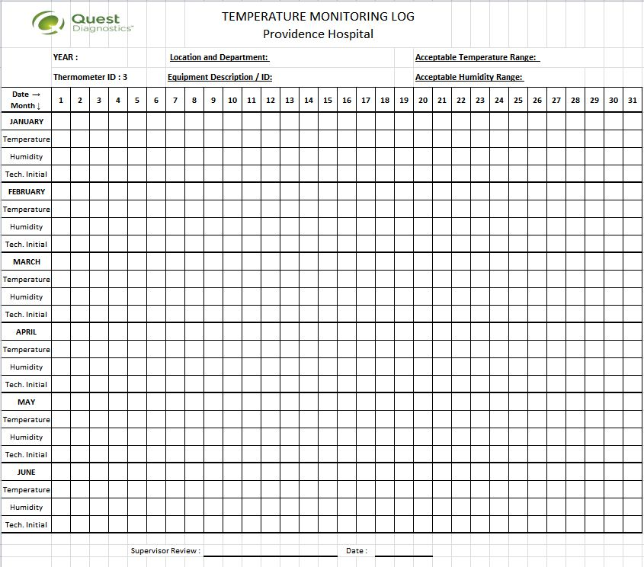

ADDENDUM B Out of Limits and Corrective Action Documentation

