Technical SOP
Title | Blood Parasites and Malarial Screen Preparation
Prepared by | Altreisha Foster | Date: 8/8/2010
Owner | Altreisha Foster | Date: 8/8/2010
Laboratory Approval | Local Effective Date:
Print Name | Signature | Date
Refer to the electronic signature page for approval and approval dates.
Annual Review
Print Name | Signature | Date

TABLE OF CONTENTS
1. TEST INFORMATION 2
2. ANALYTICAL PRINCIPLE…………………………………………………………………….3
3. SPECIMEN REQUIREMENT 3
4. REAGENTS 6
5. CALIBRATORS/STANDARDS 6
6. QUALITY CONTROL 6
7. EQUIPMENT and SUPPLIES 8
8. PROCEDURE 8
9. CALCULATION 9
10. REPORTING RESULTS AND REPEAT CRITERIA 9
11. EXPECTED VALUE 19
12. CLINICAL SIGNIFICANCE 19
13. PROCEDURE NOTES 19
14. LIMITATIONS OF METHOD 20
15. SAFETY 20
16. RELATED DOCUMENTS 21
17. REFERENCES 21
18. REVISION HISTORY 21
19. ADDENDA 22

TEST INFORMATION

Assay | Method/Instrument | Order Code | Local Code
Blood Parasites Malarial Preparation & Screen | Manual Microscopy | PMAL  FMAL

Synonyms/Abbreviations
Malaria, Malaria smear, Plasmodium sp.,

Department
Hematology
- ANALYTICAL PRINCPLE

Malaria is an infectious disease caused by a parasite, Plasmodium, which infects red blood cells. This infection is characterized by cycles of chills, fever, pain and sweating every one, two, or three days depending on disease progression. The classic and most used test in diagnosing Plasmodium infections is the microscopic review of thick and thin stained peripheral blood smears. Malaria parasites infect circulating red blood cells and undergo various stages of development within the red cell. The WESCOR stain highlights the morphological features of these stages. Whenever the thin peripheral blood smears are stained with WESCOR and reviewed microscopically it will show the parasites inside red blood cells. Species identification can be made, based upon the size and shape of the various stages of the parasite and the presence of stippling (i.e. bright red dots) and fimbriation (i.e. ragged ends). However, malaria parasites may be missed on a thin blood film when there is a low parasitaemia. Therefore, examination of a thick blood film stained with Giemsa stain is recommended.

3. SPECIMEN REQUIREMENT

3.1 Patient Preparation
Component | Special Notations
Fasting/Special Diets | None
Specimen Collection and/or Timing | Specimens for microscopic analysis of malaria are best collected during the febrile phase of the infection. The diagnostic tool is a whole blood smear collected immediately before or during the febrile phase
Special Collection Procedures | - Finger Stick  - Ear Lobe Puncture  Anti-coagulants may interfere with parasite morphology and staining.  Disinfect the area with alcohol, allow dry (to eliminate erythrocyte fixation).
Other | - Lavender top tube (EDTA)  Whole Blood collected in EDTA tube is acceptable if a finger stick or ear lobe puncture is unavailable.  Blood treated with other anti-coagulants (citrate or heparin) is not recommended.

3.2 Specimen Type & Handling
Criteria
Type -Preferred | - Four slides (two thick smears and two thin smears) prepared from finger stick.  - Smears made from blood not treated with anticoagulant are the sample of choice for the examination for parasites in blood.
-Other Acceptable | Four slides (two thick smears and two thin smears) prepared from EDTA anti coagulated blood.
Collection Container | None for preferred. Lavender top tube for other acceptable.
Volume - Optimum | Two thin two thick finger stick smears, 1.0 mL (EDTA)
- Minimum | Two thin finger stick smears, 5.0 mL (EDTA)
Transport Container | Same as above.
Timing Considerations | Blood smear should be prepared within 2 hours of collection. Refrigerated at 2-3º C up to 24 hrs.
Stability & Storage Requirements Slides | Room Temperature: | 1 month
Stability & Storage Requirements Slides | Refrigerated: | N/A
Stability & Storage Requirements Slides | Frozen: | Not acceptable
Stability & Storage Requirements for Whole Blood | Room Temperature: | 72 hours
Stability & Storage Requirements for Whole Blood | Refrigerated: | 72 hours
Stability & Storage Requirements for Whole Blood | Frozen: | Not acceptable
Unacceptable Specimens & Actions to Take | Clotted: test not performed; test cancelled  Grossly hemolysed: test not performed; test cancelled  QNS : test not performed; test cancelled  Aged: test performed no results entered; test cancelled  Frozen: test performed; test cancelled  Client services will contact the client
Compromising Physical  Characteristics | Hemolysis : avoid use of grossly hemolysed specimens  Lipemia: Acceptable  Icterus: Acceptable
Other Considerations | Treatment with anti-malarial or other anti-parasitic drugs may reduce the sensitivity of the test.

  - Thin Blood Film Preparation

Procedure | Finger stick (Fresh Blood)  - Warm finger by rubbing briskly. Clean finger with alcohol and allow to air dry.  - Puncture cleaned finger with a sterile lancet and wipe off the first drop of blood.  - Place a drop or two of blood on a clean slide labeled with the name and ID number of the patient.  - With another clean slide prepare a routine peripheral blood smear. Allow to dry thoroughly.  - Fix smear with methanol and stain with WESCOR.
Procedure | EDTA (purple top) Anti-coagulated Blood  - Make a routine peripheral smear and allow to drying thoroughly.  - Blood smears should be prepared within two (2) hours of collection.  - Fix smears with methanol and stain with WESCOR stain.

3.4 Thick Blood Film Preparation
- Place 2-3 drops of fresh or EDTA blood on a clean slide and spread in a circular motion, over an area of approximately 2.0 cm in diameter (about the size of a dime).
- Allow to air dry for 2 hours.
- Thick air dried slides are Sent to Rapid Response Lab in Chantilly, VA for confirmation.

NOTE: Do not fix the thick smears.

3.5 Microscopic Examination

Preliminary

STAT Lab:
Test request for Plasmodium parasite identification is processed STAT and delivered
to the Hematology lab immediately. Thin smears are fixed by dipping in
methanol, and then stained using the WESCOR stain. Screen one slide for blood
parasites (scan approximately 300 fields). All positive results must be immediately
reviewed by the Providence Hospital pathologist and then called to the floor by
the laboratory’s Communications Department.

Final

All slides and accompanying paperwork should be sent to Quest Diagnostics
Chantilly laboratory for further review and confirmation.

4. REAGENTS
Refer to the Material Safety Data Sheet (MSDS) supplied with the reagents for complete safety hazards. Refer to the section in this procedure covering “SAFETY” for additional information.

4.1 Reagent Summary
Reagents | Supplier &  Catalog Number | Quantity
Reagent A (Rinse) | WESCOR #SS-035A | 1 bottle
Reagent B (Eosin Stain) | WESCOR #SS-035C | 1 bottle
Reagent C (Thiazin Stain) | WESCOR #SS-035/049B | 1 bottle
Aerospray Reagent Grade Methanol | WESCOR #SS-MeOH | 1 bottle

4.2 Reagent Preparation and storage
NOTE: Date and initial all reagents upon opening. Each container must be labeled with (1) substance name, (2) lot number, (3) date of preparation, (4) expiration date, (5) initials of tech, (6) any special storage instructions; check for visible signs of degradation.

Reagent | All WESCOR reagents
Preparation | None required. Ready for use.
Storage/Stability | Store at Room Temperature away from direct light.  Reagents are stable up to expiration date suggested by the manufacturer.

5. CALIBRATORS/STANDARDS
N/A

6. QUALITY CONTROL

6.1 Controls Used
Intensity control: A negative blood film containing leukocytes is used as an intensity check prior to interpreting patient smears. If WBCs, RBCs and platelets appear well stained, then parasites will exhibit optimal staining intensity. The intensity control check should be recorded on the daily Stainer maintenance sheet. If the intensity control is not well stained, troubleshoot the problem (example: check stain pack, check stainer). Record QC intensity slide results on the daily Stainer maintenance sheet.

Previously reported positive malaria smears kept in the designated positive malaria slide box may also be used as reference slides.

6.2 Control Preparations and Storage
The intensity control smear is prepared prior to staining a batch of patient smears on
the Day shift. When the test is completed the negative slide is stored in a daily slide
box.

6.3 Frequency
The intensity control smear is stained and examined once per day on the Day Shift.

  - Tolerance Limits
Step | Action
Acceptable QC | When the WBCs, RBCs and platelets appear well stained.
Rejected QC | A run is rejected if the WBCs, RBCs, and platelets on the intensity control are not stained adequately.
Corrective Action | - All rejected runs must be effectively addressed through corrective action.  - Steps taken in response to QC failures must be documented.  - Corrective action documentation must include the following, the root cause of the problem, steps taken to correct the problem, how patient samples were handled, resolution, and the date and initials of the person recording the information.
Review of QC | - Weekly and Monthly QC must be reviewed by the lead tech or the supervisor. If controls are not within established ranges, investigate the cause for the imprecision and document implementation of corrective actions.  - Monthly QC must be presented to Laboratory Director for review and signature.

6.5 Review Patient Data
Technologists must review patient results for unusual patterns, trends or distributions in patient results (E.g. Unusually high percentage of abnormal results).

6.6 Documentation
Refer to Quest Diagnostics records management program for record retention requirements.

6.7 Quality Assurance Program
The laboratory participates in CAP proficiency testing.

7. EQUIPMENT and SUPPLIES

7.1 Assay Platform
N/A
  - Equipment
Refrigerator capable of sustaining 2–8°C.
Microscope
WESCOR Hematology Slide Stainer

7.3 Supplies
Test tubes (12x75)
Frosted slides
Applicator Sticks

8. PROCEDURE
NOTE: For all procedures involving specimens, buttoned lab coats, gloves, and face protections are required minimum personal protective equipment. Report all accidents to your supervisor.
The package insert for a new lot of kits must be reviewed for any changes before the kit is used.

8.1 Thin Blood Film Preparation
Step | Action
1. | Warm finger by rubbing. Clean finger with alcohol and allowed to air dry.
2. | Puncture cleaned finger with a sterile lancet and discard the first drop of blood by wiping with a cotton swab.
3. | Place a drop or two of blood on clean slide labeled with the name and ID number of the patient.
4. | With another clean slide prepare a routine peripheral blood smear. Allow to dry thoroughly.
5. | Fix smear with methanol and stain with WESCOR Stain.
6. | Scan about 300 fields and review for the presence of any blood parasites.

8.2 EDTA Anticoagulated Blood

Step | Action
1. | Make a routine peripheral smear and allow to air dry thoroughly.
2. | Blood smears should be prepared within two (2) hours of collection.
3. | Fix smears with methanol and stain with WESCOR stain.
4. | Scan about 300 fields and review for the presence of any blood parasites.

9. CALCULATION
None

10. REPORTING RESULTS AND REPEAT CRITERIA

10.1 Interpretation of Smears
Smears are examined utilizing oil immersion lens (100x).
Scan a minimum of 300 fields before determining that the thin smears are negative. When performing smear examination consult with other technologists or pathologists for questionable parasite morphology.
Thick smears are to be read before finalizing the report as negative.
A secondary review of all positive smears by a supervisor or Pathologist is mandatory for verification of proper identification.
NOTE: Any positive screen samples must be sent to the Quest Diagnostics Chantilly laboratory for STAT identification. Identification of Plasmodium spp and other blood parasites are medical emergencies and even a mild infections with low parasitemia can progress rapidly to fatal cerebral malaria and other disease conditions.

Table 10a. Morphological Characteristics of Plasmodium falciparum and Babesia sp.

Appearance of parasite | Plasmodium falciparum | Babesia species
Size | Small (1/4 to 1/3 RBC diameter,  3-5 μm) | Tiny to small (1/8 to 1/4 RBC diameter, 1-5 μm)
Shape | Consistent oval to round ring | Pleomorphic: pear-shaped to round ring
Appliqué Forms | Common, either marginal or bulging forms | Common, either marginal or bulging forms
Number of Chromatin dots | 1 to 2 | 1 to many ("string of pearls")
Multiple rings/RBC | Common | Common; two adjacent parasites may appear to be split into mirror images
Tetrads | No | Rarely seen
Appearance of RBCs | Normal size and shape | Normal size and shape
Parasite stages present | Ring: trophozoite with pigment (in heavy infections); banana-shaped gametocytes (rarely found) | Ring: late ring or trophozoite with no pigment, may contain a white central vacuole not seen in Plasmodium

A: Babesia microti infection, Stained thin smear. The organisms resemble Plasmodium falciparum; however Babesia parasites present several distinguishing features: they vary more in shape and in size; and they do not produce pigment.
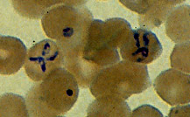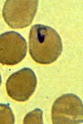

B.and C: Infection with Babesia. Stained thin smears. Note in B the tetrad (characteristic maltese cross) (left side of the image), a dividing form pathognomonic for Babesia. Note also the variation in size and shape of the ring stage parasites (compare B and C), and the absence of pigment.

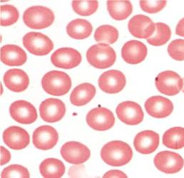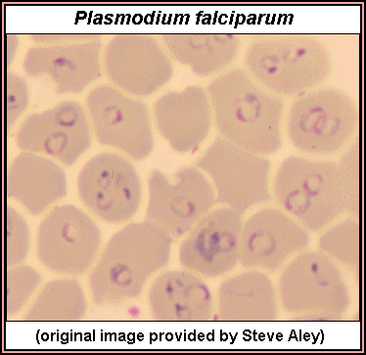

D. Normal red blood cells stained with Wrights Stain (left), E: Red blood cells infected with Plasmodium falciparum stained thin smears (right). Note in E the size and shape of the ringed stage parasites.

Table 10b. Characteristic Morphology of Plasmodium sp.

Characteristics | P. falciparum | P. vivax | P. ovale | P. malariae
Size and shape of infected erythrocytes | Normal size and shape | Enlarged up to twofold, may be oval | Normal to enlarged, frequently oval, may be fimbriated | Small to normal size, normal shape
Stippling | Occasional Mauer's dots, less numerous than Schuffner's | Schuffner's dots  (stippling) usually present, except in rings | James' stippling, darker than Schuffner’s, present in all stages, including rings | Zeiman's dots rarely seen; requires deliberate over staining
Stages seen in peripheral blood | Rings and gametocytes | All | All | All
Multiply infected erythrocytes | Common | Occasional | Occasional | Rare
Early trophozoite | Delicate ring, frequently with two small chromatin dots, often at the edge of the erythrocyte | Ring up to 1/3 diameter of the erythrocyte; larger chromatin dot than  P. falciparum | Similar to P. vivax | Smaller that P. vivax; otherwise similar
Mature trophozoite | Not seen in  peripheral blood | Amoeboid shape, fine golden brown pigment | Similar to P. vivax except less amoeboid, pigment darker brown | Compact cytoplasm, oval, round, or band-shaped, dark brown pigment
Schizonts | Not seen in peripheral blood | 12-24 merozoites | 8-12 merozoites | 6-12 merozoites often radically arranged around central pigment in a rosette form
Gametocytes | Crescent of banana-shaped | Round to slightly oval | Round to slightly oval | Round to slightly oval
Most characteristic findings | Absence of mature trophozoites and schizonts; normal size of infected erythrocytes; multiply infected RBCs; appliqué forms; banana-shaped gametocytes | Enlarged infected erythrocytes; Schuffner's dots frequently present; amoeboid trophozoite; 12-14 merozoites in each schizont | Normal to  enlarged, oval or fimbriated infected RBCs, James' stippling may be seen in rings; schizonts with 8-12 merozoites | Normal size of infected erythrocytes; no stippling; "band" trophozoite; rosette schizont with 6-12 merozoites

Ring Stage Parasites

Plasmodium falciparum: Rings
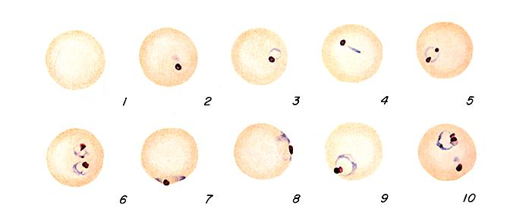

Plasmodium vivax: Rings
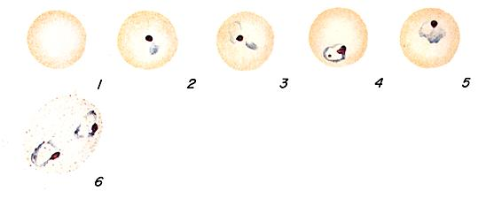

Plasmodium ovale: Rings
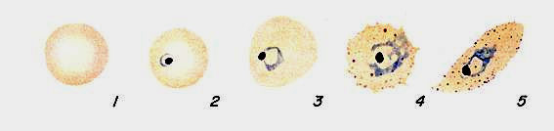

Plasmodium malariae: Rings
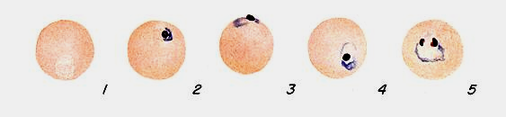

Schizonts
Plasmodium falciparum: Schizonts (usually not seen in blood)
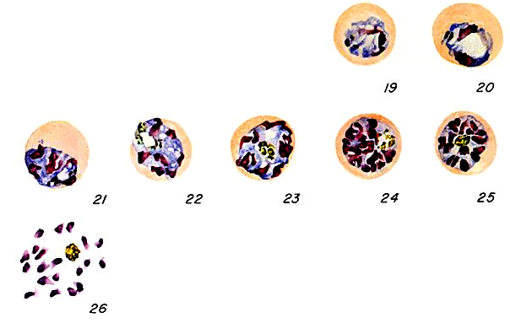

Plasmodium vivax: Schizonts
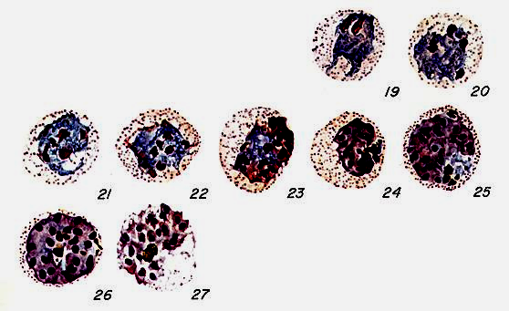

Plasmodium ovale: Schizonts
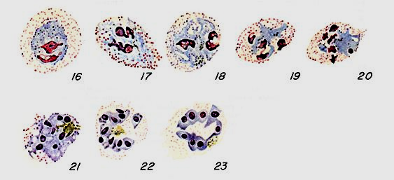

Plasmodium malariae: Schizonts
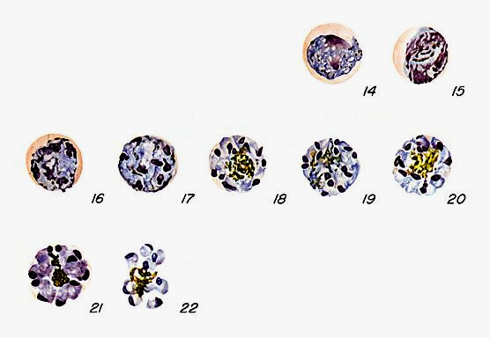

Trophozoites

Plasmodium falciparum: Trophozoites (early forms may be seen but later forms usually not seen in blood)
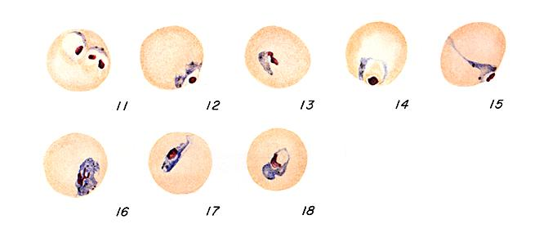

Plasmodium vivax: Trophozoites
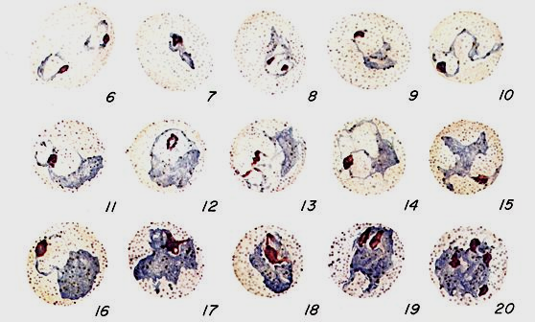

Plasmodium ovale: Trophozoites

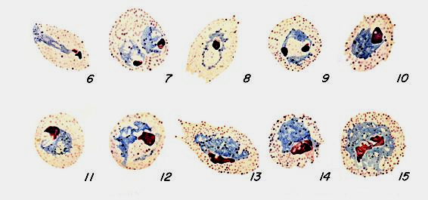

Gametocytes
Plasmodium falciparum: Gametocytes
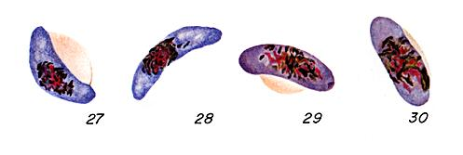
Plasmodium vivax: Gametocytes
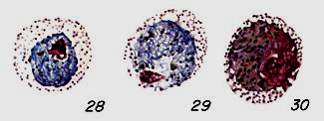

Plasmodium ovale: Gametocytes

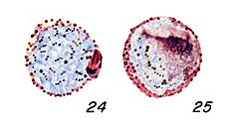

Plasmodium malariae: Gametocytes

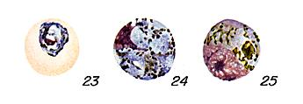

10.2 Rounding
No rounding is necessary.

10.3 Unit of Measurement
N/A

10.4 Clinically Reportable Range (CRR)
Negative and Positive

10.5 Repeat Criteria and Resulting
- Poorly stained slides; new blood smear must be prepared and stained.
- Two techs must read all smears. A positive result from a Malaria screen request, confirmed by two techs is referred to the pathologist for review.
- If NEGATIVE report: “No parasites seen confirmation to follow”.
- If POSITIVE report: “Malaria parasites seen confirmation to follow”.
- If POSITIVE but not Plasmodium spp report: “Blood parasites seen confirmation to follow”.

11. EXPECTED VALUE

11.1 Reference Range
No Plasmodium species Observed

No blood parasites Observed

11.2 Critical Value (Priority 1 & 2 Limits)
Positive for Plasmodium species

Positive for blood parasites not Plasmodium species

  - Alert Values (Priority 3 Limits)

Positive result for Plasmodium species

Positive results for blood parasites not Plasmodium species

12. CLINICAL SIGNIFICANCE
Malaria is a disease of worldwide importance characterized by fever, anemia and splenomegaly. Although four species of the genus Plasmodium (P. falciparum, P. vivax, P. malariae, and P. ovale) infect humans, malaria is clinically two diseases; the benign type due to P. vivax, P. malariae, and P. ovale, and the malignant type due to P. falciparum.

Determination of parasitemia becomes important when therapy is initiated. The patient’s parasitemia is monitored so that possible cases involving drug-resistant strains of P. falciparum may be detected. In those cases where the patient is hospitalized, monitoring of the parasitemia should be performed at 24, 48 and 72 hours after initiating therapy. Generally, if the malarial strain is susceptible to the therapeutic regime, the parasitemia will drop significantly within the first 24 hours (often by 50% or more).

Morphological diagnosis is the only practical means of identifying the parasite in blood within a clinically significant relevant time frame. Both thick and thin smears are prepared for examination. The thick films allow a greater amount of blood to be examined, which increases the possibility of detecting light infections. Morphological characteristic of the blood parasites are best seen in the thin films.

13. PROCEDURE NOTES
- FDA Status: Approved
- Validated Test Modifications: None

  - Quest Diagnostics – Providence Hospital Laboratory performs only screening of thin peripheral blood smears. Results are reported as preliminary with final reporting and parasite identification performed by Quest at Chantilly. Any positive or suspicious preliminary screening result must be submitted to the pathologist for review.
  - Any alcohol left on the skin prior to collection may fix the red cells and then they will not clear in the staining procedure.
  - Any alcohol left on the skin prior to collection may fix the red cells and then they will not clear in the staining procedure.
  - Do not dry smears using heat, as this will fix the red cells.
  - Organisms are most likely to be “captured” if the smears are taken immediately upon the onset of fever, or immediately before the fever is anticipated. In patients with a strong clinical history, but repeatedly negative results, multiple sampling throughout the fever may prove successful.
  - Platelets sitting on top of red blood cells may have the appearance of a ring form of malaria.
  - Precipitated stain may obscure malarial forms on the smear.

14. LIMITATIONS OF METHOD

14.1 Analytical Measurement Range (AMR)
N/A
14.2 Precision
N/A
14.3 Interfering Substances
None Established
14.4 Clinical Sensitivity/Specificity/Predictive Values
N/A

15. SAFETY
The employee has direct responsibility to avoid injury and illness at work. Nearly all harmful exposures to infectious substances and chemicals, and other injuries, can be avoided with effective training and consistent safe work practices.

Become familiar with the Environmental Health and Safety (EHS) Manual to the learn requirements on working safely and protecting the environment from harm. Although lab work typically focuses on the hazards of working with specimens and chemicals, we must also control other important hazards.
- Slips, trips, and falls cause many serious injuries. Please ensure that spills are cleaned quickly (to avoid slippery floors) and that you can see and avoid obstacles in your path.
- Ergonomic injuries result from performing tasks with too much repetition, force, or awkward position. Ergonomic injuries include strains and back injuries. Learn about ergonomic hazards and how to prevent this type of injury.
- Scratches, lacerations, and needle sticks can result in serious health consequences. Attempt to find ways to eliminate your risk when working with sharp materials.
- If you drive on company business (in a company car, a rental, or your own personal vehicle) you must comply with the requirements in the "Driver Safety Manual". Please remember that driving requires your FULL attention and multi-tasking while driving (e.g., talking on a cell phone) is an unacceptable risk that you must not take.
Report all accidents and injuries immediately to your supervisor, the business unit’s Environmental Health and Safety Manager or Specialist.

16. RELATED DOCUMENTS
N/A

17. REFERENCES
  - Kjeldsberg C, et al, Practical Diagnosis of Hematologic Disorders, 2nd edition, Chicago, IL: ASCP Press, 1995, pp. 172-173.
  - Atlas of Human Parasitology, 3rd edition, Chicago, IL: ASCP Press.

18. REVISION HISTORY
Version | Date | Section | Reason | Reviser | Approval
.000 | 8/2/11 | Page 1 | Edit Laboratory Approval | A. Foster | R. Levy
.000 | 8/2/11 | 3.5 | Changed performing laboratory to Hematology | A. Foster | R. Levy
.000 | 8/2/11 | 10.1 | Added instructions for other blood parasites | A. Foster | R. Levy
.000 | 8/2/11 | 10.5 | Added resulting instructions for blood parasites not Plasmodium sp. | A. Foster | R. Levy
.000 | 8/2/11 | 11.1 | Added reference range for blood parasites not Plasmodium sp | A. Foster | R. Levy
.000 | 8/2/11 | 11.2 | Added critical values for blood parasites not Plasmodium sp | A. Foster | R. Levy
.000 | 8/2/11 | 11.3 | Added alert values for blood parasites not Plasmodium sp | A. Foster | R. Levy

19. ADDENDA
Addendum | Title

