Non-Technical SOP
Title | Millipore (AFS – Analyzer Feed System)
Prepared by | Wendell R. McMillan II | Date: 4/03/2012
Owner | Wendell R. McMillan II | Date: 4/03/2012

Laboratory Approval
Print Name and Title | Signature | Date
Refer to the electronic signature page for approval and approval dates.
Local Issue Date: | Local Effective Date:

Review
Print Name | Signature | Date

TABLE OF CONTENTS

1. PURPOSE 2
2. SCOPE 2
3. RESPONSIBILITY 2
4. DEFINITIONS 2
5. PROCEDURE 2
6. RELATED DOCUMENTS 15
7. REFERENCES 15
8. REVISION HISTORY 15
9. ADDENDA 15

PURPOSE

The purpose of this procedure is to outline the use and maintenance of the Millipore AFS Water Purification System. The Millipore AFS Water Purification System will be utilized as the Analyzer Feeder System for Dimension analyzers and source for deionized water for all testing in the Laboratory.

SCOPE

This procedure applies to Laboratory staff that operates the Dimension analyzers.

RESPONSIBILITY

Laboratory staff that operate the Dimension analyzer, prepare reagents, utilize water or culture the system are responsible for monitoring and/or maintenance of the Millipore system.

DEFINITIONS

AFS – Analyzer Feed System; a water purification system that produces NCCLS Type I Product Water directly from potable tap water. The system combines Reverse Osmosis (RO) and Ion Exchange technology to accomplish this. The product water then feeds the Dimension analyzers directly, without any extra user interaction. The AFS system is designed to produce NCCLS Type I quality water.

PROCEDURE

  - Operating Principle
Potable tap water enters the Progard 3 Pretreatment Pack. The Progard 3 is used to prevent mineral scaling, organic fouling and chlorine oxidation of the Reverse Osmosis (RO) cartridge. The Progard 3 is a consumable item. The RO pump is used to boost the tap water pressure. This will create more permeate flow from the RO cartridge. The RO cartridge removes a large percentage of ions from the tap water, and in addition, removes a large percentage of bacteria and organic material. The RO has a waste (reject) stream, which is directed to a drain. All ions, bacteria and organic material removed by the RO are directed to the waste stream. The permeate flow from the RO is stored temporarily in the 10 Liter Tank.

Tap Water

Flow Schematic
Progard Pretreatment Pack

QGard A
Cartridge
Bacteria
filter
Ro pump
RO
10 L
Tank
Distribution
Pump
Degasser
Product water

Boosts tap
Water pressure
RO reject

Removes ions, bacteria
& organic matter

  - General Information

Parameter | NCCLS/CAP specification for Type I Water
Maximum bacterial content | < 10 CFU/ml*
Minimum resisitivity | 10 ΜΩ-cm**
Maximum silicate level | < 0.05 mg/L
Particulate matter | 0.22 micron filter
Organic contaminants | Activated carbon*** or Reverse Osmosis or Distillation
pH | Not specified
*CFU/ml = colony forming units per ml
** MΩ.cm=Megohm.cm compensated to 25 ° C
*** Not required by CAP

  - Operation

5.3.1 Operate/Standby Button

The keypad allows you to interface with the system. Changing the software modes, reviewing the system’s performance, and initiating maintenance procedures can be done via the keypad.

Power

Service

Operate Measure Cleaning Menu
Standby Alarm

Standby – This mode is displayed when the system is not operating any of the internal components. Normally this mode is used when starting a maintenance procedure.
The system performs an automatic flush of the RO cartridge every 6 hours (all operating modes). The flush mode rinses the RO to remove anything that has built up on the membrane surface. No water will be sent to the analyzer when the system is in this mode.

Filling Tank – This operating mode is displayed when the 10-liter tank is being filled with RO water. If the analyzer requires water, the distribution pump will send the water to the analyzer as needed.

Tank Full – This operating mode is displayed when the 10-liter tank is full of RO permeate water. If the analyzer requires water, the distribution pump will send water to the analyzer as needed.

Production – This operating mode is displayed when the water is being sent from the AFS to the analyzer. The AFS switches automatically to PRODUCTION mode if the system is in TANK FULL or in FILLING TANK mode.

The Resistivity of the product water is shown in the bottom left corner of the display. The displayed resistivity is temperature compensated to 25° C. The actual temperature of the product water is displayed in the bottom right corner of the display.

Product water can be produced from the AFS for a maximum of 18 continuous minutes. This is a software feature, which prevents the Distribution Pump from running dry. The Distribution Pump will stop after 18 minutes of continuous use. DISP. TIME OVER (Dispensing Time Over) will alternate with PRESS OPERATE in the display. You must place the system into STANDBY mode in order to reset the timer. (Hold down the OPERATE/STANDBY button for two seconds). After the timer is reset, the AFS should be changed to FILLING TANK or TANK FULL mode so that water can be sent to the analyzer if needed.
DISP TIME OVER will reset automatically as soon as the tank is full.

If you use a tank greater then 10 liters, contact your local Millipore office.
The Measure Button allows you to see various water quality related parameters.

5.3.2 Measurements when in Filling Tank or Tank Full Mode

Various measurements are made when the Tank is being filled with permeate water from the RP membrane.
Reminder: The permeate water from the RO membrane is not the final product water.

Press the Measure Button

The top line of the display will show the pressure of the water that is going into the RO cartridge. This pressure results form the RO pump increasing the tap water pressure. The bottom line of the display shows the ionic percent rejection of the RO membrane. This is determined using the feed water conductivity and permeate conductivity values. The RO ionic % rejection represents the percentage of ions that are rejected by the RO membrane and then sent to the drain.

Press the Measure Button Again

The top line of the display shows the pressure of the water that is going into the RO cartridge. The electrical conductivity of the RO feed water is shown on the bottom of the display.

Press the Measure Button Again

The top line of the display shows the pressure of the eater that is going into the RO cartridge. The electrical conductivity of the RO permeate water is shown on the bottom line of the display.

Press the Measure Button Again

The system returns to FILLING TANK or TANK FULL mode.

5.3.3 Measurements in Production Mode (Water is Being Sent to the Analyzer)

The Resistivity Value (compensated to 25° C) and the Temperature of the Product Water are displayed at all times when in PRODUCTION mode.
(See Measurements when in FILLING TANK or TANK FULL mode).

5.3.4 Cleaning Button

The Cleaning button is used to initiate either the Chlorine Sanitization cycle or the pH Cleaning cycle. Refer to the Maintenance section of the User Manual for a complete description of both cycles.

5.3.5 Menu Button

The menu button can be used to access various Customer Menus. Hold down the MENU button for 2 seconds to access the Customer Menu. The Customer Menu can be accessed in any Operating Mode.

5.3.6 Pak Life

The first screen shows the number of days remaining before the Progard 3 Pretreatment Pack needs to be exchanged. Both a day-to-day timer and a measurement of water usage calculate the number of days remaining by the system. The number of days will count down (decrease).

When a new Progard 3 Pretreatment Pack is installed, the display will show NO DATA for seven days. This message is necessary so the system can determine an accurate rate of water usage.

Press the MENU button. This scrolls the display over to the OPTIONS portion of the Customer Menu.

5.3.7 Language

This gives you the option to change the language seen on the display. The Arrow Buttons can be used to scroll between various languages.

Press the OPERATE/STAND BY Keypad Button to scroll down to the next choice in the OPTIONS selection.

5.3.8 External Alarm

An external alarm (buzzer, light, etc.) can be connected to the AFS system. When an Alarm or Service message is shown on the display, the system will send either a 100/120/230 volt signal to an external alarm connected to the system. The voltage of the signal depends upon the voltage supplied to the system.

Use the Arrow Buttons (MEASURE or CLEANING) to activate (ON) or deactivate (OFF) the External Alarm.

Press the OPERATE/STANDBY Keypad Button to scroll down to the next choice in the OPTIONS selection.

5.3.9 Pressure Units

You can change the units that are displayed for the pressure measurements when the system is in operation. This laboratory uses psi.

5.3.10 Resistivity or Conductivity Display

This option changes the displayed units during PRODUCTION mode. These units include resistivity (MΩ.cm) or conductivity (uS/cm).

Note: When you scroll to the following menu option, you will have 10 seconds before the software automatically starts the System Rinse. In order to prevent this from happening, press the MENU again before the end of 10 seconds.

Press the MENU Keypad Button to scroll over to the next menu option.

5.3.11 System Rinse

The System Rinse starts automatically after a 10 second delay. If you want to start a 240-minute System Rinse, wait 10 seconds when this display is shown.

If you accidentally start a System Rinse and want to cancel it, call Your Local Millipore Office for assistance.

The purpose of the System Rinse is to rinse the preservatives in the RO membrane. The 10-liter Tank will not fill during the 240 minutes of the System Rinse.

Note: Poor water quality could result if a NEW RO cartridge is not rinsed for the required time.

Press the MENU Keypad Button to scroll over to the next menu selection.

Press the MENU Keypad Button to exit the Customer menu.

    - Leak Detector (Located under the AFS)

If the alarm for the Leak Detector goes off, this means that there is water coming in contact with the sensor on the floor. This will shut off the water going into the AFS so it must be addressed:

- Locate the source of the leak and if water is still flowing, attempt to turn it off. If you cannot, contact the Hospital Plant Operations Department.
- After the leak has been stopped and the floor is completely dry, dry off the sensor (1) and press the reset button (2). This should get the system going again. If not, contact Millipore Technical Assistance.
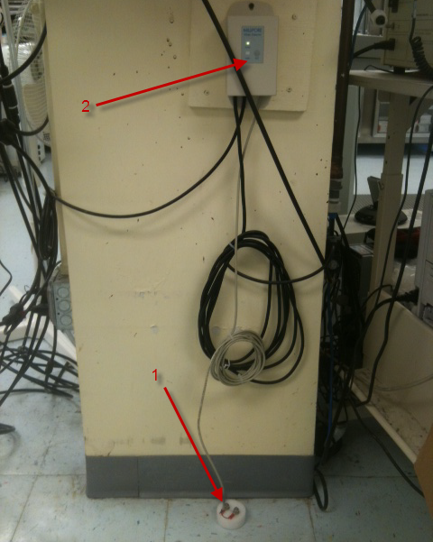

5.3.12 Replacement of Consumables

Table for quick reference for when the consumables should be exchanged:

Consumables names | When to change the Consumables
Progard Pretreatment Pack | Replace the Progard when the message “EXCHANGE PROGARD” is shown on the display. Also replace the PROGARD if the system has been turned off for more than 48 hours. System should be powered on and in STANDBY mode when the Progard is replaced.
Bacteria Filter | Replace the Simfilter or Millipak when the Progard is exchanged.
Millex Vent Filter | Replace the Millex when the Progard is exchanged.
Q-Gard A Cartridge | Replace the Q-Gard A Cartridge when the system displays “EXCHANGE CARTRIDGE” message. Replace it only after opening the manual Product Line Drain Valve and draining any water that may have stayed stagnant in the cartridge.

See the Troubleshooting Section for more information if the system is producing Low Flow.

a) Replacing Progard Pretreatment Pack

- The system should be turned on and in STANDBY mode when replacing the pack. Place the system into STANDBY mode by holding the OPERATE/STANDBY button down for 2 seconds. The STANDBY display flashes to indicate depressurization of the system.
- Open the front blue door by pressing on the 2 latches on the right side and pulling the door open.
- Pullout the used Progard.
- Remove the two protective caps from the new Progard. Wet the two O-rings on the new Progard with water.
- Insert the Progard into the system. Push it in as far as it will go.
- Close the door. It is necessary to fully snap the latches shut to hold the Progard inside. You should hear both latches “click” shut.
- Press the OPERATE/STANDBY button to change the system into FILLING TANK or TANK FULL mode. The system may initially display PRODCUTION until the pressure rises.
- Note: Replace the Progard if the system has been turned off for more than 48 hours.

b) Replacing Q-Gard A Cartridge

- You will need a Q-Gard A cartridge and at least 5 liters of water in the Tank (approximately half the Tank).
- Make sure the AFS system is in STANDBY mode. Wait for the STANDBY display to stop flashing if necessary.
- Open the Product Line Drain Valve and release any pressure in the distribution tubing.
- Close the Product Line Drain Valve.
- If there is a Q-Gard A installed, wait until the STANDBY display stops flashing:
  - Lift the pack adapter cover to the top position
  - Remove the metal locking clip
  - Pullout the Q-Gard A Cartridge
- Remove the protective caps from the new Q-Gard A Cartridge, and wet the pack o-rings using a few drops of purified water.
- Slide the pack onto the metal guide pin.
Lift up the pack slightly in order to push the bottom of the pack into the slot at the bottom of the system.
Push the pack completely onto the pack adapter. The metal guide pin should now be visible now.
- Lock the pack in place with the metal locking clip on the end of the metal guide pin.
- Lower the adapter cover over the newly installed Q-Gard A Cartridge.
- Press the OPERATE/STANDBY button to change the system into FILLING TANK or TANK FULL mode. The system may initially display PRODUCTION until the pressure rises.
- With the tubing from the Product Line Drain Valve secure in the drain, open the product Line Drain Valve to change the system into PRODUCTION mode.
- Allow approximately 5 liters of water (half of the Tank) to pass through the Q-Gard A Cartridge in order to rinse the ion exchange resin correctly.

c) Bacteria Filter/ Millipak

The Millipak should be changed at the same time as the ProGard 3. The Millipak can be used immediately after installation.

- Make sure the AFS system is in STANDBY mode. Wait for the STANDBY display to stop flashing if necessary.
- Remove the O-ring used to affix the Millipak to the bracket. Unscrew the fittings on both ends of the Millipak.
- Screw the Millipak (clear side up) into the top and bottom connectors and finger-tighten the connections. Secure the Millipak on the bracket using the O-ring. Discard the old Millipak.
- Press the OPERATE/STANDBY button to change the system into FILLING TANK or TANK FULL mode. The system may initially display PRODUCTION until the pressure rises.
- With the tubing from the Product Line Drain Valve secure in the drain, open the Product Line Drain Valve to change the system into PRODUCTION mode.
- Verify that there are no visible leaks after the Millipak fills. Vent the Millipak after filling.

d) Simfilter

The Simfilter should be changed at the same time as the Progard 3. The Simfilter can be used immediately after installation.

- Locate the Quick Disconnect Fitting, which is normally connected to the analyzer. Separate the fitting by pushing down on the metal piece and pulling the fitting apart. If a Quick Disconnect fitting is not used, remove the tubing connected to the fitting on the analyzer.
- Unscrew the metal nut and remove the tubing from the Quick Disconnect fitting. Screw the nut back on the fitting so it does not get misplaced.
- Connected directly onto the Simfilter is a fitting. Unscrew the nut and remove the tubing coming form the AFS. Discard the Simfilter, including the attached fitting. The new Simfilter comes with a fitting and tubing already attached.
- The new Simfilter can be installed at this time. Unscrew the nut from the fitting and place the nut on the tubing coming from the AFS>
- Push the tubing onto the fitting on the Simfiliter. Screw the nut back onto the fitting to secure the tubing.
- Connect the tubing on the other side of the Simfilter to the fitting connected to the analyzer. If this fitting is the Quick Disconnect fitting coming with the system:
  - Unscrew the nut on the Quick Disconnect fitting
  - Slide the nut onto the tubing from the e Simfilter
  - Push the tubing onto the fitting
  - Tighten the nut onto the fitting so that the tubing is locked into place
  - Reconnect the Quick Disconnect fitting to the analyzer

e) Changing the PrePak Pretreatment Purification Pack

- Close the feed valve and open the bleed valve to depressurize the unit.
- Remove the protective covers from the new PrePak that is to be installed, wet the “O” rings on the pack with pure water. This will ensure a good seal onto the pack support.
- Lift the front of the pack cover and push the Millipore Pack onto the metal guide pin. Push the pack onto the holder, so that the notch on the metal guide pin. Push the pack onto the holder, so that the notch on the metal guide pin emerges from the other side of the pack.
- Lock the Millipore Pack in place by placing the metal locking clip on the notch on the metal guide pin.
- Lower the pack cover. You are now ready to connect the PrePak to the water purification system.
- Open the feed valve and flush until the water runs clear. Close the bleed valve.
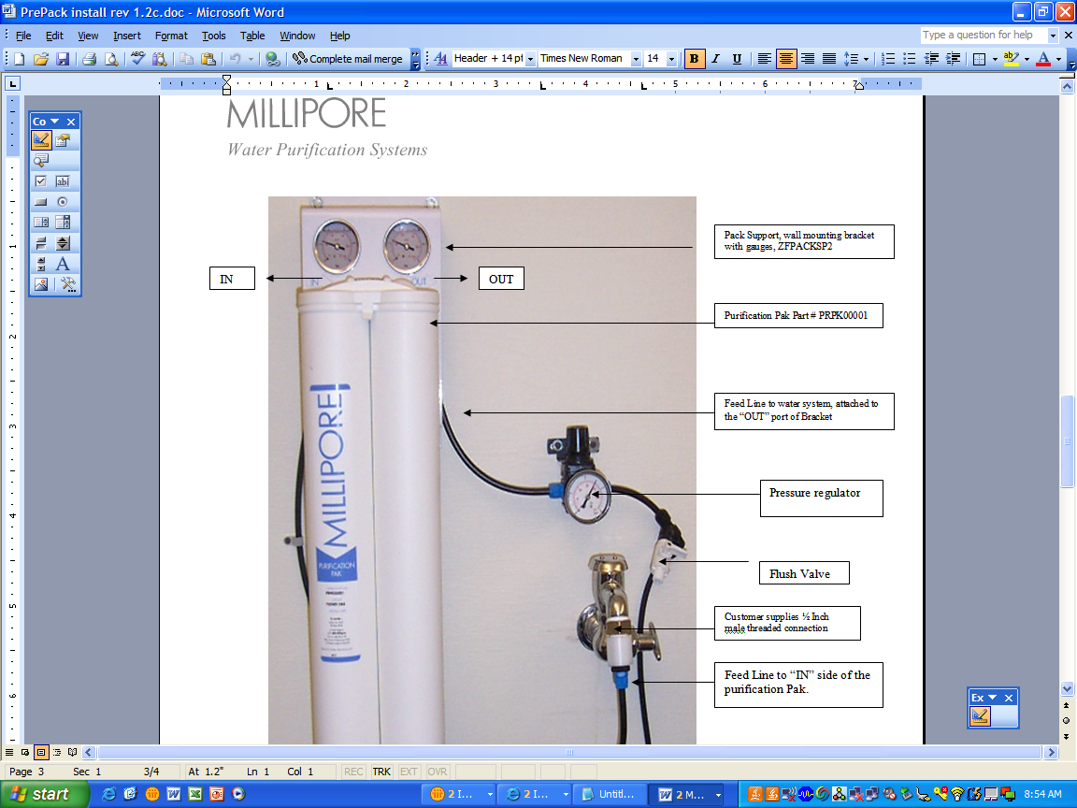

5.3.13 Maintenance

a) Cleaning of the Screen Filter

The screen filter must be cleaned each time the Progard 3 is replaced. Cleaning the screen filter will allow a better flow rate to reach the system. It also aides in preventing any large foreign particles form causing damage to the system. The screen filter is in the ½ inch FNPT fitting connected to the feed water valve. This is the valve, which supplies water to the system.

- Place the system in STANDBY mode by holding the OPERATE/STANDBY button down for 2 seconds. The STANDBY display flashes to indicate the depressurization of the system.
- Once the STANDBY display stops flashing, unscrew the sanitization port plug and put a chlorine tablet in.
- Replace the sanitization port plug. Hand tighten only.
- Start the cleaning cycle :
Hold the CLEANING button down for two seconds. The chlorine cleaning cycle starts after a 10 second delay. The remaining time of the cleaning cycle is displayed.
- Note: During the cleaning cycle, water can be drawn from the 10 Liter tank to feed the analyzer. The cleaning cycle is 15 minutes. At the end of this cycle the system automatically changes to FILLING TANK or TANK FULL mode.

b) Chlorine Sanitization of the Reverse Osmosis Cartridge

Chlorine sanitization should be performed when the message “START AUOCLEAN” appears on the display. The yellow service light also flashes.

- Place the system in STANDBY mode by holding the OPERATE/STANDBY button down for 2 seconds. The STANDBY display flashes to indicate the depressurization of the system.

- Once the STANDBY display stops flashing, unscrew the sanitization port plug and put a chlorine tablet in.

- Replace the sanitization port plug. Hand tighten only.

- Start the cleaning cycle as follows:

Hold the CLEANING button down for two seconds. The chlorine cleaning cycle starts after a 10 second delay. The remaining time of the cleaning cycle is displayed.

Note: During the cleaning cycle, water can be drawn from the 10 Liter tank to feed the analyzer. The cleaning cycle is 15 minutes. At the end of this cycle the system automatically changes to FILLING TANK or TANK FULL mode.

c) PH Cleaning of the Reverse Osmosis Cartridge

A pH cleaning should be performed as needed. If the % ionic rejection drops several points or if the flow rate coming from the AFS has decreased, a pH cleaning of the RO could renew the cartridge.

- Use the ROClean™-A (acid) once a month or when necessary when the feed water entering the AFS has a high level of hardness. A high level of hardness is defined as > 150 ppm Calcium/Magnesium and > 30 ppm Alkalinity.
- Use the ROClean-B (base) once a month or when necessary in order to remove organic buildup on the membrane. It is recommended to use the ROClean-B if the Fouling index of the feed water is greater than 5.
- Place the system in STANDBY mode by holding the OPERATE/STANDBY button down for 2 seconds. The STANDBY display flashes to indicate depressurization of the system.
- Once the STANDBY display stops flashing, unscrew the sanitization port lug and add the ROClean-B cleaning pouch.
- Screw the sanitization port plug back in place.
- Start the additional cleaning cycle:
Hold the CLEANING button down for 2 seconds
Press once on CLEANING to display the pH Cleaning mode
The pH cleaning cycle will start after a 10 second delay. The remaining time of the cleaning cycle is displayed.
- Note: During the pH cleaning cycle, water can be drawn from the 10-liter tank to feed the analyzer. The pH cleaning cycle is 90 minutes. At the end of this cycle the system automatically changes to FILLING TANK mode or TANK FULL mode.

5.3.14 Monitoring Bacterial Levels in Water

To meet NCCLS requirements for the specification of bacteria count, periodic testing is recommended. Bacteria cultures need to be performed weekly.

a) To obtain water for culture:
- Sanitize the sampling port: working from the inside out, wash the port with a 10% bleach solution, using a sterile cotton swab dipped in the 10% bleach solution for the inside of the port.
- Open the sampling port on the AFS product line and let it run for at least 1 minute.
- Collect 10 ml of water in a sterile container (urine culture collection cup).
- Record collection of water (date/tech code) on the AFS-8(D) Daily Maintenance Log

b) To order culture (This is done by specimen processing):
- Click on the name field
- Enter “WATER”
- Click Process
- Double Click the first Water Quality Control Visit
- Click Create
- Click Process to create the accession number
- Click on Orders
- Enter DIH2
- Click Save
- Click Done

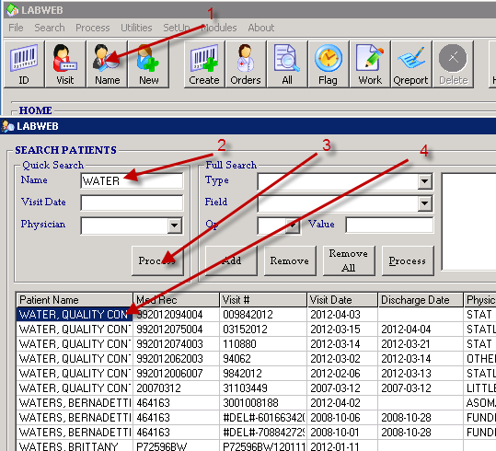
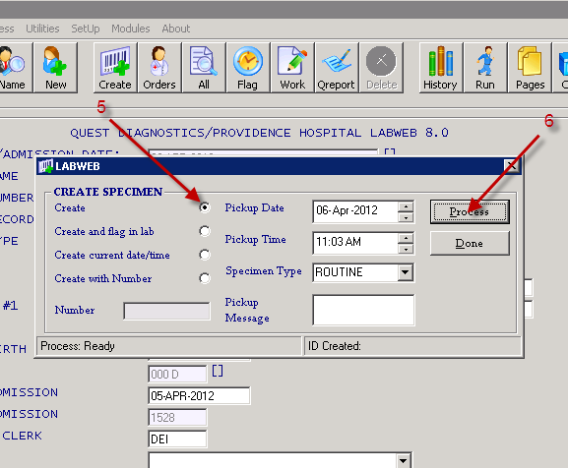
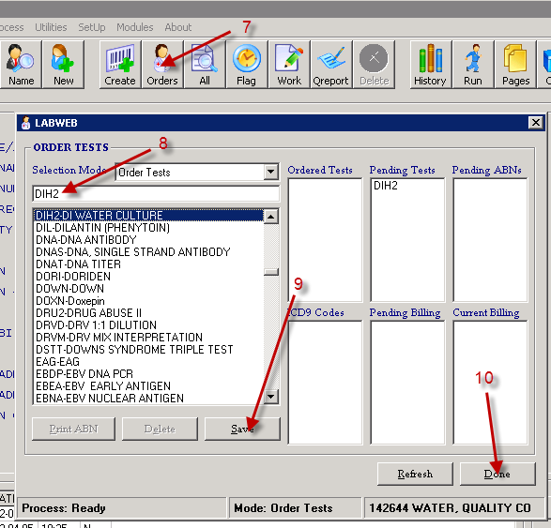

c) Group Lead will:
    - Retrieve results from printer
    - Record results as CFU/mL on the AFS-8(D) Daily Maintenance Log
    - Acceptable values are ≤ 10 CFU/mL.
    - Document corrective action if value is unacceptable.

    - AFS Daily Maintenance Log
Complete AFS-8(D) Daily Maintenance Log - System Readings form (see Addenda)

RELATED DOCUMENTS
None

REFERENCES
User manual, Millipore, 2003. www.millipore.com, www.millipore.com/techservice
1-800-645-5476

REVISION HISTORY

Version | Date | Reason for Revision | Revised By | Approved By
 |  | Supersedes SOP PHC.110

ADDENDA
AFS-8(D) Daily Maintenance Log - System Readings (see Attachment Tab of Infocard)

