MTS CAP survey corrective action competency:

Recently a SEM CAP survey was unsuccessful; using the semen analysis worksheets could have prevented the errors.

SEMB CAP 2012

1. I have reviewed the semen analysis procedure(following)
2. I will use the semen analysis worksheet to document counts on proficiency testing samples. 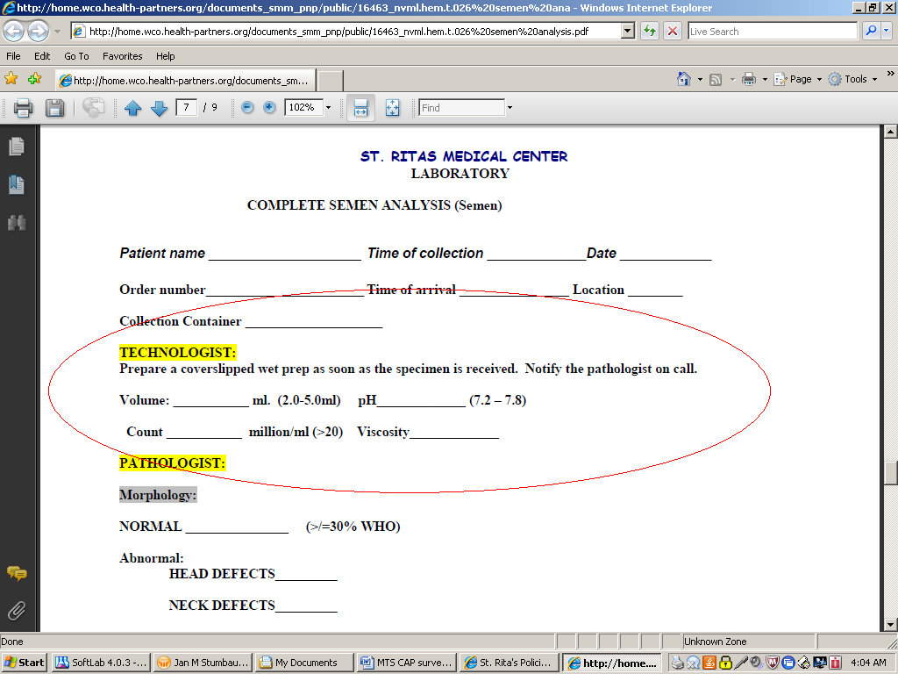
3. All worksheets will be filed with the original CAP survey forms.
4. All proficiency samples will be tested following the same procedure as patient testing to include all documentation.

Review policy [here](http://home.wco.health-partners.org/documents_smm_pnp/public/16463_nvml.hem.t.026%20semen%20analysis.pdf)