MTS CAP survey corrective action competency: SEM-B 2012

Recently a SEM CAP survey was unsuccessful; using the semen analysis worksheets could have prevented the errors.

SEM-11 and SEM-12 results were switched on CAP result form; see below

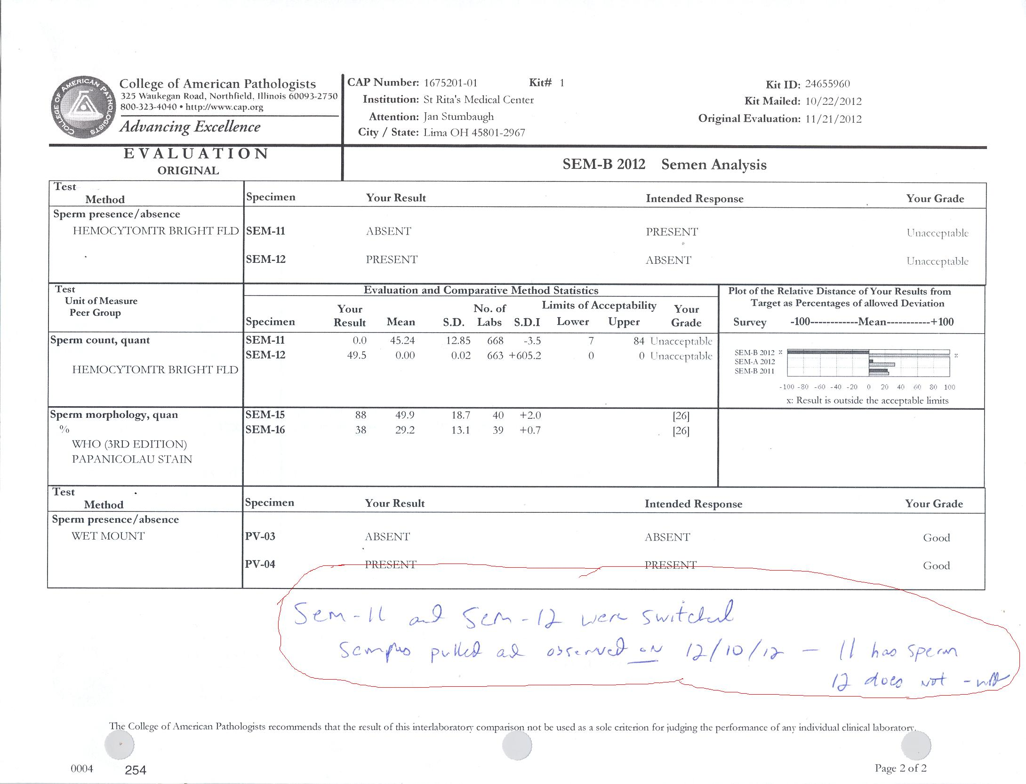

The Complete Semen Analysis worksheets should be used. Proficiency Samples should be ran in the same manner as patients. These worksheets are with the Path review forms on top of the differential slide file box.

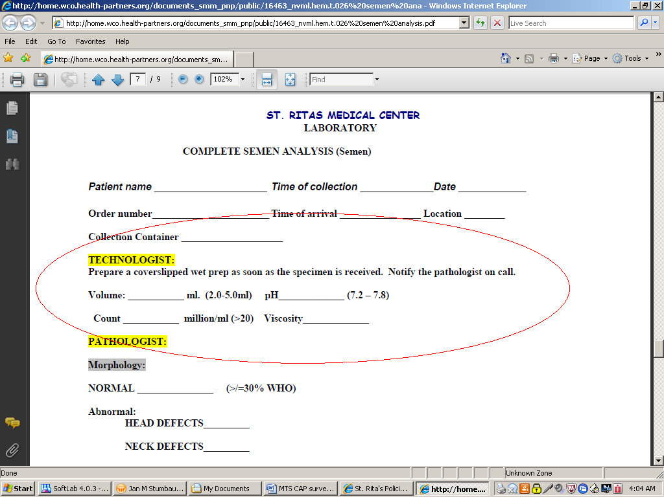

These forms will be filled out for both patients and Cap Surveys and filed with the result forms.

Failure to do so will result in disciplinary action.

Review the sperm analysis procedure.

Review policy [here](http://home.wco.health-partners.org/documents_smm_pnp/public/16463_nvml.hem.t.026%20semen%20analysis.pdf)