**MTS CAP SURVEY CORRECTIVE ACTION COMPETENCY: SEM-B 2012**

**We recently failed a semen analysis cap survey. The tech actually had accurate test counts, but didn’t record these results with the correct sample numbers. In other words, the results were switched. SEM-11 count was 49.5 not 0.0 and SEM-12 count was 0.0 not 49.5. The tech in turn not only failed the sperm counts, but also the presence/absence results.**

**Shown here is the evaluation form, grade card if you will that CAP mails back to us. All unsuccessful cap surveys are listed in our cap inspector’s checklist packets. One of the first items an inspector is required to check is to see what corrective action we took. This MTS competency was created as part of that corrective action plan.**

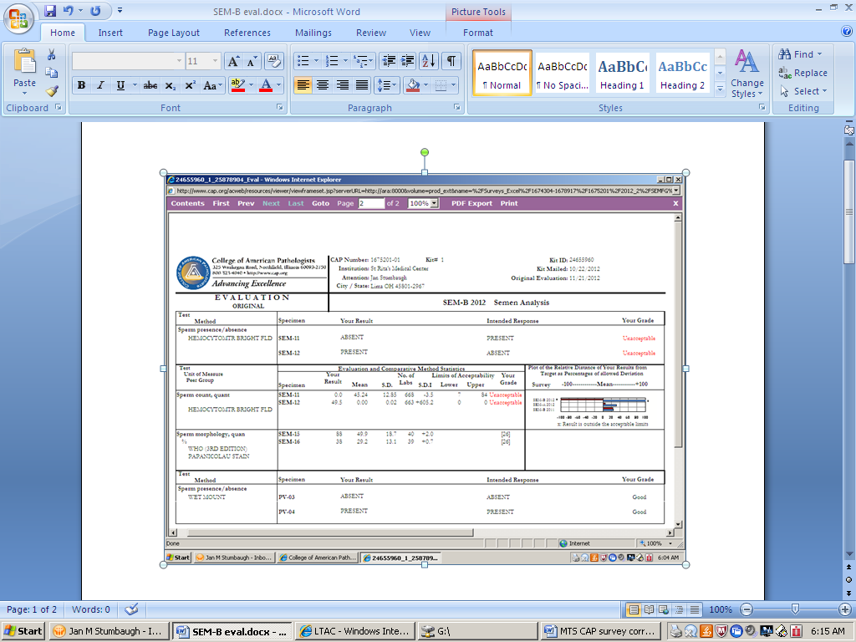

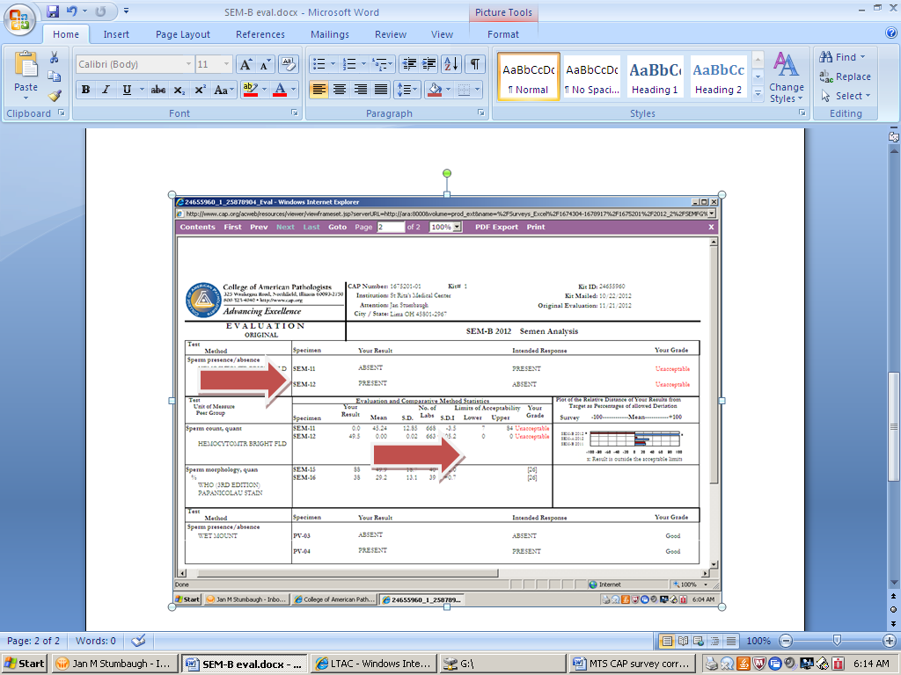

**We have sperm analysis worksheets that are a tool to use to keep track of all the testing performed on each specimen. A specimen label is attached to this worksheet and every test performed is recorded on this sheet at the time it was performed. This is to ensure the procedure is followed step by step and the results of each sample are recorded from step to step, before proceeding to another specimen/sample.**

**Shown below is the sperm analysis worksheet. The sperm analysis procedure refers to this worksheet 4 times:**

6. PROCEDURE:

Be sure to note any abnormality on the worksheet and in the LIS, such as would not liquefy”, or “specimen

contained gelatinous clumps”.

And again:

3. Determine the volume of the specimen by pouring the sample in a graduated cylinder (Suitable cylinders

found in the glassware storage MUST be pre-warmed to body temperature.) Return the specimen to its

original container and record results on the worksheet for Semen Analysis in the folder found in the top

Hematology drawer containing forms and charts.

And;

4. Determine the pH of the specimen by using the Dual-Tint pH paper calibrated for a pH range of 7.0 - l0.0.

The pH paper is located in the drawer with the counting chambers. Simply immerse a small section of

the paper in the specimen and IMMEDIATELY compare the color change with the chart located on the

paper container. Record the results.

7. Deliver the smears to Histology along with a copy of the Semen Analysis Worksheet, indicating the

Pathologist (on call) performing the morphology examination.

**Proficiency test are to be performed in the same manner as patients. This means that we are to use the sperm analysis worksheets with proficiency samples also.**

**These worksheets are to be filled out and filed with your cap survey results, as well as patient results.**

**The worksheets were not used on this unsuccessful cap survey. If the procedure had been followed, and the worksheet used, this error might not have occurred.**

**So again:**

**The sperm analysis worksheets must be used for proficiency samples as well as patients.**

**Failure to do so will result in remedial action.**

**If you have any questions, please ask the hematology lead tech, and or your core lab team leader.**

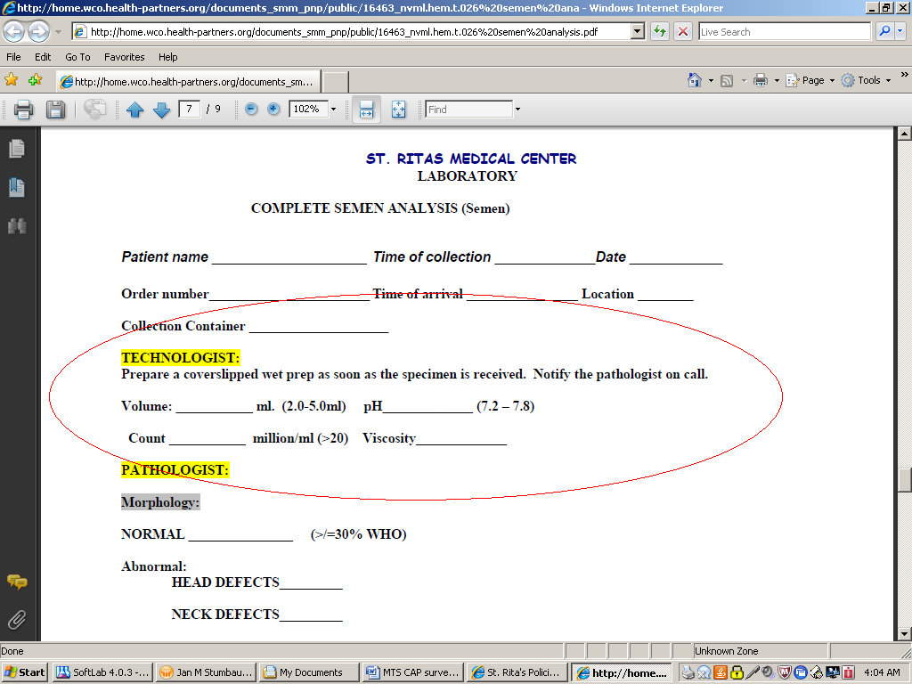

Review policy [here](http://home.wco.health-partners.org/documents_smm_pnp/public/16463_nvml.hem.t.026%20semen%20analysis.pdf)

**By checking off this MTS competency you acknowledge that;**

1. **You understand the sperm analysis procedure.**
2. **You will always use the sperm analysis worksheet for patients as well as proficiency samples.**
3. **You will initial and file the worksheet with your result form.**
4. **If you are the tech performing the clerical check you will ensure the results on the result form, match the results in the LIS as well as the results recorded on the sperm analysis worksheet.**

**2/14/2013 JMS**