This procedure is electronically produced, revised, monitored, reviewed and/or retired. For a full document history of initiation, revisions, and reviews with electronic signatures and dates, please open document in the procedure publishing software.

SUBJECT: Meridian ImmunoCard STAT!® EHEC

1. PRINCIPLE:

ImmunoCard STAT! EHEC is an immunochromatographic rapid test for the qualitative detection of Shiga toxins 1 and 2 (also called Verotoxins) produced by E. coli in cultures derived from clinical stool specimens. ImmunoCard STAT! EHEC is used in conjunction with the patient’s clinical symptoms and other laboratory tests to aid in the diagnosis of diseases caused by enterohemorrhagic E. coli (EHEC) infections.

ImmunoCard STAT! EHEC is an immunochromatographic rapid test utilizing monoclonal antibodies labeled with red-colored gold particles. The test device has a circular sample port and an oval-shaped test (Toxin 1, Toxin 2) and control (Control) window.
- The sample is applied to the chromatography paper via the circular sample port (Sample).
- The sample is absorbed through the pad to the reaction zone containing colloidal, gold-labeled antibodies specific to Shiga toxins.
- Any Shiga toxin (ST1 and ST2) antigen present complexes with the gold-labeled antibody and migrates through the pad until it encounters the binding zones in the test (Toxin 1, Toxin 2) area.
- The binding zones (Toxin 1 and Toxin 2) contain another anti-ST1 or -ST2 antibody, which immobilizes any Shiga toxin-antibody complex present. Due to the gold labeling, a distinct red line is then formed.
- The remainder of the sample continues to migrate to another binding reagent zone within the control zone, and also forms a further distinct red line (positive control). Regardless of whether any Shiga toxin is present or not, a distinct red line should always be formed in the control zone and confirms that the test is working correctly.

2. CLINICAL SIGNIFICANCE:

Among the E. coli human pathogens, Shiga toxin–producing strains of E. coli have gained in importance in recent years.¹⁻¹⁰ The group of EHEC, with their highly pathogenic serovars O157:H7, 026, 0103, 0111, 0145, and other strains are of particular concern. Production of Shiga toxins is the most common criteria for the detection of this group of bacteria. Shiga toxins can be classified into two main categories: Shiga toxin 1 (ST1) and Shiga toxin 2 (ST2). EHEC strains may produce ST1 or ST2 only or both ST1 and ST2 simultaneously. EHEC are capable of initiating life-threatening illnesses, particularly in young children, the elderly or patients with immune deficiency. The main sources of infection are contaminated, raw or insufficiently heated foods of animal origin, eg, meat and dairy products. The reservoirs for EHEC are cattle, sheep and goats and is spread through their feces. These microorganisms can enter food during the processing of meat and dairy products if hygienic conditions are inadequate. The incidence of food infection caused by Shiga toxin-producing E. coli demands reliable and rapid methods of detection. In addition to traditional culture methods, immunological techniques are becoming more useful due to their improved specificity and sensitivity. ImmunoCard STAT! EHEC is an immunological diagnostic test based on the immunochromatographic lateral flow principle.

3. SPECIMEN:
A. COLLECTION AND PROCESSING:

Preferred sample types and volumes:
Specimens in Cary-Blair based media
Raw stool: 200-300uL (100uL for testing and the remaining for retesting if needed)
Collection containers: Airtight transport containers without preservative.
Interfering substances:
None known
Collection:
- Stool specimen storage and handling for the culture of EHEC organisms: The appropriate stool specimen should either be frozen (<-70°C) or placed at 2-8°C immediately after collection. The refrigerated specimens should be cultured within 2 hours. If culturing cannot be performed within 2 hours, the specimen should be placed in a Modified Cary-Blair-based transport media. Samples in Modified Cary-Blair transport media can be stored at 2-8°C if they are cultured within two to three days. If culturing cannot be performed within this time, the specimens should be frozen at <-70°C immediately upon receipt. Specimens in Modified Cary-Blair transport medium should not be refrigerated then frozen.
- Storage of broth showing growth prior to ImmunoCard STAT! EHEC testing: Broths with growth may be held for up to seven days at 2-8°C before testing with ImmunoCard STAT! EHEC. If testing is not performed within this time period, the broth should be frozen at ≤ -20°C for up to 21 days. (See section on PRECAUTIONS.)

B. REJECTION:

Undesirable specimens:
- Specimens in formalin, PVA, or SAF
- Note: Stool in transport media (with the exception of Cary-Blair), swabs, or preservatives have not been validated for use by this method.

C. STORAGE AND PRESERVATION:

Preparation:
1. Use an applicator stick to mix stool thoroughly regardless of consistency.
2. Using a pipettor or transfer pipette (supplied with the kit):
a. Unpreserved specimen: Add 50 µL (first mark from tip of pipette) of unpreserved specimen to a culture tube containing 8 mL of GN broth or 5 mL of MacConkey broth.
b. Specimen collected in Modified Cary-Blair Medium: Add 175 µL of the preserved specimen (second mark from tip of pipette) to a culture tube containing 8 mL GN broth or 5 mL MacConkey broth.
c. Non-pipetable stool: Use a wooden applicator stick to transfer a 3-4 mm round pellet of stool into either 8 mL of GN or 5 mL of MacConkey broth.
3. Incubate inoculated broth with caps loose at 35-39°C for 16-24 hours. (Visually observe the broth tubes for growth).
4. DO NOT PROCEED WITH TESTING if the broth tube does not exhibit growth after incubation as falsely negative results may occur. Repeat the broth enrichment using the same stool sample or with a new sample collected from the patient. If the original broth enrichment was performed with GN broth, GN broth can be used in the second attempt or alternatively, Mac broth can be used instead and vice versa. The sample can also be recultured using the SMAC plate method (see package insert). Use only broth or agar cultures.
5. Using the dropper vial, add five drops (150 µL) of Sample Diluent Buffer to a small test tube.
6. Mix broth culture thoroughly by gently swirling the tube.
7. Using the transfer pipette supplied with the kit, add 175 µL of sample (second mark from tip of pipette) to the tube containing Sample Diluent.
8. Gently mix the contents of the tube with the transfer pipette by squeezing the pipette bulb 3 times. Alternatively, mix using a vortex for 10 seconds. Return the transfer pipette to the tube for later use.
9. The diluted stool broth culture can be stored for up to 30 minutes at 20-25°C before testing.

4. REAGENTS, STANDARDS, AND CONTROLS:
A. PREPARATION:

Preparation:
- Bring the entire kit to 20- 25°C before use.
Storage Requirements:
ImmunoCard STAT! EHEC is stable until the expiration date printed on the box when stored at 2 to 8°C. The Test Device should be used within 15 minutes after removal from the sealed foil pouch.

B. CONTROL PROCEDURE:

QUALITY CONTROL:
At the time of each use, kit components should be visually examined for obvious signs of microbial contamination, freezing, or leakage. Do not use contaminated or suspect reagents.

Internal procedural controls: Internal controls are contained within the test strip and therefore are evaluated with each test.
- A PINK-RED band appearing at the Control line serves as a procedural control and indicates the test has been performed correctly, that proper flow occurred and that the test reagents were active at the time of use.
- A clean background around the Control or Test lines also serves as a procedural control. Control or test lines that are obscured by heavy background color may invalidate the test and may be an indication of reagent deterioration, use of an inappropriate sample or improper test performance.

External controls:

Positive and Negative External Controls must be run with each new shipment and
new lot number received from the manufacturer. Record all new shipment control
results and new lot to lot control results in the Yearly Cumulative Quality Control
Logbook located in Microbiology. Document the new lot information on the QC worksheet upon initial use of the new lot.

Daily positive and negative controls must be run each time the test is performed and results Recorded on the LIS QC worksheet. The positive and negative controls included in the kit serve as both reagent and procedural controls.

5. EQUIPMENT:
A. INSTRUMENTS:

Materials:
- ImmunoCard STAT! EHEC Test Devices, containing immobilized monoclonal anti-ST1 and anti-ST2 antibodies. The devices are packaged in individual foil pouches with desiccants. Store at 2-8°C when not in use.
- Sample Diluent (Negative Control), a buffered diluent containing 0.094% sodium azide as a preservative. The reagent is supplied in a plastic dropper vial. Use as supplied. Store at 2-8°C when not in use.
- Positive Control, a solution of formalin-treated ST1 and ST2 toxins in a buffered diluent containing 0.094% sodium azide as a preservative. The reagent is supplied in a plastic dropper vial. Use as supplied. Store at 2-8°C when not in use.
- 50 µL/175 µL disposable plastic transfer pipettes
- Gram Negative (GN) or MacConkey broth (Broth with neutral red indicator may obscure the readability of the test.)
- Modified Cary-Blair medium (optional)
Equipment:
- Incubators, 35-39°C
- Vortex
- Interval timer
- Autoclave
- Disposable latex gloves

B. MICROSCOPIC EXAMINATIONS (AND REJECTIONS):

Not applicable

6. PROCEDURE:
A. PERFORMANCE:

- Bring all Test Devices, reagents and samples to room temperature (20-25°C) before testing.
- Use one ImmunoCard STAT! EHEC Test Device for each patient sample.
- Remove the ImmunoCard STAT! EHEC Test Device from its foil pouch. Label the device with the patient’s identification.
- Using the transfer pipette provided in the kit, slowly add 175 µL of the diluted specimen (second mark from tip of pipette) to the sample port of the device.
- Incubate the test at 20-25°C for 20 minutes.
- Read the results within 1 minute after the end of incubation.

B. CALCULATIONS:

Not applicable

C. INTERPRETATION OF RESULTS:

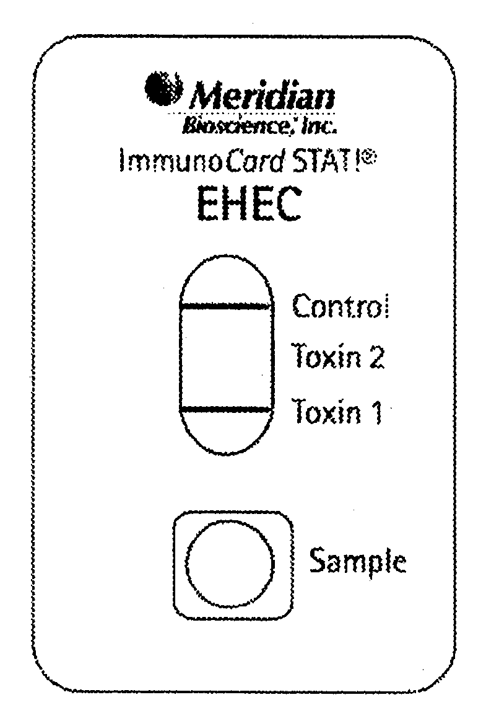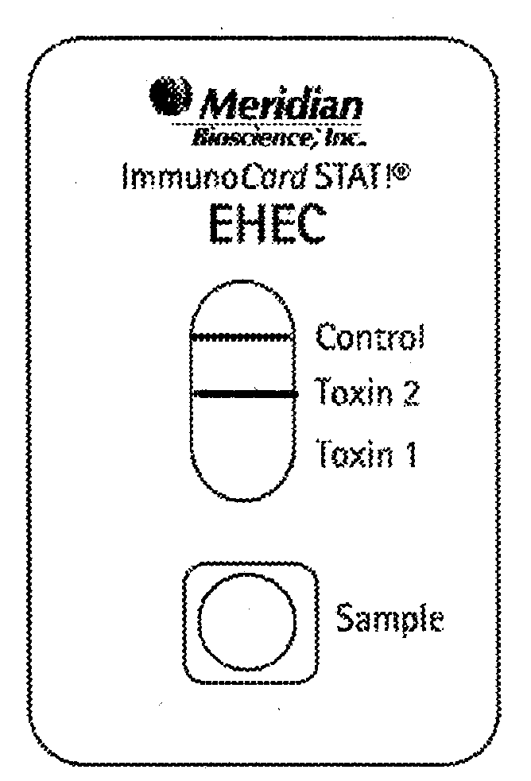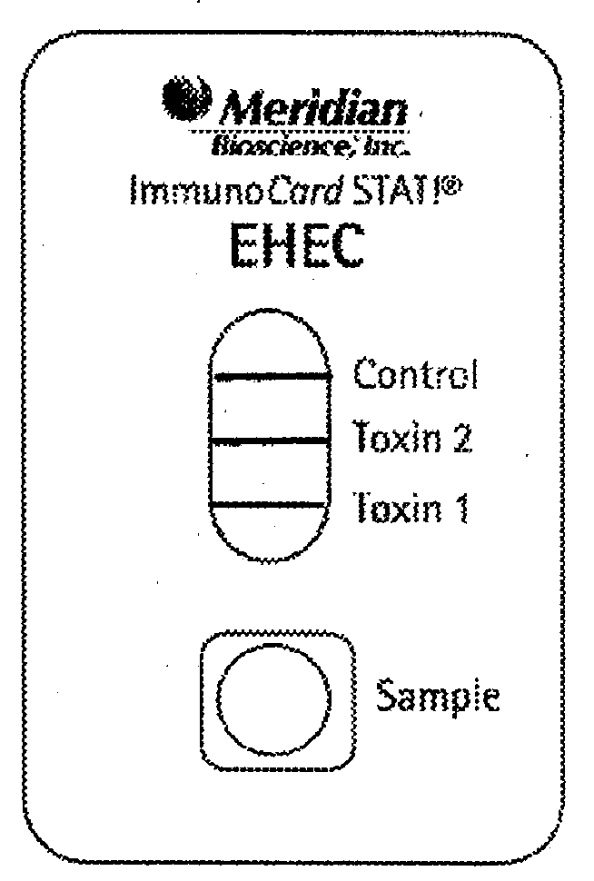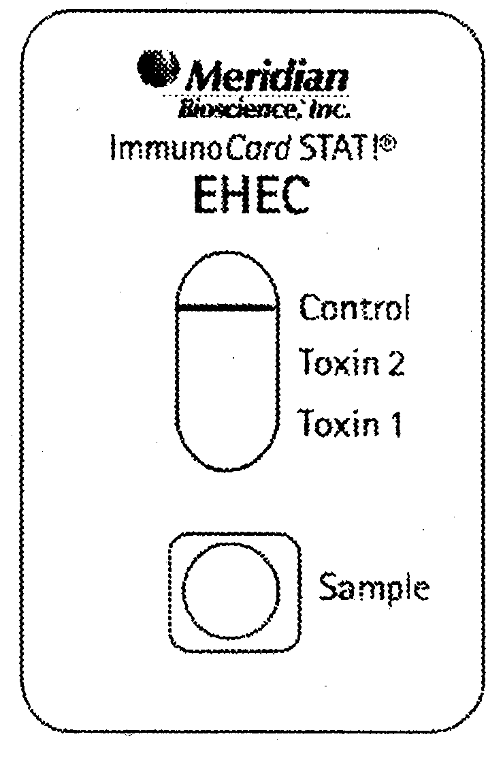
POS T1 POS T2 POS T1&2 NEG

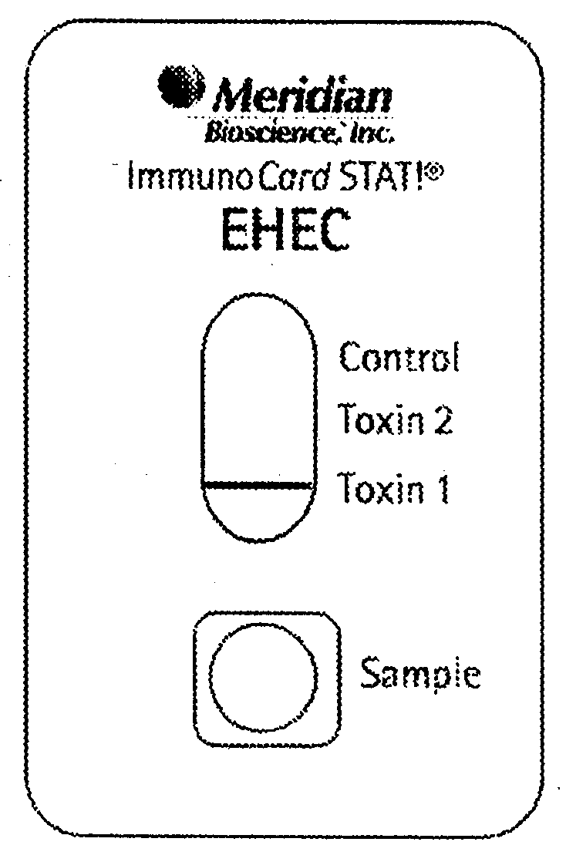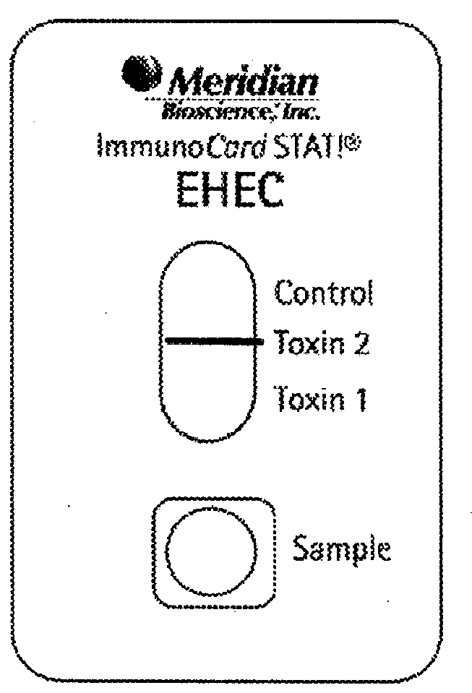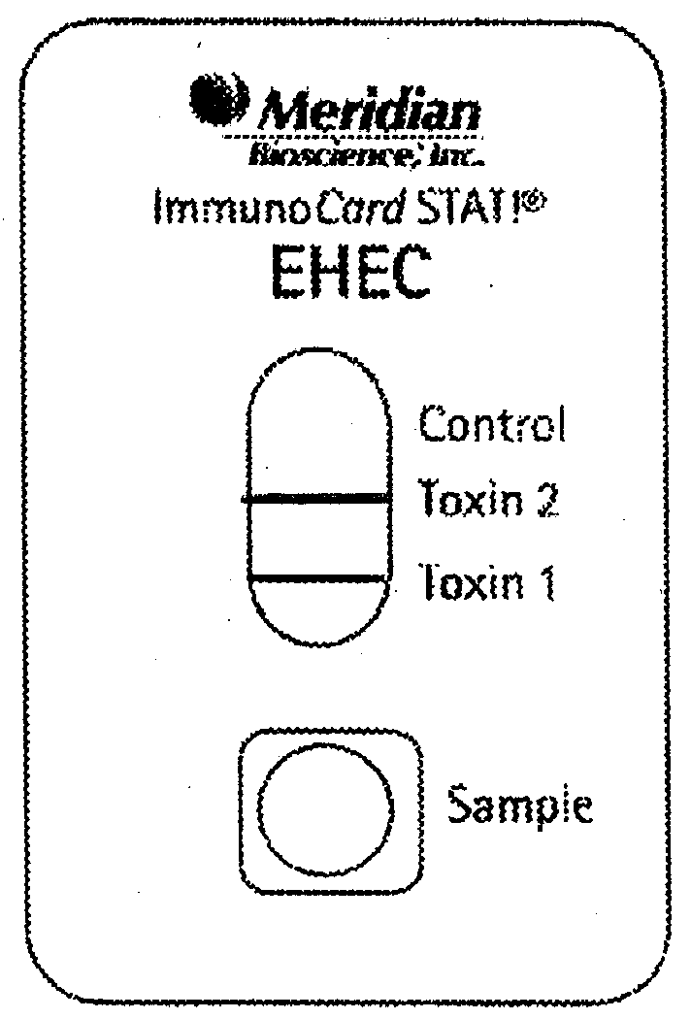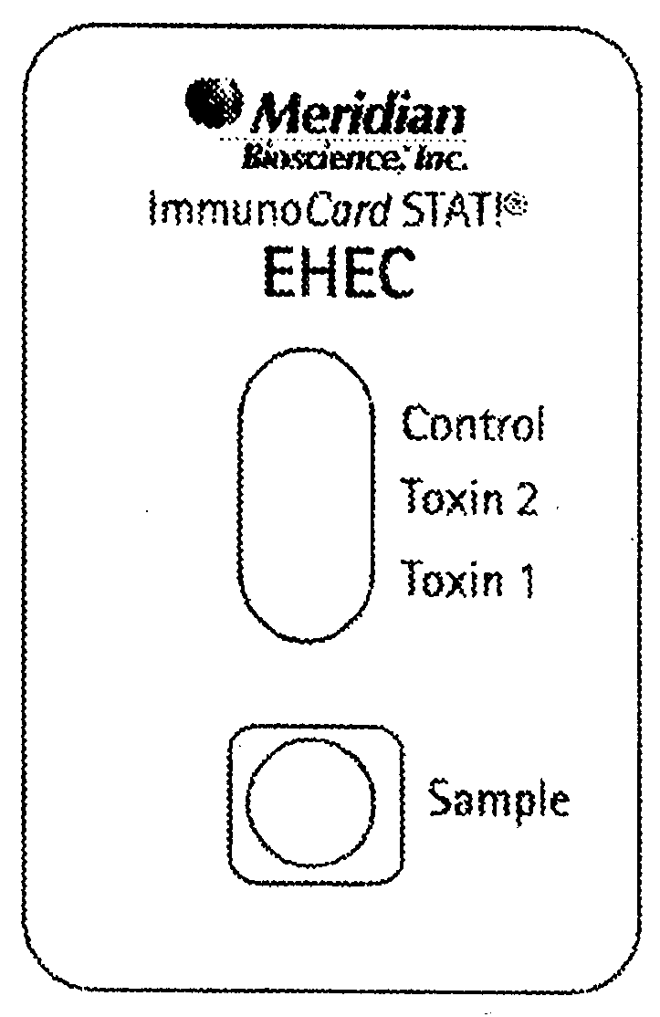
INVALID INVALID INVALID INVALID

Negative test: A PINK-RED band at the Control Line position. No other bands are present.

Positive test for Shiga toxin 1: PINK-RED bands at the Control and Toxin 1 line positions. No bands at the Toxin 2 test line. The appearance of a Toxin 1 test line, even if very weak, indicates the presence of Shiga toxin I. The intensity of the test line can be less that that of the Control line.

Positive test for Shiga toxin 2: PINK-RED bands at the Control and Toxin 2 line positions. No bands at the Toxin 1 test line. The appearance of a Toxin 2 test line, even if very weak, indicates the presence of Shiga toxin 2. The intensity of the test line can be less than that of the Control line.

Positive test for Shiga toxins 1 and 2: PINK-RED bands at the Control, Toxin 2, and Toxin 1 line positions. The appearance of Toxin 2 and Toxin 1 test lines, even if very weak, indicates the presence of Shiga toxins 1 and 2. The intensity of the test lines can be less than that of the Control line.

Invalid Test Results:
- No band at the designated position for the Control line. The test is invalid since the absence of a control band indicates the test procedure was performed improperly or that deterioration of reagents has occurred.
- A PINK-RED band appearing at either the Toxin 1 or Toxin 2 Test Line position of the device after the defined incubation limit or a band of any color other than PINK-RED. Falsely positive results may occur if tests are incubated too long. Bands with colors other than PINK-RED may indicate reagent deterioration.
If any result is difficult to interpret, the test should be repeated with the same sample to eliminate the potential for error. Obtain a new sample and retest when the original sample repeatedly produces unreadable results.

7. QC PERFORMANCE POLICY:

Internal procedural controls: Internal controls are contained within the test strip and therefore are evaluated with each test.
- A PINK-RED band appearing at the Control line serves as a procedural control and indicates the test has been performed correctly, that proper flow occurred and that the test reagents were active at the time of use.
- A clean background around the Control or Test lines also serves as a procedural control. Control or test lines that are obscured by heavy background color may invalidate the test and may be an indication of reagent deterioration, use of an inappropriate sample or improper test performance.

External controls:

Positive and Negative External Controls must be run with each new shipment and
new lot number received from the manufacturer. Record all new shipment control
results and new lot to lot control results in the Yearly Cumulative Quality Control
Logbook located in Microbiology. Document the new lot information on the QC worksheet upon initial use of the new lot.

Daily positive and negative controls must be run each time the test is performed and results Recorded on the LIS QC worksheet. The positive and negative controls included in the kit serve as both reagent and procedural controls.

A. CALIBRATION AND CALIBRATION VERIFICATION

Not applicable

B. FAILURE/REMEDIAL ACTION:

Not applicable

8. EXPEXCTED RESULTS:
Negative or see below

REPORTING OF RESULTS:

Result Obtained | Suggested Report
Positive Shiga Toxin 1 | Shiga toxin 1 detected, Shiga toxin 2 not detected
Positive Shiga Toxin 2 | Shiga toxin 1 not detected, Shiga toxin 2 detected
Positive Shiga toxin 1 and shiga toxin 2 | Shiga toxin 1 and shiga toxin 2 detected
Negative | Shiga Toxin 1 and Shiga toxin 2 not detected

A. REPORTABLE RANGE:

Not applicable

B. REFERENCE RANGE:

Negative

C. CRITICALVALUES:

Positive for Shiga toxin 1, Positive for Shiga toxin 2, Positive for Shiga toxin 1 and 2

9. REPORTING RESULTS:

Result Obtained | Suggested Report
Positive Shiga Toxin 1 | Shiga toxin 1 detected, Shiga toxin 2 not detected
Positive Shiga Toxin 2 | Shiga toxin 1 not detected, Shiga toxin 2 detected
Positive Shiga toxin 1 and shiga toxin 2 | Shiga toxin 1 and shiga toxin 2 detected
Negative | Shiga Toxin 1 and Shiga toxin 2 not detected

A. NORMAL VALUES:

Negative

B. CRITICAL VALUES:

Call all positive results.

10. PROCEDURAL NOTES:

- For in vitro diagnostic use.
- The Positive Control reagent contains formalin-treated (inactivated) shiga toxins ST1 and ST2. It should be handled, however, as a potentially hazardous material.
- Some reagents contain the preservative sodium azide which is a skin irritant. Avoid contact with reagents. Disposal of reagents containing sodium azide into drains consisting of lead or copper plumbing can result in the formation of explosive metal oxides. Eliminate the build-up of oxides by flushing drains with large volumes of water during disposal.
- Do not use kit or components beyond their assigned expiration dates.
- Test devices are packaged in foil pouches that exclude moisture during storage. Inspect each foil pouch before opening. Do not use test devices from pouches that have holes in the foil or where the pouch has not been completely sealed. False negative reactions may result if test components and reagents are improperly stored.
- Do not use the Sample Diluent or Positive Control if it is discolored or turbid. Discoloration or turbidity may be a sign of microbial contamination.
- Directions should be read and followed carefully.
- This is not a direct stool test. Stool specimens must be cultured on SMAC agar plates or in GN or MacConkey broth before testing. Failure to enrich samples before testing will cause erroneous results.
- Low levels of toxins may deteriorate and become undetectable in broth samples that are stored frozen before testing. Best results will be obtained if broth samples are tested fresh. Multiple freeze-thaw cycles should be avoided.
10. Dispose of stool specimens as potentially biohazardous materials. Inactivate cultures by autoclaving for a minimum of 15 minutes at 121 C before disposal.
11. Pipettes that are supplied with the kit should be marked at the intervals shown in the pipette diagram in PROCEDURE NOTES. When instructed to use the pipette supplied with the kit, do not use transfer pipettes with markings that differ from the diagram.

A. BACKUP FOR INOPERABLE SYSTEM

Send out specimens to ARUP Laboratory

B. REFERAL OF SPECIMENS:

If specimen is positive send to ODH for confirmation.

C. SUBMISSION/HANDLING OF REFERRAL SPECIMENS:

Reference area will send out specimen.

11. LIMITATIONS AND INTERFERRING SUBSTANCES:

- The test is qualitative and no quantitative interpretation should be made with respect to the intensity of the positive line when reporting the result.
- Test results are to be used in conjunction with information available from the patient clinical evaluation and other diagnostic procedures.
- Failure to add 175 µL of broth culture to the 5 drops of Sample Diluent (step 7 of SPECIMEN PREPARATION/ENRICHMENT – BROTH CULTURE) can lead to falsely negative results. As a visual aid it may be helpful to verify that the broth culture was added. Mark the side of the test tube with a marking pen to indicate the top of the Sample Diluent volume. Once broth culture is added, this line should appear in the middle of the diluted sample volume. The addition of more than 5 drops of Sample Diluent can also lead to falsely negative test results.
- Over incubation of tests may lead to false-positive test results. Incubating tests at reduced temperatures or times may lead to falsely negative results.
- The performance of ImmunoCard STAT! EHEC HAS NOT BEEN EVALUATED with direct stool samples. It has only been evaluated in SMAC plate culture or GN and MacConkey liquid cultures.
NOTE: Shiga toxin 1 produced by E. coli and the toxin produced by Shigella dysenteriae type 1 strains are nearly identical. Therefore, ImmunoCard STAT! EHEC may give a positive result with toxins from S. dysenteriae type 1 strains.
The two organisms can be differentiated by plating on selective growth media coupled with biochemical analysis.

12. METHOD VALIDATION:

2009

13. REFERENCES:

- Karmali MB. Laboratory diagnosis of verotoxin-producing Escherichia coli infections. Clin Microbiol Newsletter 1987;9:65-70.Maniar AC, Williams T, Anand CM, Hammond, GW. Detection of verotoxin in stool specimens. J Clin Microbiol 1990;28:134-135.
- O’Brien AD, Holmes RK. Shiga and shiga-like toxins. Microbiol Reviews. 1987:51:206-219.
- Griffin PM, Ostroff S., Tauxe R., Green KD, Wells JG, Lewis, JH, Blake PA. Illnesses associated with Escherichia coli O157:H7 infections. A broad clinical spectrum. Ann Intern Med 1988;109:705-712.
- Pai CH, Ahmed N, Lior H, Johnson WM, Sims HV, Woods DE. Epidemiology of sporadic diarrhea due to verocytotoxin-producing Escherichia coli: A two year prospective study. J Infec Dis. 1988;157:1054-1057.
- Maniar AC, Williams T, Anand CM, Hammond, GW. Detection of verotoxin in stool specimens. J Clin Microbiol 1990;28:134-135.
- Neill MA. Escherichia coli O157:H7. A pathogen of no small renown. Infec Dis Newsletter 1991;10:19-24.
- Karch H., Bohm H., Schmidt H., Gunzer F., Aleksic S., Hessesmann J. Clonal structure and pathogenicity of Shiga-like toxin producing, sorbitol-fermenting Escherichia coli O157:H. J Clin Microbiol 1993;31:1200-1205.
- Mariani-Kurkdijan P, Deamur E, Milan A, Picard B, et. al. Identification of a clone of Escherichia coli O103:H2 as a potential agent of hemolytic-uremic syndrome in France. J Clin Microbiol 1993;31:296-301.
- Kay BA, Griffin PM, Stockbine VA, Wells JG. Too fast food: Bloody diarrhea and death from Escherichia coli O157:H7. Clin Microbiol Newsletter 1994;16:17-19.
- Centers for Disease Control and Prevention, National Center for Infectious Diseases, E. coli O157:H7, What the clinical microbiologist should know. 1994.

