**Comprehensive Hematology with Automated Diff FH-6 2013 MTS**

We failed the Neut/Gran on sample FH6-01 on the DxH. Why? The specimen was ran on the DxH and verified. When the tech was transcribing the results from the LIS result page to the CAP result form, it was noticed that this sample had a high eosinophil count, of 19.5. The tech reran the sample and got a 6.5 eosinophil result. The tech repeated the sample again and again got a 6.5 eosinophil. So the tech **EDITED** the eosinophil count only. The whole differential should have been edited.

When transcribing the results to the Cap result form, it should have been noted that the numbers didn’t add up to 100%.

Notice:

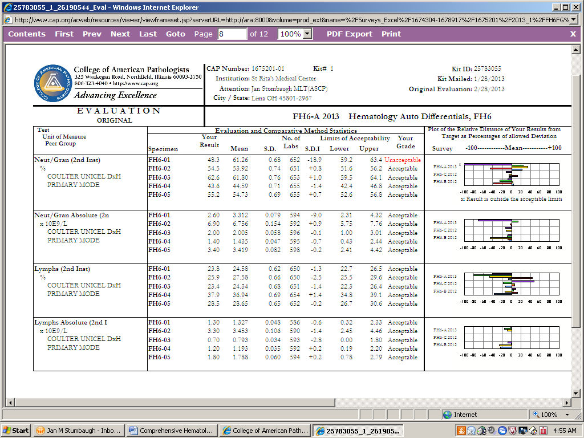

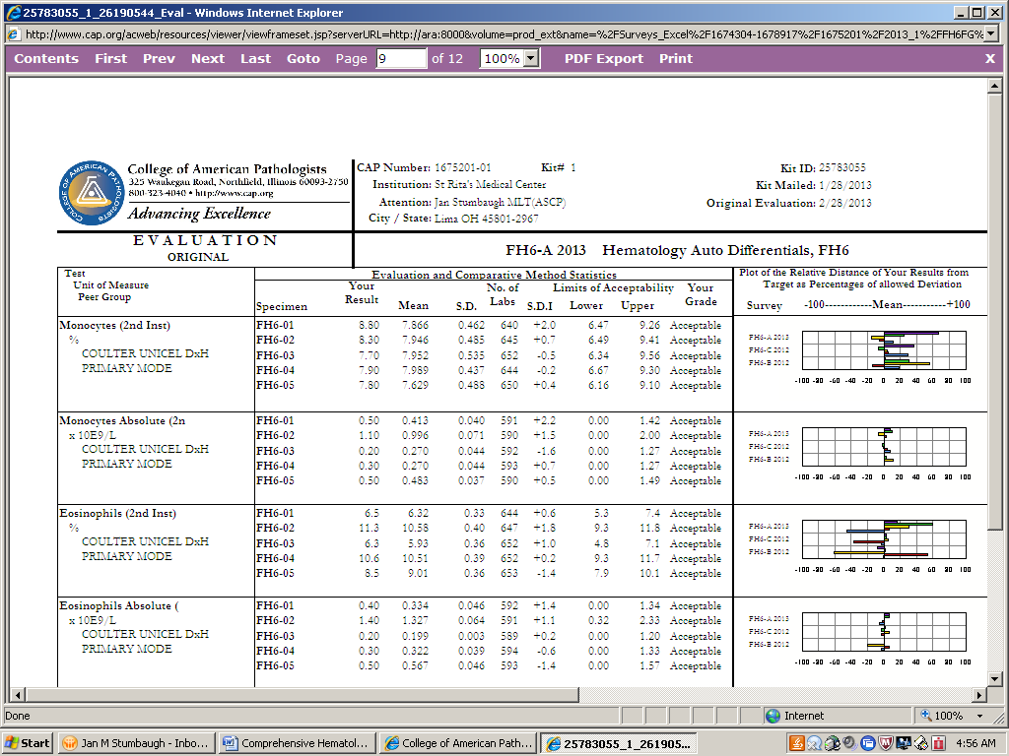

Neutrophils 48.3

Lymphs 23.5

Monos-8.8

Eos- 6.5

Basos (below) 0.0

= @88%; not 100%

The tech performing the clerical check didn’t catch this either. The mean of the correct neutrophil count was 61.5.

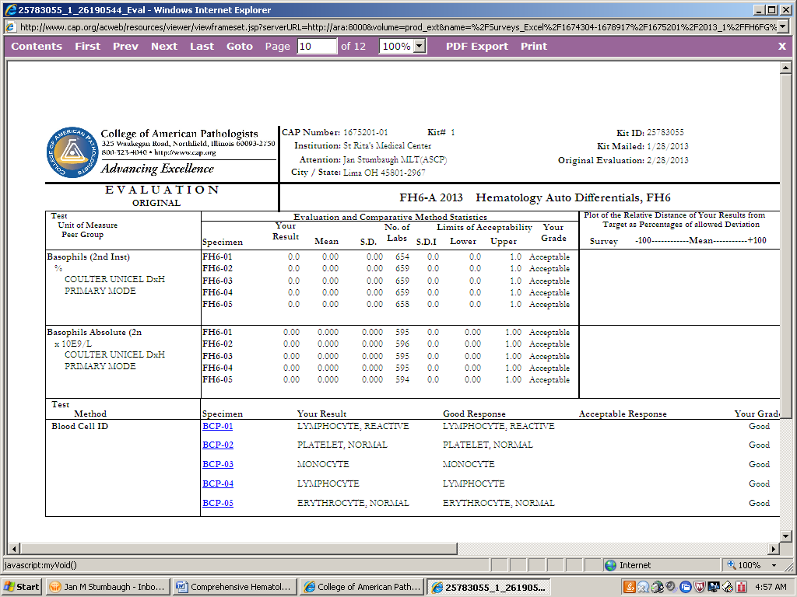

***These techs did however; correctly identify all the blood cell photomicrographs!***

This could have been a patient that we would have incorrectly reported. Be very careful to check your results, especially if you’re editing a result.

The tech performing any Cap Survey should always check:

1) The analyzer results, to the LIS results,

2) The LIS results to the Cap Survey result form

3) The Cap survey (paper) result form to the Cap Survey (online) result form.

The tech approving the Cap Survey should also perform all the above stated 3 steps.

Failure on the survey puts us at risk for being able to report out results on those tests. Multiple failures for the same test can result in the tests not being able to be performed in our lab resulting in delays and loss of revenue.

When a Cap inspector arrives, he/she has a list of all unsuccessful Cap Surveys performed in our lab. The inspector needs to see what corrective action our lab has taken to correct this error.

When it’s tech error, we will now require each tech that performs the unsuccessful test to take a custom designed MTS competency.

If you have any questions please ask your Team Leaders.

4/8/2013