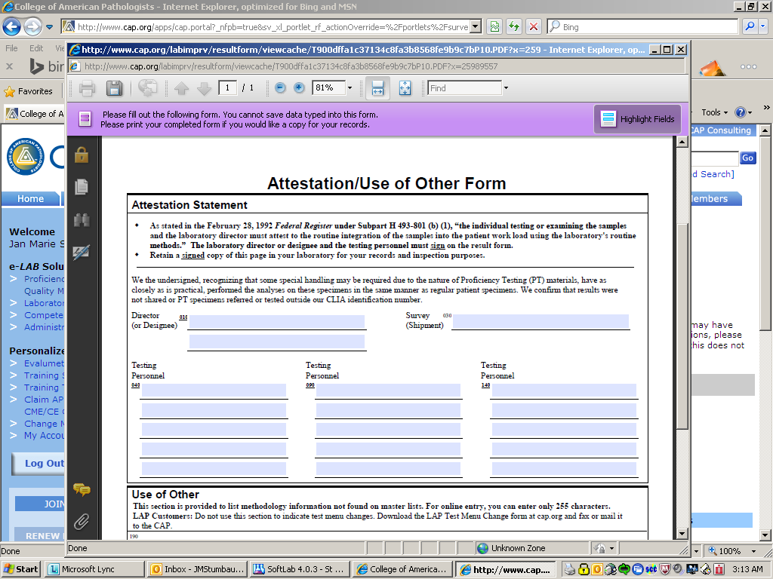

Please note the blue arrowed line. The tech performing the cap survey must sign the attestation page. This means the paper copy supplied with the survey as well as the online form.

The Director (or designee) must also sign this form. Our policy allows for the “designee” to be a qualified MT/MLT/MLS, pathologist or administrator. With this in mind, have the tech that performs the second clerical check and or approves the results on the CAP online result form to sign as the “designee”

The “Survey (shipment)” line is the survey code. For example: Fetal hemoglobin survey’s code is “APT-B 2013”

Note: This has been a CAP requirement since Feb. 28, 1992.

Please go back and check the CAP Surveys you have performed this year and make sure these lines, on the Attestation form is signed.

By checking the box to this MTS you certify that you have complied.