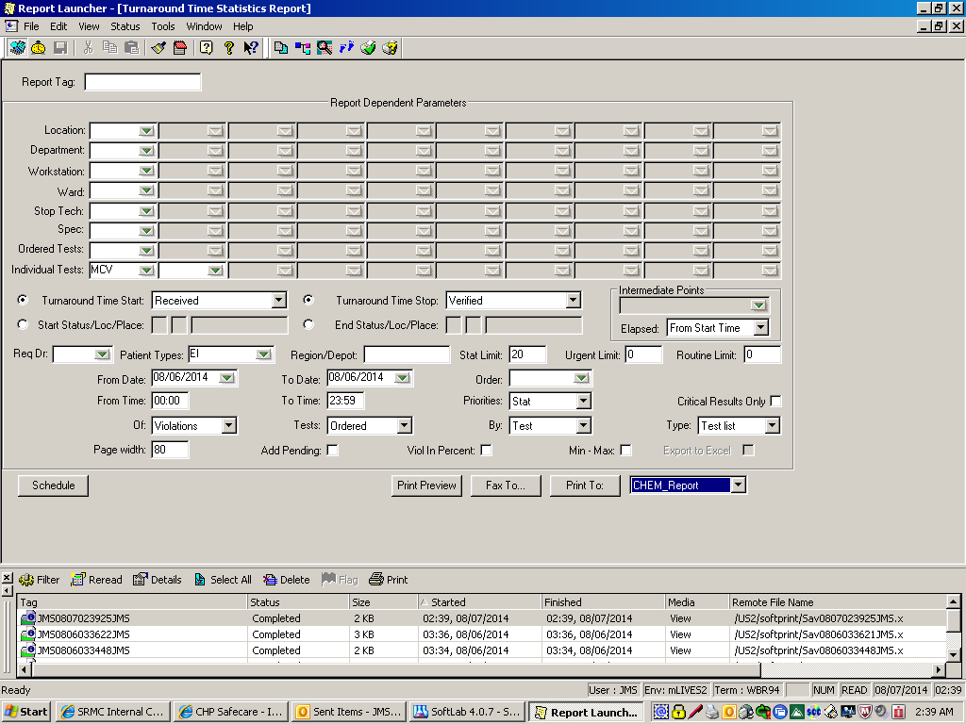

#3

#2

#1

**To bring up each shift’s TAT’s and sign off at end of each shift.**

Go to Util (utilities)> Turnaround Time Statistic . The above screen appears.

Go to **Individual Test** (see arrow #1) this is for CBC’s; Type in MCV

For BMP’s and Tropt go to **Ordered Tests (arrow #1) Type in BMP or TROPT**

At **Turnaround Time Start ,** arrow down to “Received” then over to **Turnaround Time Stop arrow down to ‘Verified’**

At **Patient Types** arrow down and choose Emergency room and Inpatients.

At **Stat Limit** fill in 20 (for MCV) 35 (for BMP) and 50 (for Tropt) then repeat with 30 for Trop.

Change **From time: To time: to correlate with your shift.**

Example; 1st shift **07:00 14:30**

**Priorities:** arrow down to **Stat**

**OF:** arrow down to **Violations**

**Go out to Type (arrow #2)** and pick **test list**

Then **Print To (arrow#3) and arrow down to choose printer.**

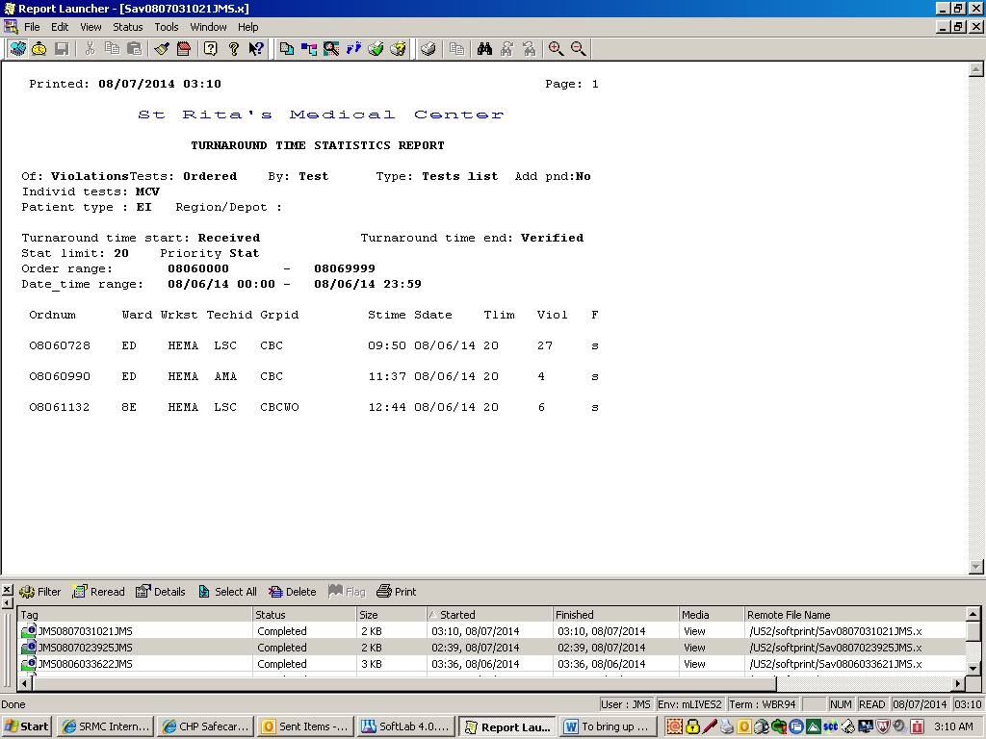

**These are the specimens that did not meet TAT’s.**

**You need to sign off on these. Try to explain what happened that this STAT test didn’t meet our goal. This is important. It is in no way judgmental or disciplinary. It is to push us as a center of excellence!**

**After jotting down an explanation, put these reports on my desk, in the Folder marked “STAT TAT REPORT”**

**These will be done every shift, at the end of your shift. This is to aid in maintaining a high quality of customer care! Thank you, Jan**