**MTS for Coagulation Cap Surveys**

We recently failed a Coagulation CAP survey for clerical errors.

The unsuccessful test was PT in seconds. As you are aware, we don’t report the PT in seconds.

However the ACL performs the PT in seconds. The INR is a calculation that uses this number.

INR= (patient PT/MNPT) ^ ISI

MNPT= mean normal PT

ISI= International sensitivity Index

To find the PT in seconds you can;

1) Print the results from the analyzer. This is the most convenient. OR

2) Bring up ‘results’ in the LIS and find it there.

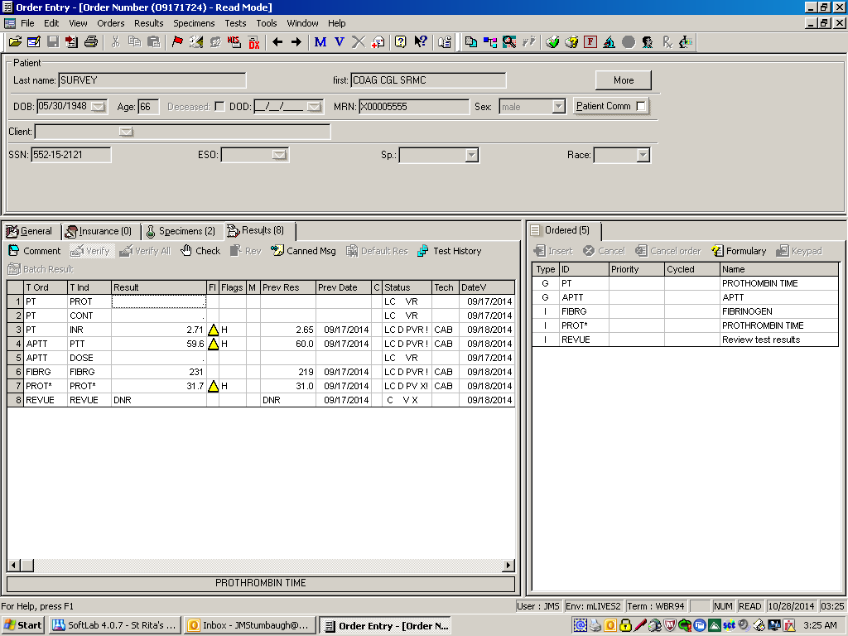

If you choose this second option you need to ‘print screen’ the results.

Simply printing the ‘instant report’ will not have the PT in seconds listed.

**PRINTED PT IN SECONDS RESULTS FOR CAP SURVEYS MUST BE PRINTED, CHECKED, AND FILED WITH SURVEY RESULTS!!!!**

The tech performing the clerical check should be checking these print offs, and not assuming the tech who performed the Cap survey transcribed the results correctly. This is part of what it means to perform the clerical check.