This procedure is electronically produced, revised, monitored, reviewed and/or retired. For a full document history of initiation, revisions, and reviews with electronic signatures and dates, please open document in the procedure publishing software.

SUBJECT: VENIPUNCTURE USING EVACUATED TUBES
MATERIALS REQUIRED: | - Disposable tube holder (barrel) with needle sheathing device attached.  - Sterile collection needle “Butterfly” Collection and Vacuette® blood collection tubes appropriate for the tests requested.  - Alcohol prep, tincture of iodine, or Chloraprep (if blood culture being collected).  - Gauze pad.  - Latex-free tourniquet.  - Gloves Note: If patient has Latex Allergy, use only Vinyl or Nitrile gloves.  - Adhesive bandage or other bandage. Paper tape or Coban can be used for patients with a latex allergy.
PROCEDURE: | - For inpatients, verify the identity of the patient according to policy by comparison of the patient name and account number and Medical Record number on the patient’s ID band and the specimen labels and other ID-banded patients. Use of the Symbol Handheld Scanners with Soft ID is required whenever possible. For outpatients, verify the patient’s identity by asking the patient to state his/her name and birth date and comparing that to the information on the activity sheet. (See St. Rita's Medical Center Policy, “Patient Identification: Verification of Patient Identification Prior to Administration of Medication or Blood Products or Obtaining Blood Samples.”)  - In the presence of the patient, cleanse hands using antiseptic hand gel or wash them at the sink.  - Select and put on appropriate size gloves. Intact gloves must be worn on both hands during the actual venipuncture. If holes or tears occur, the gloves must be replaced.  - Select needed blood collection tubes and determine the order of draw. Note: If a winged collection set is being used and only coagulation tests are being collected a discard plain red top tube must be collected prior to collection of the Blue, Citrate tube. Only enough blood to clear the tubing of air needs to be drawn into the discard tube.  - Assemble a tube holder (barrel) with attached needle sheath and needle or winged collection set.  - Insert the blood collection tube into the barrel and onto the needle up to the recessed guideline.  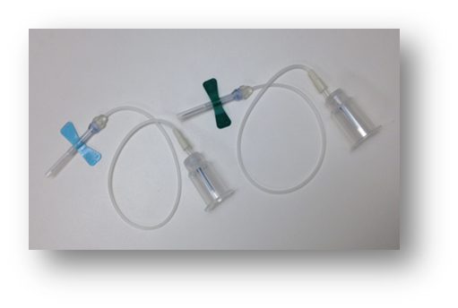  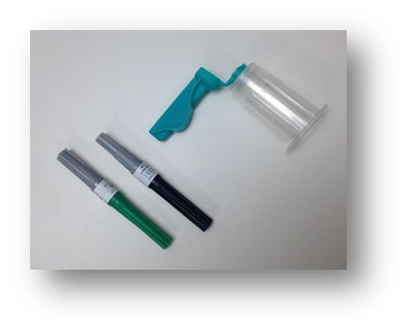  - Select a vein site as follows:  - Apply the tourniquet three to four inches above the site. The patient can be asked to make a fist, but do not allow the patient to pump the fist as this can cause changes in some analytes.  - The median cubital and cephalic veins in the antecubital fossa are preferred for venipuncture, but veins on the back of the hand and wrist are also acceptable. Veins on the underside of the wrist must never be used due to the proximity of nerves and tendons. Veins in the feet and lower extremities must not be used without permission of the physician.  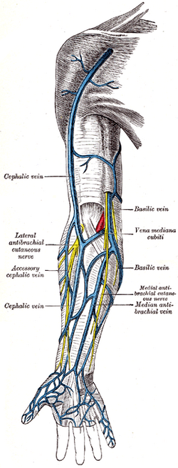  - Palpate and trace the path of the vein several times.  - Avoid areas with extensive scarring, healed burn areas, or where a hematoma exists.  - Do not utilize veins in the arm on the side on which a mastectomy was performed.  - Unless venipuncture is impossible from any other site, do not draw blood from an arm with an intravenous (IV) site. If collection is necessary from an arm with an IV, the IV must be discontinued for a minimum of two minutes before blood is collected from below the IV. Never draw blood from above an IV site.  - Remove the tourniquet after no more than 1 minute and leave it off for at least two minutes before reapplying to avoid hemoconcentration.  - Select an appropriately sized needle (21G or 22G) and thread the sterile needle onto the barrel until it is secure, or use butterfly set (21G or 23G)  - Cleanse the venipuncture site:  - Remove a 70% Isopropyl Alcohol pad from its sterile package. When drawing a blood alcohol level, iodine should be used to cleanse the site.  - Cleanse the site with a circular motion from the center to the periphery. The site should be about two inches in diameter.  - Allow the area to dry to prevent hemolysis of the specimen and to prevent the patient from experiencing a burning sensation when the venipuncture is performed. Do not wipe the alcohol dry, blow, or fan the site to aid in drying. The site should air dry.  - Re-apply the tourniquet 3-4 inches above the venipuncture site.  - Position the patient's arm:  - Make sure the patient's arm or other venipuncture site is in a downward position to prevent reflux.  - Grasp the patient's arm firmly, using your thumb to draw the skin taut, anchoring the vein. Your thumb should be one or two inches below the venipuncture site.  - Perform the venipuncture:  - Remove the needle cover. Visually inspect the tip of the needle to determine that it is smooth at the end of the point, and that the opening is clear.  - With the bevel up, line up the needle with the vein at approximately a 15-degree angle with the skin. If the view of the vein is obstructed by the sheath of the barrel, rotate the sheath out of the way, by gently grasping the sheath and turning.  - Push the needle into the vein. Initial resistance will be felt, followed by ease of penetration as the vein is entered.  - Grasp the flange of the barrel and push the tube forward until the back end of the needle punctures the stopper. Maintain the tube below the site when the needle is in the vein.  - Remove the tourniquet when blood flow is established. The tourniquet must be released after no more than one minute.  - Keep constant, slight forward pressure (in the direction of the needle) on the end of the tube. This prevents release of the shut-off valve and stopping of blood flow. Do not change position of the tube until it is withdrawn from the needle. During the procedure, do not allow the contents of the tube to contact the stopper. Movement of the fluid back and forth in the tube can cause back flow of blood into the venous system with possible adverse patient reaction.  - Fill the tube until the vacuum is exhausted and blood flow ceases. NOTE: It is normal for the tube not to fill completely. It is essential that additive tubes, especially Blue, Citrate tubes, be allowed to fill until the vacuum is exhausted (ie. flow stops) to ensure proper blood to additive ratio and correct dilution of the blood.  - When the blood flow ceases remove the tube from the barrel. Immediately mix each tube that contains an additive or clot activator by gently inverting the tube at least 8-10 times.  - To obtain additional specimens, insert next tube into barrel and repeat steps 11 through 15.  - Lightly place a gauze pad over the venipuncture site.  - Remove the needle slowly and smoothly while keeping the bevel in an upward position.  - Immediately place the gauze pad over the site and apply mild pressure until the bleeding stops. Do not ask the patient to bend his/her arm at the elbow.  - Securely snap needle into the orange sheath on the barrel by pressing on a firm surface. DO NOT use fingers to snap the sheath closed.  - Apply an adhesive or gauze bandage over the venipuncture site after all bleeding has stopped and tell the patient to leave the bandage on for at least 15 minutes.  - While still at the patient’s side, apply the LIS generated bar code label and write the time drawn and your initials on each tube. If a barcode label is not available, label each tube with at least the patient's full last name and first name (no nicknames or abbreviations) and the account number. If an account number is not available, use the patient’s birth date. When using the Symbol scanners and SoftID, scan the collected tubes now.  Note: Unlabeled or improperly labeled tubes will be discarded.  - Transport tubes to the laboratory as soon as possible. Unless specifically prohibited for the test to be performed (i.e., PFA), the pneumatic tube system may be used to transport blood and urine specimens. Specimens must be double bagged and sealed in biohazard bags before transport to the laboratory.  - Dispose of contaminated supplies in appropriate containers: sheathed needle and barrel in a puncture resistant sharps container, all other supplies, unless grossly contaminated with blood, can be discarded in the general waste. Grossly contaminated supplies must be discarded in a biohazard container.  References:  Procedures for the Collection of Diagnostic Blood Specimens by Venipuncture – Sixth Edition; Approved Standard; H03-A6; NCCLS; 2007  Collection, Transport, and Processing of Blood Specimens for Coagulation Testing and General Performance of Coagulation Assays; Approved Guideline- Third Edition; NCCLS; 1998.

