This procedure is electronically produced, revised, monitored, reviewed and/or retired. For a full document history of initiation, revisions, and reviews with electronic signatures and dates, please open document in the procedure publishing software.

SUBJECT: VITEK II

1. PRINCIPLE:
The innovative VITEK® 2 microbial identification system includes an expanded identification database, rapid results, improved confidence, with minimal training time.
The VITEK® 2 system next-generation platform provides greater automation while increasing safety and eliminating repetitive manual operations. The rapid response time means results can be provided more quickly than with manual microbial identification techniques.
The VITEK® 2 system offers Windows® based, user-friendly software, bi-directional interface and an epidemiology report module. It also includes the Advanced Expert System™ (AES) software for on-line result validation, a new generation of test cards and a comprehensive database.
The VITEK® 2 system is used for Microbial Identification - bacteria and yeast identification (ID), Antibiotic susceptibility testing (AST) and resistance mechanism detection and for Epidemiologic trending and reporting.
After primary organism isolation, handling is minimized in a simple standardized inoculum. The inoculum is placed into the VITEK®2 Cassette at the Smart Carrier Station™, where the VITEK® 2 Card and sample are linked virtually. Once the Cassette is loaded, the incubation and reading of each card is managed by the system without any intervention.
VITEK®2 uses unique ID and AST cards the size and shape of a playing card. VITEK®2 ID cards offer a comprehensive menu of available tests. VITEK®2 can provide identification and susceptibility results in as little as 5 hours.
The Advanced Expert System™, automatically provides validation of every susceptibility test result. It signals when results are ready, saving time and giving an accurate phenotype profile of bacterial resistance menchanism(s) for each isolate tested, with easy-to-read color-coded indicators.
2. CLINICAL SIGNIFICANCE:
Every day, doctors use identification (ID) and antibiotic susceptibility test (AST) results to determine the antibiotic treatment that is most appropriate for the pathology and patient, and to monitor changes in bacterial resistance to antibiotics.
Bacterial identification and antibiotic susceptibility testing play an essential role in patient care and the control of antibiotic resistance by indicating which antibiotics are most likely to cure an infection and reducing the empirical prescription of "broad-spectrum" antibiotics, which are partly responsible for the rapid increase in antibiotic resistance, avoiding the unnecessary prescription of antibiotics reduces healthcare costs.
ID/AST tests also play a role in epidemiological monitoring, making it possible to track changes in microbial resistance patterns in healthcare settings.
With the rise of pressing healthcare challenges like Multi-Drug Resistant Organisms (MDRO), microbiology labs play an ever-more critical role. When it comes to fighting infectious organisms, microbial identification (ID) and antibiotic susceptibility testing (AST) are key to providing the right information for targeted clinical responses and better patient-care outcomes. Combining an innovative, automated platform with an expansive database, the VITEK® 2 microbial ID/AST testing system offers the confidence of fast, accurate results. Its smart design helps ensure better overall laboratory workflow with fewer repetitive tasks, higher safety, improved standardization, and rapid time-to-results and reporting.
The Vitek® 2 system includes an Advanced Expert System (AES) that analyzes MIC patterns and detects phenotypes for most organisms tested. This helps optimize laboratory efficiency for lean laboratory management. Rapid results allow clinicians to discontinue empiric therapy and prescribe targeted therapy, resulting in improved patient outcomes and enhanced antibiotic stewardship.
With its ability to provide accurate “fingerprint” recognition of bacterial resistance mechanisms and phenotypes, the Advanced Expert System (AES) is a critical component of VITEK® 2 technology.

3. SPECIMEN:

- COLLECTION AND PROCESSING:

A pure culture isolate must be used for the inoculum. An isolate from any of the following media will give optimal performance:
- Trypticase Soy Agar with 5% Sheep Blood
- Trypticase Soy Agar with Horse Blood
- Tyrpticase Soy Agar
- MacConkey Agar
- Sabouraud Dextrose Agar
- Chocolate Agar
- Columbia Sheep Blood Agar
- Columbia Horse Blood Agar
- Candida ID 2 Agar
- Sabouraud Agar
- Sabouraud Agar with 2% Glucose
- Sabouraud Dextrose Agar with chloramphenical and gentamicin
- Sabouraud Dextrose Agar (Emmon’s modification)
- ChromID CPS (CPS ID 3 Agar)

NOTE: Eosin Methylene Blue (EMB) may cause erroneous results and CANNOT be used with the Vitek ® System.

B. REJECTION:

Not applicable

C. STORAGE AND PRESERVATION:

Vitek® 2 cards must be stored unopened in their original package liner at 2-8º C.

4. REAGENTS, STANDARDS, AND CONTROLS:

A. PREPARATION:

When used with the Vitek ® 2 Instrumentation, the Identification and Antimicrobial Susceptibility Test (AST) is a complete system for routine testing. Each Vitek ® 2 AST card contains selected antimicrobials dried with microbiological culture media in varying concentrations. For a list of antimicrobials and their concentrations contained on a specific AST card, see Package Insert. The individual Identification cards are each a complete system for the routine identification testing of the most clinically significant bacteria.
All products and media must be at room temperature prior to use.

B. CONTROL PROCEDURE:

For QC instructions & policies: see individual VITEK ID or AST card procedures.

5. EQUIPMENT:

THE VITEK ® 2 INSTRUMENT IS TO BE OPERATED SOLELY BY QUALIFIED, TRAINED
MICROBIOLOGY TECHNICIANS.

The Vitek®2 instrument and all components should be considered as potentially contaminated and should be handled appropriately. Qualified laboratory personnel should take the usual precautions necessary for infectious agents.

For additional information regarding any additional cleaning procedures, Power failures, Error codes, Troubleshooting issues, etc., See the Vitek ®2 Instrument User Manual.

- INSTRUMENTS:

- Vitek ®2 XL
- External Instrument Components

The following images contain a front and a left side view of the VITEK® 2 XL instrument. Use the diagram to locate and familiarize yourself with the external controls and the access doors to the interior of the instrument.
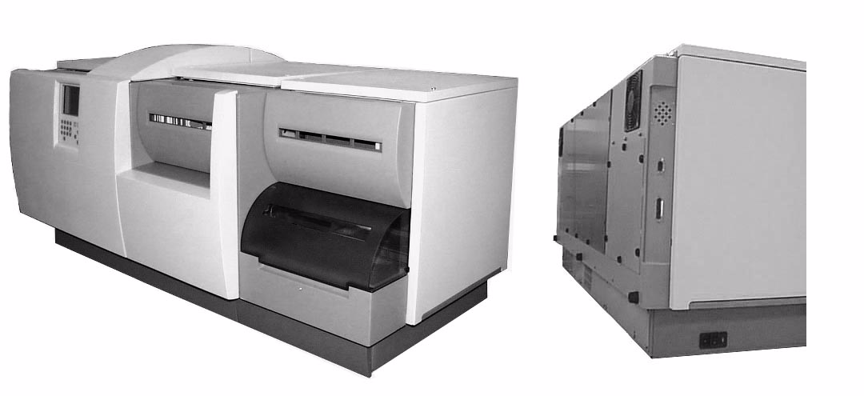
3 VITEK® 2 XL Instrument

Controls, Access Doors and
Connections

CAUTION:
ALL ACCESS DOORS AND COVERS MUST REMAIN CLOSED WHEN PROCESSING CARDS TO AVOID EXPOSURE TO LASER LIGHT.

- User Interface Screen and Keypad. This screen and keypad comprise the User Interface system.
- Front Access Door. Provides access to the diluter, pipette tip container, and a portion of the test card transport system. The door opens from the right side.
- Cassette Load/Unload Door. Provides access to the Cassette Load/Unload station. The door slides up to open. A locking mechanism prevents opening of this door at inappropriate times.
- Waste Collection Door. Provides access to the Waste Collection Station where ejected test cards are removed from the instrument. The door is held in place magnetically and lowers from the top.
- Top-Right Access Door. Provides access to the optics and the carousel. The door lifts from the front and stays in the open position.

Note: The top-right access door cannot be opened unless the Waste Collection door is opened first.
Note: This door is secured by two screws, and requires a flathead screwdriver to open.

- Top Access Door Section A. VITEK® 2 XL only. Provides access to the optics and carousel for Section A.
- Top Access Door Section B. VITEK® 2 XL only. Provides access to the optics and carousel for Section B.
- Bottom Access Door. Provides access to the drip pan. The door is held in place magnetically and must be pulled down to open.
- Saline Access Door. Provides access to the sterile saline bag. The door lifts from the front and stays in the open position.
- Center Front Sliding Door. VITEK® 2 XL only. The Cassette load/unload door must be opened before this door can be opened.

- Connections

- UPS Connection. This cable connector port connects VITEK® 2 to an uninterruptable power supply (UPS). The connection allows the UPS to notify the VITEK® 2 instrument of a power loss so the VITEK® 2 can start appropriate procedures.
- Workstation Connection. This connector port accepts the cable that connects the VITEK® 2 instrument to the workstation computer.
- AC Power Switch and Cord Receptacle. This switch supplies power to the VITEK® 2 instrument. The cord receptacle accepts the power cord that is connected to the electricity source.

- Turning on the VITEK® 2 Instrument

Note: Refer to the environmental and electrical specifications for the VITEK® 2instrument in the Vitek® 2 Instrument User Manual before starting the instrument.

Startup Procedure

1) Make sure the VITEK® 2 instrument has been connected to an appropriate power supply using the power cord supplied with the instrument.
2) Press the AC power switch to the ON position . The instrument goes through an initialization sequence that includes several self tests. During this time, VITEK® 2 is also bringing the carousel area up to its specified temperature for test card incubation. After a few minutes, the VITEK® 2 Status screen appears. The Status field at the top of the screen should show a status of Warming or OK. The Warming status means that the carousel temperature is not yet within its specified range. This can take several minutes. VITEK® 2 is ready to begin processing cards when the Status field shows OK. (For more information about the Status field, see the topic “Instrument Status Field” in Chapter 6 of the Vitek® 2 Instrument User Manual).

- VITEK® 2 Instrument Instrument Hardware Components

The VITEK® 2 instrument is an integrated system, combining the tasks of sample preparation, test card inoculation, and test card incubation and reading.
The parts and functions of the VITEK® 2 instrument can best be described by following a test card through the phases of a typical processing cycle.
The following list summarizes this cycle, and shows you where you can find more details about a particular component of the VITEK® 2 instrument.
See the Vitek® 2 Instrument User Manual pages 4-1 thru 4-20, for additional information.

Cassettes Test card transport page 4-6
Cassette Load and Unload Station Test card transport page 4-7
Boats Test card transport page 4-8
Bar Code Reader Sample preparation page 4-9
Button Memory Reader Sample preparation page 4-10
Dispenser/Pipettor Station Sample preparation page 4-11
Filler Station Sample preparation page 4-13
Sealer Station Sample preparation page 4-14
Test Card Incubation and Reading Test card analysis page 4-14
Carousel Test card analysis page 4-15
Optics Test car analysis page 4-16
Card Ejection Test card transport page 4-16
Waste Collection Station Test card transport page 4-17
User Interface System All process phases page 4-18

- Components Involved in the Test Card Processing Cycle

- Smart Carrier Station (SCS)

The SCS is not a part of the VITEK® 2 instrument, but it is the station where the entire process begins. For complete details on the SCS, see Chapter 2 of the Vitek® 2 Instrument User Manual pages 2-1 thru 2-11.

The Smart Carrier Station (SCS) is a small computer dedicated to collecting information about test cards and specimens, and for transferring that information to the VITEK® 2 instrument. The SCS, shown in has five main components.

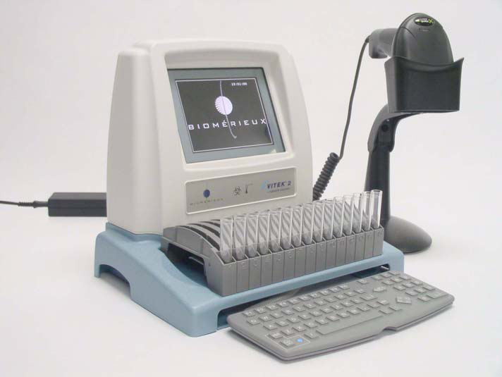
- SCS Base Unit. The SCS base contains the microprocessor. There are
connection ports on the back of the base for the keyboard and the bar code
scanner. The top of the base is specifically shaped to accept a cassette.
Metal contacts on the base connect the unit’s computer to a button memory
chip on the cassette. Ensure that the cassette is fully seated in order to make
an electrical connection to the cassette memory. This memory chip stores
the information you entered to be transferred to the workstation.
- SCS Display Screen. The display for the SCS is a liquid crystal display
(LCD). Use the display to view and confirm the information you are entering for the test cards and specimens.
- SCS Bar Code Scanner. The SCS is equipped with a bar code scanner that allows you to enter data with a simple bar code scan rather than repeated typing. You can scan most data fields. The data appears automatically on the display. The scanner can be hand-held or used while mounted in its holder.
- SCS Keyboard. The SCS keyboard has a standard set of alphanumeric keys, plus several specially designed keys for SCS functions. The SCS keyboard is smaller than a standard size keyboard, so it can be stored under the Base Unit.
- External Power Supply. The SCS is powered by an external DC power supply. This power supply accepts 120 VAC to 240 VAC mains power via a detachable two conductor power cord.

- Using the Smart Carrier Station (SCS)

- Bar Code Scanner. The bar code scanner is utilized to scan the bar codes (accession number) of each culture that is set up and also the bar codes on the test cards and the SCS Job Aid Card. The bar code on each test card includes includes information about the Test Card Type, Organism, Offline Tests, and Modifier fields.

- Cassette. Each cassette has 15 slots for test cards and 15 corresponding wells for specimen test tubes. Information entry using the SCS bar code scanner or keyboard is organized by slot, simplifying workflow.

- After a cassette is placed in VITEK® 2, a bar code reader in the instrument reads the bar code on the test card, and compares that information with the information it read from the cassette. Any
discrepancies in test card type or position in the cassette are reported to the user so that corrective action can be taken.
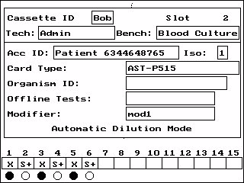
- Cassette Edit Screen. The Cassette Edit screen provides
an interface for entering test information.
This screen is repeated for each cassette slot.

• Cassette ID. This field contains the cassettte identification
string that will identify the cassette that is being edited. The
Cassette ID allows test information to be searched on the
workstation computer.
• Bench. This field contains the bench name that will be applied
to the cassette that is being edited.
• Tech. This field contains the Setup Technologist ID that will be applied to the cassette that is being edited.
• Acc ID. This field allows the entry of an Accession ID to identify a specific specimen. Up to 20 alphanumeric characters or spaces may be entered. Entry into this field is required before other test specific information can be entered.
• Isolate Number. Field that defaults to a value of 1 and is normally skipped during data entry. To replace the default, move the cursor to this field using the Up Arrow key.
• Test Card Type. This field is used to identify the type of test card that is to be placed in the cassette slot.
• Organism ID. Field used for identifying an organism in an AST card.
• Offline Tests. Field that holds results of off-line tests performed for some test cards.
• Modifier. Field used for organism modifiers. Six generic entries, mod1 to mod6, are preloaded. When this data reaches the workstation computer, the generic entry is converted to one of the first six corresponding entries in the Organism Modifier table of the bioLIAISON® database.
• Dilution Mode. The current dilution mode setting is displayed to allow quick verification.
• Slot Indicator. The slot indicator is the set of boxes at the bottom of the Cassette Edit screen. The information in the slot indicator is read as follows:
1) A number corresponding to the currently displayed slot appears over the appropriate box.
2) The row of boxes is filled in as data is entered.
3) These boxes are empty unless the user has entered data previously. A box in the row is filled automatically when the user enters data into the Card Type field. Indicators are:
• I+ = Gram positive ID
• I- = Gram negative ID
• IA = ANC ID
• IY = yeast ID
• IB = bacillus ID
• IH = haemophilus ID
• S+ = Gram positive susceptibility
• S- = Gram negative susceptibility
• SY = yeast susceptibility
• X = Indicates the position of the inoculum tube for a susceptibility test without a preceding mated ID when in Automatic Dilution mode. This slot must not contain a card.

Understanding the Slot Indicator
A shaded circle appears under a box when the SCS determines the test card in the slot requires an organism suspension. A completely open circle appears under a box when the test card in the slot requires an empty tube. Empty tubes are used for AST cards when the SCS is set to Automatic Dilution mode.

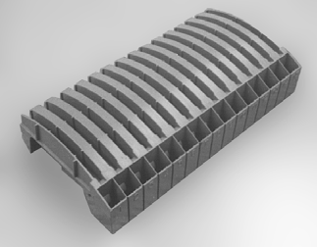
- Cassettes

The cassette is the main component of the test
card transport system. It can hold up to 15 test
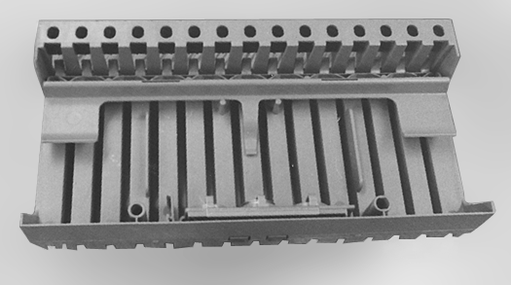
cards with their inoculum test tubes. In systems
using the Smart Carrier Station, the button memory
chip on the cassette is used to store and transport
data from the Smart Carrier Station to VITEK® 2.

Cassette Components

- Test Card Slots. The top portion of a cassette is divided into 15 test card slots that can hold various combinations of VITEK® 2 test cards.
- Test Tube Holders. The front portion of a cassette has 15 wells that hold test tubes for inoculum.
- Test Tube Release. Test tubes are held securely in the cassette by a retaining bar. A release lever is provided for easy disposal of used test tubes.
- Button Memory. For systems using a Smart Carrier Station, each cassette is fitted with a special memory chip, called the button memory. When a cassette is on a Smart Carrier Station, the button memory stores the information that you enter for each test card. This information is read by a station in VITEK® 2, which marks the memory chip as being read, allowing the cassette to be reused.
- Cassette Base. The base of a cassette is specially shaped to:
• Fit snugly onto the base unit of the Smart Carrier Station. When properly fitted on the base unit, the contacts for the button memory are touching the contacts that protrude from the base unit.
• Fit into a boat. The shape of the cassette base matches the well on the top of a boat. This ensures that the two units move as one through VITEK® 2. The shape also ensures that the cassette can only be put into a boat in the proper orientation. HAZARD WARNING
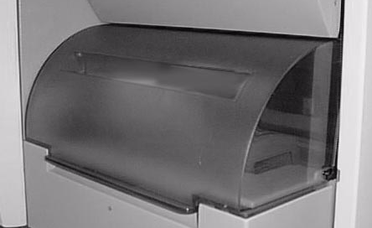
- Cassette Load and Unload Station

Load and unload cassettes from VITEK® 2 using this station.
The station consists of the cassette load door and a green
indicator light. The door has a locking mechanism.

Indicator Light States Light Status Error Condition
and Resolution

- On
The cassette load door is unlocked. You may open the door to load cassettes.
- Off
The cassette load door is locked and cannot be opened.
- Blinking
A boat with an empty cassette has arrived at the station. The cassette load door is unlocked. Open the door and remove the cassette. When you close the door, the blinking stops.

CAUTION: The VITEK® 2 test card transport system stops while the cassette load door is open. Be sure to close the door after loading or unloading a cassette.
CAUTION: Do not move or remove a boat from the instrument unless you are using the programmed function for this purpose. Doing so can cause an instrument jam.

- Boats

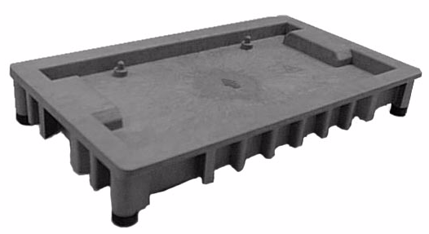
The VITEK® 2 instrument contains four plastic trays called boats. These boats carry cassettes through the processing stations inside the VITEK® 2 instrument.
BIOHAZARD WARNING
Boat Components

A boat has particular features that support its major functions:

- Test Card Transport. The top surface of a boat forms a specially shaped well into which a cassette is placed. The shape of the well conforms to the base of a cassette, providing it with a secure platform on which to ride. The two pins in the well ensure that the cassette is placed into the boat only in the proper orientation. An arrow is molded into the surface of the well to show the proper orientation of the boat when placed in the instrument.
- Notched Base. The base of each boat is notched in several places. These notches are used by the VITEK® 2 test card transport mechanisms that move the boats through the module.
- Base Supports. Each boat stands on four low-friction feet, providing a surface on which the boat can easily move.
- Spill Prevention. The well in the top of the boat catches any spills from the cassette.
- Test Card Filling. Above the cassette well, there is a flat surface that extends around the perimeter of the boat. This surface becomes the base of the vacuum chamber when the boat reaches the Filler station.

- Bar Code Reader

After a cassette is loaded onto a boat, the test card transport system moves the boat past the bar code reader station. This station reads the information encoded on the bar code label found on each VITEK® 2 test card. The following information is included in the bar code:

- Test Card Type — For example, a Gram Negative Susceptibility test card.
- Investigational Use Only (IUO) flag — This tells VITEK® 2 if an experimental test card is being processed.
- Test Card Expiration Date — This date is transferred to the workstation, which prints it on the laboratory report.
- Test Card Lot Information and Sequence Number — This includes the test card’s lot number to provide manufacturing traceability. The sequence number uniquely identifies a test card.

CAUTION: When handling VITEK® 2 test cards, make sure you do not deface the bar code in any way.

- Button Memory Reader

The Button Memory Reader is a device that the VITEK® 2 instrument uses to read the test card information stored by the Smart Carrier Station in the memory chip on a cassette. VITEK® 2 uses this test card information in two ways:

- The test card type entered at the SCS is compared to the test card type that VITEK® 2 reads with its own bar code reader. This ensures that no changes were made in the position of any test card in the cassette.
- The accession ID, test card type, and the other fields entered at the SCS are sent to the computer. This information allows the software to link the test card results from VITEK® 2 to patient demographic data and any previous test results.
- After the information is extracted from the button memory, VITEK® 2 marks its contents as Read. When the cassette is put on the SCS again, a button memory marked as Read is erased so the cassette can be used again.

CAUTION: The memory chip must be removed from the cassette before cleaning the cassette.
LASER WARNING
- Dispenser/Pipettor Station

This station automatically prepares the organism dilution used for AST (Antimicrobial Susceptibility Test) cards. VITEK® 2 provides a significant time savings by ensuring that mated ID and AST cards are processed from the same sample.

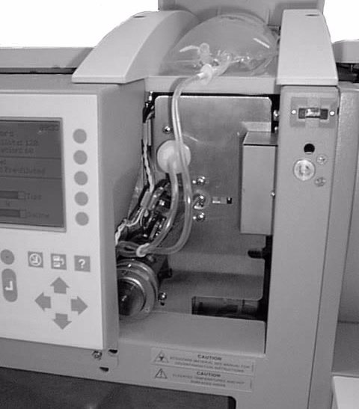
Dispenser
The dispenser system delivers 2.5 mL of sterile saline into the
test tube of each AST card in a cassette.

Dispenser System
- Sterile Saline. The top of the VITEK® 2 instrument has a
compartment designed to hold a one-liter bag of sterile saline.
This is enough saline to process about 330 AST cards.
- Dispenser Assembly. The dispenser assembly consists of a
plastic dispensing chamber and two sections of plastic tubing.
One section of tubing leads from the dispensing chamber and
is attached to the sterile saline bag. The other section of tubing
also leads from the dispensing chamber but is attached to an air pump.
It is fitted with a filter to prevent particulate contamination.

- Electromechanical Components (not shown).

The electromechanical components control how the system works.
1) When an AST card is detected, a valve opens to allow saline to travel from its bag to the dispensing chamber.
2) An optical sensor detects when the chamber is full (2.5 mL) and closes the valve.
3) The dispensing chamber rotates into position over the AST card’s test tube.
4) The air pump is activated, forcing the saline into the tube at a controlled rate that minimizes splashing.

Pipettor

The pipettor station transfers a preset volume of an organism suspension from its test tube into the test tube of its mated AST card.

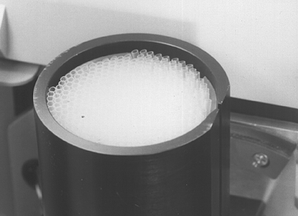
Disposable Pipettes

- Disposable Pipette Tips. To prevent contamination, VITEK® 2 uses
single-use, disposable pipette tips.
- Container. The container holds up to 350 pipette tips. It has an
internal mechanism that ensures proper deliveryof each pipette tip
to the displacement pump.
- Displacement Pump (not shown). The displacement pump
withdraws a specified volume of inoculum for dilution in the
inoculum tube of an AST card.

Note: The displacement pump is not normally visible as it is located directly behind the interface screen and keypad.

Displacement Pump Operation

The displacement pump is part of a larger assembly that performs the pipetting and transfer of the suspension when VITEK® 2 is in the Automatic dilution mode. Here is how it works:

1) The container drops a pipette tip into position.
2) The displacement pump assembly extends a hollow metal tube into the container, attaches a pipette tip to the tube, and withdraws the pipette tip from the container. The instrument checks to ensure that a pipette tip is attached.
3) The pump assembly rotates so the pipette tip is over the ID suspension test tube. The pipette tip is then lowered into the suspension. The instrument checks to make sure there is fluid in the ID test tube.
4) The pump draws the preprogrammed amount of suspension and withdraws the pipette tip from the test tube.
5) The cassette moves so that the susceptibility test tube is now under the pipette tip.
6) The pipette tip is lowered into the test tube and the pump dispenses the suspension into the tube where it mixes with the saline from the Dispenser.
7) The pipette tip is removed from its attachment and left in the sample tube for disposal.

- Filler Station

At the Filler Station, all of the test cards in a cassette are inoculated with the suspension contained in their corresponding test tubes.
The Filler Station uses a vacuum chamber and pump. When the boat carrying a cassette reaches this station, the top of the vacuum chamber lowers onto the boat, so the boat serves as the base of the vacuum chamber.

1) The pump evacuates the air from the chamber. This forces the air inside each test card to escape via the transfer tube and bubble up through the suspension. The channels and wells inside of each test card are now at a vacuum.
2) After a short period, the vacuum is slowly released. The increasing air pressure inside the chamber forces the suspension in each test tube through the transfer tube and into the channels and wells of the test card.
Various temperature and air pressure sensors in the system monitor the inside of the vacuum chamber. VITEK® 2 ensures proper test card fills by monitoring these parameters throughout the entire cycle and controlling the rate at which the vacuum is drawn and released.

Note: The seal on the vacuum chamber should be cleaned periodically. See the maintenance schedules and procedures in Chapter 7 of the Vitek® 2 Instrument User Manual.

- Sealer Station

CAUTION: The sealer station contains a wire that is heated during the sealing operation. Do not reach into the instrument during the sealing operation.

The Sealer station completes the functions inside VITEK® 2 that prepare the test cards for incubation and reading. This is accomplished by heat-sealing the transfer tube that delivered inoculum to the test card from its test tube.
This seals off the contents of the test card.
As the boat and cassette move through this station, a heated wire comes in contact with each transfer tube. The plastic tube melts, causing most of it to separate from the test card and drop into the test tube. The portion that remains in the test card is sealed by the melting plastic.

Note: The stub left from the transfer tube may be up to 0.1 inch (0.25 cm) long.

- Test Card Incubation and Reading

Once test cards are sealed, they are ready to be incubated and read. The test card transport system moves the boat and cassette into position for a mechanism, called the Card Loader, to place each test card into a slot on a carousel, where it remains throughout the reading cycle.

- Carousel

The Carousel, has a capacity of 60 test cards. During their time in the carousel, the test cards are incubated at an average temperature of 35.5 °C.

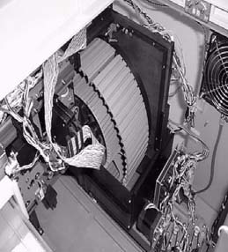
Carousel Placement

As the carousel rotates, each test card moves into the reading
position every 15 minutes. A mechanical device called the →
Reader Head, conveys the test card through the optics stations.

Carousel Reader Head

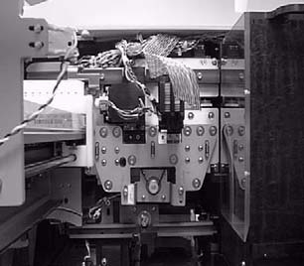
After the reading cycle, the test card returns to its slot in the
carousel, where it continues to incubate until its next read cycle. →

Note: The carousel is divided into four sections so it can be easily removed
for periodic cleaning. See Monthly Cleaning and Preventative Maintenance.

- Optics

The VITEK® 2 instrument performs its identification and susceptibility analyses by continually monitoring the growth and activity of organisms inside the wells of the test cards. The optics system performs this function.

Transmittance Optics

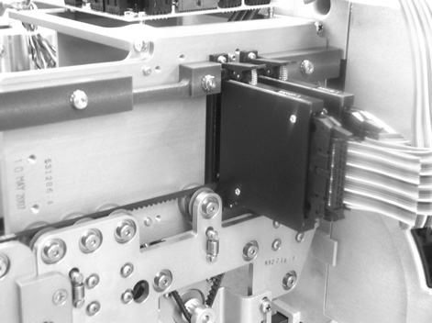
The transmittance optics use visible light to directly measure organism growth. These optics are based on an initial light reading of a well before significant growth has begun.
Light transmittance samplings of the same well every 15 minutes
measure organism growth by how much light is prevented from
going through the well.

Optics
The optics use light emitting diodes (LEDs) that produce light at the appropriate wavelengths, and silicon photodetectors to capture the transmitted light. The system is self-calibrating.

Note: The optics should be cleaned periodically. See Monthly Cleaning and Preventative Maintenance.

- Card Ejection

The card ejection function permanently removes test cards from the carousel after their testing is completed. The mechanism that performs this function is the same drive belt system that moves the test cards through the reader.
Instead of returning to the carousel, an ejected test card continues on to the Waste Collection Station.
The amount of time that cards are held before being ejected automatically from the carousel is set by an option in the System Configuration screen at the workstation computer. Cards can also be ejected at any time using a manual ejection function.

CAUTION: Make sure that all test card processing has been completed before ejecting a test card.
CAUTION: Do NOT re-insert ejected test cards into the VITEK® 2 instrument.
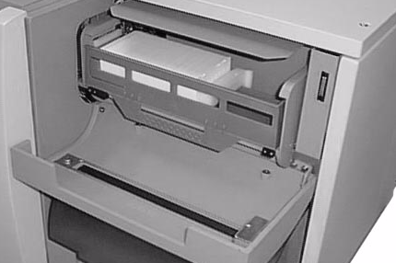
- Waste Collection Station

- The card ejector removes test cards that have completed testing from
the reader. These test cards are collected in a tray at the Waste
Collection Station for removal from the VITEK® 2 instrument and
disposal.
- The station holds up to 60 test cards.
- The instrument counts test cards as they fill the tray, and sends a message to the VITEK® 2 interface screen when the station is full. A sensor in the station detects when the tray has been emptied or if the tray is missing.
- Access the Waste Collection Station by opening the waste collection door on the front of the VITEK® 2 instrument.

Note: Keep the Waste Collection Station door closed except when test cards are being removed from the station.
Note: Empty the waste collection tray after loading a new cassette into the instrument.
Note: Periodically remove the waste collection tray for cleaning. See Monthly Cleaning and Preventative Maintenance.

- User Interface System

Throughout the entire processing cycle for test cards, communication between the user and the VITEK® 2 instrument is essential. The VITEK® 2 User Interface System provides the means of that communication.

- Keypad and Screen

A keypad and screen are located on the front of the instrument. VITEK® 2 uses the screen to send messages about its operation, on-board disposables, and possible problems. Use the keypad to respond to the instrument instructions, to send commands to VITEK® 2, and to perform other functions.

- Option Buttons. Use these buttons to select menu options or other specified functions.
- Help (?) Key. Press this key at any time to access the error/message queue.
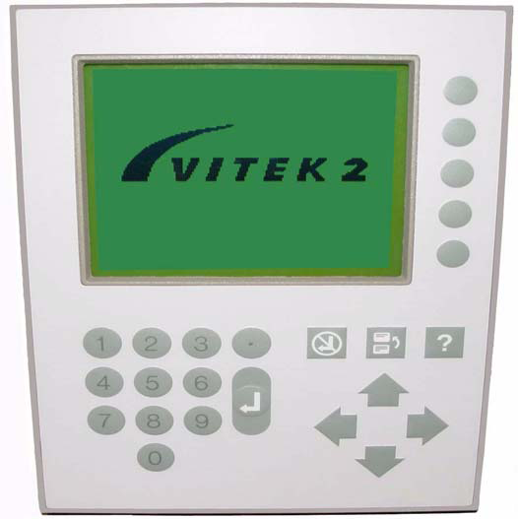
- Previous Screen Key. Use this key to:
• Exit from a screen or function to its menu.
• Return to a previous screen in a function.
• Go from a sub-menu to its previous menu.
• Go from the Main Menu to the Status screen.
- Undo Key. Use it to cancel the last action performed.
- Arrow Keys. Use these keys to:
• Scroll a screen or menu.
• Move the cursor on screen.

Note: When Arrow keys are active, their icons appear on the display.

- Enter Key. Use this key to complete data entries, or when instructed to do
so on a screen.
- Numeric Keys. Use these keys to enter a number onto a screen.

B. MICROSCOPIC EXAMINATIONS (AND REJECTIONS):

Not applicable

6. PROCEDURE:

THE VITEK ® 2 INSTRUMENT IS TO BE OPERATED SOLELY BY QUALIFIED, TRAINED
MICROBIOLOGY TECHNICIANS.

MAINTENANCE

- Maintaining Disposables

A specific part of the Status screen is devoted to the maintenance of theVITEK® 2 disposables. For additional information see Chapter 6 of the Vitek® 2 Instrument User Manual.

Monitoring the Disposables

Note the two bar graphs at the bottom of the Status screen screen.
- The Tips graph displays the current level of pipette tips that remain in the instrument.
- The Saline graph displays the level of saline that remains in the instrument.

When comparing the disposables level to your work load, it is important to remember that the
graphs are APPROXIMATIONS of the actual level of disposables.

The Dispenser/Pipettor Accessory Kit

If the disposables have reached a low level, or if they have expired, you need to install Dispenser/Pipettor Accessory Kit. The kit consists of a container of pipette tips and a saline dispenser tube with its associated tubing. The following describes how to install an accessory kit.

- Installing an Accessory Kit, Part A: Saline and Tubing

Note: If the card transport system is processing cassettes through the Card Transport Station, the following message appears: Card transport system is busy. Please try later.

CAUTION: Use aseptic technique when installing an accessory kit.

1) Access the Change Saline function using the path:
Main Menu > Utilities > Maintenance > Change Saline
The following prompt appears:
About to change saline. Do you wish to continue?
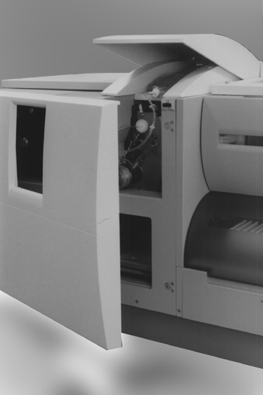
2) Press Yes to continue with the saline change.
After you proceed the instrument displays the following message:
Proceed with saline change?
3) Open the front access door to expose the Dispenser Station, then lift
the saline access door to expose the saline bag.
4) Pull on the filter disk to remove it from its connector.
5) While pushing the Dispenser Release button, carefully pull the shot
tube out of its housing.
6) The entire assembly is now disconnected. Since they are Single Use
Only items, you must discard the saline tube, its tubing, and the saline bag.

Note: Since the saline dispenser tube does not come in contact with any specimen,
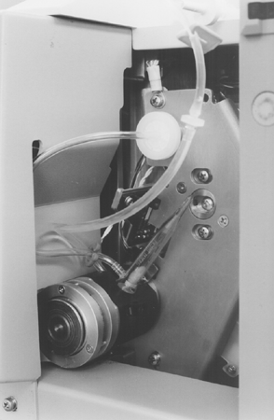
it is not considered a biohazard. Use normal laboratory precautions when
disposing of this assembly.

CAUTION: To prevent possible contamination of the saline, use aseptic
technique when handling the saline dispenser tube.

7) Remove a new bag of 0.45% sterile saline from its protective pouch.
8) Remove a new tubing assembly from its container.
9) Remove the covers from the large port of the saline bag and from the
cannula of the tubing assembly.
10) Insert the cannula from the tubing assembly into the port of the saline bag.
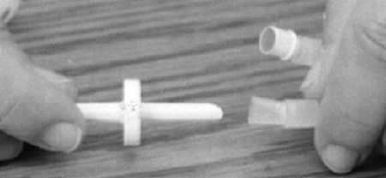

Cannula and Tubing Assembly

11) Place the new bag of saline on its shelf on the top of the instrument, placing the eyelet of the bag over the post at the back of the shelf.
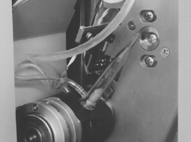
12) While pushing the release button insert the saline dispenser tube into its housing. After the tube is fully inserted, release the button.

Saline Dispensing Chamber

Note: Make sure that the saline dispenser tube is firmly seated in the
housing and that the tubing flows smoothly without any kinks or twisting.

13) Grasp the filter disk and firmly push it onto the connector located above
the saline dispenser tube.

Note: Avoid excessive pressure, however, as it could cause the filter to break.

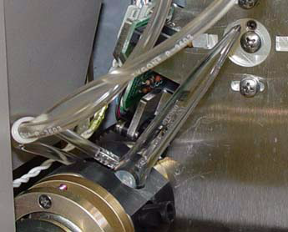
14) Press the round plate to allow saline to flow into the saline dispenser tube.
Do not allow the saline level to fill above the top inlet port.
15) Release the round plate.
16) Close both the front access door and the saline access door to the instrument.
17) Press Done.
The following message appears: Performing Dispenser Self Test
The self test checks for proper installation of the saline dispenser tube.
It is recommended that you wait for the test to complete (about 20 seconds)
before leaving the instrument.
- If the test is successful, the Maintenance menu appears.
- If the test fails, the following message displays:
Saline Dispenser Tube installation error
There is a problem with the saline dispenser tube installation. Inspect the tube installation and correct it as needed.
18) Press Continue to return to the Change Saline screen.
19) At the Change Saline screen, press Cancel to return to the Maintenance menu or Done to repeat the test.

- Installing an Accessory Kit, Part B: Pipette Tips

If the card transport system is processing cassettes through the Card Transport Station, the following message appears: Card Transport System is busy. Please try later.

CAUTION: Use aseptic technique when installing an accessory kit.
1) Access the Change Pipette Tips function using the path:
Main Menu > Utilities > Maintenance > Change Pipette Tips
2) The following message appears: About to change pipette tips. Do you wish to continue?
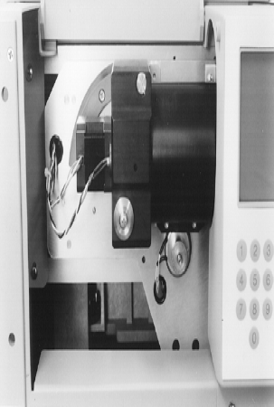
3) Press Yes to continue with the pipette tip change.
The following message appears: Proceed with adding pipette tips.
4) Open the front access door to expose the Pipettor Station.
5) Open the Pipette Tip access door.
6) Rotate the pipette tip container 90° in a counterclockwise direction.
7) Remove the pipette container from its base using a pulling motion.
8) Discard any pipette tips that remain in the container.

CAUTION: To avoid contaminating new pipette tips, do not touch
the inside of the pipette container.

Note: Discarding the remaining tips is required in order for VITEK® 2 to maintain an accurate count of them. This action also minimizes the risk of contamination.

9) Open a pipette tip replacement pack and hold it in one hand

CAUTION: The exposed ends of the pipette tips are the ones that come in contact with your specimens. Appropriate precautions to prevent contamination during this procedure are advised.
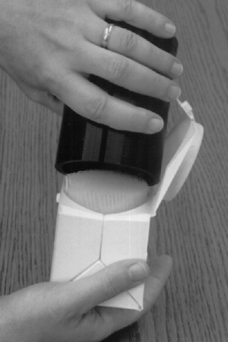
10) Hold the empty pipette container in your other hand with its open
end down and lower it over the exposed ends of the pipette tips.
11) Invert the container and pack so that the pipette tips fall into the
container from the pack.
12) Replace the pipette tip container on its base, making sure that
it is firmly seated.

Note: There is a key pin on the side of the container that must mate
With a slot on the container base. If the container is not seated
correctly, you will not be able to rotate it back into position.

13) Rotate the container 90° in a clockwise direction, making sure
that it is fully seated in the down position.
14) Close both access doors and press Done.
The following message appears: Performing Pipettor Self Test
- The Pipettor self test only checks the electric motors in the Pipettor Station. If the motors pass the test, no further message is displayed, and you are done with the installation.
- If a problem is found, the following message appears: Pipette Tip installation error
- IF this message appears, call bioMérieux for assistance.

15) After changing both saline & pipettor tips, perform the Dispenser/Pipettor diagnostic test, as follows to ensure that the Pipettor Station is functioning properly.

- Dispenser/Pipettor Volumetric Test

Note: The transport system must be idle to perform this test.

1) Prepare a test cassette with the following items:
• Two test tubes containing 3.0 mL saline, placed in test tube slots 1 and 3.
• Three blank test tubes, placed into test tube slots 2, 4, and 5.

Note: This cassette does NOT require the use of the Smart Carrier Station.

2) Access the Dispenser/Pipettor diagnostic test using the path:
Main Menu > Utilities > Diagnostics > Dispenser/Pipettor
The following message displays:
About to perform dispenser Pipettor test. Do you wish to continue?
3) Press the Yes option button.
A message on the display will instruct you to load the cassette that you prepared in Step 1.
4) Open the cassette load door, load the test cassette and close the cassette load door.
5) Allow the cassette to process and return to the cassette load/unload
door. Remove the cassette.

- MONTHLY CLEANING AND PREVENTATIVE MAINTENANCE

- Cleaning the Carousel

The four sections of a carousel should be removed and cleaned monthly, or as conditions require.

CAUTION: The carousel should be considered as potentially contaminated and should be handled appropriately. Qualified laboratory personnel should take the usual precautions necessary for infectious agents

- Removing the Carousel for Cleaning

Note: This procedure must be performed when the VITEK® 2 instrument is completely idle (no cards are processing anywhere in the instrument): If there are cards processing anywhere in the instrument, a screen prompts you to make sure processing is complete and all cards have been ejected from the instrument before cleaning.

1) Access the Carousel Cleaning function using the path:
Main Menu > Utilities > Maintenance > Cleaning > Carousel Cleaning

Note: If you have a VITEK® 2 XL, the screen display allows you to select Reader A or Reader B. If cards are not processing in the selected incubator, and the carousel sections have not been removed, the following screen displays: Preparing for Section removal: Continue or Cancel

Note: When the Continue button is pressed, you are required to remove all of the sections. This will require about four minutes. The Cancel button provided here is the only opportunity to cancel this operation.

2) Press Continue.
The following message displays: Remove the incubator access cover now
3) Open the Waste Collection door for the carousel being cleaned.
4) Open the top access door for the carousel being cleaned.
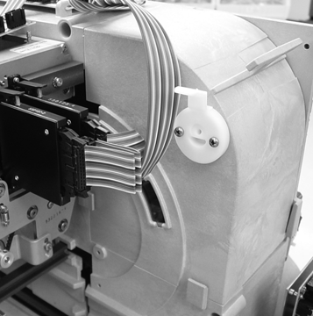
Note: The remaining steps may be easier if you also remove the Waste
Collection tray.

5) Remove the incubator access cover from the carousel by lifting the
top of the cover straight up from the instrument.

When you remove the cover, the message on the screen changes to:
Preparing for Section Removal

6) When the carousel is in position, the following screen displays:
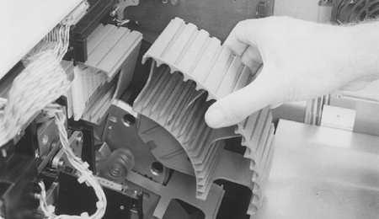
Remove section now
Current number of sections: 4 of 4
Press here after completion

7) The carousel is removed in four sections. Grasp the first
carousel section and pull it slightly forward (toward the front
of the instrument). You should then be able to pull the section
up and to the right, as shown.

8) Press the Press here after completion option button to indicate removal of the carousel section.
The following message displays:
Current number of sections: 3 of 4
The carousel turns 90° so that the next section can be removed. During this time the message: Preparing for Section Removal displays again on the screen.
9) Repeat this procedure, starting at Step 6, until all four carousel sections have been removed.
10) Press the Press here after completion option button.
The following message displays: Replace the incubator access cover now
11) Install the carousel cover over the carousel.
Once you have replaced the incubator access cover, the Cleaning menu appears.

Carousel Cleaning Methods
The four sections of the carousel should be thoroughly cleaned and dried before they are replaced in the VITEK® 2 instrument. The carousel material is designed to withstand the following cleaning methods:
• 10% bleach solution
• Phenolic cleaning solution
Note: To disinfect a contaminated surface, use the 10% bleach solution and allow it to remain in contact with the contaminated surface for five minutes. Rinse and allow to air dry.

- Replacing the Carousel After Cleaning

After the four carousel sections have been removed, the Cleaning menu displays.

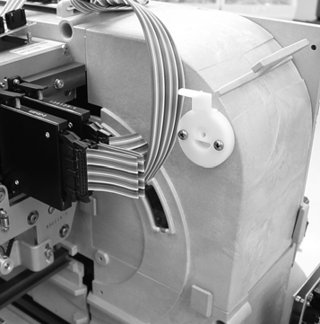
1) Access the Carousel Cleaning function using the path:
VITEK 2 Main Menu > Utilities > Maintenance > Cleaning > Carousel Cleaning
The following screen message displays: Preparing for Section Replacement

Note: If the power has cycled, the screen below displays automatically.

2) Press Continue to continue with the carousel replacement.
The following message displays: Remove the incubator access cover now
3) Remove the incubator access cover from the carousel by lifting the top of
the cover straight up from the instrument.

When the access cover has been removed, the following message displays:
Preparing for section replacement
When the carousel is in position, the following screen displays:
Replace section now

Current number of sections: 0 of 4
Press here after completion
4) Take any one of the carousel sections and orient it as shown in.
The bottom of the section should be touching the base plate and
the top portion should be tilted slightly toward the front of the
instrument.
5) Slide the section down along the base plate while maintaining the
Tilted angle.
6) When the section has been pushed down all the way, release the
Top portion, allowing it to rest against the base plate.
When you perform Step 6, two pins on the back of the section should engage the two holes in the base plate and secure the section.
7) Press the Press here after completion option button to indicate that the section is in place.
The carousel turns 90° to move the first section out of the way and the following message appears:
Preparing for Section Replacement
8) Repeat this procedure, starting at Step 4, until all four carousel sections have been replaced.
The screen displays the following message: Replace the incubator access cover now
Install the carousel cover over the carousel.
10) Lower the top access door for the carousel being cleaned.

Note: Replace the Waste Collection Tray if it was removed earlier.

11) Close the Waste Collection door.

- Cleaning the Cassettes

Cassettes should be cleaned monthly, or as conditions require.

Note: The cassettes should be considered as potentially contaminated and should be handled appropriately. Qualified laboratory personnel should take the usual precautions necessary for infectious agents.

CAUTION: Exposing the button memory to the recommended cassette cleaning procedures can cause irreparable damage to the unit.

The cassette material is designed to withstand any of the following cleaning
methods:
• 10% bleach solution
• Phenolic cleaning solution

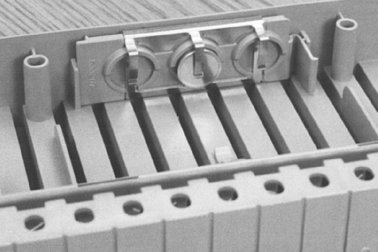
Note: To disinfect a contaminated surface, use the 10% bleach solution and allow it to remain in contact with the contaminated surface for five minutes.

1) Turn an empty cassette over so that its underside is facing you, as shown.
2) Apply a slight inward pressure to the plastic tab that extends from the
memory module.
3) At the same time, pull the button memory module away from the cassette.
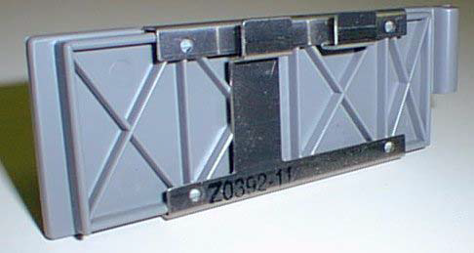
4) Clean the metal contacts on the module with an alcohol wipe.

Note: When cleaning multiple cassettes, it is not necessary to match
the button memory module to a particular cassette. The units are
completely interchangeable.

The cassettes should be thoroughly cleaned and dried before they are used again.
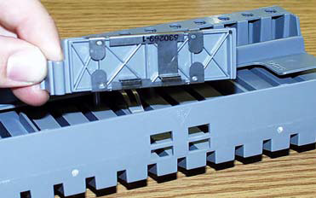
- Replacing the Button Memory Module

1) Turn the cassette over and hold it in your right hand.
2) Hold the memory module by the extended tab in your right
Hand so that the two metal contacts will line up with the two
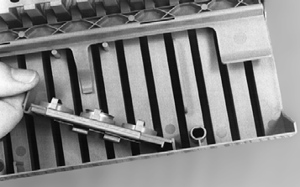
holes in the side of the cassette.

3) Place the other end of the module against the holding bracket
and push the module towards the side of the cassette.
The module should snap into place.

- Cleaning the Boats

Note: The procedures in this section should be performed monthly, or as conditions require.
Note: Replace the boats after cleaning the inside of the instrument using the procedures listed.
Note: The boats should be considered as potentially contaminated and should be handled appropriately. Qualified laboratory personnel should take the usual precautions necessary for infectious agents.
Note: This procedure should be performed while the instrument is idle. If you are performing this procedure to remove only a particular boat, the system can continue to process with as few as one boat.

1) Access the Boat Cleaning function using the path:
Main Menu > Utilities > Maintenance > Cleaning > Boat Cleaning
The following screen appears:
Boat Cleaning
Current number of boats 4 of 4
Remove Boat

2) Press Remove Boat. If there are boats in the card transport system, and it is not idle, the instrument displays the message:
Card transport system is busy. Please try later.
If the system is idle, the instrument moves a boat to the boat dock while displaying this message:
Moving Boat to Boat Dock.
When the boat is ready for removal, the following message appears:
Boat is at Boat Dock. Please remove it.
3) Open the front access door. A boat will be positioned below the Dispenser/Pipettor Station.

Note: A boat may be positioned at the Cassette Load Station, but it must NOT be removed from that position.

4) Remove the boat from below the Dispenser/Pipettor Station and press the Press here after completion option button.
The screen displays: Current Number of Boats: 3 of 4.
5) Repeat this procedure, starting at Step 2, until all 4 boats have been removed.
6) Press the Previous Screen key.
The four boats should be thoroughly cleaned and dried before they are replaced in the VITEK® 2 instrument. The boat material is designed to withstand either of the following cleaning methods.
• 10% bleach solution
• Phenolic cleaning solution
Note: To disinfect a contaminated surface, use the 10% bleach solution and allow it to remain in contact with the contaminated surface for five minutes.

- Replacing Boats after Cleaning

Note: If you are performing monthly maintenance on the entire instrument, do not replace the boats until after you clean the base pan. Refer to the procedure.

1) Access the Boat Cleaning function using the path:
Main Menu > Utilities > Maintenance > Cleaning > Boat Cleaning
The following message appears: Current number of boats: 0 of 4
2) Press Replace Boat. If there are boats in the card transport system, and it is not idle, the instrument displays the message: Card transport system is busy. Please try later.
3) If the system is idle, the instrument prepares for the boat replacement, and then displays this message:
Replace Boat.
4) Open the front access door and replace the boat below the Pipettor Station.
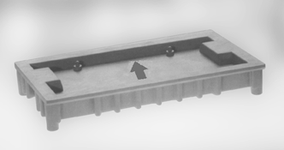
Note: Boats must NOT be replaced at the Cassette Load/Unload Station.

5) Make sure that:
• The front legs of the boat are positioned in the channel
of the base pan.
• The boat is oriented with the arrow (2) pointing toward the back.
6) Press the Press here after completion option button shown below after replacing the boat.
The first screen reappears with the boat count at 1 of 4.
7) Repeat this procedure, starting at Step 2, until all four boats have been replaced.
8) Press the Previous Screen key when the display shows: Current number of boats: 4 of 4.

- Cleaning the Instrument Interior

This section describes the procedure for cleaning the inside of the instrument,when the instrument has been shut down and no cards are processing.
To troubleshoot optics while cards are processing, see Cleaning Optics (Cards Processing) on page 8-23 of the Vitek®2 User Manual.
The procedures in this section should be performed monthly, or as conditions require.

CAUTION: There are elevated temperatures and hot surfaces inside the instrument. Shut down the instrument before starting the cleaning or any other procedures inside the instrument. RD

- Shutting Down the Instrument
ARNING
Note: Finish processing all cards before beginning this procedure.

1) Access the Shut Down function using the path:
Main Menu > Utilities > Maintenance > Shut Down
If any cards are processing the instrument displays this message:
Cards are currently processing. Do you wish to continue?

CAUTION: If you select Yes to continue with shutting down the instrument, the cards being processed may be TERMINATED.

The instrument displays the following prompt: Shutting down instrument. Do you wish to continue?

2) Press Yes to shut down the instrument.
The instrument briefly displays the following message while it moves some internal components to their shutdown positions: Shutting Down Instrument
When this process is complete, the instrument displays the message:
Shut down has completed. Turn power off when ready.
3) Press the AC power switch to shut the instrument off.
4) Remove the AC power cord to prevent any possible electrical hazard. It is now safe to access the inside of the instrument.

- Cleaning the Test Card Collection Tray

1) Open the Waste Collection door and remove the test card collection tray.
2) Thoroughly clean and dry the tray before replacing it in the VITEK® 2 instrument.
The tray material is designed to withstand either of the following cleaning methods:
• 10% bleach solution
• Phenolic cleaning solution

Note: To disinfect a contaminated surface, use the 10% bleach solution and allow it to remain in contact with the contaminated surface for five minutes.

3) Replace the test card collection tray in the Waste Collection Station.

- Cleaning Optics (Normal Maintenance)

Note: Perform the procedure Shutting Down the Instrument before cleaning the optics.

CAUTION: Do not wear powdered latex gloves while cleaning the optics. The gloves that contain a powder can interfere with the optics.

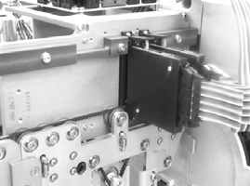
CAUTION: Do not use commercial glass cleaner when cleaning the optics. This may result in calibration failures observed as the optics age. Clean optics using a quality, lint free lens paper that has been slightly moistened with alcohol.

1) Open the Waste Collection door.
2) Lift the top access door.
This exposes the transmittance optics.
The optics consist of multiple units that are hinged on the
bottom and held in place by spring-loaded levers.

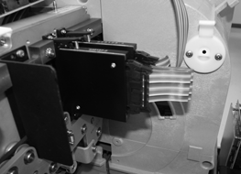
3) Using your right hand, grasp the optics unit and place your thumb
on the lever.
4) Push down on the lever to release the unit and allow it to rotate on
its hinges.
5) Inspect the glass on both surfaces for cracks or scratches.

Note: Any apparent crack or scratch should be reported to bioMérieux.

6) Using a quality, lint free lens paper that has been slightly moistened with alcohol, clean both glass surfaces of each Transmittance Optics.
7) While cleaning the emitter side of the Transmittance Optics, push the reader head plate down and clean the glass as close to the belt as possible.
If foreign material remains on either surface, repeat this step using an alcohol wipe. Squeeze out excess alcohol before using, and dry the surface with lens paper. Make sure that you do not leave streaks on the glass.
8) Rotate the unit back into place while pushing down slightly on the lever
until it is secured.
9) Replace the empty test card collection tray in the Waste Collection Station.
10) Close the top access door.
11) Close the Waste Collection door.

Note: After cleaning the optics and returning power to the instrument, perform the Optical Diagnostic Test.

- Optical Diagnostic Test
The Optical Diagnostic Test should not be performed if ID cards are processing. However, in some cases you need to perform the optical diagnostic test in response to an optics error.
• Transmittance Optics Errors with ID Cards Processing — After cleaning the transmittance optics in response to a transmittance optics error, await the next read cycle of the cards to determine if the cleaning was effective.
• Transmittance Optics Errors without ID Cards Processing — You may perform the Optical Diagnostic Test after cleaning transmittance optics in response to a transmittance optics error.

CAUTION: Performing the Optical Diagnostic Test while ID cards are processing may result in ID cards being TERMINATED.

1) Access the Optical Diagnostic Test using the path:
Main Menu > Utilities > Diagnostics > Optics
2) (VITEK® 2 XL Only) Select a Reader.
The following message appears: About to perform optical test. Do you wish to continue?
3) Press Yes to continue.
4) If the optical test fails, call bioMérieux.
5) Once the test is complete, press Previous Screen to exit the window.

- Cleaning the Base Pan, Vacuum Seal and Vacuum Chamber

Note: Perform the instrument shutdown procedure on before proceeding with this procedure.
Note: If the boats have not already been removed, perform the procedure to remove them.

The base pan, vacuum seal, and vacuum chamber are designed to withstand any of the following cleaning methods.
• 10% bleach solution
• Phenolic cleaning solution

Note: Remove all boats (see Removing Boats for Cleaning) and shut down the instrument (see Shutting Down the Instrument) before performing this procedure.

The base pan is the surface on which the boats move.
The vacuum seal is the bottom surface of the vacuum chamber
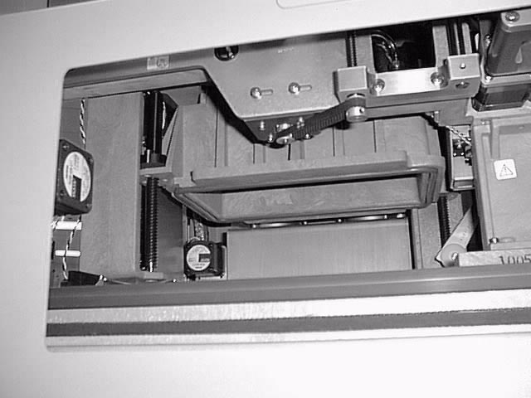
where the chamber makes contact with a boat.

- Using a solution of disinfectant and warm water, wipe off
any dust or dirt from the surface of the base pan.
Particular attention should be paid to the area beneath the
Dispenser/Pipettor Station, where drips or spills may have occurred.

Note: To disinfect a contaminated surface, use the 10% bleach solution and allow
it to remain in contact with the contaminated surface for five minutes

2) Using plain water, wipe the same surfaces again to remove any disinfectant residue.
3) Repeat Step 1 and Step 2 to clean the vacuum seal and the interior surface of the vacuum chamber.

Note: The remaining cleaning procedures in this section do not require that the instrument be shut down. You can now turn the instrument back on.

- Cleaning the Drip Pan A

N Note: This procedure should be performed monthly, or as conditions require.
BIOHAZARD WARNING
VITEK® 2 has a small container, called the drip pan, located underneath the Dispenser/Pipettor Station. The pan is designed to catch any spills that occur at this station.
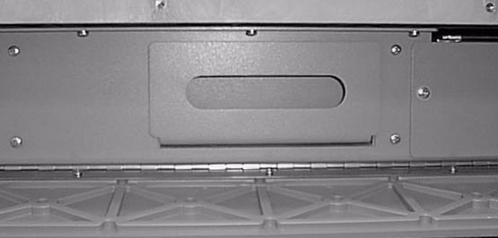
Note: This procedure should be performed after you clean the base pan.

- Removing the Drip Pan
- Lower the bottom access door located in the bottom, front
portion of the instrument. The plate is held magnetically and
should swing down on its hinges when you pull on it at both ends.
2) Grasp the handle of the drip pan and carefully pull it from the instrument.

- Cleaning the Drip Pan
The drip pan should be thoroughly cleaned and dried before it is replaced in the VITEK® 2 instrument. The pan material is designed to withstand either of the following cleaning methods:

• 10% bleach solution
• Phenolic cleaning solution

Note: To disinfect a contaminated surface, use the 10% bleach solution and allow it to remain in contact with the contaminated surface for five minutes.

- Replacing the Drip Pan
1) Holding the pan by its handle, push it into the space provided for it under the front of the instrument.
2) Close the bottom access door by pushing it up. The door is held in place magnetically.

- Turning the Instrument On

1) Move the AC power switch to the ON position.
The system goes through the initialization process. When the Status screen appears it will display a status of Cleaning, indicating that all four boats have been removed.
2) Perform the boat replacement procedure described previously.
After all four boats have been replaced, the Status screen should display a status of OK.

Note: If the instrument was shut down for a long period of time, the status may be Warming. Wait until the status is OK before resuming test card processing.

- Cleaning the SCS

Note: This procedure should be performed monthly, or as conditions require.

The SCS base unit, keypad, display, and bar code scanner (except the clear lens) are designed to withstand any of the following cleaning solutions when applied first to a cleaning cloth and then to the SCS:
• 10% bleach solution
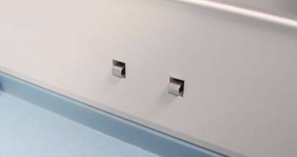
• Phenolic cleaning solution
To clean the SCS:
1) Remove the cassette if one is on the SCS base unit.
2) Push the power switch on the SCS to the off position.
3) Remove the SCS AC power cord from its outlet.
4) Note the metal contacts, and take care only to wipe them
gently in an up and down motion.

5) Clean all surfaces of the SCS base unit, keypad, display, and bar code scanner, except the clear lens of the scanner.
6) Wipe the clear lens of the bar code scanner using a quality, lint free lens paper that has been moistened with a commercial glass cleaner. If foreign material remains on the surface, repeat this step using an alcohol wipe.
7) Allow all parts to dry thoroughly before reconnecting the power cord and switching the power on.

- Record all maintenance performed on the the VITEK® 2 XL Maintenance Log.

- For additional information regarding any additional cleaning procedures, Power failures, Error codes, Troubleshooting issues, etc., See the Vitek ®2 Instrument User Manual

- PERFORMANCE:

NOTE: For detailed instructions on Vitek®2 card set-up. See individual Vitek®2 card procedures.

THE VITEK ® 2 INSTRUMENT IS TO BE OPERATED SOLELY BY QUALIFIED, TRAINED
MICROBIOLOGY TECHNICIANS.

- Smart Carrier Station (SCS)

- Using the bar code scanner,
• Scan the accession ID, and place a specimen test tube in its well.
• Scan the test card, and place it in the corresponding slot.

The Cassette Edit screen is used to store information about specimens and their test cards. You enter the information by positioning the cursor in a data field for a particular test card slot. By default, the cursor is always in the Accession ID field for slot 1 when the screen is first accessed. All fields are empty unless previous data was entered for that slot.

- Access the Cassette Edit screen.
The SCS displays the Cassette Edit screen automatically whenever
a cassette is firmly seated on the SCS base unit.
- Select the correct slot.
• Make sure that the Cassette Edit screen is displaying the correct
slot (1–15). Use the Next Slot or Previous Slot keys.
• Make sure that the cursor (blinking bar) is in the correct field.
Use the Up or Down Arrow keys.
- Enter the correct data by using the bar code reader or manually.

Note: The SCS does not allow you to enter expired cards.
Note: If you need to change any of the data you have entered, you must do so before you remove the cassette from the SCS.

Correct Positioning of AST Cards

When VITEK® 2 is performing the dilution (Automatic Dilution mode), you must follow these rules:

• The AST card must be placed in a slot immediately following the slot containing the inoculum test tube.
• A Gram negative inoculum can be used for either one or two susceptibility tests. When diluting the inocula for two tests, the test cards must occupy the two slots immediately following the slot containing the inoculum test tube.
• The VITEK® 2 AST card type (e.g., AST-GN74) MUST be entered in the Card Type field on the Smart Carrier Station Cassette Edit screen. The instrument is unable to prepare an AST dilution if the card type is not entered.

These rules apply whether or not an ID card is used.

After the information for a cassette has been entered at the SCS, the cassette is ready to be loaded into the VITEK® 2 instrument. Before loading the cassette, always check the Status screen. Look at all the information to make sure it is okay to load the cassette.

- Using the Cassette Load Station

The Cassette Load Station is composed of the cassette load door and a green indicator light. The indicator light tells you the status of the load station. Before you attempt to load a cassette, make sure the indicator light is on or is blinking.

- Loading a Cassette

- Open the Cassette Load Station by lifting the cassette load door up. There
should be an empty boat at the station, or one with a cassette that contains
waste.

CAUTION: Do not attempt to load a cassette if a boat is not at the station.
Damage to the cassette and the VITEK® 2 instrument is possible.

2) Place the cassette in the boat so that the specimen test tubes face the front of the instrument.
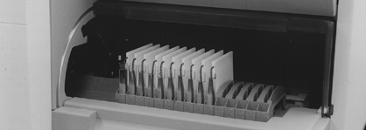

Note: The boat is shaped such that it will only accept a cassette in the proper orientation.

CAUTION: To avoid possible processing errors, make sure that all the test cards and test tubes are properly seated in the cassette.

3) Close the cassette load door.
The Cassette icon appears on the Status screen.
4) Monitor the instrument until the Cassette icon disappears and the boat moves forward to process cards.

- Monitoring Card Processing

After a cassette is loaded, the test cards in it are scanned by the bar code reader in VITEK® 2. This information is sent to the workstation so that a listing of the test cards is in the Directory window.
Additional information is provided once the test cards reach the Card Incubator and Reader Station and are read for the first time.

Note: The VITEK® 2 instrument should be attended during the first minute after a cassette is loaded and the boat moves forward to process cards. This period is denoted by the presence of the Cassette icon on the VITEK® 2 Status screen. See Cassette Load Processing Errors on page 8-10 of the Vitek®2 Instrument User Manual for additional information.

Cassette load processing errors are a special set of errors that occur immediately following the loading of a cassette.
• They are often caused by problems that can be resolved quickly, thereby preventing any interruption in workflow.
• They occur at predictable times.

- Examples of types of errors

  - The bar code reader was unable to read one or more bar codes on the test cards.
  - The card has passed its expiration date.
  - An inconsistency was found between the information read from the button memory on the cassette and the bar codes on the test cards.
  - The bar code reader detected a susceptibility card for which there is no inoculum.
  - The number of test cards in the cassette exceeds the number of available slots currently in the reader carousel.
  - There is an insufficient quantity of pipette tips or saline to process the number of cards being loaded.

For any type of load error, the VITEK® 2 instrument backs the cassette out to the Load Station so that you can resolve the error. If the cassette loading door is not opened within 10 minutes, the instrument assumes that no corrective action will be taken. The errors are ignored and the cassette is restarted. Any test card in the cassette that has a load error will not be processed. The cards remain in the cassette when the cassette returns to be unloaded.
When loading a cassette, wait until the “happy” tune is heard before leaving the instrument.

- Resolving Bar Code Read Errors

• The cassette is backed out to the Cassette Load Station.
• The error alarm is activated.

- Press the Help (?) key to display the Error queue.
- Resolve the error noted.
3) Place the cassette back into the Cassette Load Station and close the door.

This restarts the processing cycle for this cassette.

- Unloading the Cassette and Removing Waste

- Unloading a Cassette
During test card processing, test cards are unloaded from the cassette and placed into the carousel at the Card Reader and Incubator Station. This means that when the boat and cassette return to the unload station, only the specimen test tubes and the severed transfer tubes remain in the cassette.
The cassette must be removed so that the boat is available to accept another cassette.

1) When you are processing test cards, look for the green indicator light at the unload station to be blinking.
This indicates that an empty cassette is at the station.
- Open the cassette load door and remove the cassette from the boat.

Note: The boat itself should not be removed.

- Close the cassette load door.

CAUTION: Leaving the door to the Cassette Unload station open will interfere with the proper processing of the test cards in the VITEK® 2 instrument.

4) Dispose of the materials in the cassette in appropriate biohazard container. The cassette can now be used
to process additional test cards.

All of the materials in an empty cassette should be treated as biohazards and disposed of accordingly. All organism suspensions should be considered as potentially infectious.
Qualified laboratory personnel should use acceptable procedures for biohazardous waste.
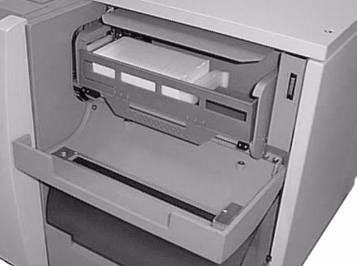
- Removing Ejected (completed) Test Cards

The Waste Collection Station is emptied each morning or as necessary.
When a test card is ejected, it is removed from the carousel in the
Card Reader and Incubator Station, and placed in the Waste Collection
Station. This station has a capacity of 60 test cards, equivalent to the
capacity of the carousel.

- Removing the Waste Collection Tray

1) Open the Waste Collection Station door. Note that waste test cards are held in a removable tray.
2) Place the index finger of one hand on the sliding retainer bar to prevent it from snapping back.
3) Remove the waste collection tray from the station by lifting the front edge of the tray slightly and then pulling it toward you.
4) When the tray is clear of the station, allow the sliding retainer bar to slowly slide back into place.
5) Dispose of the test cards in the tray into a biohazard container.

Note: Once cards have been removed from the Waste Collection Station, never reinsert them. This will cause the instrument to jam.

- Replacing the Waste Collection Tray

- Slide the tray onto its shelf, lifting the front edge to clear the retaining brackets.
- Close the waste collection door.

Note: If the waste collection tray is not replaced, the instrument cannot eject cards and eventually stops processing.

B. CALCULATIONS:

Not applicable

C. INTERPRETATION OF RESULTS:
bioMérieux’s Advanced Reporting Tool (bioART™), utilizes the power of customization in reporting to maximize efficiency and standardization:
- Automatically transfers consistent results to the Laboratory Information System (LIS) to be reviewed.
- Utilizes customized alerts for unusual organisms and sensitivity patterns that need reviewed prior to transfer to the LIS.
- Improved standardization by implementing consistent interpretive comments.
- Advanced Expert System (AES)
The system includes an Advanced Expert System (AES) that analyzes MIC patterns and detects phenotypes for most organisms tested. This helps optimize laboratory efficiency for lean laboratory management. Rapid results allow clinicians to discontinue empiric therapy and prescribe targeted therapy, resulting in improved patient outcomes and enhanced antibiotic stewardship.

- VITEK® 2 technology with the Advanced Expert System™ offers:
Knowledge base developed from >100,000 references
>2,000 described phenotypes
>20,000 MIC distributions
>100 resistance mechanisms detected
>99 organisms
On average, provides a resulting range of five to seven MIC doubling dilutions per antibiotic
Extended MIC range to enable low-level resistance detection
Resistance-oriented results that highlight unusual phenotypes
Deduced antibiotic results to meet formulary requirements
Checks every result every time

The Advanced Expert System™ ensures quality susceptibility test results and decreases the chance for human error through rapid, automatic and systematic validation of every susceptibility test result. Every Minimum Inhibitory Concentration (MIC) result is checked against a database of more than 3,500 phenotypes and 30,000 MIC distributions to determine consistency with previously defined wild or resistant phenotypes.

Colored confidence indicators allow for easy and consistent result review:

Green: Indicates isolates fit an expected pattern for a defined phenotype. Results can be rapidly and confidently released with little or no intervention by laboratory personnel. These results can also be auto-posted to the LIS for faster targeted therapy.
Yellow: Indicates an MIC value does not fit the expected pattern for a known phenotype. The antibiotic is flagged for follow-up.
Red: Indicates an MIC pattern for the tested isolate that could not be matched to a known phenotype. The isolate is stopped for review, providing confidence that ambiguous results will not be reported. Red indicators may suggest technical errors or a new mechanism of resistance.
Purple: Indicates organisms that do not have predefined phenotypes in the database. The isolate is stopped for review.
Black: Indicates no breakpoints defined for the organism and antimicrobials tested.

7. QC PERFORMANCE POLICY:

For QC instructions & policies: see individual VITEK ID or AST card procedures.

A. CALIBRATION AND CALIBRATION VERIFICATION

Not applicable

B. FAILURE/REMEDIAL ACTION:

Not applicable

8. EXPEXCTED RESULTS:

A. REPORTABLE RANGE:

Not applicable

B. REFERENCE RANGE:

Not applicable

C. CRITICALVALUES:

Not applicable

9. REPORTING RESULTS:

THE VITEK ® 2 INSTRUMENT IS TO BE OPERATED SOLELY BY QUALIFIED, TRAINED
MICROBIOLOGY TECHNICIANS.

A. NORMAL VALUES:

The Advanced Expert System™, automatically provides validation of every susceptibility test result.
- Automatically transfers consistent results to the Laboratory Information System (LIS) to be reviewed.
- Utilizes customized alerts for unusual organisms and sensitivity patterns that need reviewed prior to transfer to the LIS.
- Improved standardization by implementing consistent interpretive comments.

B. CRITICAL VALUES:

Any questionable identifications or sensitivity patterns are held in the Vitek®2 until reviewed by a qualified trained Microbiology technician.

10. PROCEDURAL NOTES:

- THE VITEK ® 2 INSTRUMENT IS TO BE OPERATED SOLELY BY QUALIFIED, TRAINED
MICROBIOLOGY TECHNICIANS.
- The Vitek®2 instrument and all components should be considered as potentially contaminated and should be
handled appropriately. Qualified laboratory personnel should take the usual precautions necessary for
infectious agents.
- For additional information regarding any additional cleaning procedures, Power failures, Error codes,
Troubleshooting issues, etc., See the Vitek ®2 Instrument User Manual.
- Results can be obtained as quickly as 3 to 7 hours thanks to the combination of analysis software and an
original, miniaturized consumable, the VITEK 2 card, which is available for wide range of antibiotics.
- VITEK 2 identifies the vast majority of routine organisms (over 300 microorganisms).
- For the more complex microorganisms, VITEK 2 can be combined with complementary manual methods:
1) The API® range for identification,
2)Etest® for antibiotic susceptibility testing.
- A pioneer in the field of resistance interpretation software, bioMérieux has integrated the
Advanced Expert System (AES™), the reference in its field, into the VITEK 2 platform. The AES
systematically compares every MIC result to an extensive knowledge base providing validation of results.
- VITEK®2 uses unique ID and AST cards the size and shape of a playing card. Ready-to-use and low-cost,
VITEK®2 ID cards offer a comprehensive menu of available tests. Based on this breakthrough innovation,
VITEK®2 can provide identification and susceptibility results in as little as 5 hours.

- The VITEK® 2 system can:
- Reduce time to microbial identification and antibiotic susceptibility testing results
- Offer an extensive identification and susceptibility menu
- Reduce waste with a miniaturized card-format that measures 10 cm x 6 cm x 0.5 cm and weighs only 16 grams
- Meet the needs of any size laboratory
- VITEK® 2 systems use Advanced Colorimetry™, an identification technology that enables identification of routine clinical isolates. Advanced Colorimetry provides:
- High discrimination between species
- Low rate of multiple choice and misidentified species
- Minimal number of off-line tests

- VITEK 2 technology with the Advanced Expert System™ offers:

- Knowledge base developed from >100,000 references
- >2,000 described phenotypes
- >20,000 MIC distributions
- >100 resistance mechanisms detected
- >99 organisms
- On average, provides a resulting range of five to seven MIC doubling dilutions per antibiotic
- Extended MIC range to enable low-level resistance detection
- Resistance-oriented results that highlight unusual phenotypes
- Deduced antibiotic results to meet formulary requirements
- Checks every result every time

- Bacterial identification
- This test identifies the pathogen responsible for an infection.
- Identification tests must be quick and reliable. Reducing time-to-results is important for:
- improving patient care,
- managing outbreaks,
- fighting healthcare-associated infections.

Antibiotic susceptibility testing
- Antibiotic susceptibility testing determines the susceptibility of a bacterial strain to a specific antibiotic or a panel of antibiotics.
- The microorganism is placed in contact with the antibiotic(s) and the test reveals if the microorganism will grow or not in the presence of the antibiotic(s).
- This information is reported to the clinician as the Minimum Inhibitory Concentration (MIC), the measure of a microorganism’s susceptibility or resistance to an antibiotic.

- Clinicians use antibiotic susceptibility test results to help determine the most appropriate treatment for the infection and the individual patient.
- Antibiotic susceptibility testing can also be used to detect bacterial resistance to antibiotics.

A. BACKUP FOR INOPERABLE SYSTEM

Pure isolate sent to ARUP for complete identification and susceptibility.

- REFERAL OF SPECIMENS:

Not applicable
C. SUBMISSION/HANDLING OF REFERRAL SPECIMENS:

Isolate sent out by Reference testing.

11. LIMITATIONS AND INTERFERRING SUBSTANCES:

THE VITEK ® 2 INSTRUMENT IS TO BE OPERATED SOLELY BY QUALIFIED, TRAINED
MICROBIOLOGY TECHNICIANS.

- Card performance may be compromised if a suspension is used that is not within the appropriate zone on the Vitek® 2 DensiChek.
- Do not use the card after the expiration date shown on the package liner.
- The card must be stored unopened in the package liner. Do not use the card if the protective package liner has been damaged, or if no desiccant is present.
- Allow the card to come to room temperature before opening.
- Age of the organism / saline suspension must not exceed 30 minutes before inoculating card.
- Use of media, other than the recommended types, must be validated by the customer laboratory for acceptable performance.
- The card performs as intended only when used in conjunction with the Vitek® 2 System.
- Use clear plastic test tubes only. DO NOT USE GLASS TEST TUBES. Variation exists among test tubes of standard diameter. Carefully place the tube into the cassette. If resistance is encountered, discard and try another tube that does not require pressure to insert.
- Do not use powdered gloves, as the powder can cause false positive fluorescent results.
- Special consideration must be given to specimen source and patient drug or antimicrobic regimen.
- Interpretation of test results requires the judgment and skill of a person knowledgeable in microbial identification testing. Additional testing may be required.
- All patient specimens and microbial cultures are potentially infectious and should be treated with universal precautions.
- EMB (eosin methylene blue agar may cause erroneous results and cannot be used with the Vitek® 2 System.
- Any change or modification of the procedure may effect and / or produce erroneous results.
- The Vitek® 2 GN cards cannot be used directly with clinical specimens or other sources containing mixed flora.

12. METHOD VALIDATION:

Prior to 9-1-92

13. REFERENCES:
- Vitek ®2 Software and Advanced Expert System™ User Manual.
- Vitek ®2 Instrument User Manual.

