Do not store clean, unused blood -draw items inside a Biohazard Specimen Bags.


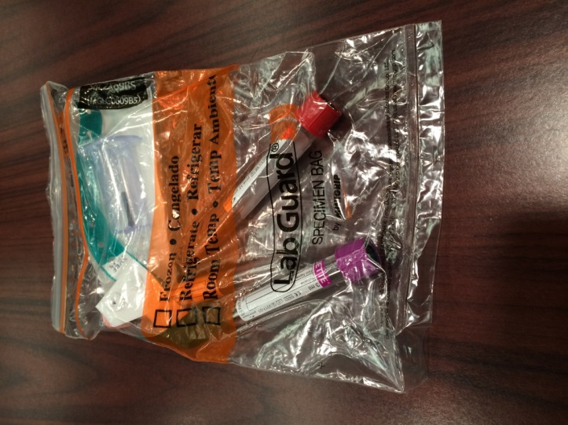

Instead the clean, unused blood draw items can be kept with the folded bag and held together with a rubber band as seen in the example below


