**Starting October 12, 2015**

**Pre-surgical draws for IOS patients to be drawn at JTSM or VWCH draw locations for testing at SRMC/NVML**

**If a patient chooses a Van Wert or Joint Township location to be drawn the following protocols are required:**

◻ **Patient may only be drawn 2 days prior to their procedure for type and screens or crossmatches.(If they are drawn one day prior we can accept however we will need to ensure sample arrives in time to perform testing prior to procedure.) The set up with IOS is to have no more or less than 2 days prior to surgery.**

◻  **IOS is to** **fax order for patient’s lab work to lab patient intends to have blood work drawn and indicate which location and date of patient’s surgery on the order. Locations and hours noted below.**

◻ **Joint township and Van Wert will draw lab work according to our policy using our secureline bands and clear plastic protective bands for blood bank samples. They will order a BDRAW test which will appear on the serology incomplete list. We will receive the BDRAW when they arrive. Voucher will need sent to registration to be registered like an outpatient drop off sample. Then we will order the tests and perform.**

* **We will provide the bands to JTSM and VWCH so if they call and ask for more to be sent please do so.**

◻ **IOS ,JTSM and Van Wert may contact the blood bank at SRMC if they have any questions.**

** **Samples will arrive as collected only and they will use labels as seen below.** 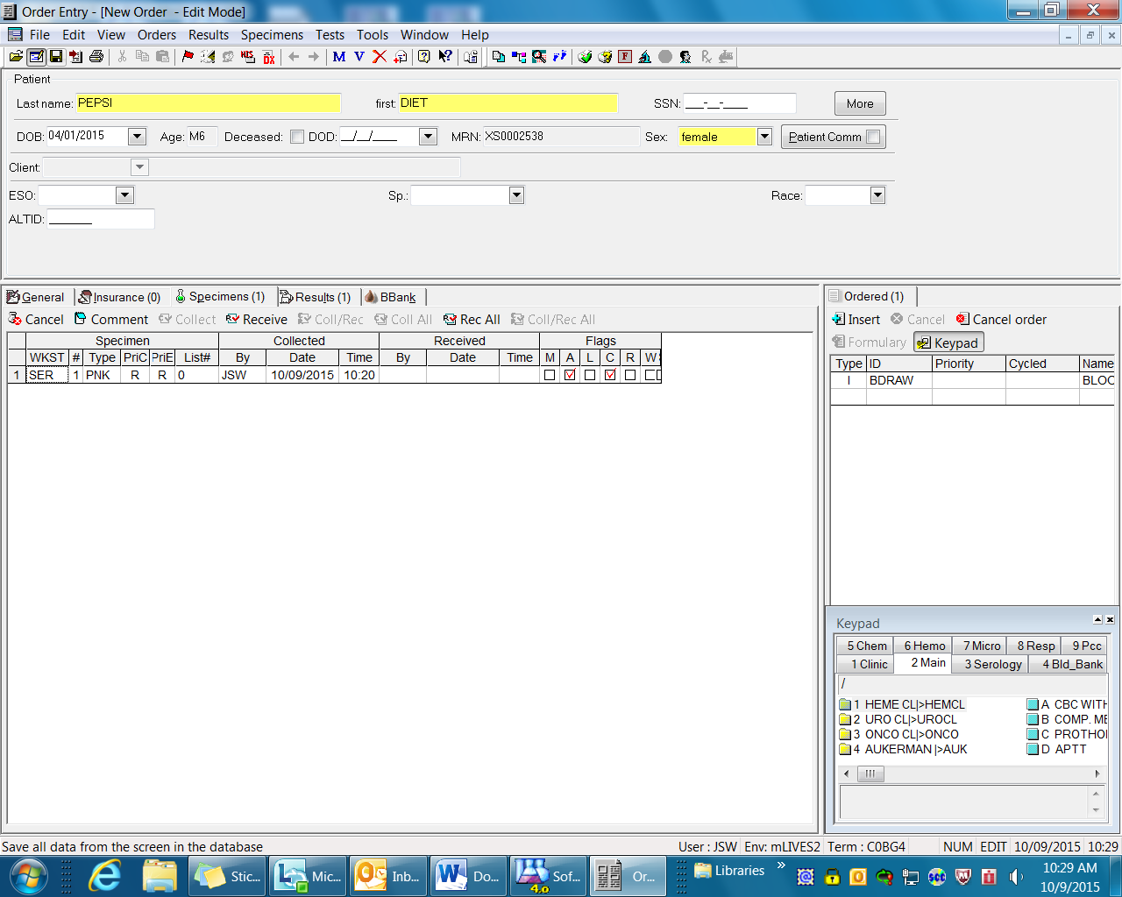



**\*\*Technical staff will need to monitor for these BDRAW samples on the serology incomplete. See below**

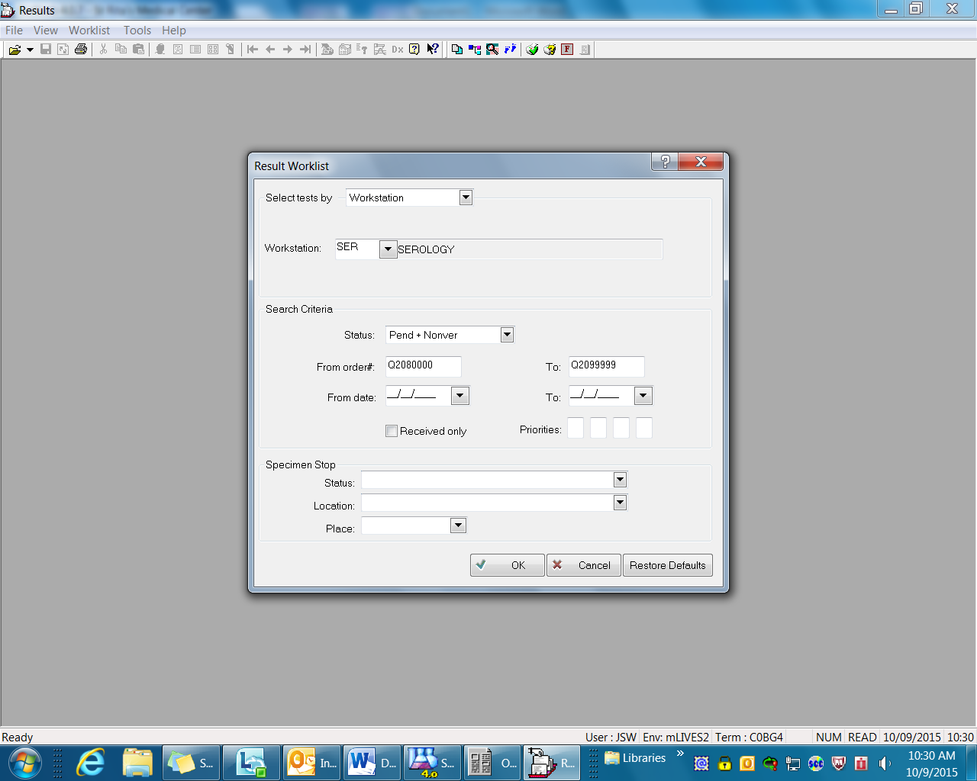

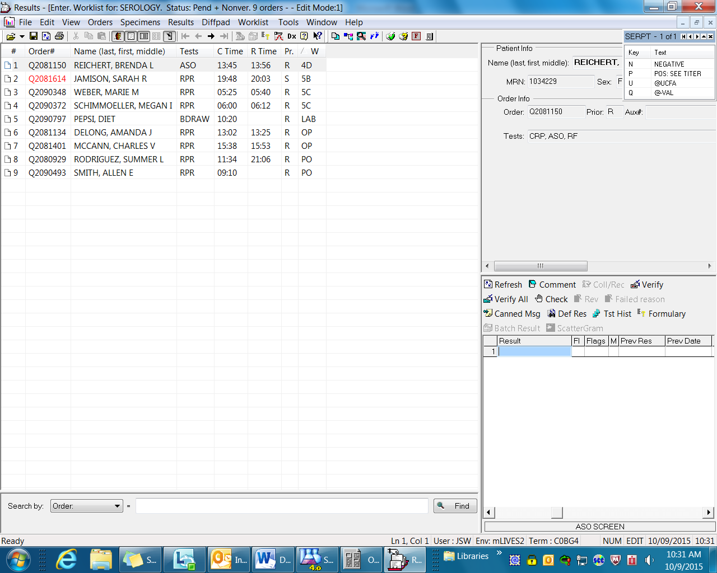

**\*\*Above it shows the BDRAW sample as collected but not received.**

**\*\* Once the sample(s) arrive(s) in lab specimen processing will receive and send the voucher to Registration to be registered as a drop off Outpatient. Once we have a good billing number we can order tests according to the requisition voucher.**

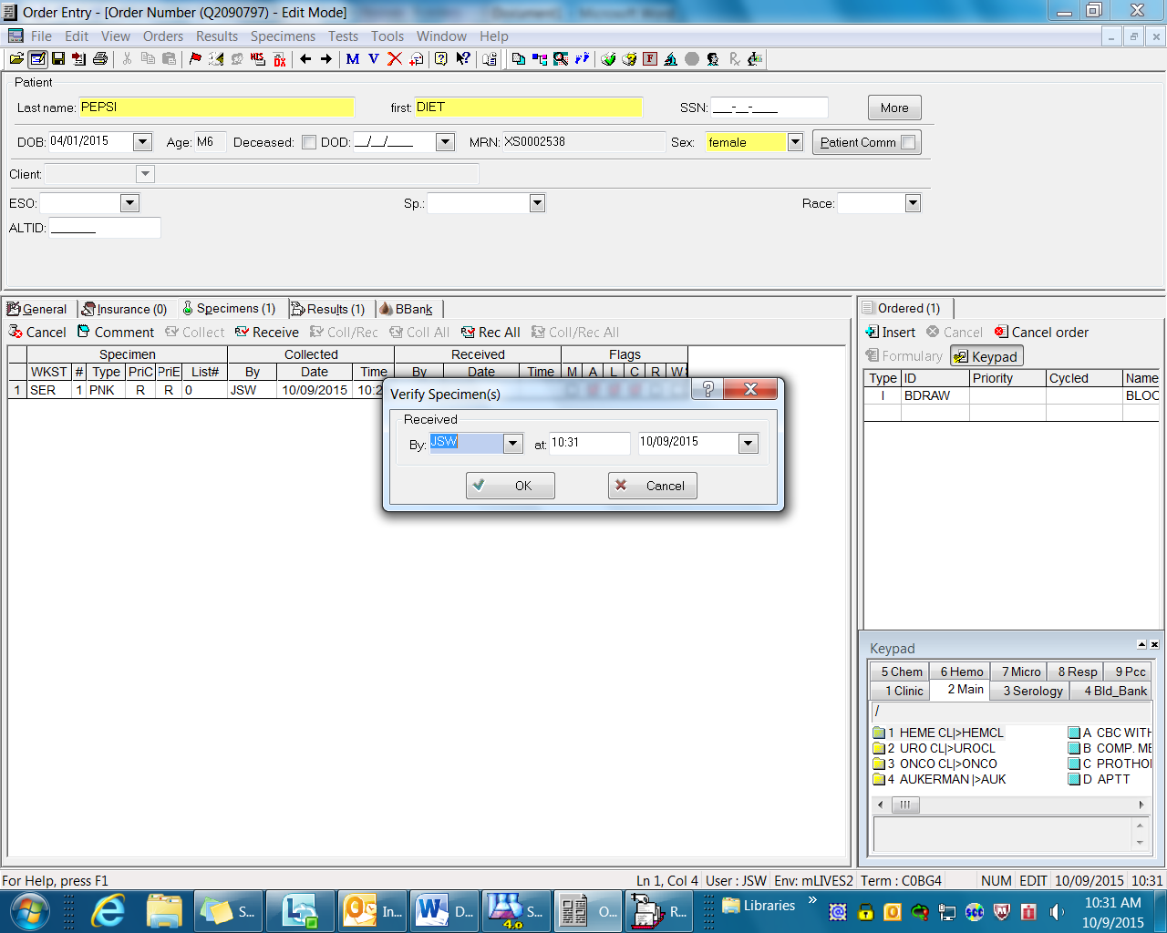

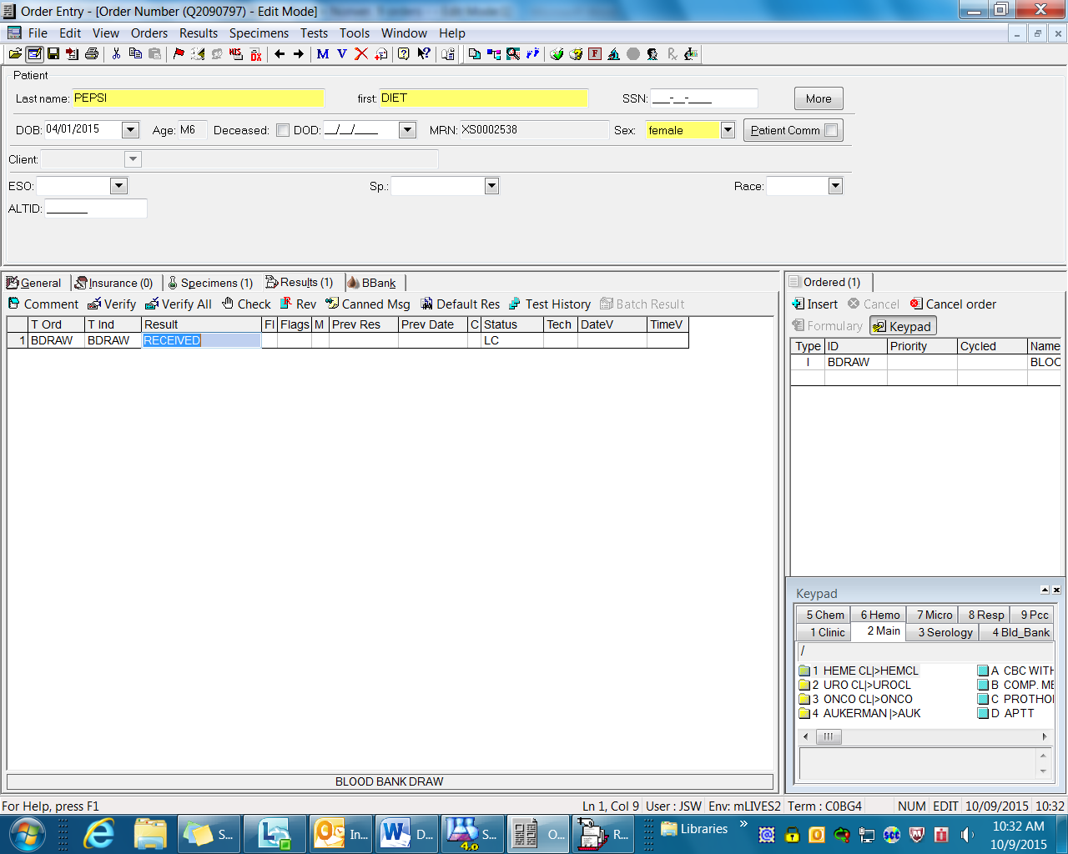

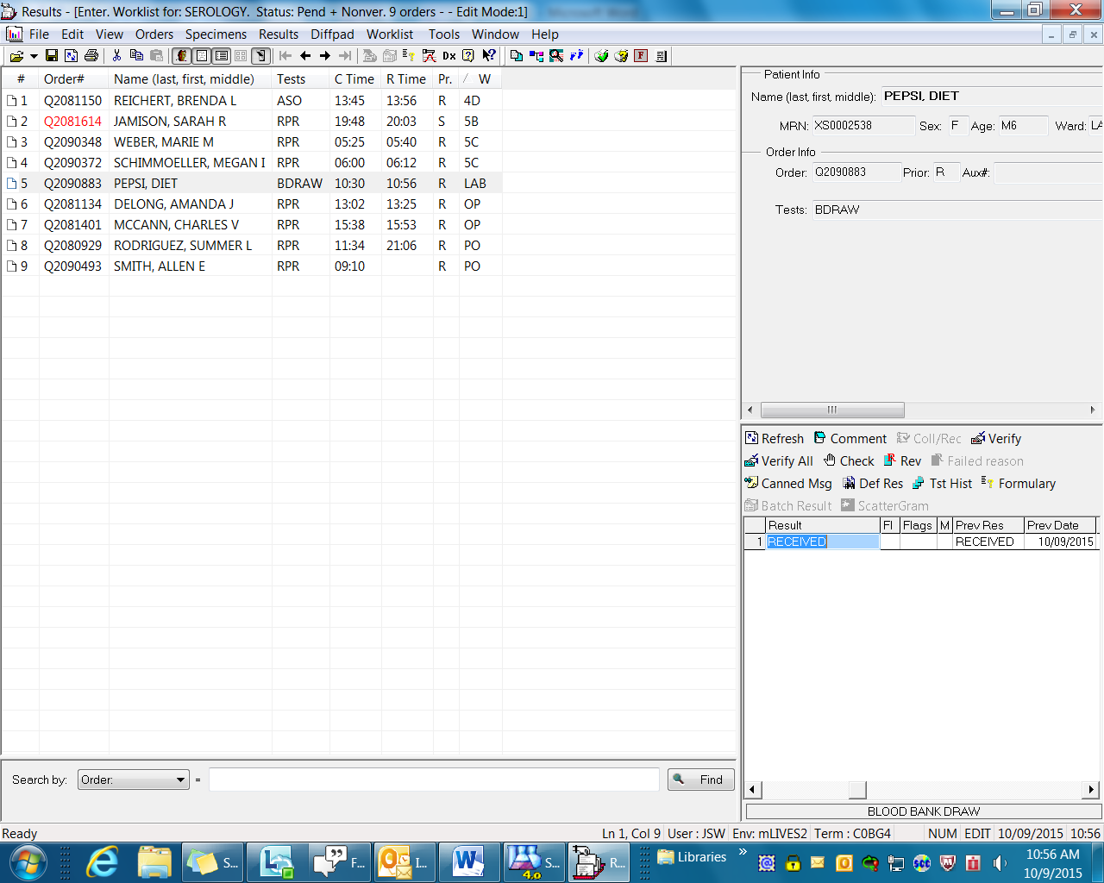

**\*\* Once received in the LIS the test will still appear on the incomplete list until we go in and verify the received result. This way we ensure the samples were received and ordered.**

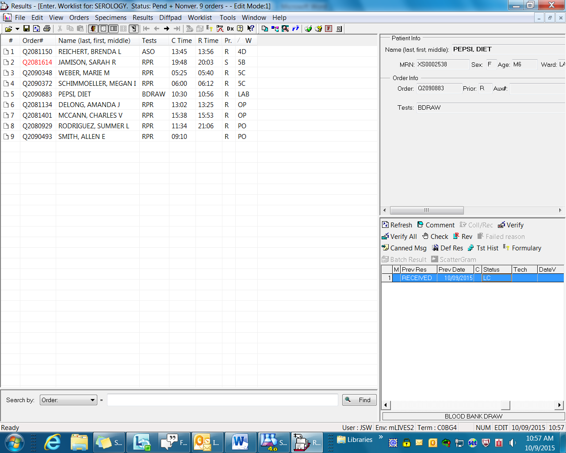

**\*\* You can verify from the pending list by making sure you are on correct order and using the box in the bottom right corner. Select verify or verify all. Note status will change from LC to LC V and test will be removed from incomplete list.**

